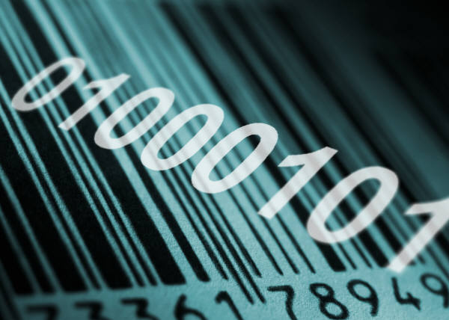

Top Secret Communications: Codes and Ciphers

Overview: Learn to communicate like a spy with some basic codes and ciphers.

Objective: Visitors learn several examples of ciphers and use them to translate and transcribe messages.

Related Exhibits:
Totems
Coat of Arms
Instant Messaging
Sentence Structures

Format Options:
Table top walk-up
Make and Take
Content for class

Age Appropriateness: Families; Grades 2 and up.

Staffing Prerequisites: 1 person

Vocabulary:
Symbol: character or image that represents an idea, concept, or other abstraction.

Code: the usage of characters or words to represent words, sentences, or ideas; a system of symbols.

Cipher: a formal coded message where the original meaning has been obscured; the method used to transform a readable message (called plaintext or cleartext) into an unreadable, scrambled or hidden message (called ciphertext).

Materials Provided: Code samples, masters for Mexican Army and Caesar Cipher Disks.

Additional Materials Needed:
- Paper
- Pens/pencils
- Scissors
- Brass fasteners
- 3 or 5 oz. plastic cups
- Craft glue or staplers
- Paper towel tubes (at least two)
- Tape

Demonstration Notes:
Codes and ciphers are forms of secret communication. A code replaces words, phrases, or sentences with groups of letters or numbers, while a cipher rearranges letters or uses substitutes to disguise the message. The study and design of such secret communication is called cryptology.

Secret writing has been employed about as long as writing has existed. Cryptology has long been employed by governments, the military, businesses, and organizations to protect their messages. Today, encryption is used to protect stored data and transactions between computers.

To Do:
- Examine each code and learn the rules.
- Decipher the sample messages for each code.
- Write your own messages in the code.
- Make a Caesar Cipher or a Mexican Army Cipher (instructions attached).
- Make a Jefferson Wheel (instructions attached).

Extension:

Have a Spy-themed special event. Make disguises; create listening or other surveillance devices, write secret messages in codes or with invisible ink, set up mysteries or crime scenes to solve, classify footprints, fingerprints, and lip prints, run chromatography analysis, learn handwriting analysis, and examine fibers. There are many great activities on this theme -- get creative!

Transposition Ciphers

In a transposition cipher, a message is kept secret by moving the letters around. Here are a few examples; see if you can figure them out!

ext ras pac esb etw een wor dsm ake ago odc iph er

The answer:
“extra spaces between words make a good cipher”
An easy way to encode a message is to put the spaces in different spots. This is called a Space Cipher. The message is divided into groups of two, three, four or five letters to make the message harder to read.

egassem a edih lliw sdrawkcab gnitirw

The answer:
“writing backwards will hide a message” Another way to encode a message is to write it backwards. Don’t add punctuation; it makes the code too easy to decipher. Be careful that your message is not the same forward as backwards (a palindrome) too! For example, don’t write top spot.

esu fno cyl lae rot sec aps dna esu dra wkc abe tir w

The answer:
“write back-wards and use spaces to really confuse”

If one form of cipher is good, two must be better!

How else could you rearrange letters to hide a message? Try to create your own transposition cipher!

Substitution Ciphers

This type of cipher works by replacing a letter with a substitute, which can either be another letter, a pair of letters, a number, a symbol, or any combination of letters, numbers, or symbols. Substitution ciphers are the oldest ciphers used by spies. Believe it or not, the letter-to-letter cipher was invented by Julius Caesar!

Here is one example of a substitution cipher. The top row shows the original letters; the bottom row shows the substitutes.

A | B | C | D | E | F | G | H | I | J | K | L | M
C | D | E | F | G | H | I | J | K | L | M | N | O

N | O | P | Q | R | S | T | U | V | W | X | Y | Z
P | Q | R | S | T | U | V | W | X | Y | Z | A | B

In this example, the letters are shifted two spaces to create our cipher.

Use the cipher above to decode this message:

___ ___ ___ ___ ___ ___ ___ ___ ___ ___ ___ ___ ___
I G V V J G O G U U C I G

Now, try this number cipher:
A | B | C | D | E | F | G | H | I | J | K | L | M
1 | 2 | 3 | 4 | 5 | 6 | 7 | 8 | 9 | 10 | 11 | 12 | 13

N | O | P | Q | R | S | T | U | V | W | X | Y | Z
14 | 15 | 16 | 17 | 18 | 19 | 20 | 21 | 22 | 23 | 24 | 25 | 26

___ ___ ___ ___ ___ ___ ___ ___ ___ ___ ___ ___!
19 3 9 5 14 3 5 9 19 6 21 14

Here is a very famous symbol cipher called the Pigpen Cipher. It is similar to the code used by the Freemasons in the 18th Century to keep their records secret. The symbols look like strange glyphs, but they are really quite easy to catch on to, once you know the trick! Pigpen uses a simple device to create the symbols for each letter.

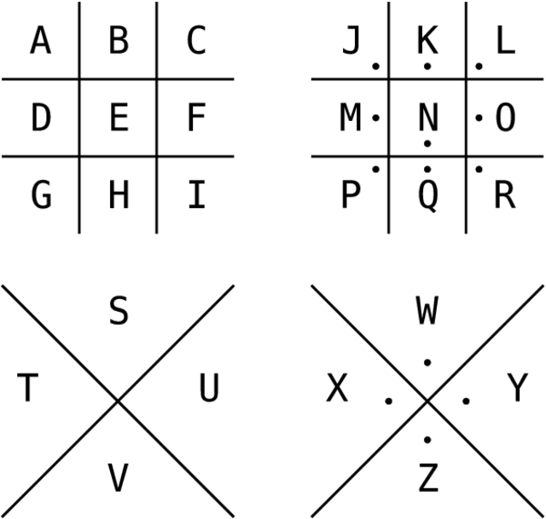

Each letter is represented by the part of the “pigpen” that surrounds it.

A | B | C | D | E | F | G | H | I | J | K | L | M
a | b | c | d | e | f | g | h | i | j | k | l | m
N | O | P | Q | R | S | T | U | V | W | X | Y | Z
n | o | p | q | r | s | t | u | v | w | x | y | z

Decode this Pigpen message:

__ __ __ __ __ __ __ __ __ __ __ __ __ __ __ __ __ __ __ __ __.
i have no special talents.

__ __ __ __ __ __ __ __ __ __ __ __ __ __ __ __ __ __ __
i am only passionately

__ __ __ __ __ __ __.
curious.

-- __ __ __ __ __ __ __ __ __ __ __ __ __ __
--albert einstein

Make a Scytale Cipher

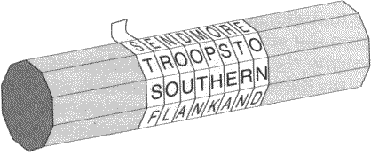

Scytale (skee-ta-lee) ciphers were first used by the Spartan army in Greece in 500 B.C. The “dispatch-scroll” was used to send coded messages between generals during battle. The scytale was a wooden cylinder. The message writer wrapped a long strip of paper around the scytale, wrote the message along the strip, then unwound the strip to create a meaningless collection of letters. The message was deciphered by wrapping the strip of paper around a scytale of the same size.

You will need:
A cylinder, such as a paper towel tube
A long strip of paper, cut ½ inch wide
Tape
Writing utensil

To do:
- Wrap the strip of paper around the paper towel tube until it covers it from one end to the other. Try to avoid overlapping the paper or leaving gaps.
- Write your message along the length of the tube. Place one letter per strip of the paper. When you need more space, turn the tube away from you and keep writing.
- Unravel the strip and send the message!

To decipher a message:
- Make sure you have a cylinder that is the same size as the person who wrote the message.
- Wrap the strip of paper around your cylinder and read the message.

Make the scytale even more secretive by using invisible ink or by writing your message in another cipher!

Make an Alberti Cipher Wheel

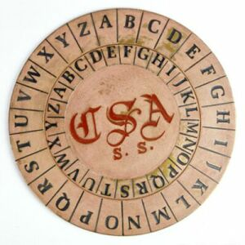

Italian Leon Battista Alberti invented the Alberti Cipher Wheel in 1466. His simple substitution cipher machine made ciphering and deciphering messages much faster and easier. Use these templates to create your own Alberti Cipher Wheels.

To Do:
- Choose either the Caesar Cipher or the Mexican Army Cipher template for your cipher wheel.

- Assemble the cipher wheel.

- Choose a code letter or number. You will base your cipher on this code. If you choose the letter “R” on the Caesar Cipher, you will turn the smaller circle until the “R” lines up with the “A” on the larger circle. When writing your message, find the letter you want to use on the smaller circle and then write the corresponding letter from the larger circle. When decoding, you will find the letter on the large circle and write down the letter from the small circle.

- For the Mexican Army Cipher, you will choose a code number for each disk (four in total). If you choose 20 (disk 2), 49 (disk 3), 77 (disk 4), and 85 (disk 5), you would line each of those numbers up with the “A” on disk 1. You would then cipher your message by choosing a corresponding number from any ONE of the four number disks for each letter in your message. When decoding, you will find the number on one of the small disks, then write the letter from the large disk.

Cipher Wheel Templates courtesy of secretcodebreaker.com.

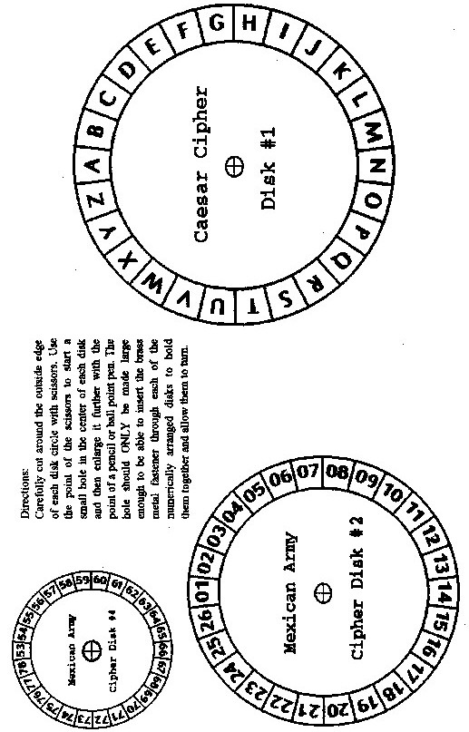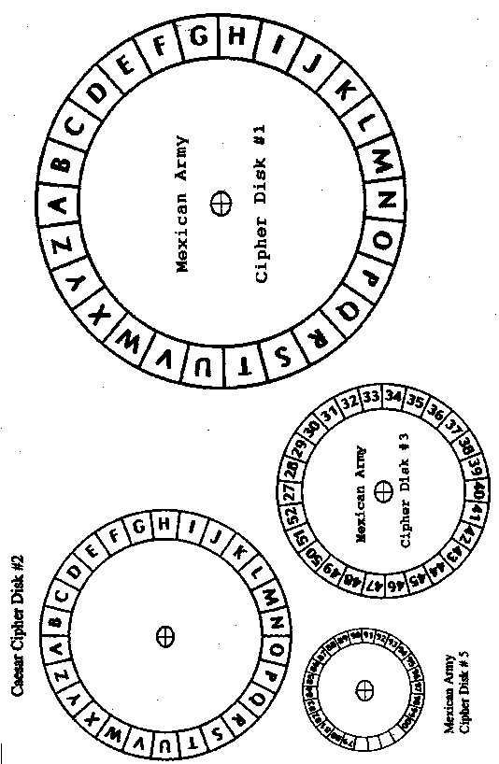

Make a Jefferson Wheel

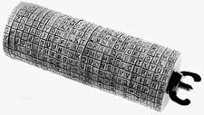
Thomas Jefferson invented this cipher device while an ambassador to France. It consists of 26 wooden disks, each with the 26 characters of the alphabet placed in random order on its outside edge. Each disk had a number on its face so that the disks could be arranged on the spindle in an assigned order.

To create the cipher, the disks were stacked on the spindle in the predetermined order. The disks were spun until the plain text appeared in a row across the face of the wheel. The writer then chose any other row as the enciphered text. The process was repeated until the entire message was enciphered.

To decipher the code, the disks were once again stacked in the correct order, and then spun until the enciphered text lined up all in one row across the face of the wheel. The reader then turned the entire device until a line of recognizable text was found.

You will need:
Craft glue or a stapler
3 or 5 oz. plastic cups
Alphabet paper strips (attached)

To do:
- Stack two or three plastic cups and either glue or staple them together. Make as many sets of these “wheels” as you wish.
- Cut the alphabet paper strips. Remove the number at the top of each row, but keep it with the correct strip.
- Glue the alphabet strips around the rim of the stacked cups. Glue the number inside the cups.
- Now, by stacking a given sequence of “wheels” together, you have made your own Jefferson Wheel. You can now perform the same basic enciphering and deciphering actions as the original.

  0
  K
  7
  2
  L
  Q
  P
  6
  O
  E
  Z
  R
  A
  3
  X
  G
  5
  8
  S
  Y
  1
  N
  9
  B
  M
  H
  T
  U
  F
  0
  C
  4
  V
  W
  D
  I
  J
  1
  I
  Q
  J
  P
  E
  7
  4
  B
  2
  M
  H
  K
  6
  V
  1
  Y
  R
  D
  T
  X
  5
  A
  Z
  G
  W
  9
  N
  F
  8
  0
  U
  3
  O
  S
  C
  L
  2
  5
  J
  2
  N
  E
  D
  1
  X
  H
  G
  F
  3
  0
  Z
  P
  M
  L
  U
  Y
  C
  B
  T
  9
  R
  K
  A
  8
  6
  4
  Q
  7
  V
  I
  S
  O
  W
  3
  Q
  O
  0
  D
  A
  S
  W
  4
  2
  B
  M
  G
  V
  F
  9
  T
  E
  7
  J
  1
  H
  Z
  C
  6
  U
  8
  P
  Y
  3
  X
  N
  I
  R
  5
  L
  K
  4
  G
  R
  0
  2
  B
  V
  J
  N
  C
  A
  H
  I
  K
  P
  T
  8
  X
  E
  S
  4
  U
  1
  W
  Z
  F
  L
  6
  7
  3
  5
  M
  O
  D
  9
  Q
  Y
  5
  I
  3
  0
  Z
  7
  D
  Q
  L
  T
  W
  E
  9
  J
  Y
  C
  6
  H
  G
  K
  N
  V
  5
  S
  F
  P
  B
  8
  X
  M
  R
  1
  U
  2
  A
  O
  4
  6
  L
  M
  R
  O
  6
  J
  U
  X
  B
  Q
  5
  2
  T
  0
  9
  G
  S
  3
  F
  P
  1
  Z
  7
  N
  C
  I
  K
  8
  H
  4
  Y
  V
  A
  W
  D
  E
  7
  M
  S
  6
  K
  8
  U
  Q
  1
  I
  Y
  X
  P
  2
  R
  N
  B
  4
  J
  H
  O
  9
  3
  A
  0
  Z
  E
  L
  G
  7
  V
  C
  W
  T
  5
  F
  D
  8
  V
  R
  Z
  F
  Q
  G
  N
  U
  E
  9
  Y
  3
  4
  7
  J
  0
  I
  5
  D
  M
  T
  P
  8
  A
  S
  L
  K
  6
  O
  W
  C
  H
  X
  2
  1
  B
  9
  U
  P
  T
  A
  5
  R
  O
  I
  E
  B
  2
  W
  J
  F
  Y
  X
  G
  3
  K
  D
  N
  4
  L
  1
  H
  9
  C
  Q
  V
  Z
  6
  M
  S
  8
  0
  7
  10
  N
  S
  I
  G
  7
  H
  D
  U
  5
  L
  9
  T
  V
  0
  Z
  B
  W
  Y
  O
  P
  R
  1
  K
  4
  8
  F
  2
  M
  C
  3
  6
  Q
  A
  J
  E
  X

