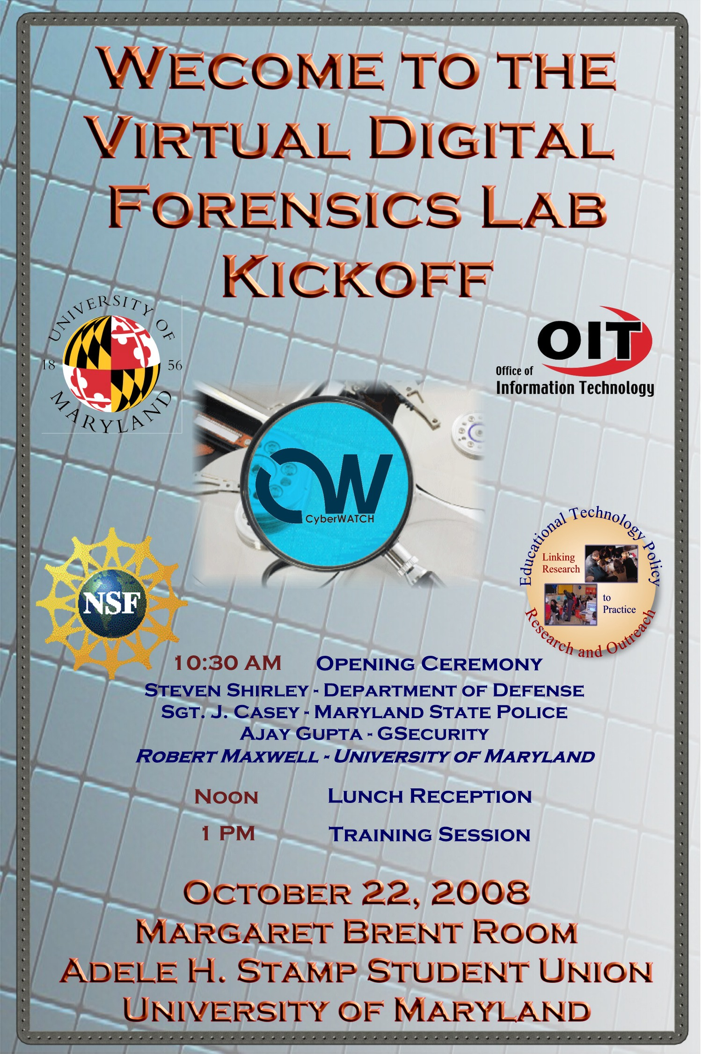
About the Virtual Digital Forensics Lab

CyberWATCH and the University of Maryland’s Office of Information Technology (OIT) are proud to establish a Regional Digital Forensics Lab (DFL) through a grant from the National Science Foundation. The DFL will be a “virtual lab” that will serve as a resource in the teaching of digital forensics at CyberWATCH universities and community colleges, and will offer sample curricula and resources, including forensic case studies, for use by CyberWATCH member institutions and state and local agencies throughout the Washington, D.C. metropolitan area. The first full semester the DFL will be available for use in courses will be Spring 2009.

An important part of the project involves making available computing power and software appropriate for the forensic examination of both network activity and digital media. The virtual lab will consist of virtual machines running on hardware hosted at the University of Maryland, College Park that will function as forensic workstations.

The University of Maryland has been a part of the CyberWATCH consortium for many years, and we are excited to host this shared Digital Forensics Lab that will be used to provide hands-on experience and education to the next generation of information security professionals in the region.
Dr. Jeffrey Huskamp
Vice President and Chief Information Officer
University of Maryland.

Funded by the National Science Foundation, the CyberWATCH consortium is composed of higher education institutions, businesses, and government agencies from across the region focused on improving cybersecurity and safety through education.

Key Personnel:

Dr. Vera Zdravkovich
Prince George’s Community College
CyberWATCH Regional Center Principal Investigator

Dr. Jeffrey Huskamp
Vice President and Chief Information Officer
University of Maryland.

Gerry Sneeringer
Director of Security, Office of Information Technology
Campus IT Security Officer
University of Maryland, College Park

Robert Maxwell
Lead Incident Handler
OIT Security
University of Maryland

Dr. Davina Pruitt-Mentle
Education Technology Policy, Research and Outreach,
CyberWATCH K-12 PI

CyberWATCH – University of Maryland
Digital Forensics Lab Kickoff Agenda
Wednesday, October 22, 2008
Adele H. Stamp Student Union
Margaret Brent Room

10:30 AM

OPENING REMARKS
Dr. Davina Pruitt-Mentle
Director, Educational Technology Policy, Research and Outreach

Dr. Vera Zdravkovich,
Prince George’s Community College
CyberWATCH Principal Investigator

Gerry Sneeringer
Director of Security, Office of Information Technology
Campus IT Security Officer
University of Maryland, College Park

Steven D. Shirley
Executive Director
Department of Defense Cyber Crime Center (DC3)

Sgt. J. Casey
Maryland State Police
Computer Crimes Section/Computer Forensics Lab

Ajay Gupta, President
GSecurity
Director of Cyber Security Services
Prince George's Community College

Robert Maxwell
Lead Incident Handler
OIT Security
University of Maryland

12:00 NOON
Luncheon Reception

1:00 - 3:00 PM
Training Opportunity

An examination of browser forensics, focusing on atypical browsers and alternative Operating Systems (OS). We will look at Internet Explorer on Windows briefly, then on to Firefox, Opera, Chrome, and others. We will look at the effects of “private browsing” and running from removable media. From there we will tackle those pesky "alternative" OSes: Linux and OSX. Altogether an interesting afternoon for cybersleuths.


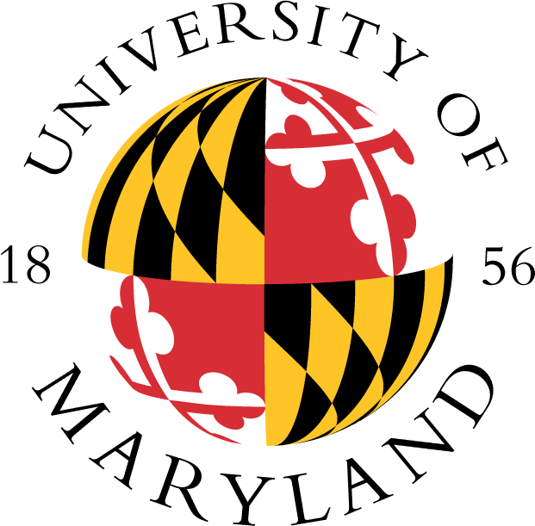
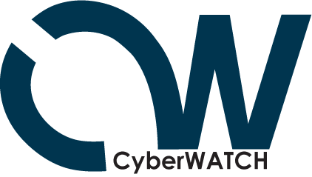
About NSF

The National Science Foundation (NSF) is an independent federal
agency that supports fundamental research and education across all
fields of science and engineering, with an annual budget of $5.92
billion. NSF funds reach all 50 states through grants to over 1,700 universities and institutions. Each year, NSF receives about 42,000 competitive requests for funding, and makes over 10,000 new funding awards. The NSF also awards over $400 million in professional and service contracts yearly. For more information about NSF, visit http://www.nsf.gov/.
About CyberWATCH

CyberWATCH: Washington Area Technician and Consortium
Headquarters is a consortium of higher education institutions,
businesses, and government agencies in the Washington D.C./Maryland/Virginia region that is focused on building and maintaining a stronger information security/assurance workforce. In addition, CyberWATCH is committed to improving the quality and increasing gthe awareness of information security/assurance in the education and business communities. For more information about CyberWATCH, visit www.cyberwatchcenter.org.

CyberWATCH is funded by a grant from the National Science Foundation (NSF).

About the University of Maryland
The University of Maryland is the state’s flagship
university and one of the nation’s preeminent public
research universities. Ranked No. 18 among public
universities by U.S. News & World Report, it has 29
academic programs in the U.S News Top 10 and 90
in the Top 25. The Institute of Higher Education (Jiao Tong University, Shanghai), which ranks the world’s top universities based on research, puts Maryland at No. 37 in the world and No. 8 among U.S. Flagship universities. The faculty includes three Nobel Laureates, seven Pulitzer Prize winners, 40 members of the National Academies of Science, and scores of Fulbright scholars. The university is also recognized for its diversity, with one-third of the student population being students of color. For more information about the University of Maryland visit www.umd.edu.

