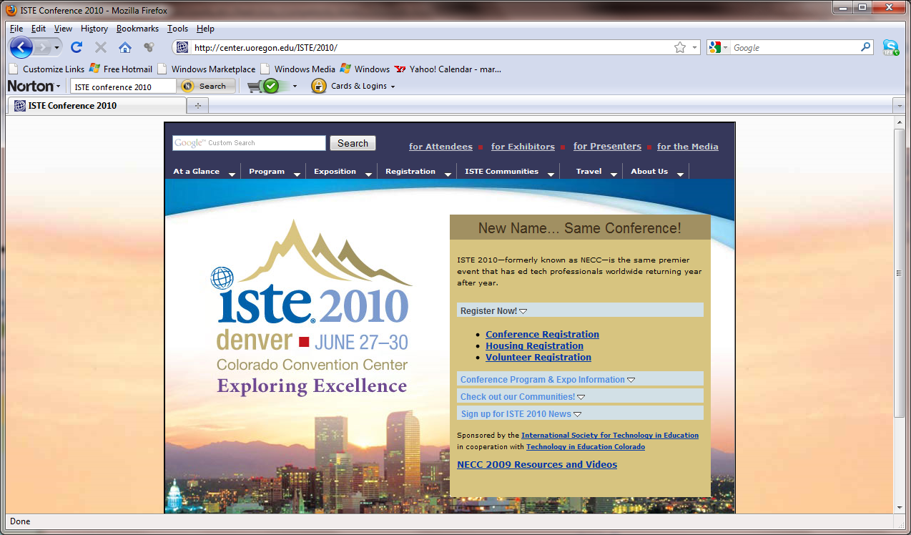 |  | How to Promote Safe and Responsible Cyber Behavior: Best-Practice Guidelines and Materials  June 27, 2010  ISTE 2010
Instructors: |  | Davina Pruitt-Mentle, PhD and Portia Pusey
 |  | Agenda topics
12:30 – 1:00 |  | Introductions/Needs and Interests
Overview
C3 Baseline & Framework
1:00 – 1:45 |  | Research
 |  | Adolescent Development, definitions, legal framework and institutional responses
 |  | Real world consequences
1:55 – 2:45 |  | Cyberethics Cybersafety
 |  | Online Reputation Management
 |  | Electronic Cheating and Ethical Development
 |  | Research & Stats
 |  | Curriculum Resources and online tools
2:50 – 3:15 |  | Cybersecurity
 |  | Top 10 Issues
 |  | Activities
 |  | Curriculum and Tools for Security Training and Awareness
3:15-3:30 |  | Closure
 |  | Evaluation

 | Davina Pruitt-Mentle,Ph.D.  Director  Portia Pusey  Educational Technology Policy, Research, and Outreach  dpruitt@umd.edu  410-531-3910 |  |  | Suzanna Tiapula  Director, National District Attorneys  Association's  National Center for  Prosecution of Child Abuse  Washington, D.C.

