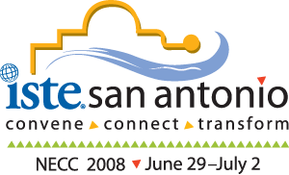 |  | Addressing C3:  Cyber Ethics, Safety, and Security in Web 2.0  June 28, 2008  NECC 2008
Instructors: |  | Davina Pruitt-Mentle, Nancy Willard
 |  | Agenda topics
8:30 – 8:45 AM |  | Introductions/Needs and Interests
 |  | Overview
8:45 – 9:30 AM |  | C3 Framework
 |  | Cyberethics
 |  | Electronic Cheating and Ethical Development
 |  | Internet Citizenship-Rights and Responsibilities
9:30 – 10:30 AM |  | Cybersafety
 |  | Cyberbullying and Cyberthreats
 |  | Cybertechnologies and Activities
 |  | Research into threats of violence or suicide and how this relates to cyberbullying
 |  | Additional concerns related to youth high-risk online behavior
 |  | Limits on online speech, including family values, school rules, user agreements, civil and criminal law
 |  | Legal Considerations for Schools
 |  | Curriculum Resources and online tools
10:30 – 11:30 AM |  | Cybersecurity
 |  | Top 10 Issues
 |  | Privacy and Identity Protection
 |  | Overview of terms/lingo
 |  | Backing Up, Anti-Virus Protection, and Firewalls
 |  | Curriculum and Tools for Security Training and Awareness
 |  | State and National Initiatives
 |  | Closure/Evaluation
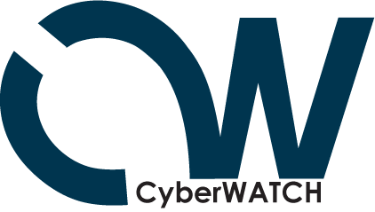 | Davina Pruitt-Mentle  Director  Educational Technology Policy, Research, and Outreach  dpruitt@umd.edu  410-531-3910 |  |  |   Nancy Willard, M.S., J.D.  Executive Director  Center for Safe and Responsible Internet Use  nwillard@csriu.org  541-556-1145

