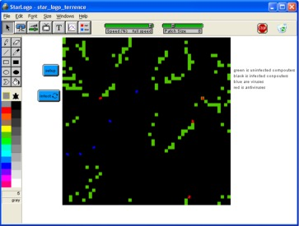
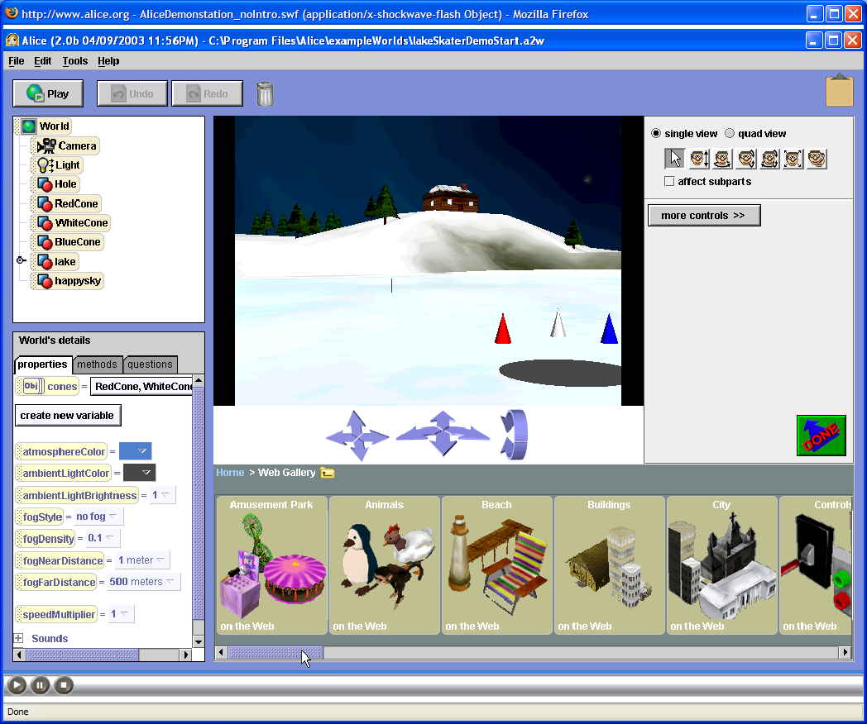
Attention
Rising Junior-Senior Students

You are invited to participate in a special program sponsored by
the National Science Foundation:

Young Scholars Program:

Information Assurance, Information Security
and Digital Forensics

When: M-F June 30 –July 18, 2008

No Class July 4th

Time: 8am-1:00 pm

Where: Applied Research Lab

Cost: none

(you must provide your own transportation)

(Morning and afternoon snacks provided. Bring your own lunch recommended)

Note: This program is limited to 18 students.
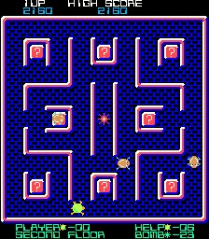
Students will engage in hands-on computer activities and learn about digital literacy (technology fluency and applications, team building, collaboration tools, problem based critical thinking), defending against viruses, Trojan Horses, and worms; and applying basic security concepts through gaming, modeling and simulation development, while investigating exciting careers that interconnect the fields of science, math, technology, and computer security. Students will also discuss such topics as cryptography, system vulnerabilities, and careers in information assurance/digital forensics. Tours of local labs, NIST and NSA will be conducted, and students will have the opportunity to hear from a variety of speakers from state and federal agencies and local security companies.
- Explore various modeling and simulation software packages (MicroWorlds, Excel, GoogleSketchUp and RoboLab)
- Create an Animated Story & Interactive Game/Maze with MicroWorlds
- Develop an Interactive Educational Mini Simulations/Games with Excel and Star Logo
- Designing, build and program a cybernetic devices with ROBOLAB
- Develop a computer animation using a 3D model

7 Internships are available through NSF (National Science Foundation) funding and will be arranged based on the students’ interest (as related to IA/IS/DF) and success in the IA/IS/DF course. An attempt will be made to arrange for internships close to the students place of residence.

Tentative Field Trips & Speakers:

- NIST National Institute of Standards & Technology
- NSA Cryptologic Museum
- National Center for Missing and Exploited Children
- Maryland Internet Crimes Against Children Task Force
- CyberWATCH

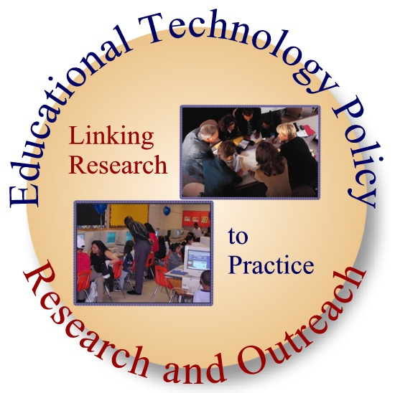

For More Information:
Davina Pruitt-Mentle
(NSF PI/YSP Coordinator)
410 531-3910
dpruitt@umd.edu

Rick Marquart
Richard_Marquart@hcpss.org
410-313-7009

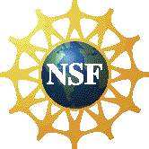
____________________________________________________________________________________________________
Student Last Name Student First Name Middle Name

_______________________________________________________________________________________________________________________________ Street Address Town State Zip Code

_______________________________________________________________________________
Parent/Guardian Last Name First Name

____________________________ _______________________________________________________
Home Telephone Number Parent/Guardian Work Phone and/or Cell Phone Number

______________________________________________________________________________
Emergency Contact Last Name Emergency Contact First Name

________________________________________ __________________________________________________
Emergency Contact Home Telephone Number Emergency Contact Work Phone and/or Cell Phone Number

Parent E-mail Address, if available: __________________________________________________________

______________________________________________________________ ___________________________________
Signature of Student Date

______________________________________________________________ ___________________________________
Signature of Parent/ Guardian Date

→ PLEASE RETURN THIS FORM DIRECTLY TO HCPSS STEM OFFICE

