Step by Step Directions to make a Thermometer

- Determine which cell the temperature you will be referencing is. We will put it in B3, and assume it is Farenheit.
- Make the ranges for your thermometer.
  - In D3, put F
  - In F3, put C
  - In D4, put >212
  - In F4, put >100
  - In D5, put 212
  - In F5, put 100
  - In D20, put 32
  - In F20, put 0
  - In D21, put <32
  - In F21, put <0
  - 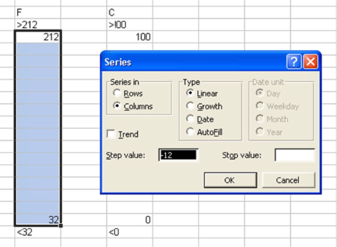Highlight Cells D5:D20
  - Select Edit→Fill→Series
  - Make Sure Linear is Selected.
  - Click OK
  - Repeat with Cells F5:F20
  - Select Columns D:F
  - Center the Columns
  - Choose Format→Cells
  - Go to Number Tab, and select Number under category. Set to 1 decimal place
- Make each value from E4:E21 be equal to =$B$3
- Select Cell E21 (No conditional Formatting necessary).
  - 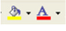Make Text Color Red
  - Make Fill Color Red
- Select Cell E20
  - Choose Format→Conditional Formatting
  - Fill in boxes below.
  - Choose Format, and fillout as below.
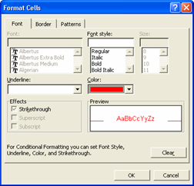
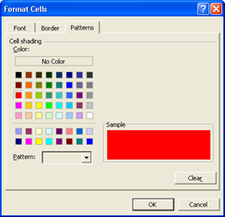
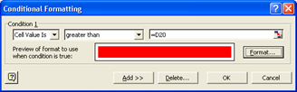
  - Click OK
  - Select Cell E20
  - Choose Edit→Copy
  - Choose Range E5:E19
  - Choose Edit→Paste Special
  - Choose Formats Radio Button and Click OK
  - Select Cell E4
    - Repeat steps a-d above, but replace =D20 by 212
- Hide Black text
  - Highlight E4-E21
  - Change Text Color to White.

You are Done!!!! Test it out!

