Steps to Make a Clear Button
- To Make a Clear button – you will be making a button to implement a macro
  - A macro is a “recording” of a set of steps
  - To work, macros must be enabled on the spreadsheet (this might not be true by default) – to check
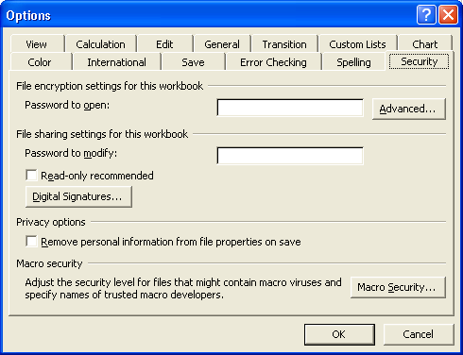
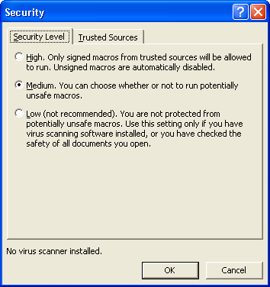
    - Click on Tools→Options, Security Tab, Macro Security Button
    - Set Security Level to Medium
- Before you make the Macro - SAVE
- Show Forms Menu
  - 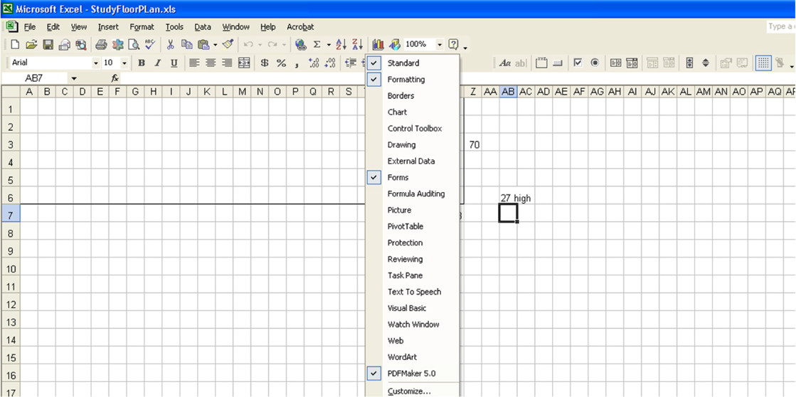Right click on toolbar area, make sure Forms is checked
- Click on the button icon, use your crosshair mouse pointer to click and draw a button
- You will be prompted to name the macro that is to be associated with this button, following this you will have the chance to record the macro.
  - Change the Name of the Macro
  - Click Record
  - Clear each of the answers which you entered into the Responses cells in Response Column
  - Click “Stop” Button which should appear
    - If you can’t find the stop button, stop the Macro with Tools→Macro→Stop Recording
  - Right Click on Button and click on Edit Text
  - Change button name to Clear
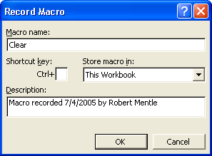
  - Save your worksheet. In the future clicking on the button will clear answers a student entered. I suggest naming the button "Clear."
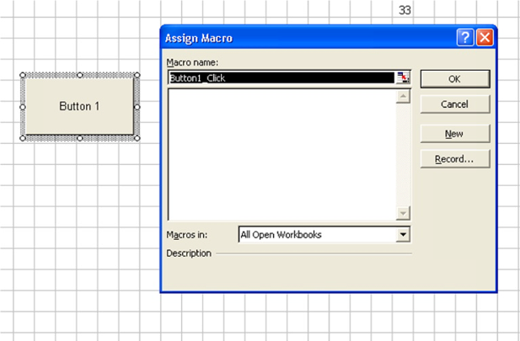

Some Macro Resources
- David McRitchie’s Macro Pages
- O’Reilly Book - order
- Excel Macros
- From Microsoft – Record a simple macro

