Excel Tutorials

Sorting
There are several different ways to sort depending on what you want to do.

Sorting by One Column
- The easiest way to sort your spreadsheet is to click on a cell with data in the column you want to sort, and then click the ascending or descending () button.
- The other columns in your spreadsheet should stay with the appropriate row.

Sorting by Multiple Columns
In some cases you want to sort by more than one column. For example, you may want to sort first by grades, and then alphabetically within each grade.
- It is easiest if you first Click within the first column you want to sort.
- In the menubar, click on Data→Sort.
- You can choose up to three columns to sort by.
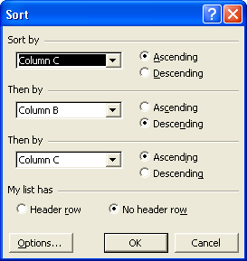

Autofilter
Another interesting way to sort, is using the Autofilter function. Autofilter does not sort, as much as select fields that contain a selected value.
- It is easiest if you first Click on a cell within the first column you want to sort.
- In the menubar, click on Data→Filter→Autofilter
- Down arrows will be added to the top rows of your columns.
  - You can select a particular group.
  - The top “10” values (This number is selectable)
  - A custom set of values
  - All
This allows an easier method of examining specific groups. For example, you might want to see if there are any commonalities among gender groups, ethnicities, or different performance levels. Sometimes having all the data can be distracting.

