Excel Tutorials

Conditional Formatting (“Red Flagging”)
Conditional formatting allows you to have a cell to have a “red flag” depending on its contents. You can use this to look at a large group of data and automatically change the background of each cell, its borders, or its font characteristics. To do this
- Click on the cell whose formatting you want to change (“flag”).
- In the menu bar, click on Format→Conditional Formatting.
- 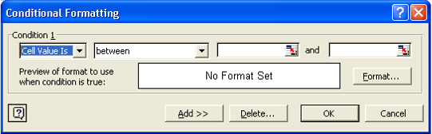Edit the appropriate values in the box which pops up.
- Click the Format Button.
- Edit the Font, Border, and Patterns (Color) tabs to fit the style you would like. Remember, this formatting will only be used if the condition is TRUE.
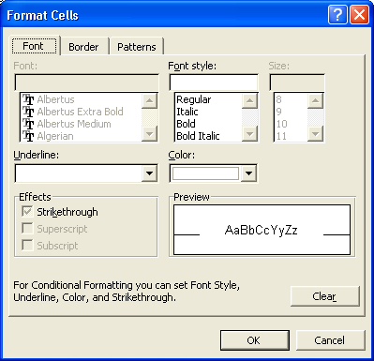
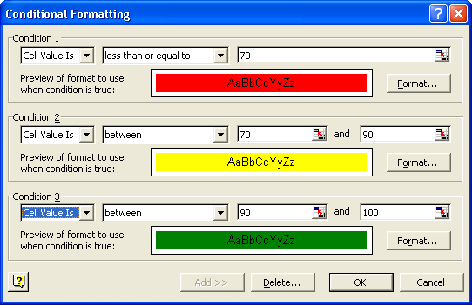
- If you would like to add additional conditional formatting, Click on the ADD>> button above. You can have three conditions per cell.
Example Completed Conditional Formatting Pop up

To copy and paste this formatting
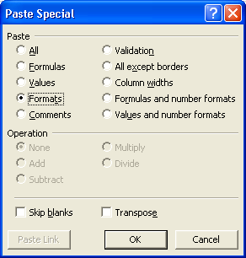
- Click on the cell which has the formatting you wish to copy.
- Either type Ctrl-C or do Edit→Copy
- Click on or highlight the cell(s) that you wish to have the same formatting.
- DO NOT TYPE CTRL-V.
- From the menubar, use Edit→Paste Special
- Click on Formats radiobutton.
- Click OK button.

You do not use the regular Paste (Ctrl-V) because you are not copying a value or a formula, instead you are copying the “formatting” of the cell, i.e. the conditional color selection.

