Please Join Us on September 7th, 2006
for
The New Majority Kickoff Reception

An MHEC Grant through the
Maryland Institute for Minority Achievement and Urban Education
with
Curriculum and Instruction &
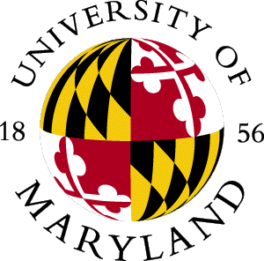
Educational Technology Outreach
in the College of Education

and the

Department of Spanish and Portuguese

in the College of Arts and Humanities

When: | September 7th , 2006 5:00 PM
Where: | 3315 Benjamin Building University of Maryland, College Park
Food will be served

The New Majority Project will assist educators in addressing the content-area language and literacy needs of Latino middle and high school students. This kickoff reception will share the overarching goals and specific activities of the New Majority Project.
Opening and Introductions

Dr. Jim Greenberg, Director K-16 Partnership Development Center
College of Education

Dr. Martin Johnson, Director MIMAUE
Associate Dean for Urban and Minority Education
College of Education

Dr. Stephen M. Koziol, Professor and Chair of the
Department of Curriculum and Instruction
College of Education

Dr. Pierre Verdaguer, Associate Director, Academic Affairs,
School of Languages, Literatures, and Cultures

Dr. Bruce Katz, Regional Assistant Superintendent,
Prince George’s County Public Schools

Keynote Speaker
Mr. Will Campos, Prince George’s County Council, District 2

