The New Majority
MHEC Improving Teacher Quality State Grants:

An MHEC Grant through the
Maryland Institute for Minority Achievement and Urban Education with
Curriculum and Instruction &
Educational Technology Outreach in the

College of Education,

and the Department of Spanish and Portuguese in the

College of Arts and Humanities

Assisting educators in addressing the content-area language and literacy needs
of Latino middle and high school students

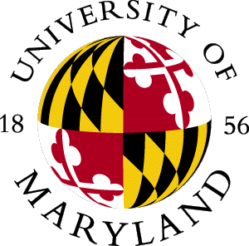

Commitment
- Four Workshops [2006-2008]
- Research Evaluations
Fall 2006
- 3 Credit Graduate Course
- Bladensburg High School/Online
- EDUC698: Universal Design/At for Learning and Literacy for English Language Learners
Principles of UDL
Integrating Technology
Gender, Culture and Digital Sensitivity
AT software for the general classroom

Summer 2007
- Teaching ESOL Reading and Writing in the Secondary Content Areas
Second Language Acquisition
Bilingualism
Sheltering Instruction
Instructional Grouping
5 week program /UMCP
Fall 2007
- Latino Bilingualisms and Biculturalisms
Social-linguistic fundamentals
Latino communities
U.S. Latina/o literary and cultural production

Incentives
- On-site Support
- Nine Graduate Credits
- MSDE credits

- Knowledge acquisition of content-area language and literacy needs
- Participation in premier research study

For More Information
Contact:

Millicent I. Kushner, Ed.D.
Asst. Professor TESOL and
Second Language Education and Culture
The University of Maryland
2311 Benjamin Building
Dept. of Curriculum and Instruction
College Park, MD 20742
Phone: (301)405-3148
Fax: (301)314-9055
millik@umd.edu
Davina Pruitt-Mentle
Director: Educational Technology Outreach
College Of Education
The University of Maryland
2127 Tawes
College Park, MD 20742
Phone: 301-405-8202
dpruitt@umd.edu

