Low Vision vs. Functionally Blind
Persons with visual impairment generally fall into one of two categories
- persons with low vision (this includes many in the general populations-like myself. It also includes many ELL students who have not been tested)
- persons who are functionally blind
Persons from each of these groups sometimes have overlapping AT needs. Other times, the two groups of persons have very different needs. To illustrate this point, I will introduce you to two persons with differing levels of vision impairment. Each will give you some information about their needs for technology.
Virginia.  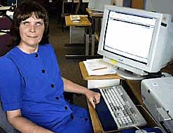 | Melvin.  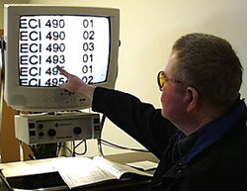 | Susan  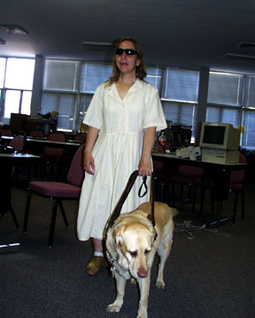
My name is Virginia. I have been blind since the age of 19 and have little usable vision at this time. I depend on my sense of touch and hearing to function in this world. For example, I will use touch to explore new objects, figure out which is the top and bottom of a garment, locate the utensils on a table top (they are placed in regimented placements but I occasionally move them), locate my guide dog and things like that. I can also use my sense of touch to read because I know Braille, but I prefer to use my sense of hearing for reading because Braille is not my first language for reading. I use my hearing extensively to know where people are around me, determine who is speaking to me, know whether the traffic is heavy or stopped as I approach an intersection, recognize whether there is someone in a room and, as I said above, to read.
For technology, I need speech. Since I am more comfortable using this sensory channel, I prefer to have information presented auditorally. This means, I would like my computer to talk to me - they are so funny when they talk. You should hear the computer say "cyberspace." It turns out like "se - bur - spese" I also need to have all my reading materials available in talking book format. Usually my mother reads my textbooks into a tape player and I listen to the tape when she his done. I also need a talking clock and appointment book. This way I can keep track of all my varied appointments and responsibilities. I use my sense of touch as a back up system for reading and writing. For example, I will take notes by whispering into a tape recorder. When I get home at night or between classes, I will transcribe those notes into Braille to read later. I will study from my tape player, however. I use Braille for permanent documents.

Hi, I'm Mel. I have very low vision and have difficulty reading printed materials. Where I have the most difficulty is in trying to read small print. My vision specialist tells me that I need to have all my print enlarged 6-8 times normal size. That is, where you will read print that is 12 pitch or point (that is standard), I must have 72 to 96 point fonts to be able to read without difficulty. I also have difficulty with straight white paper. The reflection from your standard papers (on white stock) causes my eyes to water and sometimes hurt. I can read this for a short period of time, but the longer I read black on white papers, the more difficult it becomes.
For technology, I need to have the text magnified or enlarged. I prefer to use what vision I have because I am generally quite independent with modifications. When I read, I need to have the text size increased. I can do this with a magnifier or through special software on my computer - ZoomText, a screen enlarger. When I am not using the computer, I will use a CCTV [you will learn about this in the lessons in this unit] to enlarge the text size. I don't use auditory information much, only as a back up system if I cannot get the text enlarged enough. One other thing, I need to have the background color of all text documents changed to a pale yellow color because this will decrease my fatigue when I read text. If it is printed on white paper, my eyes will get tired from the glare. After a few moments of reading my eyes will begin to water.
NOTE: RULES OF THUMB for the GENERAL POPULATION
- size 12 is standard and the smallest font size that should be used. However, 14 is much better- especially with students just learning to read (this could also be ELL students), students with reading difficulties (dyslexia!). many times teachers will use size 10 font to get a test or quiz on one page.
- Double spacing between questions is also a good idea.
- PPT font should be 20+ font size
- WORD has the Zoom feature on the standard menu bar --available to increase the screen size. Later in the course we will learn about the other accessibility features that are in the standard Microsoft suite that most of us do not realize are there.
- Standard black on white background can make anyone’s eyes fatigue. Try changing your background to different colors. On your menu bar –Format-> Background and choose a color. To get rid of-Format-> Background-> No Fill
- For students with disabilities (dyslexia, ADD, ADHD) simply changing the background color and/or font can increase fluency speed and comprehension. The “color” acts as an extra sensory feature.

I'm Susan. I am blind and have been blind since I was very young. Where I have the most difficulty is with visual information, and there is a lot of it out there. I cannot use information that is presented visually because I have no residual vision. All the textbooks I use must be given to me in an alternative format or they are useless.
I need to have the text changed to Braille, or if that is not possible, into a talking book tape. I prefer to Braille because I am used to it and think that I do much better with this than with a tape. Have you ever listened to a tape to read a book. You probably did not notice how hard it is to back up and read a section of the text again (and I need to do that a lot when reading technical information). I am also not used to listening to things on tape that I need to remember. I can remember information much better if it is in Braille. When I write, I use Braille also. I have a Braille notetaker that I can enter all my class notes, appointments, and phone numbers into so I can read them later. I tried to use auditory methods - a tape player - but kept losing the tapes and couldn't remember what I put on the tape. Braille is so much easier to work with. The last thing I need is a guide dog. Galli is my buddy. She helps me get around the campus and community. Without her, I would need to stay home a lot more than I do. I guess those are my technology needs.

As you can see, Virginia and Melvin share some of the same AT needs, but they also have other, very different needs. This is not uncommon.
When choosing technology for persons with visual impairment and blindness, the level and amount of their residual function is an important variable. Technology for persons with visual impairment is designed around two general principles.
- Creating alternative sensory input.
- Augmenting existing vision.

Creating alternative sensory channels.
In Virginia's case where she does not have residual vision, the goal is to create alternative sensory input to overcome her inability to process information visually. Despite her lack of vision, she has two primary sensory channels that can be used to gain information: Hearing and Touch.. With the assistance of AT devices, Virginia can use these sensory abilities to compensate for her loss of vision
Virginia's technology for:
- Hearing
- Touch

Augmenting existing vision.
If the person has residual vision, as Melvin does, then our goal is to augment the existing ability wherever possible and use alternative sensory channels only as necessary. Melvin is able to use three sensory channels to gain information. Melvin uses a system of AT devices to compensate for his limited vision.
Melvin's technology for:
- Vision
- Hearing
- Touch
Technologies that Provide Alternative Sensory Feedback

Read Access Technology for Persons with Vision Impairment and Blindness in the readings

