Selected Microsoft Word Features

Action | Display
Software and Operating Systems Standard 1194.21 (a)When software is designed to run on a system that has a keyboard, product functions shall be executable from a keyboard where the function itself or the result of performing a function can be discerned textually.  To meet this standard Microsoft Word provides keyboard equivalents. Some keyboard equivalents appear in menus as this File Menu shows.  - For a student who uses screen reading technology to speak information on the display, the keyboard equivalent replaces a mouse command  - To save a file  - Keyboard—Press Control and S, or  - Mouse—Click Save in the File Menu  Users can find additional keyboard shortcut information and technical support from the Word Help menu or online  http://www.microsoft.com/enable/training/office2000/default.aspx | 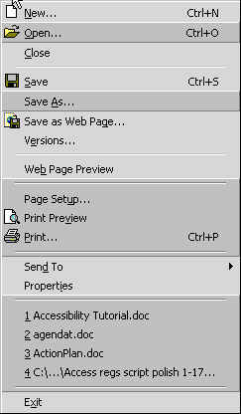
Software and Operating Systems Standard 1194.21 (g) Applications shall not override user selected contrast and color selections and other individual display attributes.  (j) When a product permits a user to adjust color and contrast settings, a variety of color selections capable of producing a range of contrast levels shall be provided.  Go to Start, Settings, Control Panel, then double click on Display. Select the Appearance tab. Click on the drop down box for Scheme and select the Pumpkin (large) setting. Now click in the Word window to demonstrate how Word accepts the user selected color contrast settings. This is what should happen in an application when an operating system accessibility feature is changed. | 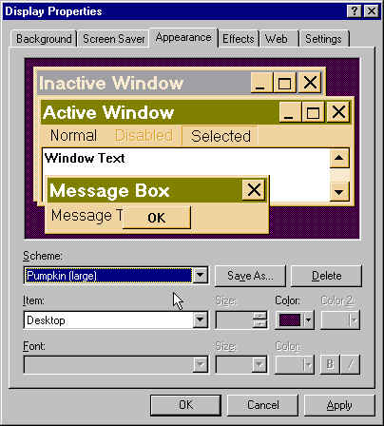
Software and Operating Systems Standard 1194.21 (h) When animation is displayed, the information shall be displayable in at least one non-animated presentation mode at the option of the user.  Click on Tools, then Options. Select the General tab. Click on the feature “Provide feedback with animation” for Word to give visual along with auditory feedback. This accessibility feature works not only for students who are deaf but students who don’t process what they hear well. | 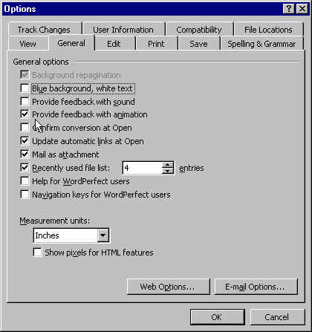
In some cases, Microsoft Word exceeds the Software and Operating Systems Standards 1194.21.  For example, the AutoCorrect feature provides another option for developing keyboard shortcuts that save time.  Go to the Tools menu, select AutoCorrect. Create an abbreviation by typing “tech prod” in the Replace text box after the “Replace text as you type” feature. Then type “technology-based instructional products” in the “With” text box. Click OK. Then type “tech prod” to see how Word retypes this abbreviation or misspelling. | 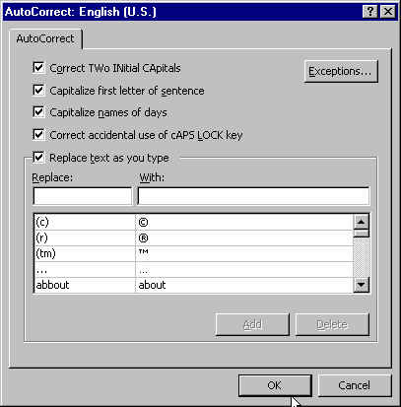

For additional information about other accessibility features that Microsoft Word offers, go to:
http://www.microsoft.com/enable/training/office2000/default.aspx

