Important Concepts in AT
Now that we better understand what AT is and how it can benefit all populations not just persons with disabilities, it is important that you understand four basic concepts about AT. The following concepts pervade all discussions of AT throughout this course. These concepts are:
      - low vs. high technology
      - the 80/20 rule,
      - AT as a system, and
      - the notion that AT is a team process.

AT: Low vs. High.
One helpful distinction to keep in mind when thinking about AT is the difference between low-tech and high-tech.
Unfortunately, there is no universally agreed upon definition of high- or low-tech devices, but each definition has certain similar elements.
Low-tech = devices that are non-electronic, generally use simple electronic designs (if any at all), are low cost, are simple to use, and require little or no formal training to effectively operate. Low, or light tech as some will refer to this class of devices, can often be fabricated by school personnel, family members, or friends.
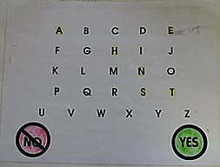
A simple communication board
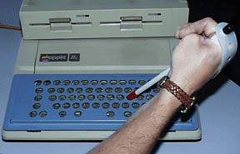
A writing template for the computer
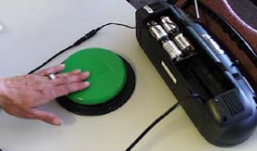
A simple on/off environmental control unit
High-tech = devices that are electronic, driven by a computer, generally expensive (over $1,000), and are complex, often requiring more in-depth knowledge and skills to operate effectively. High tech devices are rarely fabricated by persons other than those with extensive knowledge in electrical circuitry, mechanics, and programming.

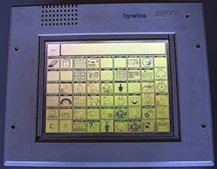
A Communication Device
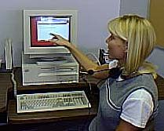
Voice Recognition System
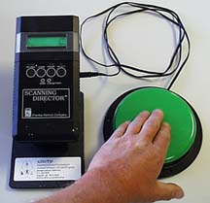
An Environmental Control Unit
You will frequently find persons relying more on low tech, even those who use high tech devices. Why?
- Low tech alternatives are less expensive so, if the solution is not effective, the team is rarely out a lot of money.
- Because of the relative simplicity of low end (tech) solutions, teams and the consumers who use the device do not need to invest large amounts of time in training.
- Many high tech devices will fail to perform on occasion. For example, the battery on a device that speaks for a person may lose its charge. When this happens the individual needs a back up system. Low tech is perfectly suited to fulfill this purpose.

The 80/20 Rule
Related to the high-tech/low-tech dichotomy, is the notion that AT solutions can range from low-tech modifications and devices to the most expensive high-tech devices, sometimes costing $20,000 or more. For many persons, especially employers and service agency staff, this is a scary proposition. People are reticent to consider AT devices because they are only aware of high-tech devices whose cost is prohibitive. For this reason, it is important that you know the 80/20 rule.
THE RULE: Eighty percent of the effective AT solutions for persons with disabilities are simple, low-tech devices. Only twenty percent of the necessary modifications involve high-tech options (The 80/20 rule)
Visit the Job Accommodation Network site and review the following brief reports and articles about AT to see just how costly some of the effective accommodations are:
"Low Cost Solutions"
"Situations and Solutions"

AT as a system.
AT can be thought of as system that resembles a jigsaw puzzle consisting of several pieces. In a typical jigsaw puzzle the puzzle is incomplete and the final image is indistinct until all pieces are in place. The same situation exists with AT systems. Without each piece of the puzzle, the AT intervention is incomplete, and is more likely to fail. You should also be aware that each component of this puzzle interacts with each other element. Isolating devices, strategies, and supports from each other - as is often the case with AT interventions - can have disastrous consequences.
Strategies
Supports

Devices
Devices

There are a whole host of AT devices available to assist a person with a disability. AT devices may be low-tech or high-tech. Although AT devices can be categorized in many ways, here are some of the more common categories:

- Mobility Aids

- Wheelchairs
- Canes, crutches, standers, walkers
- Guide dogs, white and sonic canes
- Vehicle accessories

- Personal Care Aids

- Braces and supports
- Bathing Aids
- Carrying Devices
- Adapted clothing
- Dressing Aids
- Eating aids
- Grooming and hygiene aids
- Health Care Aids
- Toileting Aids

- Computer Access Devices

- Adapted Keyboards
- Alternative keyboards
- Emulated keyboards
- Mouse emulation
- Alternative Output Devices
- Specialized sofware

- Communication Aids

- Speech Aids
- Reading Aids
- Writing Aids
- Telephone Aids

- Control Devices

- Extension devices
- Adaptive switches
- Environmental control units

- Sensory Aids

- Aids for Persons Who Are Blind and Low Vision Aids
- Aids for Persons Who Are Deaf and Hard of Hearing

- Recreation and Leisure Aids

- Adaptive Play
- Games
- Gardening
- Sports and Fitness
- Photography
- Music and Art

- Prosthetic and Orthotic Devices

- Prosthetics
- Orthotics

- Positioning Devices

- Therapy Equipment
- Seating Equipment

Supports

Equally as important as devices and services are the supports available to a person with a disability. It is often the nature and quality of the person's support network that determines the ultimate success of any AT intervention. Three important supports are:

Modifications to the persons environment that make it easier for them to use their AT devices. Examples of environmental modifications include:
- providing adequate lighting,
- eliminating mobility barriers (furniture, etc.) that impedes movement, and
- altering the perceptions of other persons who must work with the individual with a disability.

Improving the persons overall skill repertoire to increase their ability to effectively use AT devices and strategies. In addition, any AT intervention should be integrated into an overall educational plan. Team members should target two types of skills for all AT
interventions:
- Functionally equivalent skills. Functionally equivalent skills are those skills that are the target of the AT intervention. For example, if the target of using a communication device to solicit someone's attention, the team would include goals and objectives to teach the person how to use to AT device to gain the attention of a friend, teacher, or job coach.
- Functionally related skills. In addition, the team should include functionally related skills such as general content knowledge, self-care skills, social interaction skills, and the like. These skills allow the individual to function in a wider variety of settings because the education plan has developed a range of more general skills.

Training partners (co-workers, job coaches, etc.). It is essential that the persons (all teachers involved) who work with, and support, an individual with a disability receive training in using the AT device(s) and strategies appropriately, maintaining the device(s), and in troubleshooting device malfunctions. Often this type of training is provided by the vendor of AT devices, and is delivered to the AT coordinators only—very little training is delivered to the general classroom teacher.

Strategies

Strategies are one essential element in any AT intervention. Persons with disabilities (and their support network) need to learn how to operate the AT device(s) they use. Without this type of support (training) AT devices are often underused or abandoned.

Training and technical assistance supports are needed by the persons who are using, or who are working with those who use AT devices. Typically this group of persons who are in need of supports includes the person with a disability, family members, all teachers or employers, therapists, aides or personal assistants, and even peers (see notes on AT TEAMWORK)

There are three levels of training necessary to effectively implement AT devices and services.

- Operational Competence. At this level, the person must learn about the device features and maintenance routines. The person should be trained in
the basic operation of the device, given information about how to turn on or shut down the device, maintain and care for the equipment, and be generally familiar with the features contained in the device and know how to configure these features. For complex, high tech AT devices, their level of training and support can take up to one year to complete. For low tech, simple AT devices, this training period can be as short as one day or as long as several weeks. It should be noted that initial operational competence quickly develops into more in-depth operational competence as the person more fully understands the capabilities of the device or devices.

- Strategic Competence. Once operationally competent, the person must learn how to integrate the device into typical routines (work, leisure, community travel, education, etc.). This stage requires extensive support on the part of significant others. The device, be it low- or high- tech, must be configured (programmed in some instances) to fit the environment(s) of use. Often, the AT team must conduct a comprehensive environmental analysis prior to altering the device and implementing the AT intervention in that environment.

- Problem-solving and Coping. Lastly, the person needs to learn how to cope with problems, solve device malfunctions, and learn routines to repair interactions where the device cannot meet their immediate needs. This is such a critical area for support. Often, AT teams neglect to provide this level of support, then are surprised when the AT device is underused or rejected months or years after successful use by the person with a disability. Someone should be available to the person with a disability on an ongoing basis to help with equipment failures, upgrades, programming in new language or functions, and answering technical questions about the device.

Without considering, and carefully planning for, each of the elements of the AT puzzle, the ultimate effectiveness of any AT intervention is compromised.

___________________________________________________________________

