

Empowering Students Through Technology
The Bank of America Building•
5800 Martin Luther King Jr. Highway•Seat Pleasant, MD 20743
(301) 925-9350 • FAX (301) 925-9352
www.patriots-ttc.org gloria@patriots-ttc.org

REGIONAL MARYLAND MIDDLE SCHOOL
SCIENCE BOWL
University of Maryland
Benjamin Building Room 0220
Saturday, March 10, 2007
8:00am – 4:00pm

Agenda

8:00 am Science Bowl Personnel Arrive

Moderators and Scientific Judges Arrive
for Quick Question Review

All Other Volunteer Arrive
- Rule Judges
- Timers
- Scorekeepers

8:30 am Team Check-In

9:00 am Introduction to Science Bowl Activities
- Welcome-College of Education & Educational technology Outreach
- Keynote Speaker – Congressman Wynn, MD 4th District
- Presentation -Tomette Herring, Lockheed Martin
- Overview of Science Bowl Rules & Regulations

9:30 am Round Robin

10:30-10:45 am Break

12:15 pm Tie Breaks

12:30-1:15 pm Lunch

1:30 pm Single Elimination Rounds

2:00 pm Play Off for 3rd Place

2:30 pm Final Rounds

3:00 pm Hydrogen Cell Car Races


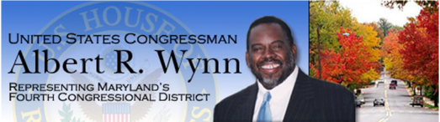Awards and Pictures

