To go to the next page and do something
The instruction command within a button going to the next page does not have to be only the command for a page (by the way, there is a prevpage and nextpage command).
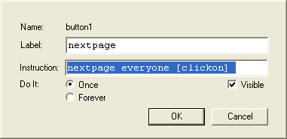

Method 1:
Put what you want to do in the instruction field of the button.

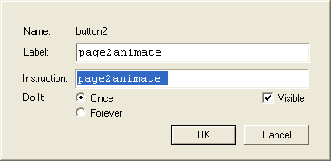
Method 2
Create a procedure, and use that as the instruction field of your button.

to page2animate
page2
everyone [clickon]
end

The second method would be best if you wanted to something more complex, i.e. start a sound and one turtle. Putting it all in the instruction field may be too much.
merge "runners "pages
merge "runners "procedures
merge "runners "shapes

namepage (np)  page-name | Names the page being displayed with the input. Namepage corresponds to the Name Page function in the Pages menu. Once the page is named, the page-name is a command that displays that page. | Given that this page doesn't already exist:  namepage "presentation
nextpage | Displays the next page in the page list. Pages are listed alphabetically in the page list. Rename your pages to create the desired sequence.  See pagelist, prevpage and Pages Menu in the section Fundamentals. | Given that there are several pages in the project:  repeat count pagelist  [nextpage wait 10]
prevpage | Stands for previous page. Displays the previous page in the page list. Pages are listed alphabetically in the page list. Rename your pages to create the desired sequence.  See pagelist, nextpage and Pages Menu in the section Fundamentals. | Given that there are several pages in the project:  repeat count pagelist  [prevpage

