Create your own quiz to review vocabulary, geography terms, spelling words or science definitions. Using short answer items, you can create your own review quizzes. Students can have fun creating their own quizzes and trivia questions to stump classmates.
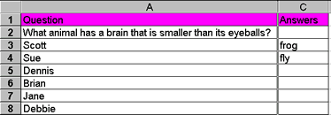
How to Unhide Rows and Columns
http://www.forsyth.k12.ga.us/kadkins/excel_tips.htm from Excel Tips
©Kathy Adkins

