http://www.forsyth.k12.ga.us/kadkins/bingo.htm

Create a easy bingo card for students to insert their own vocabulary randomly. At the end of the week after everyone has created and printed their cards, play a game for review.
The Bingo Master template is a wonderful tool created by Steve Mashburn. It will generate up to thirty bingo cards to use with a unit of study.
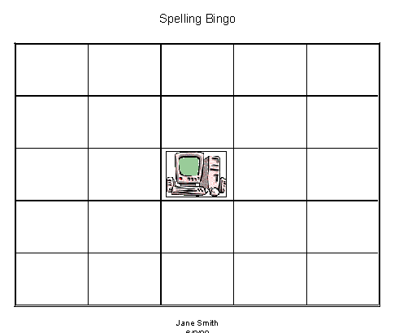
Highlight cells A1 to E5 and format following these directions:
- Go to Format, Cell, and click the border tab.
- Place a double line border for the outline and a single line for the inside border. Click OK.
- Go to Format, Row and click Height. Type in the number 90.
- Go to Format, Column and click Width. Type in the number 15. Click OK.
Click Print Preview Button(magnifying glass). Click Setup
- Go to the Page Tab and click Landscape.
- Go to the Margins Tab and click to check Horizontally and Vertically
- Go to the Header and Footer Tab. Click the Custom Header Button. Highlight the text and replace with the title Spelling Bingo. Highlight the text, Spelling Bingo and click the A button(Text) to change font to 20 pt. Click OK twice.
- Click the Custom Footer Button.
- Highlight the text and replace with your name.
- Press Enter and click the calendar button to place the date. Click OK twice.
- Click Close to go back to worksheet.
Add a picture in the free space.
- Click in cell 3C.
- Go to Insert on the menu bar and click object then clipart gallery.
- Locate picture, highlight and click Insert. Resize the picture to fit the box.
- Save the worksheet.
- Print a copy for an example.
Using the Bingo Template
Utilizing the template, students take turns at the computer and randomly insert vocabulary into the chart. They print and do not save after completing their personalized bingo board. The contents are then cleared for the next student to complete the activity. Save the printed boards through the week and use as a fun way to review vocabulary before a spelling or vocabulary quiz.
Back to The ABC's to Excel

