Educational Technology Services  October 2003 | Helpful Resources  The Excel Addict: http://www.theexceladdict.com/  Joseph Rubin's Exceltip.com: http://www.exceltip.com

Excel Tricks and Treats
Back to Tech Tuesday/Web Wednesday topics
Excel is an exceedingly powerful software package. Here are some tricks and treats that might make your work more efficient, interesting or at least cool!!

1. Color your Worksheet Tabs:
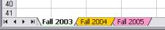
If you use a file with several worksheets, you can use color in your tables to help visually locate them. To make color tabs, right click on the tab you wish to edit and choose Tab Color from the popup menu. Select a color and click OK.

2. Jumping to the end of a range of data:
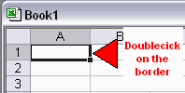
To quickly move to the last cell in a long range of data, you can doubleclick on the cell border in the direction you wish to move.

3. Using the Fill Handle:
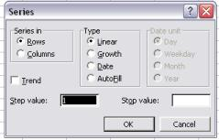
To quickly complete a series of data such as numbering, dates, etc, you can use the fill handle in the lower right of the cell outline in a selected cell. If you have an unusual series, you can create and select several cells to set the series and Excel will attempt to complete the rest of the series. You can also right click and drag the fill handle. When you release the mouse button, you will be able to format the series more specifically if needed.

4. Conditional Formatting:
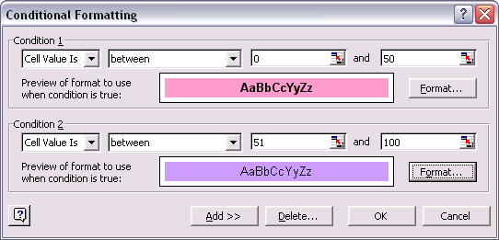
You can format your cells appearance based on up to three different criteria. This can be used to help color code a gradesheet, expense sheets or other data. You can also use it to create simulations. To access this feature, select a group of cells and choose Format - - > Conditional Formatting from the top menu.

5. Using a Form to add Data:
If you have a lot of data to enter into a spreadsheet, using a form might make the task easier than jumping between cells. To create a form, first create the header row for your spreadsheet with the fields you need to enter. Then, highlight those cells and select Data -- > Form from the top menu.

6. Add a toolbar calculator
If you need a calculator in your Excel toolbar, here is how to add one: Choose View -->Toolbars --> Customize. Click on the Commands tab. In the Categories list, choose Tools. In the Commands list, choose Custom. (You'll see a little gray calculator icon next to it.)
Drag the calculator icon to the toolbar, letting it drop wherever you'd like it to live in your toolbars

7. Background Image in your spreadsheet:
To customize your spreadsheet even more, you might want to add a background image Choose Format --> Sheet -- > Background. Select your picture file.

8. Wrapping text:
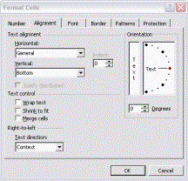
Excel is a nice way to make tables. To make line breaks where YOU want them, type ALT + ENTER for the line break within a cell.
To wrap text within a certain size of cell(s), choose Format --> Cells --> Alignment to select Wrap Text.

9. Named Range:
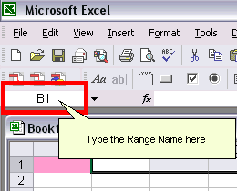
You can give a meaningful name to a cell or range of cells and then use that name instead of the actual cell reference in your formulas. Using names is much easier to remember when creating formulas.
Distance Learning * Online Learning * A/V and Media Support * Instructional Technology * Educational Technology Resources * Site Index

Problems with this site? Please let us know.
Search | Pellissippi State Home Page


