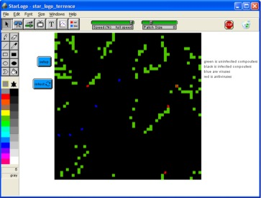
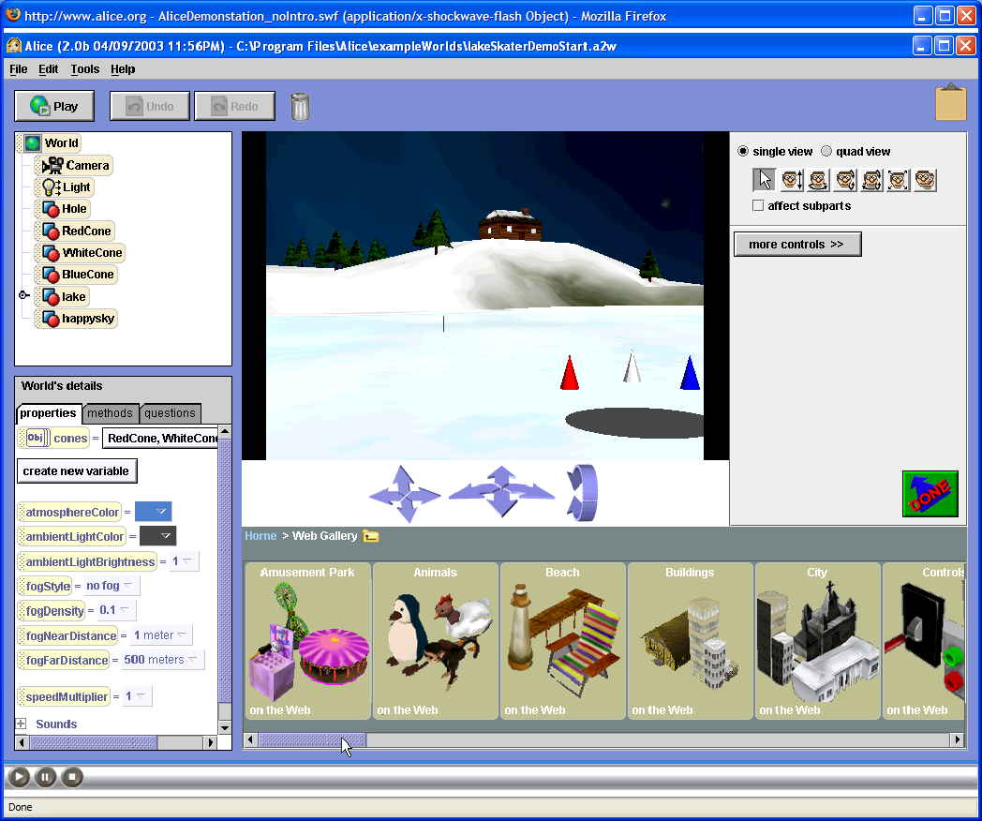
Summer 2009

July 6th - July 24th 2009

8:00 -1:00

ARL Computer Lab

Information Assurance/Computer Security/Digital Forensics:

Young Scholars Program

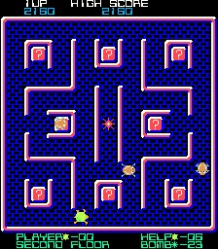
High school IS/IA/DF Scholars gain valuable skills related to digital literacy while exploring career opportunities related to Computer Security, Information Assurance, and Digital Forensics. Investigate the design and use of games and simulations for educational purposes, and the research and development issues associated with each. Experience various modeling and simulation software packages (MicroWorlds, Excel, Scratch, and StarLogo).
Participants will engage in hands-on activities and learn about digital literacy (technology fluency and applications, team building, collaboration tools, problem based critical thinking), defending against viruses, Trojan Horses, and worms; and applying basic security concepts through gaming, modeling and simulation development, while investigating exciting careers that interconnect the fields of science, math, technology, and computer security. Students will also discuss such topics as cryptography, system vulnerabilities, and careers in computer security/digital forensics, and will learn more about security clearance processes and identity management strategies. Tours of local labs will be conducted, and students will have the opportunity to hear from a variety of speakers from state and federal agencies and local security companies.

- Explore various modeling and simulation software packages (MicroWorlds, Excel, Scratch, and StarLogo)
- Create an Animated Story & Interactive Game/Maze with MicroWorlds
- Learn more about Careers in IA/IS and Digital Forensics
- Develop an Interactive Educational Mini Simulations with Excel, Star Logo and Scratch
- Develop Digital Forensics and Cryptography Skills through activities and exercises
Tentative Field Trips & Speakers:

- FBI Digital Forensics
- National Electronics Museum
- Edgewood Chemical Biological Center
- Maryland Internet Crimes Against Children Task Force
- CyberWATCH
- NSA/ Cryptologic Museum
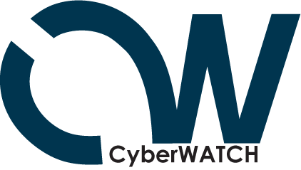
For More Information:

Lee Summerville
Rick Marquart
(HCPSS STEM coordinators)
410 313-7009
Lee_summerville@hcpss.org
Richard_marquart@hcpss.org

Davina Pruitt-Mentle
dpruitt@umd.edu

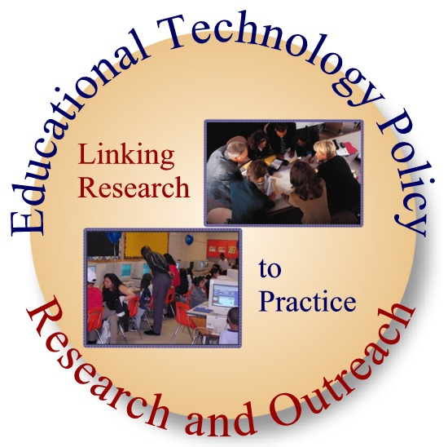

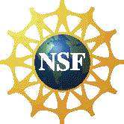

Summer 2009

July 6th - July 24th 2009

8:00 – 1:00

ARL Computer Lab

Information Assurance/Computer Security/Digital Forensics:

Young Scholars Program

Student Name (Last name, First Name, MI) :______________________________
Street Address: ______________________________
City, State, Zip Code: ______________________________

Parent/Guardian (Last name, First Name) :______________________________
Home Phone: ______________________________
Parent/Guardian Work/Cell Phone: ______________________________
Parent/Guardian Email Address if available: ______________________________

Emergency Contact (Last Name, First Name): ______________________________
Emergency Contact Home Phone: ______________________________
Emergency Contact Work/Cell Phone: ______________________________

______________________________________________________________ ___________________________
Signature of Student Date

______________________________________________________________ ___________________________
Signature of Parent/ guardian Date
PLEASE RETURN THIS FORM TO
ARL STEM OFFICE
10920 Route 108
Ellicott City, MD 21042

