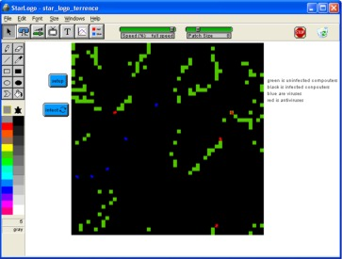
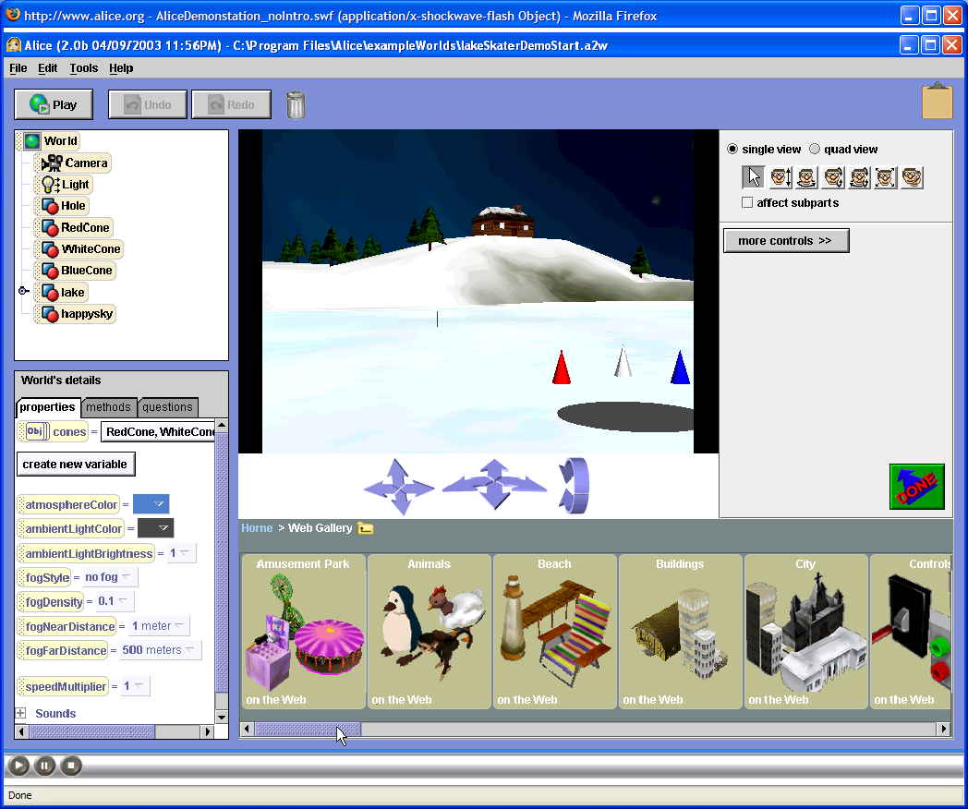
Summer 2009

July 13 - July 24, 2009

North County High School

July 27 – August 8, 2009

South River High School

8:00 AM - 3:00 PM

Information Assurance/Computer Security/Digital Forensics:

Young Scholars Program

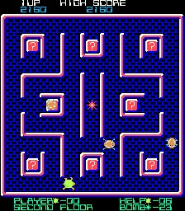
High school IS/IA/DF Scholars gain valuable skills related to digital literacy while exploring career opportunities related to Computer Security, Information Assurance, and Digital Forensics. Investigate the design and use of games and simulations for educational purposes, and the research and development issues associated with each. Experience various modeling and simulation software packages (MicroWorlds, Excel, Scratch, and StarLogo).
Participants will engage in hands-on activities and learn about digital literacy (technology fluency and applications, team building, collaboration tools, problem based critical thinking), defending against viruses, Trojan Horses, and worms; and applying basic security concepts through gaming, modeling and simulation development, while investigating exciting careers that interconnect the fields of science, math, technology, and computer security. Students will also discuss such topics as cryptography, system vulnerabilities, and careers in computer security/digital forensics, and will learn more about security clearance processes and identity management strategies. Tours of local labs will be conducted, and students will have the opportunity to hear from a variety of speakers from state and federal agencies and local security companies.

- Explore various modeling and simulation software packages (MicroWorlds, Excel, Scratch, and RoboLab)
- Create an Animated Story & Interactive Game/Maze with MicroWorlds
- Learn more about careers in IA/IS and Digital Forensics & Security Clearance Processes
- Develop an Interactive Educational Mini Simulations with Excel and Scratch
- Develop Digital Forensics and Cryptography Skills through activities and exercises
Tentative Field Trips & Speakers:

- FBI Digital Forensics
- NSA/NG
- Edgewood Chemical Biological Center
- Maryland Internet Crimes Against Children Task Force
- CyberWATCH
- National Electronics Museum


For More Information:
Davina Pruitt-Mentle
410 531 3910
dpruitt@umd.edu

Karen Fowler
(AACPS coordinator)
443 603 7754
kfowler@aacps.org



Summer 2009

July 13 - July 24, 2009

North County High School

July 27 – August 8, 2009

South River High School

8:00 AM - 3:00 PM

(Students are responsible for their own transportation and lunch)

Information Assurance/Computer Security/Digital Forensics:

Young Scholars Program

Program Location: ______________________________

Student Name (Last name, First Name, MI) :______________________________
Street Address: ______________________________
City, State, Zip Code: ______________________________

Parent/Guardian (Last name, First Name) :______________________________
Home Phone: ______________________________
Parent/Guardian Work/Cell Phone: ______________________________
Parent/Guardian Email Address if available: ______________________________

Emergency Contact (Last Name, First Name): ______________________________
Emergency Contact Home Phone: ______________________________
Emergency Contact Work/Cell Phone: ______________________________

______________________________________________________________ ___________________________
Signature of Student Date

______________________________________________________________ ___________________________
Signature of Parent/ guardian Date
PLEASE RETURN THIS FORM TO
Karen Fowler
Advanced Studies and Programs Resource Teacher
2644 Riva Road, Annapolis, MD 21401

