

Summary Report from the
Young Scholars 2007 Programs
Students, Learning and Technology
Joppatowne High School, Joppatowne, MD (Harford County) July 9 through July 20th

Walker Mill Middle School, Prince George’s County, MD
July 9th through 27th



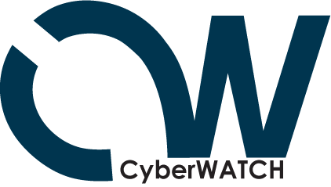

ETPRO CyberWATCH Subcontract Deliverables by Year Update

YEAR 2
Young Scholars Program
Event Summary
ETPRO delivered its Young Scholars Program: Students, Learning and Technology (SLT) at two locations in Maryland the summer of 2007. The Harford County Program took place at Joppatowne High School in Joppatowne, MD (Harford County) from July 9 through July 20^{th.} The Prince George’s County Program took place at Walker Mill Middle School from July 9th through 27th.

Both programs focused on activities that highlighted topics in cybersecurity to illustrate the needs to operate in a secure manner and to emphasize the exciting opportunities in this field. Students engaged in hands-on computer activities and learned about digital literacy (technology fluency and applications, team building, collaboration tools, problem based critical thinking), defending against viruses, Trojan Horses, and worms; and applying basic security concepts through gaming, modeling and simulation development, while investigating exciting careers that interconnect the fields of science, math, technology, and computer security. Students also discussed such topics as cryptography, system vulnerabilities, and careers in computer security and digital forensics. Tours of local labs and NSA were also conducted, and students had the opportunity to hear from a variety of speakers from state and federal agencies and local security companies.
The Cyberwatch Grant supported a total of 56 students. 13 students attended Program I at Joppatowne High School and 43 attended Program II at Walker Mill Middle School.

Name | Grade | Gender | Ethnicity
Joseph | 10th | M | African-American
Brittany | 10th | F | Hispanic
Ashwyn | 10th | M | African-American
Keeyan | 10th | M | African-American
Andrea | 10th | M | White
David | 10th | M | White
Andrew | 10th | M | White
Jarrod | 10th | M | White
Ben | 10th | M | White
Dajuan | 10th | M | African-American
Leah | 10th | F | White
Justin | 10th | M | White
Robert | 10th | M | White
Table 1: Participants at Joppatowne High School
Douglas Handy, Career and Technology Program coordinator for MSDE Program suggested the opportunity to run Program I at Joppatowne High School to help jump start recruitment for a newly proposed Maryland State Department of Education (MSDE)Career and Technology Education (CTE) track. Students were recruited for the Joppatowne High School Program through Leah Beaulieu (recruitment sheet found at end of report). Ms. Beaulieu is the program coordinator for a new Homeland Security and Emergency Preparedness Program which is being piloted in the fall 2007-08 school year. The program will then be added to the MSDE CTE programs.
Recruitment for Program II was done through Prince George’s County Schools and The Patriots Technology Training Center (PTTC), a non-profit foundation committed to promoting technology-related careers.
STUDENT | Grade | Gender | Ethnicity
Kenny | 10th | M | African American
Kerry | 10th | M | African American
Khayree | 9th | M | African American
Ty’Quan | 8th | M | African American
Marcus | 8th | M | African American
Tiffany | 8th | F | African American
Maurice | 7th | M | African American
Daniel | 7th | M | African American
Gerard, Jr. | 9th | M | African American
Alexander | 8th | M | African American
Talaya | 10th | F | African American
Nassyyiah | 8th | F | African American
Chevon | 9th | M | African American
Brandon | 7Th | M | African American
Theodus | 10th | M | African American
Emmanuel | 8th | M | African American
Jawwaad | 6th | M | African American
Miles | 8th | M | African American
Calton | 8th | M | African American
Diamond | 7th | F | African American
Darien | 8th | M | African American
Kayla | 9th | F | African American
Michael | 10th | M | African American
Cristin | 8th | M | African American
Orion | 9th | M | African American
Rigel | 7th | F | African American
Kenneth | 8th | M | African American
Daelyn | 8th | M | African American
LaJoy | 11th | F | African American
Jordan | 7th | M | African American
Solomon | 9th | M | African American
Timothy | 10th | M | African American
James | 4th | M | African American
Karis | 5th | F | African American
Brittany | 7th | F | African American
Evan | 7th | M | African American
Jasmine | 7th | F | African American
Terrence | 8th | M | African American
Weaver | 9th | M | African American
Jessica | 10th | F | African American
Cara | 11th | F | African American
Tara | 11th | F | African American
Tracey | 8th | F | African American
Table 2: Participants at Walker Mills Middle School
Overview
The purpose of SLT is to foster excellence in 21st century skills which will help students succeed in college/careers, and prepare themselves with the skills necessary to meet the shifting and constantly changing demands of the future workplace. The program provides a means to explore technology applications essential to college success while also focusing on career possibilities that connect engineering, science, math and technology. Critical need areas are emphasized such as IT/IA and cybersecurity/computer forensics with a special focus on exposing students to the plethora of career opportunities in cybersecurity and cybersafety—a critical need area for this region.
Students participate in cutting-edge technology projects, robotic activities, and Logo-based computer learning environments in a hands-on setting, offering new technology skills, problem solving design challenges and field trips.
A number of mini-assignments and projects focused around cybersecurity issues. These included:
- Using Microworlds (a Logo based software package) to build an interactive and/or multi-media story that discusses different facets of cyberethics or cybersecurity. The final project should be “kid friendly” and interesting—while still getting “a message across”.
- StarLogo — create a simulation illustrating the dangers of computer viruses on the Internet. Simulate computers with and without virus protection, and include variables such as aging of the virus protection, new viruses, and exponential growth of the viruses as they spread across the network.
- Cybersecurity “game” built in Excel
- Developing an idea for a new state of the art secure cell phone (included research, design, marketing)

JOPPATOWNE PROGRAM OVERVIEW
Embedded within the two week content session were two field trips and several speaker sessions. The first field trip included a tour of the Edgewood Chemical Biological Center, in Edgewood Maryland where students were first briefed by Dr. Jim Baker, on the historical overview and mission of ECBC. Students then visited the Advanced Design Manufacturing Division were they viewed a video on what the ADM mission entailed: concept development, conceptual modeling and animation, computer aided design, including unmanned robotics, to rapid prototyping and 3D capturing to manufacturing and fabrication. Students then visited and spoke with engineers in the unmanned robotics section, watched a rapid prototyping through layered object manufacturing (LOM) in the ACM section where each received a final product keepsake that was being produced through the LOM.
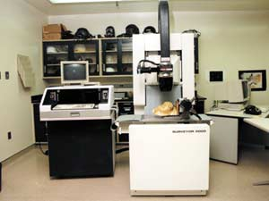
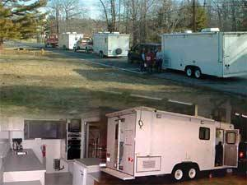
Students then loaded back on the bus and were transported to the Mobile Laboratory Specialties section. ECBC has built five variants of the mobile laboratory, used to provide safe, reliable, transportable engineering controls certified for the safe containment and examination of the most hazardous materials. These labs have supported numerous programs and provide a variety of capabilities including atmospheric monitoring, on-site chemical analysis, soil extraction, and surface water analysis. In addition, laboratory operators can generally perform these investigative functions within a 24-hour turnaround time.
For the second field trip students visited the National Security Agency’s Cryptologic Museum organized by curator Jennifer Wilcox. The tour began with speakers discussing NSA employment and opportunities as well as additional options such as summer programs and internships. The tour then allowed students to see artifacts that sustain the history of the cryptologic profession. Students were able to hear about some of the most dramatic moments in the history of American cryptology: the people who devoted their lives to cryptology and national defense, the machines and devices they developed, the techniques they used, and the places where they worked. Student favorites included the Slave Quilt, Biometrics Exhibit, Code Talkers and the Enigma machine.
Additional speakers in Joppatowne included Detective Robert Smolek from the MD Internet Crimes Division who shared Internet safety tips as well as an overview of Digital Crime and Digital forensics. Casey O’Brien, Associate Professor in the Network Technology department, in the School of Applied and Information Technology (SAIT), and one of the Co-Directors of the CyberWATCH Center, a consortium of colleges/universities, government agencies, and businesses committed to improving the quantity and quality of the information security workforce in the Baltimore/Washington D.C. metropolitan area, shared the connection between IS/IA career opportunities and the new MSDE Homeland Security high school track offerings.

2007 Course Outline/Schedule

Week 1 Week 2
Monday  7/9  7/16 | Session 1:  - Welcome & Logistics  - Overview  - Introduction to MicroWorlds™ for multimedia creation  - Skill Development with MicroWorlds™ | Session 6:  - StarLOGO challenges  - Show and Share MicroWorlds Products
Tuesday  7/10  7/17 | Session 2:  - Logo Skills Continued  - Indiv Animated Story  - Group Challenges/Indiv Game | Session 7:  - Field Trip Edgewood Chemical Biological Center IT/IA field trip 9-11:30  NOTE** Field trip  Box lunches will be provided
Wednesday  7/11  7/18 | Session 3:  - Indiv Animated Story  - Group Challenges/Indiv Game  - Thinking about our MicroWorlds final projects  - Simulation/Game Development in MicroWorlds | Session 8:  - Guest Speaker- Robert Smolek MD Internet Crimes Division  - 21st Century Skills  - Stimulus Materials for e-portfolio  - Adding video  - Adding field trip pictures and reflections  - StarLOGO Project Development
Thursday  7/12  7/19 | Session 4:  - National Cryptologic Museum Field Trip  NOTE** Field trip will place us back @ 1:30-2:00  Box lunches will be provided | Session 9:  - StarLogo Project Development  - Guest Speakers-CyberWATCH Casey O’Brien Connecting IS/IA careers with the new MSDE Homeland Security Program
Friday  7/13  7/20 | Session 5:  - Skill Development with MicroWorlds™  - Introduction to StarLOGO  - Guest Speaker TappedIn | Session 10:  - StarLOGO Project Show and Share  - e-portfolio Show & Share  Baltimore Sun (Harford County) interview/pictures
VISIT OF

Joppatowne High School
Homeland Security and Emergency Preparedness Program
Students and Faculty Members

Tuesday, 17 July 2007

Center Host: Mrs. Mary Doak, DSN 584-7231 Mil Uniform: Duty Uniform
Civilian: Business Casual Attire

ARRIVAL DATA: DEPARTURE DATA:
Date: 17 Jul 07 Date: 17 Jul 07
Time: 0900 Time: 1130
Mode: POV Mode: POV
LOC: Bldg E3549 LOC: Bldg 5604
ITINERARY

Time Event Mode/Location POC
0900 Arrive at ECBC

0900-0930 ECBC Overview Bldg E3549, Auditorium Dr. Jim Baker
0930-0935 Walk to Advanced Design Manufacturing Bldg E3549, Rm 125

0935-1035 Tour Advanced Design Manufacturing Bldg E3549, Rm 125 Mr. Mark Schlein

1035-1045 Travel to Bldg E5830

1045-1130 Tour Mobile Labs Bldg E5830 Mr. Eric Stevens

1130 Depart Edgewood

WALKER MILL PROGRAM

WEEK 1

Monday, July 9, 2007
Erika Mills, Exhibition Outreach Coordinator for the History of Medicine Division, National Library of Health coordinated a field trip to the National Institute of Health (NIH), Bethesda, MD where the students attended and explored the real science and history behind CSI in NIH’s engaging and interactive exhibition on forensics. Tour guide, Katherine Powell provided the students with a fascinating and informative look at forensics science in a fun and interactive setting. Students were able to explore the following topics:
- Post-mortem autopsy procedures and instruments
- Forensic entomology and anthropology
- Identification techniques-anthropometry, fingerprint, DNA profiling
- Technological advancements – crime screen recording, radiology, toxicology, etc.
- Forensics in popular culture

Tuesday, July 10-Thursday 12, 2007
Naval Research Warfare Center (NAVSEA) personnel Ray Gusmache, Max Lupton, Mataline Dillard, Colin Roberts, Cesar Smith, Mike Henderson, Stanley Bak, Stella Jackson, Christy Ryon, and Elizabeth Bucknes worked with students to build and program rockets and robotics and develop a scientific “egg drop” experiment. Each student received a Workbook that contained a schedule and details of the daily training sessions.

The overall objective entailed a robotic challenge, rocket launch and the egg drop contest. The students were divided into teams consisting of 5-6 members that competed in these challenges.

Robotic Challenge – Students were exposed to 8 robotic challenges. The challenges occurred within an 8ft x 8ft challenge board. Two robotics kits and two computers were given to each team to complete each task. Team members were either a programmer or a builder of the robotic which performed mission challenges. Upon meeting requirements, team were awarded a mission completion card which demonstrated their ability to successfully program the robotic.

Rocket Launch – Each student was provided with a rocket and three motors. Students were given a class regarding the safe loading of a rocket motor and recovery system into a rocket. One the final day of training, students were able to launch their rockets.

Egg Drop Experiment – Each team of students worked with the construction of a protective device to prevent an egg from cracking when it was dropped at specified heights. The winning team(s) was given the egg flag to put on the challenge board.

The training sessions were as follows:

Tuesday, July 10, 2007
0800-0830 Welcome: talk about egg drop
0830-1130 Robotics
1130-1200 Lunch
1200-1300 Egg Drop
1300-1400 Robotics

Wednesday, July 11, 2007
0800-0830 Talk about robotics
0830-1100 Robotics
1100-1130 Lunch
1130-1230 Egg Drop
1230-1400 Rocket assembly

Thursday, July 12, 2007
0800-0830 Update on events
0830-1030 Robotics
1030-1200 Rocket Launch
1200-1230 Lunch
1230-1345 Egg drop contest
1345-1400 Closing
*The Seat Pleasant Mayor, city officials, county council, board of education members, the community, family and friends were invited to attend the robotic performances and launching of the rockets. The Seat Pleasant Fire Department provided their fire truck to be utilized in the egg drop experiment/contest. News media were in attended and the students were highlighted on NBC4 news, CT news, and the Gazette and Washington Post newspapers.

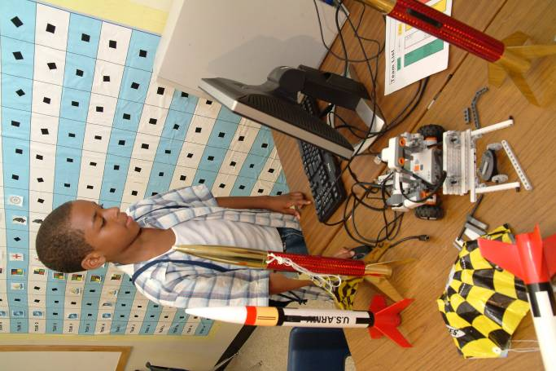
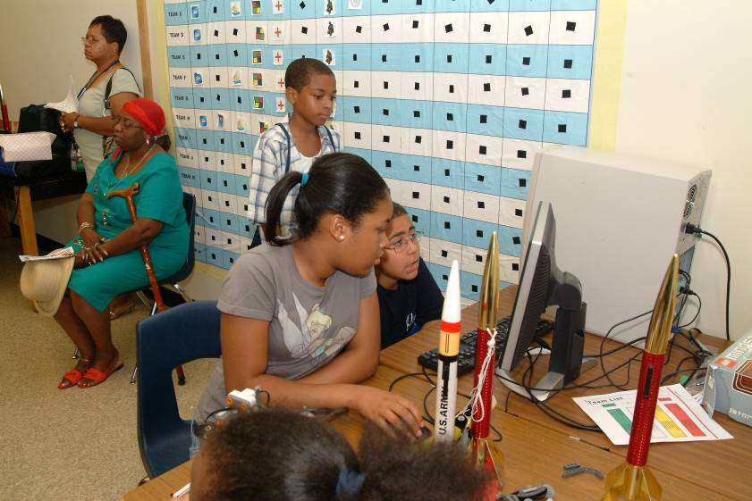
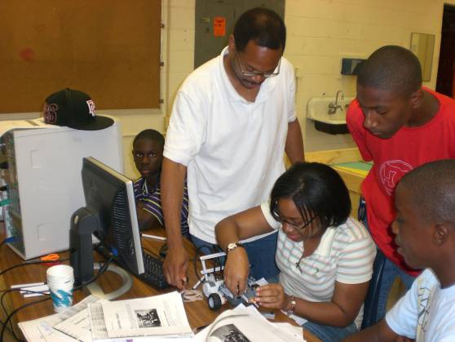
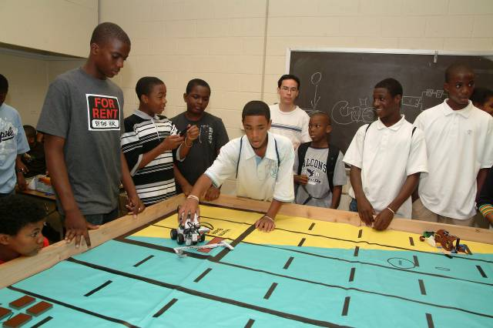

Friday, July 13, 2007
Students participated in a training session on “How to Conduct Research Using the Internet”. Students were instructed on how to use search engines, narrowing a search using queries, how to cite information from the internet to avoid plagiarism and synthesizing information to compile a report.

Students were able to navigate the internet in order to retrieve specific information and filter essential information and develop language that indicates original thought in order to create a document that informs the target audiences. The topic was researching engineering and computer science programs. Question prompts included: what different type programs are there? what different degree programs and opportunities are there? how can a student prepare? what scholarships are available?

WEEK 2

During the second week of the YSP high school students experienced a week of job shadowing at various IT and security business locations. These included APPTIS, INGENIUM Corporation, The National Academies, US Department of Transportation, BAE Systems, US Department of Energy, and Solvern Innovations. Middle school students worked on specific Digital Fluency activities including working with animations, sounds and video in PPT, Excel spreadsheet, gaming with Excel and utilizing open source software NetLogo and StarLogo.

WEEK 3

Monday, July 23, 2007
Jamie Dawson, instructor, provided a brief introduction on the creation of a personal portfolio. Students participated in a hands-on session brainstorming and drafting ideas for their final portfolio presentation.

In the afternoon, Ajay Gupta, Director of Cyber Security Services at Prince George's Community College and President of GSecuirty, Inc. spoke with students about careers in the IA/IS field, the difference between “good and bad” hacking, types of positions in these fields, what these positions “do”, and answered students’ questions about general security and privacy issues on the computer and cell phone, salary of these careers and how pathways to enter these careers.

Tuesday, July 24, 2007
Students attended a field trip to the National Security Agency’s Cryptologic Museum organized by curator Jennifer Wilcox. The tour began with speakers discussing NSA employment and opportunities as well as additional options such as summer programs and internships. The tour then allowed students to see artifacts that sustain the history of the cryptologic profession. Students were able to hear about some of the most dramatic moments in the history of American cryptology: the people who devoted their lives to cryptology and national defense, the machines and devices they developed, the techniques they used, and the places where they worked. Student favorites included the Slave Quilt, Biometrics Exhibit, Code Talkers and the Enigma machine.

Wednesday, July 25, 2007
Students received classroom instruction and participated in the development and delivery of a newsletter about their field trip experience and brainstormed the development, delivery and marketing of a state of the art and secure cell phone. Members were selected to allow students the opportunity to perform as a team. Digital Literacy skills from earlier sessions were reinforced.

Thursday, July 26, 2007
Students attended a field trip to the Carderock Observatory, Bethesda, MD. A presentation was provided Tom Warring and Nancy Radcliff covering the 100-year history of the Carderock Division and a walking tour of the large unique testing facility. Students were able to view the David Taylor Model Basin, Circulating Water Channel, and the Rotating Arm plus visit the model shop where precise scale models of all Navy ships and submarines are constructed and tested. Students participated in a hands-on ship leveling test and received first-hand experience on how actual testing is done.

Friday, July 27, 2007
This was the final day of camp. Students finalized their newsletters. A farewell picnic was the final and closing touches to a summer camp that was full of student learning advancements in the fields of technology and science, yet in a relaxed, exciting atmosphere.

Lessons Learned

The transition from the YSP under the University of Maryland domain to the ETPRO happened unexpectedly and with a very short turn around to recruit a large number of students. Connections with existing partnerships and with the Maryland State Department of Education and Patriots Technology training center provided a means to more easily recruit and organize a program in a short period of time. While the Joppatowne program has proved to be a wonderful way to connect a summer enrichment program with a newly developed Careers with Technology track for High school students, several glitches need to be ironed out for the upcoming summer.

An original connection with MSDE put me in connect with the coordinator/assistant superintendent of instruction for Harford county. The coordinator was excited about the program being offered in the county for several high school tracks currently in place, and was extremely excited about the possible connection with the newly proposed homeland security track. This track was being piloted in the 2007-08 school year, and included 3 sub-tracked: Information and communication technology, criminal justice and law enforcement, and Homeland Security science (Biochemical/biohazard). I was introduced to the coordinator of the newly proposed program and a date and time was arranged to present the program overview, student requirements and numbers, length of time and recruitment strategies. A decision was made to host the program at the Joppatowne high school facility, in the computer programming (CISCO Academy) lab. However, due to building renovations, the program could only be held two weeks, unlike the normal three week content agenda. The meeting to present the program overview was to include other school/county representatives, however only the Joppatowne representative was present. Upon following up it was found that the program had become “territorial” and given the program was scheduled to take place at Joppatowne high school, and a teacher from Joppatowne high school would be assisting (the grant would help cover instructor expenses), the Joppatowne high school coordinator had not given information to the other schools. After speaking with the county coordinator it was shared that Joppatowne high school was planning to provide 15 students for the program. If numbers after initial recruitment looked low an effort would be made to recruit from other schools. However, due to the timing (this recruitment was taking place during the last few weeks of school) this additional recruitment strategy was questionable. The coordinator guaranteed via email 15 students plus 3 on a wait list. Several attempts were made to be provided with the contact information about the student participants but none were sent. It was shared that the coordinator was unsure about sharing student contact information.

Upon the first day of class only 8 students showed up. Upon review, the Joppatowne instructor assistant and myself realized that the recruitment paperwork that had been sent out by the coordinator had been printed on 2 sides instead of 2 separate papers (to save paper). Therefore, when students submitted their application they also submitted the program information sharing the dates, times etc. Assistants and myself shared the task of calling the participants’ parents and making sure they were still able to attend. By the second day we had 15 students. By the second week 2 students had dropped. One due to a injury in soccer practice and another due to unexpected out of town emergency.

Additionally, it was eye opening to have the school coordinator in charge of the new Homeland Security high school career track and the instructional assistant, who was the school’s Cisco Academy teacher, see IN THE BEGINNING “very little connection” between the content of the YSP and the new Homeland Security program to be offered by the school. There were three sub-tracks offered in the Homeland security track. One was the Information and communication technology sub-track, however, both the coordinator and teacher shared this “covered GIS content only”. The criminal justice and law enforcement “doesn’t really include technology”, and Homeland Security science was tagged as “Biochemical/biohazard”, and again it was shared that it “doesn’t include Cyber security content”. They did feel the YSP was a great summer opportunity for their students and hoped there would be “something” that could be applied to the curriculum they were starting to develop over the summer for the new proposed high school career track program. During the two weeks I made sure all field trips and speakers spoke to the issue of how IA/IS play out in Homeland Security’s mission. Casey O’Brien and Robert Smolek did a stellar job in fine tuning the connection during their talks. Indeed, the program coordinator, “plans to include more in IA/IS” in the Information and Communications Technology and criminal Justice sub-tracks. She has since contacted me to make arrangements for her to attend the upcoming IA/IS/Digital Forensics Career preparation and opportunity Workshop.

The coordinator was specifically directed to recruit upcoming 11th and 12th graders, however all students were rising 10th graders. While the students were able to participate actively and stayed engaged with the content, this age group is harder to find internships/externships due to age requirements. I am working with the county career placement staff to find appropriate offerings for 8 students. Due to the partnership between ECBC and Harford County with the new pilot program we anticipate 8 internships/shadowing experiences to be available.

We plan to host the program again in Harford County with the following modifications:
- arrangements be done early enough to find a host school that can deliver the full three week program
- recruitment be done through Harford county but coordinated with ETPRO. Arrangements must be made to share contact information with ETPRO to allow follow up and verification of commitment with students and parents
- separate information form and registration/application forms be sent to parents/students
- recruitment of at least 6 students who are rising junior/seniors to allow for easier internship/externship placement

The program delivery at Walkers Mill proved to be invaluable in reaching a larger number of students. At the same time the large number of students at one time and the wide age groups involved seemed unruly at times. Limiting the number of students enrolled will have to be given consideration for next year. An alternative would be to enroll the large number but group students in a way to rotate around. Additionally staff would be needed which would accrue extra expenses as well as prior training of the YSP content before the summer program begins. A cost analysis will be done to provide insight. We will also investigate the grade ranges for the program. A large number of 7th and 8th graders attended. Perhaps we should offer a slightly modified program for this grade range, or sub-divide the larger group into grades 7-8-9 and 10-11-12.

Summary Evaluations from the Attendees

Evaluation and Feedback (0-4) 4 being the highest
General Questions | Average
The course objectives were clear. | 3.8
The length of the course was sufficient to cover the subject matter | 2.9
Overall, the course instructors and speakers were effective. | 4.0
I learned new information in this course. | 4.0
I’d like to learn more about IT/IA and Cybersecurity | 3.0
I may consider Cybersecurity as a career choice | 3.4
Speaker's Presentations
0 - 4 scale, with 4 being strongly agree | Average
Joppatowne Program
Jim Baker, Edgewood Chemical Biological Center (ECBC) | 2.9
Mark Schlein, ECBC, Advanced Design Manufacturing Division (ADMD) -security concept to delivery- video and team briefing | 3.2
ECBC, ADMD, unmanned robotics section | 4.0
ECBC, ADMD, rapid prototyping through layered object manufacturing (LOM) | 4.0
Eric Stevens, ECBC, Mobile Lab Specialists | 3.1
Jennifer Wilcox, NSA Cryptologic Museum briefing and internship/career opportunities | 3.8
NSA Cryptologic Museum briefing and internship/career opportunities | 3.3
TappedIn CyberSMART! | 2.9
Robert Smolek, Digital Crime and Digital Forensics | 4.0
Casey O’Brien, Network Technology | 3.7
Joppatowne Program Speaker's Presentations Average | 3.49
Walker Mill Program
Erika Mills, History of Medicine, National Institute of Health (NIH) CSI history | 3.2
Katherine Powell, NIH, interactive forensics science | 4.0
Navel Research Warfare Center (NAVSEA) activities | 4.0
Ajay Gupta, Cyber Security Services and GSecurity, Inc. | 3.0
Jennifer Wilcox, NSA Cryptologic Museum briefing and internship/career opportunities | 2.9
NSA Cryptologic Museum briefing and internship/career opportunities | 3.0
Tom Warring & Nancy Radcliff, David Taylor model Basin, Carderock Observatory | 4.0
Walker Mill Program Speaker's Presentations Average | 3.44
Both Program Presentations Average | 3.47

How could this course be improved?

- More time
- We should get credit
- Nothing. It was GREAT!
- More shadowing
- Food
- More field trips
- Nothing. Really fun

Joppatowne Homeland Security program coordinator’s survey: Computer Security/Digital Forensics: YSP Survey

- List and describe 2 things you really liked about the program
  - Using the programs
  - How to make things function
  - It was computers
  - Trying to learn more
  - Dad thought it would be cool
  - Programming- 5 listed
  - Programming type things
  - Networking
  - Making networks
- List and describe 2 things you think should be changed for next summer
  - All grades should be able to apply for this class
  - We should be able to get tutored for this program
  - 3 field trips
  - Hours-3 listed
  - Food-4 listed
  - More trips
  - More speakers- 2 listed
  - Go to ordinance museum 2 listed
  - I wanted to fall asleep
  - More snacks
- Did you like the field trip to the Cryptologic Museum? Why or why not
  - Yes-11 listed
  - No-2 listed
  - It was cool learning about our history
  - Learned how they transmitted messages
  - Cool
  - Careers sound great
  - Enigma machine-3 listed
  - Quilts -4 listed
  - Spy planes were cool
- Did you like the field trip to Edgewood Chemical Biological Center? Why or why not
  - Yes-13 listed
  - I loved the way how you get to use and create models of things
  - You get to see what is happening in the future
  - It was cool and informative
  - I loved the robotics
- Which computer program did you find the most interesting?
  - Microworlds-9 listed
  - When made games
  - StarLogo 2 listed
- Which computer program did you find the most boring, or the least interesting?
  - Microsoft Visual Basics- 11 listed
- How would you rate this program overall? Circle 1: A B C D
  - A-12 listed
  - B-1 listed
- Additional comments
  - Thanks for the doughnuts
  - Go to the thrift store for fun

Joppatowne Homeland Security program coordinator’s survey: Computer Security/Digital Forensics: YSP Survey

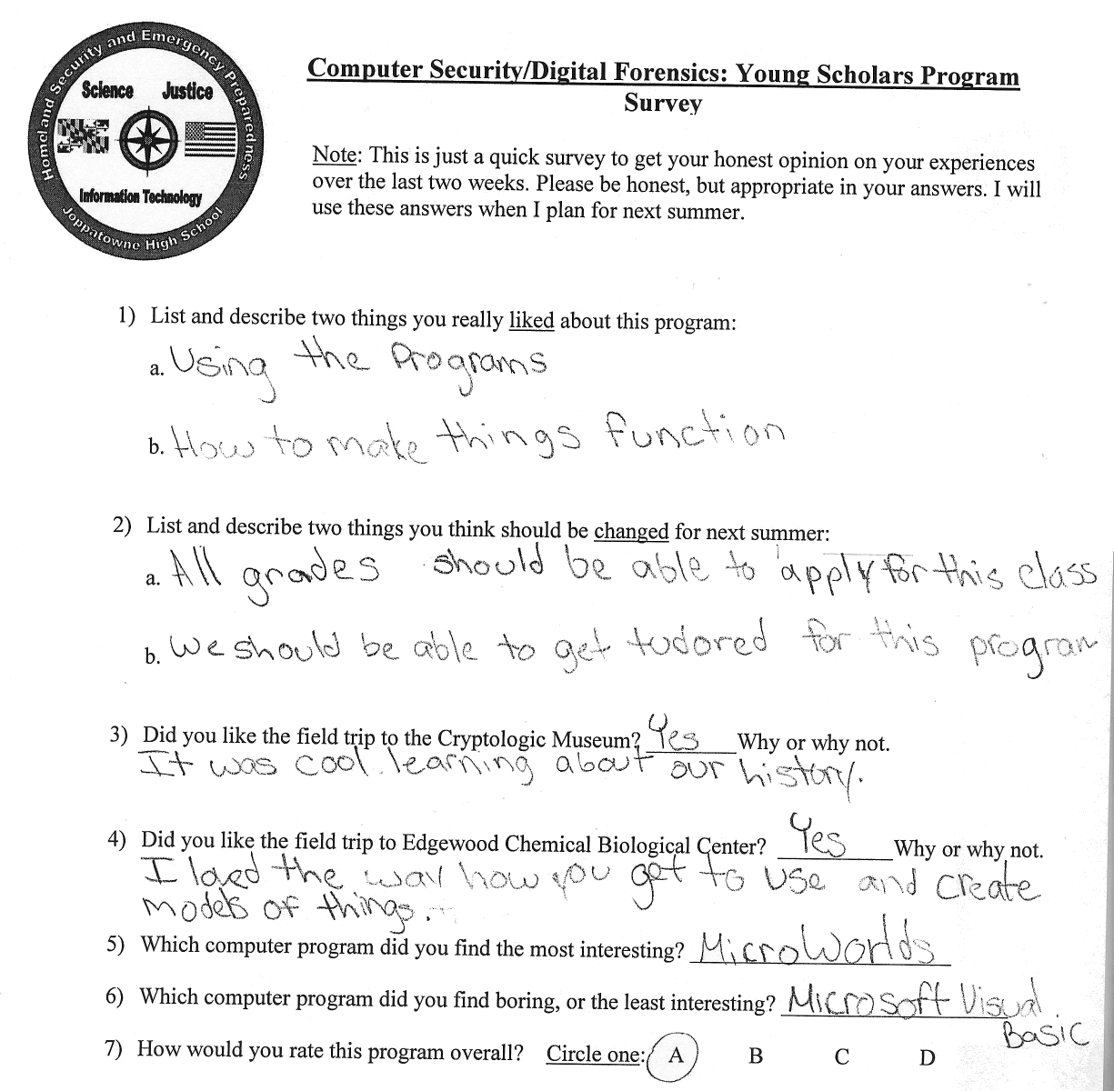

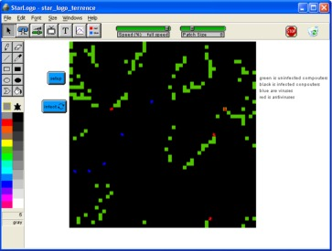
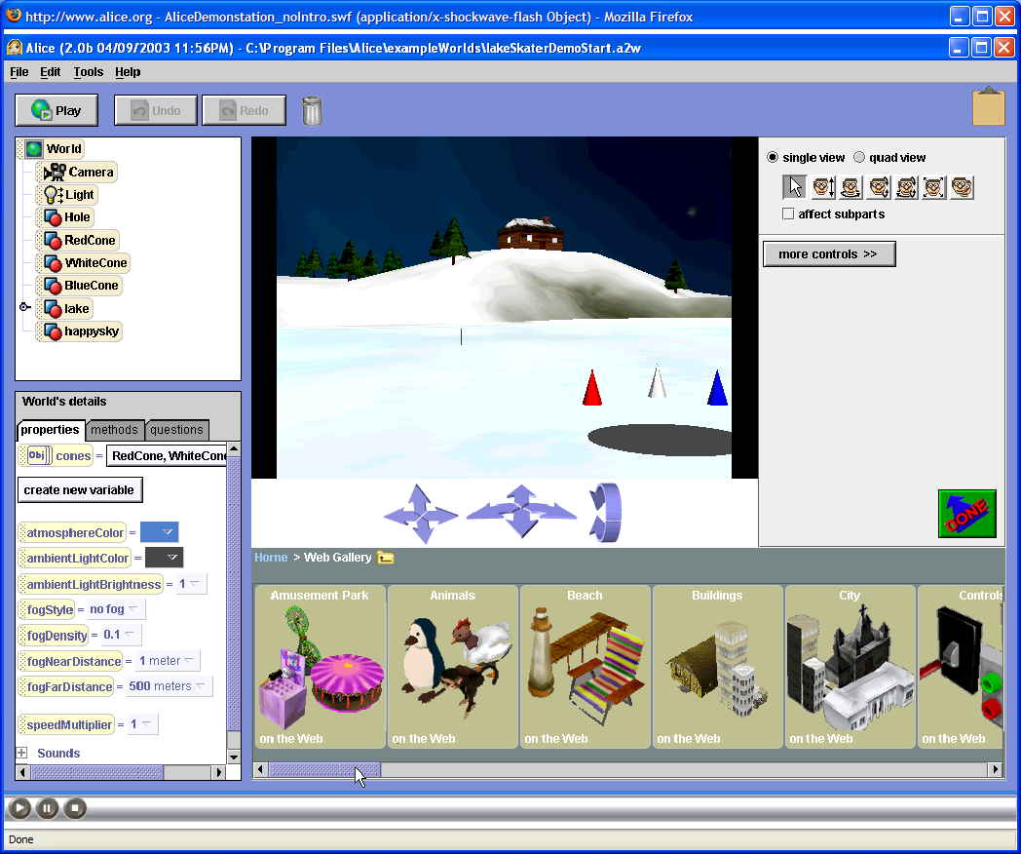
Summer 2007

July 9-20, 2007

8-12:00 AM

Joppatowne High School

Computer Security/Digital Forensics: Young Scholars Program
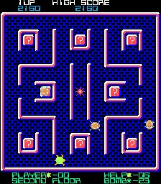
High school CS/DF Scholars gain valuable skills related to digital literacy while exploring career opportunities related to Computer Security, Information Assurance, and Digital Forensics. Investigate the design and use of games and simulations for educational purposes, and the research and development issues associated with each. Experience various modeling and simulation software packages (MicroWorlds, Alice, Excel, Squeak, StarLogo).
8 Internships are available through NSF funding and will be arranged based on the students’ interest (as related to CS/DF) and success in the CS/DF course. An attempt will be made to arrange for internships close to the students place of residence. Depending on the students’ needs, internships will be arranged to take place immediately after the CS/DF course, during the school year or for the following summer.
Participants will engage in hands-on activities and learn about digital literacy (technology fluency and applications, team building, collaboration tools, problem based critical thinking), defending against viruses, Trojan Horses, and worms; and applying basic security concepts through gaming, modeling and simulation development, while investigating exciting careers that interconnect the fields of science, math, technology, and computer security. Students will also discuss such topics as cryptography, system vulnerabilities, and careers in computer security/digital forensics. Tours of local labs and NSA will be conducted, and students will have the opportunity to hear from a variety of speakers from state and federal agencies and local security companies.
- Explore various modeling and simulation software packages (MicroWorlds, Alice, Excel, Squeak, StarLogo)
- Create an Animated Story & Interactive Game/Maze with MicroWorlds
- Design Evaluation Criteria for Academic Simulations Through Wiki & Blogger Contributions
- Develop an Interactive Educational Mini Simulations with Excel, Star Logo and Squeak
- Develop a computer animation using a 3D model

For more about the course: syllabus, standards met, past products, course outline visit: http://www.edtechoutreach.umd.edu/CourseInfo/educ275.html
Tentative Field Trips & Speakers:
- Battelle
- NSA Cryptologic Museum
- National Center for Missing and Exploited Children
- Maryland Internet Crimes Against Children Task Force
For More Information:
Davina Pruitt-Mentle
410 531 3910
dpruitt@umd.edu

Leah Beaulieu
(JHS coordinator)
410 612-1510
Leah.Beaulieu@hcps.org

Summer 2007

July 9-20, 2007

8-12:00 AM

Joppatowne High School

Computer Security/Digital Forensics: Young Scholars Program
____________________________________________________________________________________________________
Student Last Name Student First Name Middle Name

_______________________________________________________________________________________________________________________________ Street Address Town State Zip Code

_______________________________________________________________________________
Parent/Guardian Last Name First Name

____________________________ _______________________________________________________
Home Telephone Number Parent/Guardian Work Phone and/or Cell Phone Number

______________________________________________________________________________
Emergency Contact Last Name Emergency Contact First Name

________________________________________ __________________________________________________
Emergency Contact HomeTelephone Number Emergency Contact Work Phone and/or Cell Phone Number

Parent E-mail Address, if available: __________________________________________________________

______________________________________________________________ ___________________________________
Signature of Student Date

______________________________________________________________ ___________________________________
Signature of Parent/ Guardian Date

→ PLEASE RETURN THIS FORM DIRECLTY TO MS. BEAULIEU IN ROOM 207 AT JHS.

