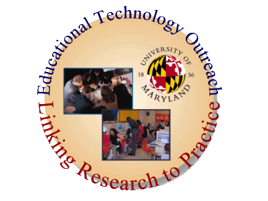


Summary Report from the
Girls Workshop
Cool Careers for Girls in Cybersecurity
October 2nd, 2008
University of Maryland, College Park, MD



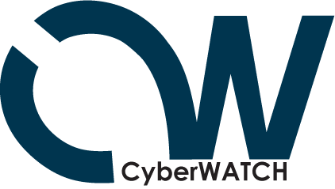

University of Maryland CyberWATCH Subcontract Deliverables by Year Update

YEAR 3
Cool Careers for Girls in Cybersecurity Workshop-Maryland
Event Summary
The sixth Cool Careers in Cybersecurity Workshop which provides information and skills necessary to navigate the professional pipeline in the vast fields of Cybersecurity and Information Assurance as well as other science, technology, engineering, and mathematics (STEM) fields, was held on Thursday October 2, 2008.The workshop was run in conjunction with the 7th annual Cyberethics, Cybersafety and Cybersecurity (C3) conference. 35 middle school girls from Prince George’s County Public schools and 17 high school students (N: F=6; M=11) from Fairfax County VA, participated in a full day session which included hands-on activities, speakers, and an opportunity to talk with professionals in the field. Students had the opportunity to learn more about Cyberethics, security and safety, as well as, learning first hand from IT/IA experts about career opportunities and pathways in Cybersecurity. Attention was given to issues for women from underrepresented groups in the breakout sessions.
The participants heard from the opening speaker Elizabeth Lodal, former principal of Thomas Jefferson High School for Science and Technology (VA) and Virginia Education Commission of the States Commissioner regarding both the need for smart choices in the digital age (what you put on facebook and what you send through email) and how these choices connect with future careers specifically related to STEM careers. This was followed by a panel discussion on Students and Technology: Facing Facebook Realities where Javaune Adams-Gaston, PhD Executive Director, Executive Director's Office, University of Maryland Career Center, Jeffrey C. Huskamp, PhD Vice President and Chief Information Officer at the University of Maryland and Matt Supple, Asst. Director, Advising and Programming Fraternity & Sorority Life, University of Maryland discussed the “Facebook phenomenon,” cybersafety, cyberethics, and ways to help students become more responsible in their on-line activities.
A luncheon allowed students the time to network with IT/IA professionals. The Keynote Luncheon was Jane Scott Norris, CISSP, Co-Chair, Government Advisory Board (ISC)² who expanding upon the earlier panel discussion regarding on-line activity, (ISC)² and shared additional insight and recent issues all parents, students and educations need to be aware of involving social networking and websites (focused on downloading malware and spoofing). Students then attended a breakout session with Jane to hear more about (ISC)² and its partners, the field of IA/Is and the opportunities for women.

In the afternoon the high school students heard from Brooks Whiteford, a recent graduate in IS/IA and current member of the Technology Department at Calvert Hall College High School. Brooks shared a Hands on Safety and Security How to’s—Bring Your Laptop session. Middle school students were not able to attend this session as they had to catch the bus back to school.

Detailed Agenda

Thursday’s Agenda
8:30 am | Registration Check in: Refreshments, Posters and Vendors
9:00 am -9:15 am | Opening Remarks:  Davina Pruitt-Mentle, Director, ETPRO and C3 Conference Chair
9:15 am -10:00 am | Opening Keynote:  Elizabeth Lodal  Former principal, Thomas Jefferson High School for Science and Technology, Virginia;  Virginia Education Commission of the States Commissioner
10:00 -11:00 am | Students and Technology: Facing Facebook Realities  Social networking Web sites (like Facebook and MySpace) are staples in the lives of students, enabling them to share their lives via blogs and photos with literally thousands of people. While these electronic connections provide a useful outlet, many fail to realize the pitfalls of such web sites—especially when they can be accessed by future university administrators, professors and prospective employers. Join our panel of experts as they discuss the “Facebook phenomenon,” cybersafety, cyberethics, and ways to help students become more responsible in their on-line activities.  Javaune Adams-Gaston, PhD Executive Director, Executive Director's Office, University of Maryland Career Center  Jeffrey C. Huskamp, PhD Vice President and Chief Information Officer at the University of Maryland  Gerry Sneeringer, Director of Security, OIT, University of Maryland  Matt Supple, Asst. Director, Advising and Programing Fraternity & Sorority Life, University of Maryland
11:00 - 11:15 am | Break
11:15 -12 noon | Safety and Security KEYNOTE  Maintaining a Safe IT Environment When Your Child Knows More About the Technology Than You Do  Jane Scott Norris, CISSP-ISSAP, ISSMP, CAP, CISM  Chair (ISC)² U.S. Government Executive Writers Bureau  Co-Chair (ISC)² Government Advisory Board for Cyber Security  We all live in a technically dynamic world where our teenagers are much more comfortable with the information technology world than their parents, teachers and other adult figures. Technology is a double-edged sword. It can be used in positive ways to improve learning and communications; however it also has a dark side that leads to problems that have been well documented in the media of late. This presentation will discuss common vulnerabilities, contemporary computer and communications technologies, and discuss parental strategies for preventing privacy, cyber bullying and other related issues.  Expanding upon the earlier panel discussion regarding on-line activity, (ISC)² will share additional insight and recent issues all parents, students and educations need to be aware of involving social networking and websites.
12 noon 1:15 pm | Lunch and Luncheon Keynote Speaker  Michael Kaiser, Executive Director, National Cyber Security Alliance  Colony Ballroom  NCSA will show and share their new website, and will discuss this year’s partnership events, including USA Today lesson plans and the current national PSAs. Over lunch learn how you and your students can enter the K-12 Cybersecurity awareness contest. NCSA will also share their newly launched resource center and will discuss their current survey findings.
1:15 pm - 1:45 pm | Vendor and poster session reviews
1:45 pm - 2:45 pm | What the Research is Telling Us  Panel  Amanda Lenhart, Senior Research Specialist, Pew Internet & American Life Project  Peter Grunwald, Research and Guidelines on Online Social Networking Survey  Ashley Mouberry Sieman, Assistant Director- Housing and Residence Life and Judicial Affairs.  Marymount University
2 :45 pm - 3:00 pm | BREAK
3:00 pm - 4:00 pm | Hands on Safety and Security How to’s—Bring Your Laptop  Brooks Whiteford, Technology Department, Calvert Hall College High School
4:00 pm - 4:15 pm | Closure and Give Aways
Friday Workshop Agenda
8:30 am — 9:00 am | Workshop Check in
9:00 am — 11:30 am | What Do Academic Integrity/Honor Codes and Strong Acceptable Use Policies Have to Offer?  This session will begin with a panel discussion sharing academic integrity/honor codes and other strategies implemented by local public and private K12 schools and post-secondary institutions. Lessons learned of what works and what doesn’t for all grade levels will be shared. Leave with exemplary examples and "how to's" to draft your own honor code to implement in your school. Already have one? Come ready to share!  - Brian Schiffer, Character Education, Perry Hall High School, Baltimore County Public Schools  - Rick Kirschner, Assistant to the Headmaster for Student Life, Banfield Ethics Chair, Landon School  - Amy Ginther, Coordinator, Policy Development and Education Project NEThicssm University of Maryland  - Diane Harvey, UMCP, Maryland K-20 Academic Integrity Committee Co-Chair  - Chris Madsen, CEO Trufina
11:30-Noon | Lunch - A light lunch will be provided
Noon -2:00PM | Practical Ethics Activities for the Classroom  How can you implement an already full agenda with ethics activities? How can you promote academic integrity into a fully packed curriculum? Teachers will share how they have met the challenge. Designed for participant input and interaction.  - Zulma Whiteford, Director of Academic Technology, Our Lady of Perpetual Help School  - Victor Hall, Technology Education Teacher, Berlin Intermediate School, Worcester County Public Schools  - Laura Brown, Media Specialist, Wheaton High School, Montgomery County Public Schools
2:00 pm - 3:30 pm | Streamlining C3 Content  Classroom curricula are already packed, and the demands on teachers' time precludes them from developing and including ethics, safety, and security units in their classroom. How can we inject these topics into the classroom? The session will share how to combine available C3 content into existing curricula and lessons. Classroom examples will be shared.  - Mala Bawer, Co-Founder and Executive Director, CyberSmart! Education  - Katie Donovan, Community Outreach Coordinator, NetSmartz® Workshop
3:30 pm | Closure and Give Aways
 | Workshop sessions are open to all conference registrants, but are limited by space. Please check off your desire to participate in a workshop during the registration process, and you will receive a confirmation email. As a courtesy to the presenters who are developing and printing materials, to our workshop committee in planning refreshments, and to other participants who may wish to attend, please only select the workshops if you are committed to attending.

Speaker Biographical Sketches

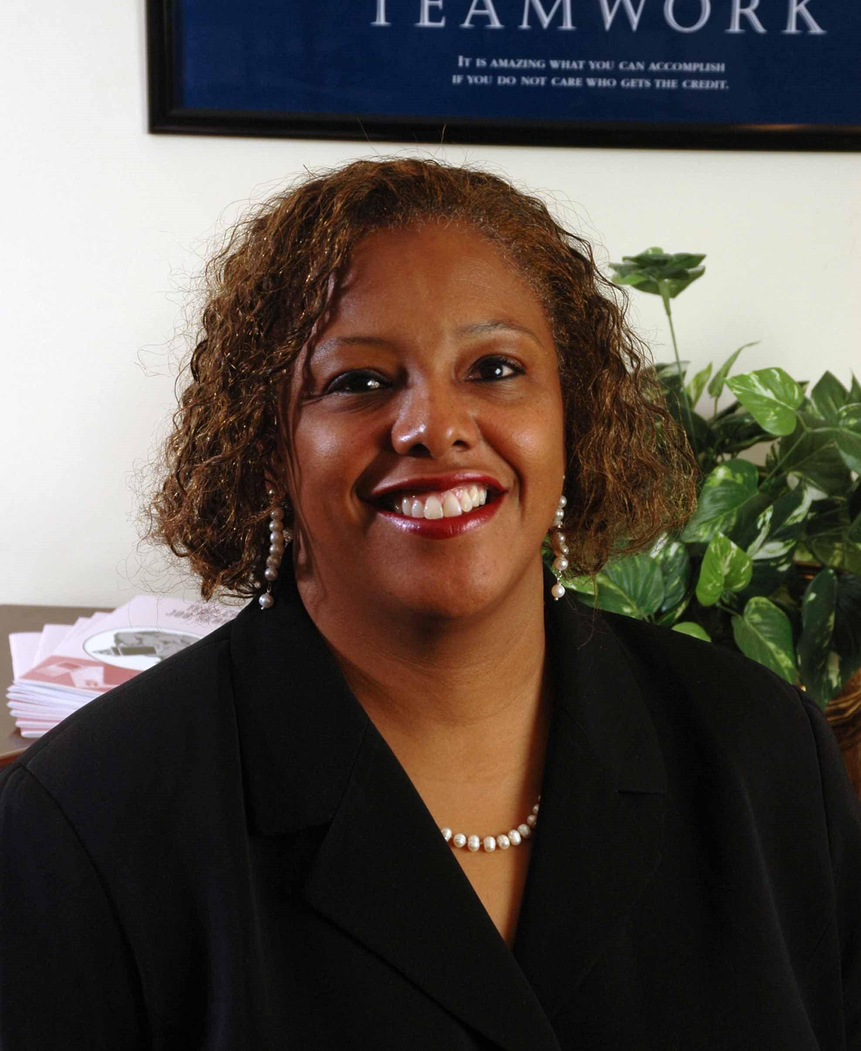 Javaune Adams-Gaston, PhD
Executive Director, Executive Director's Office
University of Maryland Career Center
Dr. Adams-Gaston is responsible for directing the career development and advancement of over 30,000 undergraduate and graduate students at the University. Additionally, in cooperation with Alumni Affairs, she is responsible for the development of a career program for alumni. Included in her portfolio are interactions with University administrators and faculty as well as CEO’s and recruiters from corporations. She provides supervision and oversight for the new President’s Promise Initiative, an opportunity for new University of Maryland students to receive a special experience that complements the academic curriculum. She presents and conducts research on topics including career issues, cultural diversity, first year student outcome assessment, student athlete issues, time and stress management, effective organizational communications and university climate conditions.

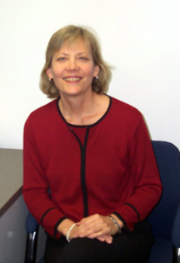
Amy Ginther
Coordinator, Policy Development and Education
Project NEThics^{sm}
University of Maryland
Amy has been at the University of Maryland since 1994, serving first in the Office of Student Conduct where she advised the Student Honor Council and adjudicated cases of academic dishonesty. Her prior work was also in the field of student affairs administration in residential life settings at the University of California Davis, Minnesota State University, Mankato, and Carnegie Mellon University.
She is currently the coordinator of the Project NEThics group in the Office of Information Technology. Project NEThics is the group charged with promoting acceptable use of information technology and investigating incidents of computing resource misuse. In this role, Amy works with graduate assistant staff members who manage the processing of copyright infringement notices, provides user education on a variety of issues, consults with web developers on copyright and intellectual property questions, serves on the university's trademark committee, coordinates the response to cases involving abuse of information technology resources, and serves as a liaison to departments as cases require (university Police, Office of Student Conduct, Office of the Victim Advocate). Amy also serves as a member of the university's Peer Consultant Network of the Center for Leadership and Organizational Change. She has presented at EDUCAUSE national conferences, the EDUCAUSE Mid-Atlantic regional conference, as well as at local meetings on topics of policy development, copyright and intellectual property, protection against identity theft, the pluses and perils of social networking, and others.


Victor Hall
Technology Education Teacher
Berlin Intermediate School
Worcester County Public Schools
Victor Hall has been teaching technology education for the past ten years for Worcester County Public Schools in Maryland and Indian River School District in Delaware. In 1987, he earned his Associates Degree in Graphic Communications from Chowan College and worked in the printing industry as a graphic designer and production coordinator. In 1996, he earned his Bachelors Degree in Vocational Education from Delaware State University and started his new career in teaching technology. In 2005, he earned his Masters Degree in Instructional Technology in Education and has been teaching technology for Worcester County Public Schools. He has been given the opportunity to serve on several committees: National SAFE Committee with ISTE and eSchool News, Maryland Technology Literacy by 8th Grade Student Assessment Committee, MICCA Conference Presenter 2006, 2007 & 2008, and Worcester County Public Schools Technology Implementation Plan Team.


Jeffrey C. Huskamp
Vice President and Chief Information Officer
University of Maryland, College Park
Dr. Jeffrey C. Huskamp is the Vice President and Chief Information Officer at the University of Maryland. Before joining the University of Maryland in May 2004, Dr. Huskamp was the first CIO of East Carolina University and has more than 30 years of experience in information technology, high- performance computing, and high-performance networking. He earned his doctorate in Electrical Engineering and Computer Science from the University of California, Berkeley with his thesis in the area of computer security. His accomplishments include service as the Vice President for Computing at the John von Neumann National Supercomputer Center, service as the Director of the North Carolina Supercomputing Center, and co-author of a production timesharing operating system for the Serial 5 Cray-1. Dr. Huskamp has served as principal investigator on a number of National Science Foundation grants and was the General Chair for the recent SC2004 High- Performance Computing, Networking, and Storage conference.
Dr. Huskamp's passion is to provide students and faculty with the best information technology environment to nurture their success. Jeff is also passionate about safety and security educational efforts to the K12 arena.

Michael Kaiser
Executive Director
National Cyber Security Alliance (NCSA)
Mr. Kaiser joined NCSA in 2008. Prior to joining NCSA, Mr. Kaiser spent 25 years in the field of victim’s services and rights at National Center for Victims of Crime where held the positions of Director of Program Development and the Director of Programs, and at Safe Horizon in New York City, where he held a variety of senior staff positions, including Associate Director for Development and External Affairs and Associate Director for Administration.
Throughout his career, Mr. Kaiser has been involved in developing new programs and expanding the capacities of communities to respond to victims of crime. He has worked on numerous efforts to raise public awareness about the impact of crime and to encourage victims to seek help. Among those accomplishments are: developing programs and that engage teens in creating public education and outreach programs for their peers; conducting a nationwide training and technical assistance program on stalking to improve the law enforcement, victim services, and prosecutorial response to the crime; and developing housing alternatives for intimidated victim/witnesses in three communities.
In the areas of technology, Mr. Kaiser has developed training and other programs on the use of technology in crimes such as stalking and identity theft, and worked on programs exploring the use of technology to improve community policing. Along with his wife Laura Fisher Kaiser, he co-authored The Official eBay Guide to Buying, Selling, and Collecting Just About Anything (Simon and Shuster, 1999). He was one of a small group of eBay University instructors and has personally trained more than 8,000 eBay users on expanding their eBay businesses.
Mr. Kaiser has served on several non-profit Boards. He is currently the Chair and a founding Board Member of SPINUSA a national non-profit based in Massachusetts, and has served on the Board of Trustees of the College of the Atlantic in Bar Harbor, Maine, and New Destiny Housing Corporation in New York City.


Elizabeth Lodal
Former principal, Thomas Jefferson High School for Science and Technology, Virginia
Virginia Education Commission of the States Commissioner
Elizabeth V. Lodal has served as principal of Thomas Jefferson High School for Science and Technology, McLean High School, Langston Hughes Middle School, and Joyce Kilmer Middle School, in Fairfax County, Virginia. Lodal received the 2005 AAUW Virginia Educator of the Year, the 1998 Rice University Distinguished Alumni Award, and the 1993 Rabbi Richard Sternberger Social Justice Award. The FCPS Board named the McLean High School Library and the TJHSST College and Career Center after her. She holds commendations from the Fairfax County Board of Supervisors, the Virginia General Assembly and the United States Congress. Lodal serves on the Boards of the National Science Resource Center (Smithsonian Institution and National Academies); the Washington National Opera; the Northern Virginia Science Center; the American Boychoir School; and Landmark Volunteers.

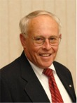
Lynn McNulty, CISSP
Director of Government Affairs, (ISC)2,
Mr. McNulty brings a wealth of information security management experience in government and private practice. During his 30-year career in the federal government, Lynn was Associate Director for Computer Security at the National Institute of Standards and Technology, the first Director of Information Systems Security at the State Department, and Security Program Manager at the Federal Aviation Administration. Lynn has been a consultant since 1995, providing government affairs, business development, and information security policy consulting services to private and public sector clients. He also served on the (ISC)2 Board of Directors for several years, manages government affairs for (ISC)2 and is Co-Chair of the (ISC)2 Government Advisory Board for Cyber Security. He is also a member of the Information Security and Privacy Advisory Board established by the Federal Information Security Management Act.
Lynn is actively pursued by both national and local media outlets for comment as an expert source on U.S. federal government information security policy and related issues. He has been a guest on PBS's Jim Lehrer News Hour and has been featured in numerous federal IT publications such as Government Executive Magazine, Federal Computer Week, Government Computer News, Federal Times, and SIGNAL Magazine.
Chris Madsen
CEO
Trufina
A technology and business development veteran, Chris co-founded Brightmail, where he led product management and business development. There he successfully built business relationships with companies including Microsoft, AT&T, Comcast and Symantec. Brightmail was sold to Symantec in 2004. Chris was a former partner at Milestone Equity Partners, and previously held management and sales positions with Trusted Information Systems, IDS (VRML company), Thinking Machines Corp, and Symbolics.

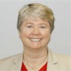
Jane Scott Norris
Chair (ISC)² U.S. Government Executive Writers Bureau
Co-Chair (ISC)² Government Advisory Board for Cyber Security
Former Dean of the School of Applied Information Technology
FSI, the training institute for the Department of State (Retired)
Former CISO (first) of Department of State
Ms. Norris is an Information Assurance consultant who retired from the Senior Foreign Service after 21 years with the Department of State. During her government career, she served in IT leadership positions on four continents, rising to Dean of the School of Applied Information Technology at the Foreign Service Institute. As Dean, her duties involved matching the training and professional development of State’s IT professionals and computer users worldwide to the Department’s strategic vision and designing and implementing a curriculum at two Virginia campuses, at regional centers abroad, and in virtual classrooms.
She also devised and implemented a two-year program to develop future IT leaders through formal and on-the-job training. In an earlier assignment, she conceived and developed the federal best practice of incentive pay awards for IT professionals. Ms. Norris also served as State’s first Chief Information Security Officer. She developed a professionally qualified, process-oriented, results achieving team whose first major accomplishment was to develop and implement a certification and accreditation process to meet an Office of Management and Budget mandate to authorize all operational systems in eighteen months. Although considered "impossible" by OMB and senior Department officials, her team accomplished the task ahead of schedule and well under budget, thereby protecting State’s $1 Billion IT budget from OMB redirection. Her myriad achievements across the information security program were the catalyst in changing the Department's traditional risk-averse approach to information security to one of risk management. Ms. Norris led her team in developing the Certification and Accreditation Professional credential in cooperation with (ISC)².
Ms. Norris currently contributes to the information security community in a variety of public-private venues as: speaker and panelist at conferences; Co-Chair of the (ISC)² Government Advisory Board; Chair of the (ISC)² Executive Writers’ Bureau; and Advisory Committee member for the Federal Information Assurance Conference. In 2004 and again in 2005, Ms. Norris was one of five finalists chosen from across academia, government, and industry in the CSI national Information Security Executive of the Year awards.

Davina Pruitt-Mentle
Director, ETPRO
Founder, C3™ Institute
Chairman, C3™ Conference
Davina Pruitt-Mentle serves as Director for Educational Technology Policy, Research and Outreach (ETPRO).Her primary responsibilities include providing professional development opportunities for educators through workshops and graduate courses, many of which are run on line, and overseeing grant initiatives and research projects that advance effective learning and teaching through technology integration. She has also been instrumental in developing ETPRO’s K-12 STEM Outreach model which introduces or re-engages youth to STEM using culturally savvy, community connected activities, in an informal fun fashion while bridging informal activities to classroom content.
She has extensive experience in the research, development and delivery of educational media, including computer software, multimedia, distance learning and print materials. She served on the advisory committee for the national TSSA standards (Technology Standards for School Administrators) and Partnership for 21st Century Skills, and presently serves on the Maryland State Technology Plan Advisory Committee, the Maryland TL8 Advisory Council, Prince George’s County Chamber of Commerce Education and Workforce Steering Committee and serves as the Education Chair for the Prince George’s County Technology Council. In 2006 she was appointed to serve on the K-16 Maryland Committee on Library Information Literacy and Ethical Use. She has a three ISTE NCATE Program Review Board appointment.
Her research and development interests have focused on the role of distance learning in education, particularly cultivating the Internet as an environment in which to conduct professional development (PD) opportunities, and cultural differences towards technology use. A main initiative within this PD framework involves educators and students knowledge of Cybersecurity, Cybersafety and Cyberawareness (C3). In partnership with the National Cyber Security Alliance, Homeland Security, Educause Security Task Force, the National Center for Missing and Exploited Children, and the Federal Trade Commission, several initiatives have been put in place to include an annual C3 conference, C3 workshops and graduate level courses, on-line tutorials and the National Cyber awareness month interactive calendars (April and October). Other research initiatives focus on constructivist learning and teaching via technology, through her Young Scholars Mindtools Program, Digital Fluency curriculum and professional development through gaming theory. She has acted as consultant to a wide number of technology and education-related organizations. She has authored and presented at numerous national, regional and state conferences and teaches graduate courses to practicing educators on a wide range of technology related topics.


Gerry Sneeringer
Director of Security
Office of Information Technology
Campus IT Security Officer
University of Maryland, College Park
Mr. Sneeringer is charged with driving the development of the university’s IT security strategy; ensuring university compliance with federal, state, and university IT security policy; collaborating with campus researchers to bring real world experience to their academic pursuits; and working with IT professionals throughout the university to protect its data, computers, and networks.
Gerry prepared for this role by serving in a diverse collection of IT positions during his 20-year career at the university. Prior to his involvement in security, he worked the front lines as a user consultant, developed applications, maintained UNIX systems, established network operations, served as engineer responsible for remote access, and served as Interim Director of Network Infrastructure.
Gerry represents the university in a number of security venues, including the University System of Maryland Security Group, the Maryland chapter of FBI/Infragard, and organizations such as EDUCAUSE. He has spoken on security topics as a panelist or presenter at a number of state, regional, and national conferences. Gerry, a University of Maryland alumnus, holds a bachelor’s degree in computer science and has been recognized as a Certified Information Systems Security Professional.

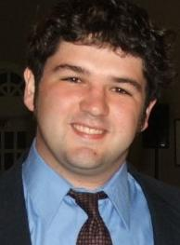
Brooks Whiteford
Technology Department
Calvert Hall College High School
Brooks Whiteford, a recent college graduate, has worked in many different areas of technology. Before receiving his degree in Computer Science in 2008 from St. Mary's College of Maryland, Brooks lead an effort to revive the college's radio station, resulting in a flourishing program with strong student involvement. The facility was renamed after Brooks shortly before his departure.
Brooks now works for the Technology Department at Calvert Hall College High School, where he graduated from in 2004. There, he assists faculty, staff and students with their most challenging technology needs and projects. Brooks also continues to volunteer at Our Lady of Perpetual Help School, where he has worked to help advance learning through the use of technology. Through the implementation of resources such as classroom video projection systems, the school's dynamic webpage, and an advanced e-learning system, OLPH continues to remain on the forefront of development in the field of educational technology.
Brooks is looking forward to continuing his growth in his passion for academic technology, as well as expanding his interests even further.

Lessons Learned:
Overall the workshop went very well. Allowing students to network with professionals was well received. Speakers and attendees (law enforcement, attorney generals etc…) went out of their way to introduce themselves and answers questions—as well as ask several questions of the students. The security presentation (hands on) allowed them to see first hand careers in this area while also learning how-to’s. Students also were able to visit with several of the student interims posted at the poster session and display areas.

Summary Evaluations from the Attendees

Evaluation and Feedback (0-4) 4 being the highest
General Questions | Average
The workshop/conference objectives were clear. | 3.9
The length of the workshop was sufficient to cover the subject matter | 3.7
Overall, the workshop instructors and speakers were effective. | 3.8
I learned new information in this workshop. | 4.0
I’d like to learn more about IT/IA and Cybersecurity | 3.0
I may consider Cybersecurity as a career choice | 3.4
Speaker's Presentations
0 - 4 scale, with 4 being strongly agree
Elizabeth Lodal | 2.5
Panel: Javaune Adam-Gaston, Gerry Sneeringer & Matt Supple | 3.9
Keynote Jane Scott-Norris | 3.4
One on One with Jane Scott-Norris, Lynn McNulty, Whiteford | 3.9
One on One with interins and Graduate students | 3.9

How could this workshop be improved?

- I think all students need to learn about this information—for their own safety and protection and because it really shows how this area is growing. There seem to be many new jobs I had never heard of before
- I think career counselors and schools need to learn about this—I neverknew and I am interested in technology
- More time to visit with students and business people
- We should also be able to stay long enough for give aways

Please list any additional comments or suggestions

- Thank you, this was surprisingly interesting
- The FOOD was GREAT!!
- A great field trip
- The food
- Give aways
- I enjoyed talking with the people in the small group and they answered many questions that we all think about—like how much you get paid

