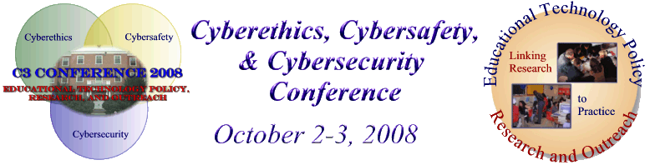

Summary Report from the
7th Annual C3 Conference
Cyberethics, Cybersafety, & Cybersecurity
http://www.edtechpolicy.org/C32008/index.html
Implications for the Educational Community
October 2, 2008 - Conference Sessions
October 3, 2008 - Conference Workshops
University of Maryland, College Park, MD



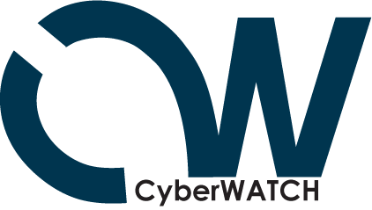

ETPRO CyberWATCH Subcontract Deliverables for the C3 Conference

YEAR 4
Cyberethics, Cybersafety and Cybersecurity (C3) Conference
Event Summary
The Annual C3 Conference focuses on Cyberethics, Cybersafety and Cybersecurity as related to the educational setting (K-20). NSF funding has allowed additional participants to attend and provided for enhancements to the Cybersecurity programming. School districts budgets are increasingly constrained, and the funding allows for teachers to participate in the program. Additionally, we have focused efforts on Cybersecurity issues for the user services and IT support staff, and paid for their attendance. As security has become a front-and-center concern of IT departments and a common frustration for end-users, the support requirements for help desks and IT support staff have emerged as a critical competency for the central and departmental IT organization. This portion of the conference provided IT support personnel with an introduction to the common cybersecurity issues that their organizational users face. It also explored strategies and solutions for addressing user concerns and organizational requirements for improving the security of information systems. NSF funding paid for registration for 100 attendees (recruited from local school system, private/charter school and area 2-4 year college IT departments). This registration included access to both days of the conference, speakers, and workshops, a CD of course material, and numerous handouts. Additional monetary support came from the National Cyber Security Alliance, (ISC)² , and Northrop Grumman. Workshop sponsorships came from NetSmartz, CyberSmart! and the C3 Institute, enabling us to deliver a high quality, well received conference that addressed the needs of the educational community. Over the two days we had 254 people in attendance over the two days, representing Maryland, Virginia, New Jersey and Delaware school districts in addition to representatives from higher education, non profits, criminal justice, government agencies, and the business community The conference website can be found at: http://www.edtechpolicy.org/C32008/index.html The C3 conference has become one of the annual activities associated with National Cyber Security Awareness month--a congressional initiative led by the National Cyber Security Alliance. Each year the C3 conference will be held the first week in October to help kickoff the monthly awareness campaign. The 2009 conference will be held October 1 & 2.

Detailed Agenda

Thursday’s Agenda
8:30 am | Registration Check in: Refreshments, Posters and Vendors
9:00 am -9:15 am | Opening Remarks:  Davina Pruitt-Mentle, Director, ETPRO and C3 Conference Chair
9:15 am -10:00 am | Opening Keynote:  Elizabeth Lodal  Former principal, Thomas Jefferson High School for Science and Technology, Virginia;  Virginia Education Commission of the States Commissioner
10:00 -11:00 am | Students and Technology: Facing Facebook Realities  Social networking Web sites (like Facebook and MySpace) are staples in the lives of students, enabling them to share their lives via blogs and photos with literally thousands of people. While these electronic connections provide a useful outlet, many fail to realize the pitfalls of such web sites—especially when they can be accessed by future university administrators, professors and prospective employers. Join our panel of experts as they discuss the “Facebook phenomenon,” cybersafety, cyberethics, and ways to help students become more responsible in their on-line activities.  Javaune Adams-Gaston, PhD Executive Director, Executive Director's Office, University of Maryland Career Center  Jeffrey C. Huskamp, PhD Vice President and Chief Information Officer at the University of Maryland  Gerry Sneeringer, Director of Security, OIT, University of Maryland  Matt Supple, Asst. Director, Advising and Programing Fraternity & Sorority Life, University of Maryland
11:00 - 11:15 am | Break
11:15 -12 noon | Safety and Security KEYNOTE  Maintaining a Safe IT Environment When Your Child Knows More About the Technology Than You Do  Jane Scott Norris, CISSP-ISSAP, ISSMP, CAP, CISM  Chair (ISC)² U.S. Government Executive Writers Bureau  Co-Chair (ISC)² Government Advisory Board for Cyber Security  We all live in a technically dynamic world where our teenagers are much more comfortable with the information technology world than their parents, teachers and other adult figures. Technology is a double-edged sword. It can be used in positive ways to improve learning and communications; however it also has a dark side that leads to problems that have been well documented in the media of late. This presentation will discuss common vulnerabilities, contemporary computer and communications technologies, and discuss parental strategies for preventing privacy, cyber bullying and other related issues.  Expanding upon the earlier panel discussion regarding on-line activity, (ISC)² will share additional insight and recent issues all parents, students and educations need to be aware of involving social networking and websites.
12 noon 1:15 pm | Lunch and Luncheon Keynote Speaker  Michael Kaiser, Executive Director, National Cyber Security Alliance  Colony Ballroom  NCSA will show and share their new website, and will discuss this year’s partnership events, including USA Today lesson plans and the current national PSAs. Over lunch learn how you and your students can enter the K-12 Cybersecurity awareness contest. NCSA will also share their newly launched resource center and will discuss their current survey findings.
1:15 pm - 1:45 pm | Vendor and poster session reviews
1:45 pm - 2:45 pm | What the Research is Telling Us  Panel  Amanda Lenhart, Senior Research Specialist, Pew Internet & American Life Project  Peter Grunwald, Research and Guidelines on Online Social Networking Survey  Ashley Mouberry Sieman, Assistant Director- Housing and Residence Life and Judicial Affairs.  Marymount University
2 :45 pm - 3:00 pm | BREAK
3:00 pm - 4:00 pm | Hands on Safety and Security How to’s—Bring Your Laptop  Brooks Whiteford, Technology Department, Calvert Hall College High School
4:00 pm - 4:15 pm | Closure and Give Aways
Friday Workshop Agenda
8:30 am — 9:00 am | Workshop Check in
9:00 am — 11:30 am | What Do Academic Integrity/Honor Codes and Strong Acceptable Use Policies Have to Offer?  This session will begin with a panel discussion sharing academic integrity/honor codes and other strategies implemented by local public and private K12 schools and post-secondary institutions. Lessons learned of what works and what doesn’t for all grade levels will be shared. Leave with exemplary examples and "how to's" to draft your own honor code to implement in your school. Already have one? Come ready to share!  - Brian Schiffer, Character Education, Perry Hall High School, Baltimore County Public Schools  - Rick Kirschner, Assistant to the Headmaster for Student Life, Banfield Ethics Chair, Landon School  - Amy Ginther, Coordinator, Policy Development and Education Project NEThicssm University of Maryland  - Diane Harvey, UMCP, Maryland K-20 Academic Integrity Committee Co-Chair  - Chris Madsen, CEO Trufina
11:30-Noon | Lunch - A light lunch will be provided
Noon -2:00PM | Practical Ethics Activities for the Classroom  How can you implement an already full agenda with ethics activities? How can you promote academic integrity into a fully packed curriculum? Teachers will share how they have met the challenge. Designed for participant input and interaction.  - Zulma Whiteford, Director of Academic Technology, Our Lady of Perpetual Help School  - Victor Hall, Technology Education Teacher, Berlin Intermediate School, Worcester County Public Schools  - Laura Brown, Media Specialist, Wheaton High School, Montgomery County Public Schools
2:00 pm - 3:30 pm | Streamlining C3 Content  Classroom curricula are already packed, and the demands on teachers' time precludes them from developing and including ethics, safety, and security units in their classroom. How can we inject these topics into the classroom? The session will share how to combine available C3 content into existing curricula and lessons. Classroom examples will be shared.  - Mala Bawer, Co-Founder and Executive Director, CyberSmart! Education  - Katie Donovan, Community Outreach Coordinator, NetSmartz® Workshop
3:30 pm | Closure and Give Aways
 | Workshop sessions are open to all conference registrants, but are limited by space. Please check off your desire to participate in a workshop during the registration process, and you will receive a confirmation email. As a courtesy to the presenters who are developing and printing materials, to our workshop committee in planning refreshments, and to other participants who may wish to attend, please only select the workshops if you are committed to attending.

Speaker Biographical Sketches - 2008

Speaker Biographical Sketches

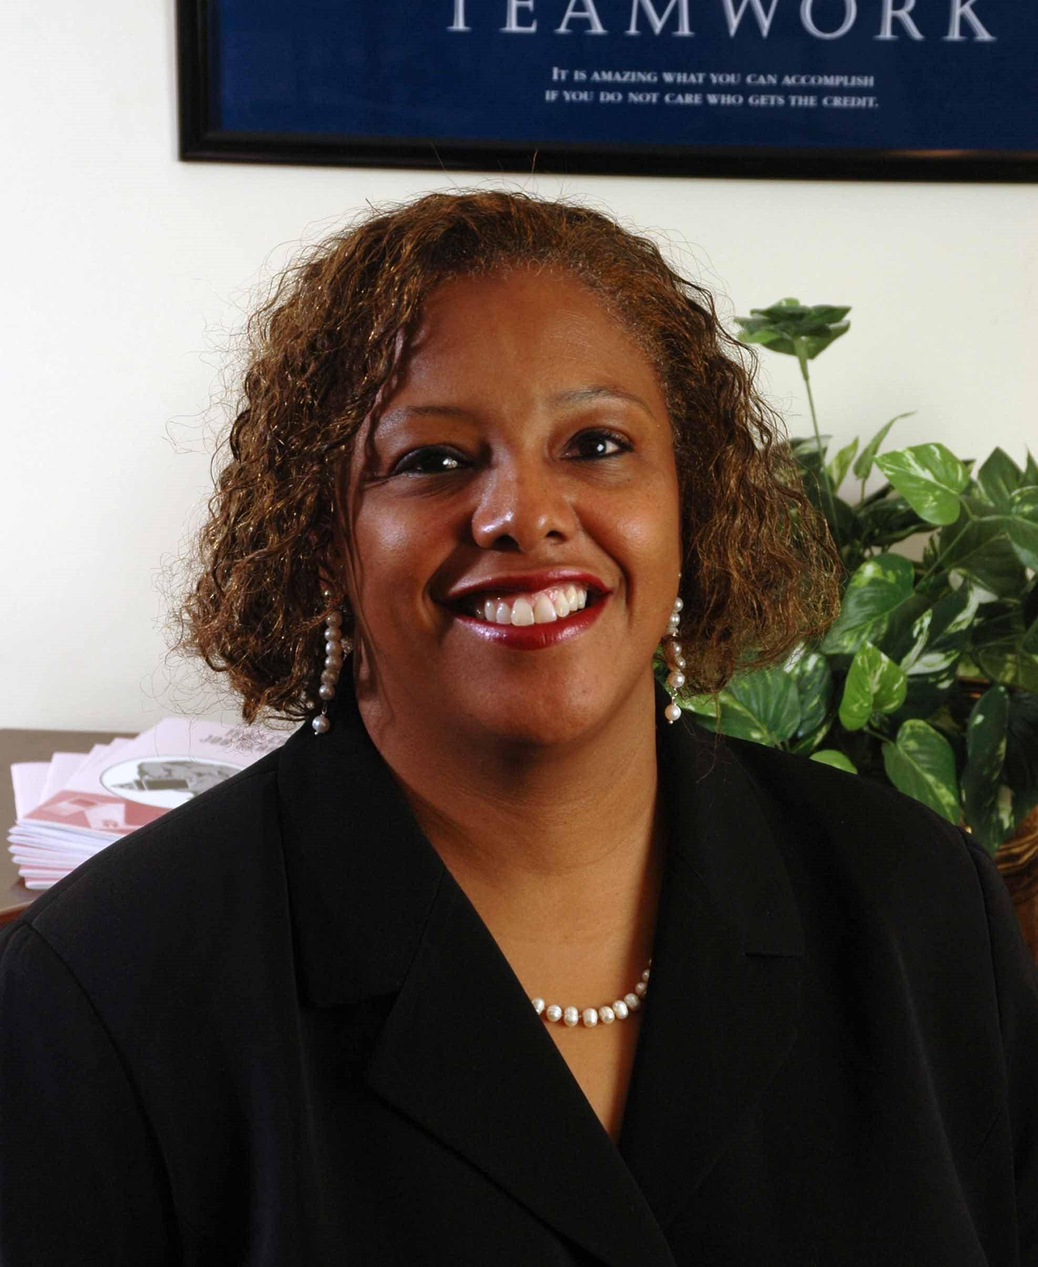 Javaune Adams-Gaston, PhD
Executive Director, Executive Director's Office
University of Maryland Career Center
Dr. Adams-Gaston is responsible for directing the career development and advancement of over 30,000 undergraduate and graduate students at the University. Additionally, in cooperation with Alumni Affairs, she is responsible for the development of a career program for alumni. Included in her portfolio are interactions with University administrators and faculty as well as CEO’s and recruiters from corporations. She provides supervision and oversight for the new President’s Promise Initiative, an opportunity for new University of Maryland students to receive a special experience that complements the academic curriculum. She presents and conducts research on topics including career issues, cultural diversity, first year student outcome assessment, student athlete issues, time and stress management, effective organizational communications and university climate conditions.

Mala Bawer
Co-Founder and Executive Director
CyberSmart! Education
Mala is a veteran information industry executive. She was part of the part of the senior management launch team for the earliest field trials of the first consumer online service, Knight-Ridder's Viewtron. She also played a pivotal role in the introduction of the first networked interactive public video kiosk service, Teleguide, a partnership of Southam and Times-Mirror Corporation, as head of the New York sales office. Prior to conceiving CyberSmart!, she co-founded the award winning interactive financial information service Stockalert. Mala received her Master's Degree in Business Administration from the Darden Graduate School at the University of Virginia and her Bachelor of Arts Degree from the University of Michigan, Ann Arbor.
CyberSmart! provides a solution to today's increasingly disengaged students. Their facilitated online professional development provides educators with hands-on experience in the 21st century skills they need to meet the learning needs of todays digital generation.… SAFELY. Their widely acclaimed free CyberSmart! Student Curriculum is used by K-12 teachers around the world to empower students to use the Internet safety, responsibly and effectively.

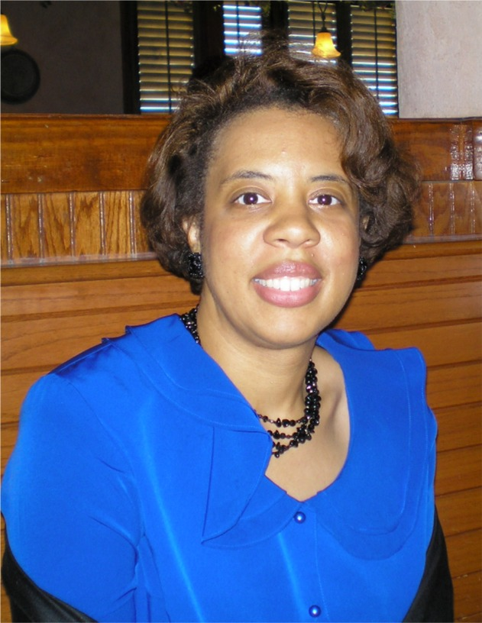
Laura Brown
Media Specialist
Wheaton High School
Laura Brown is currently a library media specialist at Wheaton High School in Montgomery County Public Schools (MCSP). She has been a media specialist for almost twenty years. Her experience includes being a media specialist at a community college, a university, and grades PreK- 12th, a military library, and a state agency. She was also a technology consultant for MCSP for three years. In this role she trained teachers, administrators, and other school staff personnel the technology being used in the school system. Ms. Brown is from Detroit, Michigan and has an undergraduate degree in Economics, with a minor in African American Studies Pennsylvania State University. She has her Masters in Library Services from the University of Alabama, and a Masters in Elementary Education from Auburn University. She also has a certification in Educational Leadership from Auburn University, and graduate course work in aeronautics from Oklahoma State University. She has presented at a number of state conferences which include MSTA and MICCA, and is a certified Promethean trainer and ThinkPort trainer for Maryland Public Television. She resides in Hanover, Maryland and enjoys scrap booking, card making, rug hooking, writing, and biking.

Katie Donovan
Community Outreach Coordinator
NetSmartz® Workshop
Katie Donovan is the Community Outreach Coordinator for the NetSmartz® Workshop, an educational resource of the National Center for Missing & Exploited Children® (NCMEC). Katie has worked in both the fields of child advocacy and child health. For six years she volunteered at the Collin County Children's Advocacy Center in Plano, Texas doing a variety of work to help prevent child abuse and serve victims of abuse in North Dallas. While a student at The Pennsylvania State University, Katie helped raise over $46 million in the fight against pediatric cancer as a leader of the Penn State Dance Marathon, the largest student-run philanthropy in the world.
Before joining the NetSmartz Workshop, Katie held community service and marketing internships at The Dallas Morning News/WFAA TV and Penn State Intercollegiate Athletics, and was previously employed in the Marketing Department at the Corporate Executive Board in Washington D.C.
As a member of the NetSmartz Outreach team, Katie's focus has shifted to spreading awareness of the importance of Internet safety education.
Katie graduated from The Pennsylvania State University with a bachelor's degree in Public Relations and a double minor in Sociology and Business.
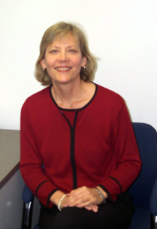
Amy Ginther
Coordinator, Policy Development and Education
Project NEThics^{sm}
University of Maryland
Amy has been at the University of Maryland since 1994, serving first in the Office of Student Conduct where she advised the Student Honor Council and adjudicated cases of academic dishonesty. Her prior work was also in the field of student affairs administration in residential life settings at the University of California Davis, Minnesota State University, Mankato, and Carnegie Mellon University.
She is currently the coordinator of the Project NEThics group in the Office of Information Technology. Project NEThics is the group charged with promoting acceptable use of information technology and investigating incidents of computing resource misuse. In this role, Amy works with graduate assistant staff members who manage the processing of copyright infringement notices, provides user education on a variety of issues, consults with web developers on copyright and intellectual property questions, serves on the university's trademark committee, coordinates the response to cases involving abuse of information technology resources, and serves as a liaison to departments as cases require (university Police, Office of Student Conduct, Office of the Victim Advocate). Amy also serves as a member of the university's Peer Consultant Network of the Center for Leadership and Organizational Change. She has presented at EDUCAUSE national conferences, the EDUCAUSE Mid-Atlantic regional conference, as well as at local meetings on topics of policy development, copyright and intellectual property, protection against identity theft, the pluses and perils of social networking, and others.

Peter Grunwald
President
Grunwald Associates
Peter Grunwald has worked with electronic information services for schools and families for more than 15 years. He is President of Grunwald Associates, a research and consulting firm in Bethesda, Md.
Grunwald Associates has conducted some of the industry's most respected surveys on educator and family technology use since 1995. These surveys have helped define the process by which students use and are influenced by media, and have been called the "gold standard" in the industry. The surveys use a unique public-private model to finance a combination of rigorous methodology and analysis by "hands on" industry leaders. Grunwald research consistently receives wide press coverage, including the New York Times, Financial Times, PARADE Magazine, CNN, the Wall Street Journal, Washington Post, USA Today and many other outlets.
Before forming Grunwald Associates, Mr. Grunwald was Vice President of Issue Dynamics, Inc. (IDI), a leading Washington DC public affairs firm in the telecommunications industry. At IDI, Mr. Grunwald created marketing and other alliances between corporate clients and leading education organizations as well as content providers. Prior to joining IDI, Mr. Grunwald was Director of Sales and Field Marketing for GTE Education Services. In that role, he helped market and manage the largest commercial online network in education.
Mr. Grunwald received a Masters in Education from Harvard University.

Victor Hall
Technology Education Teacher
Berlin Intermediate School
Worcester County Public Schools
Victor Hall has been teaching technology education for the past ten years for Worcester County Public Schools in Maryland and Indian River School District in Delaware. In 1987, he earned his Associates Degree in Graphic Communications from Chowan College and worked in the printing industry as a graphic designer and production coordinator. In 1996, he earned his Bachelors Degree in Vocational Education from Delaware State University and started his new career in teaching technology. In 2005, he earned his Masters Degree in Instructional Technology in Education and has been teaching technology for Worcester County Public Schools. He has been given the opportunity to serve on several committees: National SAFE Committee with ISTE and eSchool News, Maryland Technology Literacy by 8th Grade Student Assessment Committee, MICCA Conference Presenter 2006, 2007 & 2008, and Worcester County Public Schools Technology Implementation Plan Team.

Diane Harvey
Undergraduate Studies Librarian
University of Maryland Libraries
Diane Harvey is the Undergraduate Studies Librarian at the University of Maryland Libraries. She works closely with undergraduate research programs at the University, and teaches several courses that provide undergraduates with research experiences. She received degrees from Rutgers University and Johns Hopkins University, and has worked in a variety of university and specialized libraries including Johns Hopkins, Rutgers, and the Newseum.

Jeffrey C. Huskamp
Vice President and Chief Information Officer
University of Maryland, College Park
Dr. Jeffrey C. Huskamp is the Vice President and Chief Information Officer at the University of Maryland. Before joining the University of Maryland in May 2004, Dr. Huskamp was the first CIO of East Carolina University and has more than 30 years of experience in information technology, high- performance computing, and high-performance networking. He earned his doctorate in Electrical Engineering and Computer Science from the University of California, Berkeley with his thesis in the area of computer security. His accomplishments include service as the Vice President for Computing at the John von Neumann National Supercomputer Center, service as the Director of the North Carolina Supercomputing Center, and co-author of a production timesharing operating system for the Serial 5 Cray-1. Dr. Huskamp has served as principal investigator on a number of National Science Foundation grants and was the General Chair for the recent SC2004 High- Performance Computing, Networking, and Storage conference.
Dr. Huskamp's passion is to provide students and faculty with the best information technology environment to nurture their success. Jeff is also passionate about safety and security educational efforts to the K12 arena.

Michael Kaiser
Executive Director
National Cyber Security Alliance (NCSA)
Mr. Kaiser joined NCSA in 2008. Prior to joining NCSA, Mr. Kaiser spent 25 years in the field of victim’s services and rights at National Center for Victims of Crime where held the positions of Director of Program Development and the Director of Programs, and at Safe Horizon in New York City, where he held a variety of senior staff positions, including Associate Director for Development and External Affairs and Associate Director for Administration.
Throughout his career, Mr. Kaiser has been involved in developing new programs and expanding the capacities of communities to respond to victims of crime. He has worked on numerous efforts to raise public awareness about the impact of crime and to encourage victims to seek help. Among those accomplishments are: developing programs and that engage teens in creating public education and outreach programs for their peers; conducting a nationwide training and technical assistance program on stalking to improve the law enforcement, victim services, and prosecutorial response to the crime; and developing housing alternatives for intimidated victim/witnesses in three communities.
In the areas of technology, Mr. Kaiser has developed training and other programs on the use of technology in crimes such as stalking and identity theft, and worked on programs exploring the use of technology to improve community policing. Along with his wife Laura Fisher Kaiser, he co-authored The Official eBay Guide to Buying, Selling, and Collecting Just About Anything (Simon and Shuster, 1999). He was one of a small group of eBay University instructors and has personally trained more than 8,000 eBay users on expanding their eBay businesses.
Mr. Kaiser has served on several non-profit Boards. He is currently the Chair and a founding Board Member of SPINUSA a national non-profit based in Massachusetts, and has served on the Board of Trustees of the College of the Atlantic in Bar Harbor, Maine, and New Destiny Housing Corporation in New York City.


Rick Kirschner
Assistant to the Headmaster for Student Life
Banfield Ethics Chair
Landon School
A D.C. native, Rick attended Landon School for ten years before attending Princeton University where he received a B.A. in History in 1987. He earned a law degree from Brigham Young University in 1993 where he also coached the men’s lacrosse team. Rick served three years as a Judicial Official in the North Carolina Judicial Branch before turning to a career in Independent Education. He taught history and coached football and lacrosse at St. Anne’s-Belfield School in Charlottesville, Virginia, was Associate Director of Admission and head lacrosse coach at St. Stephen’s and St. Agnes School in Alexandria, Virginia before returning to his alma mater as Assistant Headmaster for Student Life and as the Paul L. Banfield Chair of Ethics. In his current role, Rick directs the character education program at Landon School, a nonsectarian school for 675 boys in Bethesda, Maryland. Rick also is in charge of planning and organizing Landon’s annual leadership and ethics conference which draws students and administrators from Philadelphia to Richmond to spend a day addressing ethics, honor, and leadership. United States Supreme Court Justice Sandra Day O’Connor was the keynote speaker in 2007 while former United States Secretary of State Madeleine Albright was the keynote speaker in 2008. Landon, under Rick’s leadership, recently adopted their new Code of Character which they use to nurture a culture of integrity and civility in their community



Amanda Lenhart
Senior Research Specialist
Pew Internet & American Life Project
Amanda Lenhart is a Senior Research Specialist with the Pew Internet & American Life Project and has been with the Project since its inception in 1999. She graduated magna cum laude from Amherst College with a double major in English and Anthropology, and she earned a Masters with distinction from Georgetown University in Communications, Culture and Technology.
Amanda is the lead author of numerous Pew Internet Project reports, including, Bloggers, Social Networking Websites and Teens, Teens, Privacy and Online Social Networks, and most recently, Teens, Video Games and Civics, done in conjunction with the MacArthur Foundation. For her research about and knowledge of youth and their use of the Internet, Amanda has testified before a congressional subcommittee, the FTC and the U.S. States Attorneys General, and presented her work at academic conferences and briefings, including one most recently at the U.S. Capitol. Amanda has been quoted in major news outlets, including The New York Times, The Washington Post and USAToday and has been interviewed for many local, national and public radio and television programs such as Talk of the Nation, The Kojo Nnamdi Show, On the Media, CNN's On the Money, MSNBC TV, ABC-TV's Ahead of the Curve, The Exchange, and Futuretense among many others.

Elizabeth Lodal
Former principal, Thomas Jefferson High School for Science and Technology, Virginia
Virginia Education Commission of the States Commissioner
Elizabeth V. Lodal has served as principal of Thomas Jefferson High School for Science and Technology, McLean High School, Langston Hughes Middle School, and Joyce Kilmer Middle School, in Fairfax County, Virginia. Lodal received the 2005 AAUW Virginia Educator of the Year, the 1998 Rice University Distinguished Alumni Award, and the 1993 Rabbi Richard Sternberger Social Justice Award. The FCPS Board named the McLean High School Library and the TJHSST College and Career Center after her. She holds commendations from the Fairfax County Board of Supervisors, the Virginia General Assembly and the United States Congress. Lodal serves on the Boards of the National Science Resource Center (Smithsonian Institution and National Academies); the Washington National Opera; the Northern Virginia Science Center; the American Boychoir School; and Landmark Volunteers.

Barry Mansfield
Director of Education
CyberSmart!,
Barry Mansfield's hands-on expertise in the areas of educational technology and instructional design have made him an invaluable resource as a coach and mentor to hundreds of teachers in dozens of schools and classrooms worldwide. Most recently, Barry directed programs for the Mid-Atlantic Regional Technology in Education Consortium (MARTEC) at Temple University's Center for Research in Human Development and Education (TUCRHDE), one of ten federally funded regional education laboratories. While at MAR*TEC Barry designed, implemented, and evaluated instructional technologies, web resources, videos, and online tools for K-12 teachers and students helping them successfully infuse technologies into classrooms. During his time with MAR*TEC, Barry also co-created the innovative and acclaimed "Reflection Connection," an online collaboration tool for teachers.
Barry holds a Master's Degree in Education from Temple University and in another life was Academic Director at the Caledonian School, the premier language institution in Prague, Czech Republic. He is currently earning a doctorate in Educational Technology at the University of Delaware.
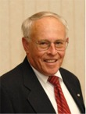
Lynn McNulty, CISSP
Director of Government Affairs, (ISC)2,
Mr. McNulty brings a wealth of information security management experience in government and private practice. During his 30-year career in the federal government, Lynn was Associate Director for Computer Security at the National Institute of Standards and Technology, the first Director of Information Systems Security at the State Department, and Security Program Manager at the Federal Aviation Administration. Lynn has been a consultant since 1995, providing government affairs, business development, and information security policy consulting services to private and public sector clients. He also served on the (ISC)2 Board of Directors for several years, manages government affairs for (ISC)2 and is Co-Chair of the (ISC)2 Government Advisory Board for Cyber Security. He is also a member of the Information Security and Privacy Advisory Board established by the Federal Information Security Management Act.
Lynn is actively pursued by both national and local media outlets for comment as an expert source on U.S. federal government information security policy and related issues. He has been a guest on PBS's Jim Lehrer News Hour and has been featured in numerous federal IT publications such as Government Executive Magazine, Federal Computer Week, Government Computer News, Federal Times, and SIGNAL Magazine.
Chris Madsen
CEO
Trufina
A technology and business development veteran, Chris co-founded Brightmail, where he led product management and business development. There he successfully built business relationships with companies including Microsoft, AT&T, Comcast and Symantec. Brightmail was sold to Symantec in 2004. Chris was a former partner at Milestone Equity Partners, and previously held management and sales positions with Trusted Information Systems, IDS (VRML company), Thinking Machines Corp, and Symbolics.

Ashley Mouberry Sieman
Assistant Director
Housing and Residence Life and Judicial Affairs
Marymount University
Templeton Research Fellow
Ashley Mouberry Sieman, a North Carolina native, currently works as the Assistant Director of Housing and Residence Life and Judicial Affairs at Marymount University. Prior to working at Marymount University, Ashley worked as a Community Director in the Department of Housing and Residence Life at the University of North Carolina at Chapel Hill.
Ashley received her master’s degree in College Student Personnel in 2003 from the University of Maryland, College Park where she completed a master’s thesis entitled “Academic dishonesty: Student and faculty perceptions at a large public institution with a modified honor code.” Ashley is currently pursuing a doctoral degree in Higher Education Administration at North Carolina State University. Her research, which is supported by a Junior Fellowship from the John Templeton Foundation and the Center for Academic Integrity, focuses on exploring the missing links in academic integrity research.

Laurie Nathan
Outreach Coordinator, NetSmartz
Laurie Nathan is the Lead Outreach Coordinator for the NetSmartz Workshop, a program of the National Center for Missing & Exploited Children (NCMEC). Prior to her arrival at NetSmartz, Ms. Nathan was a staff analyst in the Exploited Child Division (ECD) at NCMEC. During her tenure in the ECD, Laurie garnered extensive knowledge of Internet search capabilities, became familiar with the ways children can be exploited through the usage of the Internet, and worked closely with law enforcement to have these cases resolved.
Prior to her work at NCMEC, Ms. Nathan was the Director of Programs at Prevent Child Abuse of Metropolitan Washington. Laurie managed over 40 volunteers who answered calls on PhoneFriend, a support line for children ages 5 to 15. Additionally, she worked on child abuse prevention outreach campaigns for the Washington, D.C. metro area.
Ms. Nathan graduated with highest honors from Emory University in Atlanta, GA with a B.A. in Psychology and a minor in Art History.
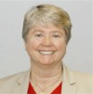
Jane Scott Norris
Chair (ISC)² U.S. Government Executive Writers Bureau
Co-Chair (ISC)² Government Advisory Board for Cyber Security
Former Dean of the School of Applied Information Technology
FSI, the training institute for the Department of State (Retired)
Former CISO (first) of Department of State
Ms. Norris is an Information Assurance consultant who retired from the Senior Foreign Service after 21 years with the Department of State. During her government career, she served in IT leadership positions on four continents, rising to Dean of the School of Applied Information Technology at the Foreign Service Institute. As Dean, her duties involved matching the training and professional development of State’s IT professionals and computer users worldwide to the Department’s strategic vision and designing and implementing a curriculum at two Virginia campuses, at regional centers abroad, and in virtual classrooms.
She also devised and implemented a two-year program to develop future IT leaders through formal and on-the-job training. In an earlier assignment, she conceived and developed the federal best practice of incentive pay awards for IT professionals. Ms. Norris also served as State’s first Chief Information Security Officer. She developed a professionally qualified, process-oriented, results achieving team whose first major accomplishment was to develop and implement a certification and accreditation process to meet an Office of Management and Budget mandate to authorize all operational systems in eighteen months. Although considered "impossible" by OMB and senior Department officials, her team accomplished the task ahead of schedule and well under budget, thereby protecting State’s $1 Billion IT budget from OMB redirection. Her myriad achievements across the information security program were the catalyst in changing the Department's traditional risk-averse approach to information security to one of risk management. Ms. Norris led her team in developing the Certification and Accreditation Professional credential in cooperation with (ISC)².
Ms. Norris currently contributes to the information security community in a variety of public-private venues as: speaker and panelist at conferences; Co-Chair of the (ISC)² Government Advisory Board; Chair of the (ISC)² Executive Writers’ Bureau; and Advisory Committee member for the Federal Information Assurance Conference. In 2004 and again in 2005, Ms. Norris was one of five finalists chosen from across academia, government, and industry in the CSI national Information Security Executive of the Year awards.

Davina Pruitt-Mentle
Director, ETPRO
Founder, C3™ Institute
Chairman, C3™ Conference
Davina Pruitt-Mentle serves as Director for Educational Technology Policy, Research and Outreach (ETPRO).Her primary responsibilities include providing professional development opportunities for educators through workshops and graduate courses, many of which are run on line, and overseeing grant initiatives and research projects that advance effective learning and teaching through technology integration. She has also been instrumental in developing ETPRO’s K-12 STEM Outreach model which introduces or re-engages youth to STEM using culturally savvy, community connected activities, in an informal fun fashion while bridging informal activities to classroom content.
She has extensive experience in the research, development and delivery of educational media, including computer software, multimedia, distance learning and print materials. She served on the advisory committee for the national TSSA standards (Technology Standards for School Administrators) and Partnership for 21st Century Skills, and presently serves on the Maryland State Technology Plan Advisory Committee, the Maryland TL8 Advisory Council, Prince George’s County Chamber of Commerce Education and Workforce Steering Committee and serves as the Education Chair for the Prince George’s County Technology Council. In 2006 she was appointed to serve on the K-16 Maryland Committee on Library Information Literacy and Ethical Use. She has a three ISTE NCATE Program Review Board appointment.
Her research and development interests have focused on the role of distance learning in education, particularly cultivating the Internet as an environment in which to conduct professional development (PD) opportunities, and cultural differences towards technology use. A main initiative within this PD framework involves educators and students knowledge of Cybersecurity, Cybersafety and Cyberawareness (C3). In partnership with the National Cyber Security Alliance, Homeland Security, Educause Security Task Force, the National Center for Missing and Exploited Children, and the Federal Trade Commission, several initiatives have been put in place to include an annual C3 conference, C3 workshops and graduate level courses, on-line tutorials and the National Cyber awareness month interactive calendars (April and October). Other research initiatives focus on constructivist learning and teaching via technology, through her Young Scholars Mindtools Program, Digital Fluency curriculum and professional development through gaming theory. She has acted as consultant to a wide number of technology and education-related organizations. She has authored and presented at numerous national, regional and state conferences and teaches graduate courses to practicing educators on a wide range of technology related topics.
Brian Schiffer
Character Education
Perry Hall High School
Baltimore County Public Schools
After leaving the film industry where he worked for 10 years as a literary manager, Brian Schiffer began teaching at a school of 5,300 kids in South Central Los Angeles. He helped to build the Humanitas SLC (small learning community) and created the school's first literary magazine. He currently teaches English 10 and Film Criticism at Perry Hall H.S. in Baltimore County. He is Chairman of the Character Education Committee, which won Maryland's "Emerging Practices" award last year. He most recently was a panelist at the MSDE Summit On School Safety Solutions.

Gerry Sneeringer
Director of Security
Office of Information Technology
Campus IT Security Officer
University of Maryland, College Park
Mr. Sneeringer is charged with driving the development of the university’s IT security strategy; ensuring university compliance with federal, state, and university IT security policy; collaborating with campus researchers to bring real world experience to their academic pursuits; and working with IT professionals throughout the university to protect its data, computers, and networks.
Gerry prepared for this role by serving in a diverse collection of IT positions during his 20-year career at the university. Prior to his involvement in security, he worked the front lines as a user consultant, developed applications, maintained UNIX systems, established network operations, served as engineer responsible for remote access, and served as Interim Director of Network Infrastructure.
Gerry represents the university in a number of security venues, including the University System of Maryland Security Group, the Maryland chapter of FBI/Infragard, and organizations such as EDUCAUSE. He has spoken on security topics as a panelist or presenter at a number of state, regional, and national conferences. Gerry, a University of Maryland alumnus, holds a bachelor’s degree in computer science and has been recognized as a Certified Information Systems Security Professional.

Jim Teicher
Executive Director and CEO
CyberSmart! Education
CyberSmart! provides facilitated online professional development and free student curriculum to help all K-12 educators apply the new literacy skills associated with our technology-enabled world. Jim is a creator of the free CyberSmart! Curriculum, originally co-published with McGraw-Hill Education. With thousands of downloads monthly, this widely used and cited curriculum provides lessons and student worksheets on 21st century skills and the interrelated topics of secure, ethical and effective use of technology.
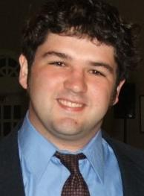
Brooks Whiteford
Technology Department
Calvert Hall College High School
Brooks Whiteford, a recent college graduate, has worked in many different areas of technology. Before receiving his degree in Computer Science in 2008 from St. Mary's College of Maryland, Brooks lead an effort to revive the college's radio station, resulting in a flourishing program with strong student involvement. The facility was renamed after Brooks shortly before his departure.
Brooks now works for the Technology Department at Calvert Hall College High School, where he graduated from in 2004. There, he assists faculty, staff and students with their most challenging technology needs and projects. Brooks also continues to volunteer at Our Lady of Perpetual Help School, where he has worked to help advance learning through the use of technology. Through the implementation of resources such as classroom video projection systems, the school's dynamic webpage, and an advanced e-learning system, OLPH continues to remain on the forefront of development in the field of educational technology.
Brooks is looking forward to continuing his growth in his passion for academic technology, as well as expanding his interests even further.
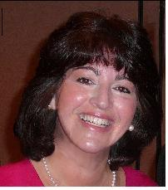
Zulma Whiteford
Director of Academic Technology
Our Lady of Perpetual Help School
Zulma Whiteford has been the Director of Academic Technology for Our Lady of Perpetual Help School in Ellicott City for the past six years. She received her Bachelor’s degree from the College of Notre Dame and her Graduate degree from Goucher College where she is now a member of their adjunct staff.
During her time at OLPH, Mrs. Whiteford has worked closely with staff to successfully integrate the use of technology into the curriculum and daily classroom activity, the theme for the school’s latest Middle States Re-Accreditation project. She has placed strong emphasis on the importance of cyber ethics and security both in and out of the classroom. Not only are the students taught the importance early on, but faculty and parents are educated as well.
Mrs. Whiteford is also a member of the MICCA Executive Board and the Elementary School Liaison for the Baltimore Archdiocese Catholic High School Technology Committee.

Lessons Learned:

Attendees appreciated the tables to take notes, and internet access. However, a few complained that there were not enough outlets. The additions of “hands-on” and/or how to sessions was well received. Many noted they would like to see an extension of this scheduled for next year. More vendors and vendor tables and poster displays need to be added for next year and time allocated for particpants to view.

2008 C3 Summary Evaluations from the Attendees

Evaluation and Feedback
1 - 5 scale, with 1 being strongly disagree, 5 being strongly agree, 6 NA | Average
General Questions
Overall, how satisfied were you with your conference experience? | 4.82
How satisfied were you with the overall logistics of the conference? | 4.53
In general, how pleased were you with the online registration process? | 4.80
I learned new information in this conference. | 4.89
I will use the information that I learned in this conference in my current position. | 4.80
I would recommend this conference to others | 4.87
Considering what I learned in the conference sessions, the cost was reasonable. | 5.00
AVERAGE | 4.82
How satisfied were you with…
Food | 4.85
Wireless computer access | 4.34
Materials and Resources | 4.76
Online session evaluation | 4.55
Attended this conference last year | 3.57
C3 e-mail notices | 4.67
C3 Institute web site | 4.56
Online event calendar listing | 3.54
AVERAGE | 4.35
Workshops
What Do Academic Integrity/Honor Codes and Strong Acceptable Use Policies Have to Offer?  Brian Schiffer, Rick Kirschner, Amy Ginther, & Diane Harvey | 4.04
Practical Ethics Activities for the Classroom  Zulma Whiteford, Victor Hall & Laura Brown | 4.78
Streamlining C3 Content  Mala Bawer, CyberSmart! & Katie Donovan, Netsmartz | 4.75
AVERAGE | 4.52
Speaker's Presentations
Elizabeth Lodal, Morning keynote | 2.99
FACEBOOK Panel: Javaune Adams-Gaston, Gerry Sneeringer, & Matt Supple | 4.89
Jane Scott Norris: Safety & Security Keynote | 2.89
Luncheon Keynote Speaker, Michael Kaiser, Executive Director National Cyber Security Alliance | 3.45
Vendor and Poster Sessions | 4.25
Research Panel: Amanda Lenhart, Peter Grunwald & Ashley Mouberry Sieman | 4.87
Hands on Security Laptop session: Brooks Whiteford | 4.89
AVERAGE | 4.032

What topics would you like to hear more about in the future?
- Legal aspects. What can we do? What can we tell parents and students?
- What ever is current. I am sure more things will happen before next year that we should know about.
- How can we get administration involved and supporting.
- Examples of how schools have integrated content into there schools or classes.
- I would love to hear more about policies that have been developed—many came this year to learn about what to include—perhaps even a hands on with this
What workshop topics/information would you be interested in??
- tools and tricks to share with parents AND students
- More about what we are legally able to do and how to best handle.
- Resources and examples of projects we can do in class
- Curriculum options of updated materials. I know several things will be new by this time next year. And I think there are several interactive and free materials I would love to see these as vendors or presenters
- How to promote or advocate for making good choices

Please indicate in the space provided comments and/or suggestions on how we can improve our conference?
- More hands on activities and small group discussion. I learned a lot when the audience was sharing.
- A much needed event, Thank you!!
- More interactive hands on if possible—possible break out sessions.

