Information Assurance -

Information Security -Digital Forensics

Career Preparation and Opportunity Workshop

For Guidance Counselors

Thursday, September 27, 2007
8:00 am – 3:00 pm

Summary Evaluation

Columbia Gateway Park
6740 Alexander Bell Drive


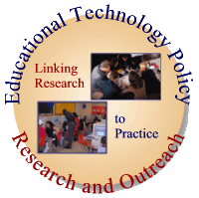


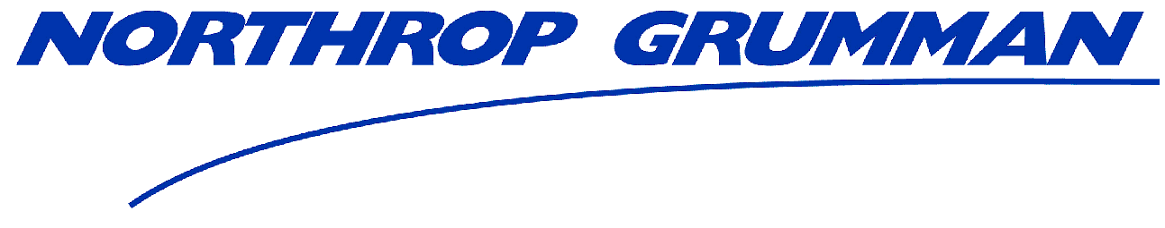



Organized by: Educational Technology Policy, Research, and Outreach
www.edtechpolicy.org

Questions | Average Evaluation  (0-strongly disagree, 4 – strongly agree)
The workshop’s objectives/goals were clear | 3.9
The 1 day length of the workshop was sufficient time to cover the subject matter | 3.4
Overall, the workshop speakers were effective | 3.9
The workshop materials are useful | 3.9
I learned new information in this workshop | 3.9
I will use the information that I learned in this workshop in my current position | 3.9
I would recommend this workshop to others | 3.9
Considering what I learned in the workshop, the cost was reasonable. | 4.0
Lynn McNulty “Information Security: A Growth Career” was relevant and useful | 3.9
Dr. Ralph K. Coppola, Director of Worldwide Education, PTC was relevant and useful | 3.9
The Panel discussion was relevant and useful | 3.9
the Working Lunch/Speaker Carroll McGillin, Cisco Academy was relevant and useful | 3.9
Robert Smolek Maryland State Police Computer Crimes Unit’s afternoon session Computer Crime and Digital Forensics, was relevant and useful | 3.9
Clearance Processes and Requirements presented by Bruce George, AACC was relevant and useful | 3.9

Comments:
- FABULOUS! Thank you for this invitation
- Outstanding information. I enjoyed the workshop. Speakers were energetic and enjoyable.
- Great! Please send presentation and videos
- This was terrific. I never knew this - was all new to us. It is fascinating. Kids should be told of these careers
- I enjoyed the day!
- Excellent job! Would it be possible to run the C3 conference in the spring, or parts in the spring? Counselors are limited to the amount of time they can leave school and 2 weeks in a row is hard [regarding the workshop held Sept 27th and the C3 conference scheduled the following week Oct 4 & 5th]
- Smaller group discussion may be helpful although enjoyed- some topics redundant - good idea to brainstorm with other counties and share - equality of attendance
- Would like copy of Coppola presentation and Cisco video and presentations
- Great workshop. Lots of great materials-a folder or bag to carry materials would have been great! But not complaining
- Oh my yes I learned a lot of new information! Opening (Lynn) was a good opener because he provided background that I didn't know and brought it down for me/us. Would like to have more specifics - step by step on how we can help get the PTC effort moving forward here in MD. Cisco was great choice at lunch time really like the engineering videos and plan to utilize. Smolek would be a great HS guest speaker. Clearance was a great end the presenters was light and entertaining and made me feel more comfortable about clearances. I realize there's never a "good time" for a counselor meeting, but think about moving this to the 2-3 week in June. That's a slower time for us. I will send this information to my HS teachers to review today's info: pre-engineering; programming; computer maintenance; LAN class; CAD class. Having someone do a background in public school teaching--(Davina) helped to keep the topics relevant to us counselors. I'm afraid I did not understand some of the topics or acronyms. A list might help. Specific examples of abstract topics would improve (a reference sheet in a program). Perhaps a S-L-O-W intro to certification titles. I loved how presenters gave us/we some specific "take aways", things, i.e., "advice to students", JHU accepts transfer from community colleges etc.
- More time great! Great topics loved it
- Video or audio recording (of event) to share the dialogue w/ co-workers
- Suggestions from presenters on how to directly motivate students in this direction would be an extra. Great assembly of professionals! Extremely helpful for my job!
- The panel added depth to what specifically these jobs are about. Having representative from large and small companies helped me understand - having women representatives was wonderful.
- GREAT DAY! Well orchestrated
- Could be improved by expanding (or doing additional career focus like this) to HS students. Wonderful conference. I would recommend my colleagues to attend without hesitation
- The environment was warm and the company was great, longer breaks would help but I didn't want to leave - cold in room only complaint this was a great workshop very informative
- Great workshop--rooms a little cold please provide CD or materials as well as video (CISCO)
- Entire workshop was very useful, relevant and helpful. I appreciate the opportunity to attend
- Could cut down on introduction length since bio provided the diversity and huge depth of experience of speakers was impressive very well designed!! Great location and food - thank you.
- Perhaps end at 2:30 but the working lunch helped - very informative. A list of the speakers (or others) and check off of if they could speak and on what topic would be helpful. Having a snapshot of each persons PPT was helpful but please provide the real thing.
- Excellent conference. Could build in time for small group reflection - each speaker in a small group time then to take strategies back to schools, teachers, students and parents I am in AWE at the caliber of presenters at this workshop today. I would love to have copies of the PPT or place to find them or DVD. My goal would be to effectively share what I have learned today. My colleagues in Montgomery and Baltimore City would appreciate this too....maybe they were invited? They missed out you need to repeat or share across the state
- I really like to take notes and appreciated speakers PPT copies Every speaker and every topic was exceptional and appropriate. I would include the tech ed departments resource teachers. Thank you for providing this workshop what wonderful speakers! Interesting! and informative
- Excellent workshop!
- More time for the panel discussion but I have a clearer idea of what they do and programs great job for organizing this EXCELLENT!!!
- All was wonderful this was great!!!

