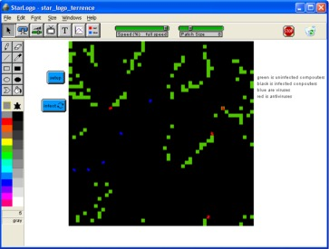
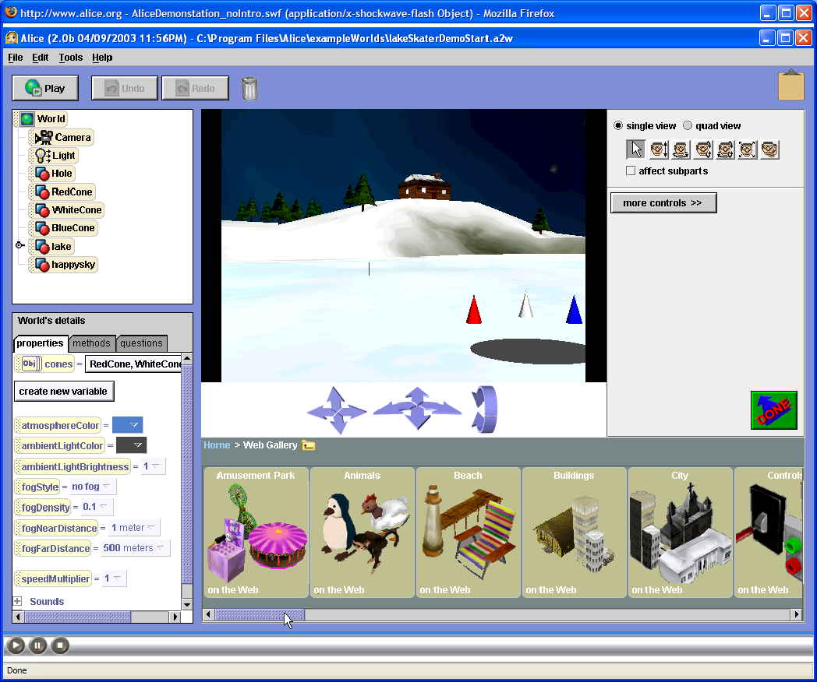
ATTENTION: All 4th and 5th Graders
After School STEM Mindtools Program

When: Mondays- 10/6, 10/13, 10/20, 10/27,  11/10, 11/17, 12/1, 12/8 | Time: 3:30-5:00 PM  12/8 will include the student showcase starts 4:45 PM

Where: DOES Media Center

Note: This program is limited to ~25 students on a

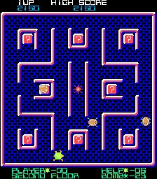
first come first serve basis. Previous and new attendees welcome. Activities will be modified to accommodate both groups
Students will engage in hands-on STEM activities and learn about digital literacy (technology fluency and applications, team building, collaboration tools, problem based critical thinking), tied to DOES math and science curriculum while learning and applying basic ethical, safety and security concepts through gaming, modeling and simulation development, all while investigating exciting careers that interconnect the fields of science, technology, engineering and math.
- Explore various modeling and simulation software packages (MicroWorlds, Building games in Excel, Scratch, and RoboLab)
- Create an Animated Story & Interactive Game/Maze with MicroWorlds and Scratch
- Develop Interactive Educational Mini Simulations/Games with Excel
- Design, build and program a cybernetic device with ROBOLAB
Based on the successful Young Scholars Program curriculum developed through a
National Science Foundation Research grant, the STEM Mindtools Program:
- Promotes careers in Science, Math, and Engineering that utilize Technology
- Correlates with the school’s on-going Science and Math curriculum
- Promotes fun and age appropriate activities
- Promotes digital literacy supporting the newly approved Maryland Student Technology Standards



For More Information:
Davina Pruitt-Mentle, Ph.D.
NSF CyberWATCH K-12/PI
410 531-3910
dpruitt@umd.edu

Please make checks out to ETPRO and mail registration forms by October 1st, 2008 to
Davina Pruitt-Mentle: 5333 Broadwater Lane, Clarksville, MD 21029.

Student’s Name: |  |  |  |  | Birthday:
Grade/Homeroom Teacher: |  |  |  |  | Allergies/medical conditions:
Parent/Guardian: |  |  | Phone 1: |  |  | Phone 2:
Address: |  |  |  | City: |  |  | Zipcode:
Email: | After class my child will:  be picked up go to aftercare in bldg
I waive any right to claim against ETPRO, staff and teachers, my child’s school or school district in the event of an accident, injury or loss of personal items. I understand I am committing to participation in Mindtools and reserving a place in class for the designated session. ETPRO does not offer refunds for tuition paid once a session has begun. Parent’s signature _____________________________________.
PLEASE SEND A NOTE FOR YOUR CHILD’S CLASSROOM TEACHER ON THE FIRST DAY OF SESSION. Please pick up from the designated room.

