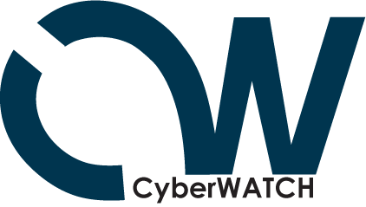

CyberWATCH 2006/07 Calendar

- March 24–26, 2006 - Collegiate CyberDefense Competition

- April 3, 2006, 10 a.m. - Consortium Meeting at Northern Virginia Community College

- April 21, 2006 – Cool Careers in CyberSecurity for Girls – University of Maryland, College Park

- April 25, 2006 – Business Forum at Metropolitan Washington Council of Governments, Washington, DC

- May 22, 2006 – Faculty training, beginning level at Northern Virginia Community College, Alexandria campus (tentative date)

- May 24-26, 2006 – National Visiting Committee (tentative dates)
May 24 or 25, 2006 – dinner for NVC and CyberWATCH Advisory Board members

- July 9-28, 2006 – Students, Learning, and Technology: Young Scholars Program – University of Maryland, College Park

- September 28, 2006, 8:30-10 a.m. – Advisory Board Meeting at Montgomery College, Germantown campus
September 28, 2006, 10 a.m. – Virtual Lab Kickoff at Montgomery College, Germantown campus

- September 2006 – Faculty training, interim level (date and time to be determined)

- October 2006 – Cyberethics, Cybersafety, and Cybersecurity Conference – University of Maryland, College Park

- October 2006 – Case studies faculty development (date and time to be determined)

- November 9, 2006, 1–3 p.m. – Northern Virginia Community College Security Laboratory Opening

- January 2007 – Case studies three-day workshop (dates to be determined)

(Advisory Board members are expected to attend the events listed in blue)

