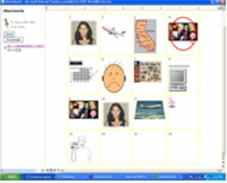
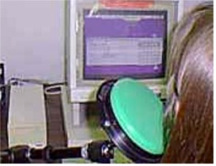
Assistive Technology and Universal Design for the General Classroom Teacher

EDUC 477/698O

Delivered Predominately Online: WebCT

This course is designed to be an introductory survey course for educators in the application of assistive technology and Universal Design in the general classroom setting. Students will be introduced to various assistive technologies and strategies.

This course will help amplify a teacher's skills in these areas by adding
the additional knowledge of AT devices, Universal Design, curriculum
adaptation and integration strategies, and assessment and evaluation
protocols to aid ALL students in the general classroom setting.

Previous Student Comments

The resources/readings were easy to read and understand, and they made me aware of all the possibilities that AT devices had to offer. As an ESL teacher I benefited a lot from this course because I learned about Universal Design principles which can be used to help students from diverse backgrounds and different learning skills function with greater independence. I also learned that assistive technology is not necessarily expensive. There are so many low tech or no-tech solutions that can be used to improve the quality of the lives of the people with disabilities.
The online/hybrid course was well designed. Assignments were meaningful and helped me to address multiple Maryland Teacher Technology Standards and ISTE/NETS standards.
Overall, the Assistive Technology in the General Classroom course was an exemplary learning experience for me. I can only hope that my classmates and the instructor have learned as much from me as I have learned from them.
For more about the course: syllabus, standards met, past products, course outline visit:
http://www.edtechoutreach.umd.edu/CourseInfo/educ477.html

