Follow the Drinking Gourd 

Jill Hansen Sharon Filadelfia

Instructional Objective
FOLLOW THE DRINKING GOURD brings the experience of escaping slavery via the Underground Railroad to life. Game content and scenarios are based on historical facts and true life narratives. After playing this game, students will be able to · name and discuss key people who took part in the struggle against slavery
· locate important places on the Underground railroad
· define code words and phrases used on the Underground Railroad
· perform code gestures used on the Underground Railroad.
This game fulfills portions of the Eighth grade California state content standards for United States History and Geography: Growth and Conflict. Individual standards that this game addresses are:
8.6.4. Study the lives of black Americans who gained freedom in the North and founded schools and churches to advance their rights and communities.
8.7.2. Trace the origins and development of slavery; its effects on black Americans and on the region's political, social, religious, economic, and cultural development; and identify the strategies that were tried to both overturn and preserve it
8.7.4. Compare the lives of and opportunities for free blacks in the North with those of free blacks in the South.
8.9.1. Describe the leaders of the movement (e.g., John Quincy Adams and his proposed constitutional amendment, John Brown and the armed resistance, Harriet Tubman and the Underground Railroad, Benjamin Franklin, Theodore Weld, William Lloyd Garrison, Frederick Douglass).
8.9.6. Describe the lives of free blacks and the laws that limited their freedom and economic opportunities.

Learners/Context
This game is best suited for eighth grade students (age 12 and up) studying American history. It is designed for use in conjunction with lesson plans that cover African-American History around the time of the American Civil War.

Object of the Game
Be the first player to arrive in Toronto, Canada (square 128) with $50.00

Game Materials
Game board
Decision sheets
Game instructions
Question cards (60)
Event cards (20)
4 game pieces
Game money - $400.00 in denominations of $10.00, $20.00, $50.00.
1 die
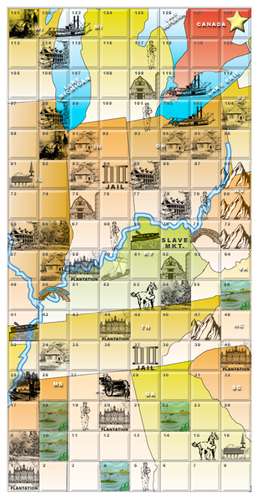
Game Board
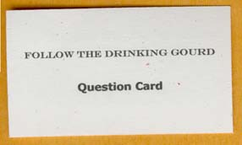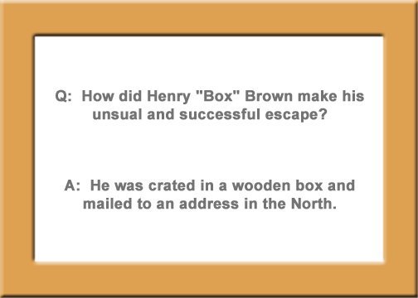
Sample Question Card
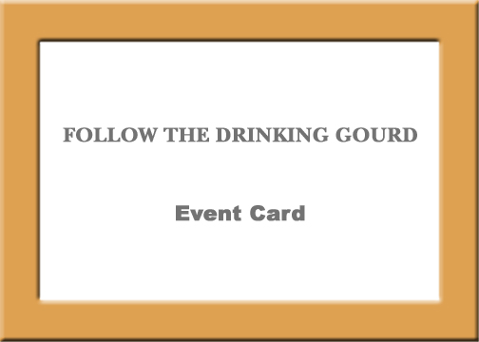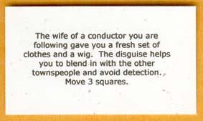
Sample Event Card

Logistics
Follow the Drinking Gourd is designed for 2 - 4 players plus one game director (preferably, the game director will be the instructor or a student who has already played the game). Playing time is 30 - 45 minutes.

How to Play
Each game piece represents a slave in the United States trying to escape to Toronto, Canada via the Underground Railroad during the time period 1830 - 1860. The game board is a map of the states and routes traveled by up to 100,000 actual escaped slaves. The game starts in square 1, which corresponds to a plantation near Jackson, Mississippi. The game ends when a player reaches Toronto, Canada, (square 128) with $50.00
Players start out with $70.00. They may need to spent money, but will also have the opportunity to get money along the way. They must have $50.00 when they reach square 128 in order to complete the game. If a player does not have enough money, he or she must travel to as many safe houses, landmarks, or event card spaces as necessary, in order to collect the full amount needed to cross into square 128, Toronto.
A player takes their turn by moving one square. The player can move in any direction, up, down left or right. No diagonal moves are allowed. Once the player makes a move to the square of their choice, the game director reads the corresponding directions for this square from the Direction Sheet. Each square on the board is reference by number to this sheet and specific outcomes and directions are tied to each square. The player must follow the directions for the square they have chosen. Sometimes players will need to make a decision, and sometimes they will roll the die to determine what happens next. The game director will read the players' fates as appropriate. After a player has fulfilled the directions for their square their play ends.
Players must choose their moves carefully, as there are perils as well as safe houses along the way as they "ride" the Underground Railroad. Landmarks and safe houses are tied to specific outcomes. Empty spaces will direct them to draw a question card, event card, or simply rest.
Alternate Versions
This game can be modified in the following ways:
- Different versions of Direction Sheets can be created to add variety and challenge to the game. This change is valuable if the game will be played more than one time by the same players.
- Players moves can be decided by rolling a die. This version of play should only be used when time is extremely limited, for reasons discussed below.
- The game can be set-up to be played in teams instead of individually.

Set up
Place each player's game piece on square 1 of the game board. Give each player $70.00. The game director should take control of the decision sheet. Place the die on the board. Arrange the event cards and question cards near the board in two neat stacks.

The Rules
1. Play always starts by moving the game piece into a new square.
2. A player's turn ends once they fulfill the directions for the square they chose.
3. Players may move one square per turn unless directed otherwise.
4. Players may move up, down, or sideways, but not diagonally.
5. Players may not cross a body of water without a bridge, boat, or ferry unless they are directed otherwise.
6. Once a safe house or station has been used, players must wait one turn to use it again. Players may land in the square, but they cannot go into the safe house.
7. Players must have $50.00 to cross into Toronto, Canada (square 128).

Design Process
After settling upon the Underground Railroad as our game topic, we identified our target audience as middle school students studying the Civil War. In the state of California this unit occurs in the eighth grade. We obtained the California State content standards so as to match the instructional objectives of the game to content teachers would be required to present.
The next step was to design the game board. We decided that it would be a depiction of the middle to eastern United States. In our first prototype, the board contained five pathways of spaces winding through the states to represent historical escape routes. Our second prototype was a graph superimposed on the depiction of the states, effectively making the entire board into game spaces. With this design, players need to make decisions based on what they know about the Underground Railroad. This format allowed us to match the content more closely to the object of the game. The graph contained features and landmarks, like safe houses, caves, bridges, and boat docks. As we researched the Underground Railroad, we found that enough information existed to include real landmarks and features in game spaces, and that we could even provide rough geographic accuracy.
We also realized that we would need to design a "decision sheet" that would tell a player the outcome for landing in each particular square. Because the "decision sheet" contains the events and possible results of each path, it is preferable that a non-game playing participant read the decision sheet to the other players. The name for this non-playing participant is the "conductor" of the game.
Our initial design called for the player to roll a die to determine how many spaces they should move across the board. We decided that this was not optimal, because it could make the game finish too quickly, and also it would eliminate the thought and knowledge process that an actual fugitive slave would have gone through when determining which route was safest. Instead, we chose a single move per turn (like checkers) type of game.
Because this is an educational game which teaches content, we devised question cards about the Underground Railroad. A correct answer is rewarded by the player being allowed to move an extra space.
We incorporated fate by using the roll of a die to determine which of several outcomes the player would encounter at the landmark and safe house squares. For example, if a player decided to move to a swamp square, he or she must roll the die. If a number 1 - 3, is rolled, the player is chased by dogs and captured, and must return to the plantation and lose a turn. If a number 4 - 6 is rolled, the player wades into the water and the dogs would lose his scent, so he is able to rest for the evening and continue moving on his next turn.
We also decided to incorporate event cards. The event cards also add an element of chance. They are tied to condition only, and not location. There are good and bad events. Examples are losing a turn because of bad weather or being given money by the Vigilance Committee.
During the final design session we played the game and planned further refinements such as re-wording the instruction sheet to make it more clear, adding more landmarks, and correcting typographical errors.

References
Books
Blockson, C. L. (1987). The Underground Railroad: Dramatic First Hand Accounts of Daring Escapes to Freedom. New York: Berkeley Publishing Group.
Blockson, C. L. (1994). Hippocrene Guide to the Underground Railroad. New York. : Hippocrene Books.
Still, W. (1871). The Underground Railroad. Chicago: Johnson Publishing Company.
Tobin, J. L. & Dobard, R. G. (1999). Hidden in Plain View, A Secret Story of Quilts and the Underground Railroad. New York: Doubleday.
Electronic
Education World. http://www.education-world.com/a_sites/sites004.shtml
National Park Service. http://www.cr.nps.gov/delta/underground/free.htm
National Geographic. http://www.nationalgeographic.com/features/99/railroad/
PBS Online. http://www.pbs.org/wgbh/aia/home.html
UC Davis. http://education.ucdavis.edu/NEW/STC/lesson/socstud/railroad/contents.htm

