
Balance Your Plate
by
Gina Chestnutt
Mark Simpson
Cynthia Vansant

Instructional Objective
The learners will be able to identify the six foods groups and select the correct number of food portions to meet a balanced daily diet.

Learners
The game is designed for learners, ages 10 to adult, who are interested in making nutritional choices about their balanced daily diet.

Object of Game
Fill your plate with the prescribed number of food portions while in the outer ring. Lose your extra portions on the inner hub and land in the middle first.

Game Materials
- Game board
- 6 playing tokens, each a different color
- A six sided die
- 1 stack of Cravings cards
- 1 stack of Profile cards
- 6 sets of food group cards ( 20-30 cards each set. The stack names: Bread, Vegetable, Fruit, Milk, Meat, Fats)
- Full plate cards

Time Required
The game is for 2 to 6 players and will play for approximately 45 minutes to an hour.

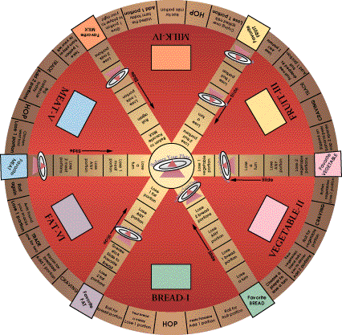
The Set-up
Put board together and place craving cards and food cards on the appropriate spaces.

Getting Started and the Rules
1. Profile cards. Each player randomly picks a profile card from the face-down shuffled deck. The Full Plate portions are determined by the profile card selected.
2. Roll the die to see who goes first. Lowest roll goes first. Pick your starting piece.
3. Roll in order for starting positions. Use the list below to place your piece on the starting Favorite Food square.
Roll=Starting favorite food square
- Roll 1 = Bread
- Roll 2 = Vegetable
- Roll 3 = Fruit
- Roll 4 = Milk
- Roll 5 = meat
- Roll 6 = Fats
4. Each player gets two rolls of the die to start. The first roll is to receive your first Favorite Food portion(s) (for being on a Favorite Food square). The second roll is to move.
5. To move. The die is rolled and the player may move clockwise or counter clockwise. Remain in the outer circle until you have enough portions for a Full Plate card. You have secured your prescribed portions at this point.
If you land on a Lose and you don't have any portions, you can't lose them. You cannot go into debt with portions.
Landing on:
- Hop- Allows you to choose your Favorite Food square. Then roll for portions.
- Trade- You may trade one portion for another. Trades are optional.
- Craving- Select a Craving Card from the shuffled deck. You are entitled to the listed food portion(s) if you answer the food card question(s) correctly.
- Favorite foods- Each time you land on a Favorite Food space, roll the die. You are then entitled to the corresponding portions of that food group. To receive the card(s), you must answer the question on the food card correctly. These spaces are also used to lose portions with a die roll once your plate is full. If you don't want to gain or lose any of those Favorite Food portions, you may opt to slide to the opposite Favorite Food square across the board.
• Portion spaces- On these spaces, you lose or gain portion(s). Once again, to add portions, you must answer the question on the food card correctly.
6. Losing extra portions. You may have leftover portions once you fill your plate. Move to the inner hub and continue to land on the needed spaces to lose extra portions.
7. Once you are left with a Full Plate only, your last task is to move to the center space with an exact roll. The first player to the center wins.

Design Process
One of our first design decisions was to decide on the movement path of the game pieces. Even though the game moves in a linear path toward an end point, we wanted to minimize the predictability by providing some options for non-linear movement. We brainstormed on either providing a sinous path with decision forks, or a circular path with several options to hop or change direction. We opted for the latter because the players need to revisit sections often in order to accumulate enough of the food group portions.
To make the fat food group portions a type of obstacle, we provided ways to unintentially accumulate them by landing on a space, being caught in a trade, or by picking a craving card. We also decided to provide 12 profile cards with different food group requirements. This forces the players to make choices on accepting or rejecting food groups. A 105 lbs. artist would need less bread portions than a 200 lb. football coach, but the coach could keep more fat portions. The players have to focus on what portions they need to gain and lose, which reinforces their learning of relative values of food groups in a balanced diet.
Playing the game a few times helped us work out the bugs. It identified the need to provide more opportunities for the players to accumulate food portions. We added more accumulation spots on the board, and made the favorite food spots a place to roll for addtional portions. We also found that the inner hub need more spots to unload portions and changed the board spaces accordingly.

References
Hamet, Roth (1993). Complete Guide to Fats, Calories, and Cholesterol. New York, NY: Penguin Books, USA

