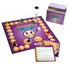
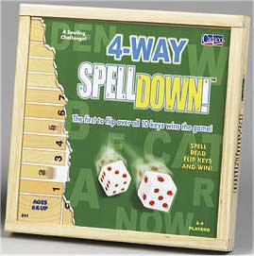
Spring 2005

Mindtools for Investigation and Education

EDUC 475/698A

Thursdays 4:15 – 7:00 PM, Location: Benjamin Computer Lab

Explore educational games, simulations and computer modeling platforms common to many domains from a variety of fields. Focus on design and research issues relevant to learning through simulations and games.

- Develop an Educational Board Game: Group Project
- Create an Animated Story & Interactive Game/Maze with MicroWorlds
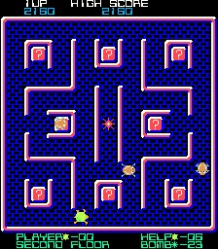
- Design Evaluation Criteria for Academic Simulations Through Wiki & Blogger Contributions
- Explore and Analyze the Variety of Educational Game/Quiz/Activities Makers Available on the Web
- Develop an Interactive Educational Mini Simulations with Excel
- e-Game Analysis
- Develop an e-Game Project: Group Project Design

For more about the course: syllabus, standards met, past products, course outline visit: http://www.edtechoutreach.umd.edu/CourseInfo/educ475Mind.html
