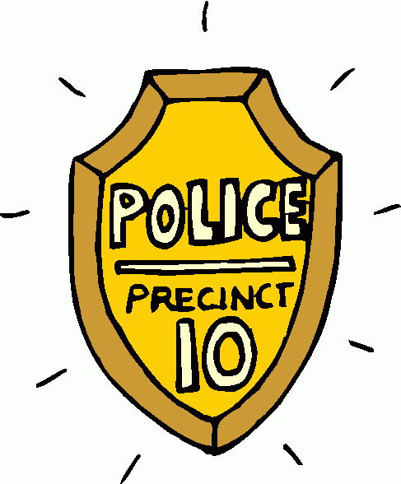Thanks for your help! Here is the information that we really need to help us catch any offenders. We were able to locate some websites that we thought would help!

Please make sure to write the answers in your own words. We can’t risk being put on probation for breaking copyright laws!

Officers on case:_____________________ Date:_______________

question | website locations | answer
What is cyber bullying? | http://www.internetsuperheroes.org/cyberbullying/index.html  http://www.netbullies.com/pages/1/index.htm | ____________________________________________________________________________________________________________________________________________________________
What are 3 forms cyber bullies might take? | http://www.dfes.gov.uk/bullying/cyberbullying_whatis.shtml  http://www.cyberbullying.ca/ | _____________________________________________________________________________________________________________________
What are the 4 types of online bullies? | http://www.netbullies.com/pages/2/index.htm | ____________________________________________________________________________________________________________________________________________________________
What can be done to prevent cyber bullying? | http://www.dfes.gov.uk/bullying/pupilindex.shtml  http://www.internetsuperheroes.org/cyberbullying/youth/kids_perspective_text.html | __________________________________________________________________________________________________________________________________________________________________________________________________

