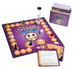
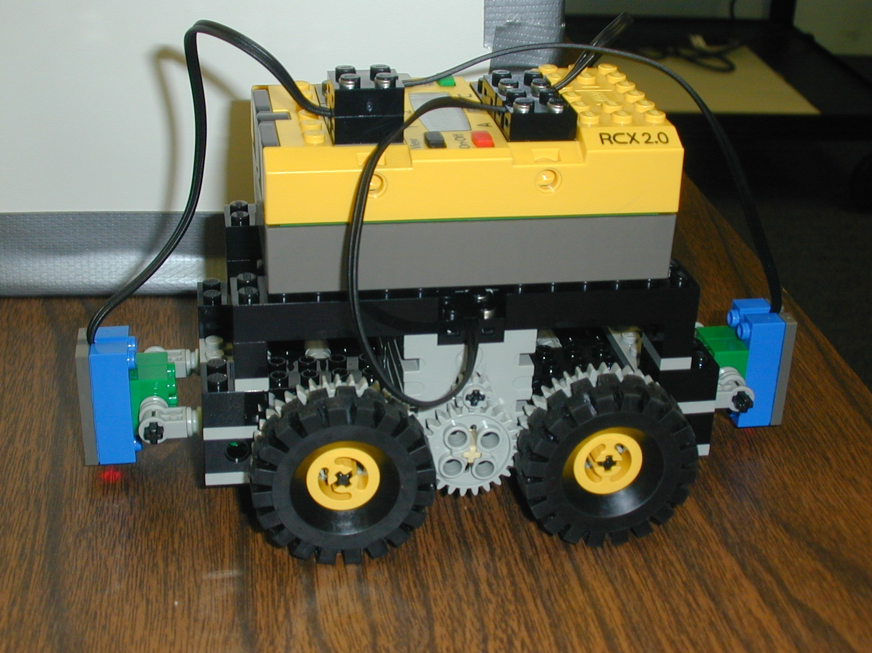
Summer 2005

July 10-29, 2005

EDUC 275

Students, Learning, and Technology:

Mindtools for Investigation and Education

Three Week Residential Program --- Three Undergraduate Credits
Rising Juniors and Seniors
___________________________________________________________________

Explore and expand knowledge of essential 21st century skills (technology fluency and applications, team building, collaboration tools, problem based critical thinking), through gaming, modeling and simulation development, while investigating exciting careers that interconnect the fields of education and technology.

- Explore various modeling and simulation software packages (MicroWorlds, RoboLab, ICONS, Squeak, StarLogo)
- Create an Animated Story & Interactive Game/Maze with MicroWorlds
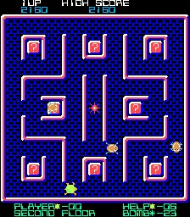
- Design Evaluation Criteria for Academic Simulations Through Wiki & Blogger Contributions
- Develop a Group Simulation with ICONS
- Develop an Interactive Educational Mini Simulations with Excel
- Participate in Robo Challenges
- Develop your own Robo-Ed-U-Tech Invention

For more about the course: syllabus, standards met, past products, course outline visit: http://www.edtechoutreach.umd.edu/CourseInfo/educ275.html
Fields Trips:
- NIST
- NSA Cryptologic Museum
- National Center for Missing and Exploited Children
- Spy Museum
- Anthrotronix
- Wind Tunnel
- Neutral Buoyancy Lab
For More Information:
http://www.summer.umd.edu/
http://www.edtechoutreach.umd.edu/
Davina Pruitt-Mentle
301-405-8202
dp151@umail.umd.edu

