Data Analysis and Interpretation Paper
Data Analysis and Interpretation with Technology Module: EDHD 435
Part 1

Fall 2004
Nina Pattakos
November 1, 2004

Background Information

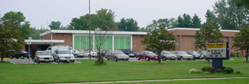
Figure 1. Weller Road Elementary School, MCPS 2004

Introduction

Weller Road Elementary School, school # 777, is located in Montgomery County Maryland at 3301 Weller Road, Silver Spring, MD 20906. Weller Road Elementary School is an older school, constructed in 1953 and renovated in 1975. This school contains various school programs such as Title I, Head Start, Extended Early Education Program (EEEP), Full-Day Kindergarten, and First through Fifth grade. The mission statement for Weller Road Elementary School states they are a family working hand-in-hand towards excellence. The school represents a multicultural population of students. Many of the students live within walking distance to the school and do walk to school; however, because of heavy traffic in the area, some students also ride the bus. I was unable to locate through the MCPS website any information regarding community use of Weller Road Elementary School for any extracurricular activities. They do, however, offer after school clubs to all students of Weller Road Elementary. More information about the school can be accessed from the school’s website: http://www.mcps.k12.md.us/ .

Demographics
Detailed demographic information for the Wheaton-Glenmont district, as shown in Figure 2, covers a 12 mile area of which Weller Road Elementary, is included.
Figure 2: 2004 Map of Wheaton-Glenmont Area in Montgomery County, Maryland
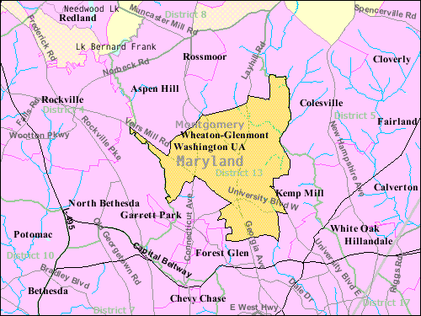
Source: 2000 U.S. Census Report
The area holds a total population of 57,694 people living in this area of which 14,956 are Hispanic. More specific detailed demographic information for Weller Road Elementary School can be accessed through the MCPS website. The opening enrollment in 2003-2004 was 614 students, 13% were African American, 11.1% Asian, 12% white, and 63% Hispanic. These statistics show the Hispanic enrollment to be the largest ethnic group in attendance. Although the Limited English Proficiency (LEP) population was only 17.3% at Weller Road, and similar percentages are approximated for the 2004-05 academic year. I attended Back to School Night which proved to need a Spanish speaking translator during the entire meeting for over half of the parents. There are currently three LEP teachers at Weller Road Elementary. Weller Road Elementary is a Title I school. Sixty two percent (61.6 %) of its students are on free or reduced lunch programs. Title I schools offer extra resources such as Para educators and translators.

Staffing
Weller Road Elementary student to staff ratio is 14:2. The staff consists of 46 teachers, 27.5 classroom teachers, 6 kindergarten teachers, 1 staff development, 3 ESOL teachers, 1 Reading, 1.4 Physical Education, 1.4 Art, 1.4 Music, .2 Preschool, 1.5 Special Education/Resource, 1 counselor, 1 media specialist and 1 assistant, and 8.063 instructional assistants. Weller Road teacher certification has increased in 2004 from 2003. There are 3 professional certificates available in Maryland: standard, advanced, and conditional. 66.7% teachers in 2004 held a Standard Professional Certificate, 30.6 % teachers held an Advanced Professional Certificates, and 2.8% has a Conditional Certificate.
According to the Maryland Report Card, a Standard Professional Certificate certifies that the teacher teaches a core academic subject (reading, mathematics, writing), requires three years of satisfactory, professional school-related experience plus six hours of acceptable credit and has a professional development plan to work towards an Advanced Professional Certificate. The Advanced Professional Certificate requires verification of three years of full-time professional school-related experience, six semester hours of acceptable credit; and a master’s degree, or a minimum of 36 semester hours of post baccalaureate course work which must include at least 21 hours of graduate credit. The remaining 15 semester hours may include graduate or undergraduate course work and/or Maryland State Department of Education Continuing Professional Development (CPD) credits, or obtained National Board Certification and earned a minimum of 12 semester hours of approved graduate course work earned after the conferral of the bachelor degree. The Conditional Certificate is issued only at the request of a local school system superintendent to an applicant employed in a local school system who does not meet all certification requirements. This certificate allows teachers to teach subjects such as English, Reading or Language Arts, Mathematics, Science, Foreign Languages, Civic and Government, Economics, Arts, History and Geography.
Technology
As shown in Figure 3, Weller Road Elementary has a student to computer ratio of 3.8:1. The 2004 Maryland Technology Inventory Report, results for Weller Road Elementary surpasses both the target and average ratios for both Montgomery County Public Schools and the state of Maryland. According to Weller’s 2004 computer count, there were 123 PC’s in the classrooms, 11 in the media center, and 30 in the computer lab. Each classroom had 100% access to the Internet. The teacher knowledge and skills show that Weller Road teachers are 20% below the Maryland Target in computer and internet use. These statistics suggest that Weller Road needs more technology training, as they have access to computers but are not utilizing resources to the full potential.

Figure 3: 2004 Technology Inventory: Student to Computer Ratio at Weller Road Elementary
Source: 2004 Maryland Technology Inventory Report

AYP Results and Other Assessments
Average Daily Attendance
The attendance rate reflects the percentage of students present in school for at least half the average school day during the school year. Weller Road Elementary School has shown a consistently high rate of attendance for grades 1-5, averaging 96% over the last five years. In 2004, the overall student attendance rate was 96.1%. The majority of students (43.7%) who were absent missed less than 2.6 days total for the year.

Reading and Math
According to the 2004 Maryland Report Card, the No Child Left Behind Act requires all states, to assess student achievement. Maryland uses the Maryland School Assessment (MSA) to measure student achievement in K-8 reading and mathematics and grade 10 reading. The MSA information is reported for grades 3 through 8 and for grade 10 in reading. The Maryland School Assessment is reported with three statewide performance standards: Basic, Proficient, and Advanced.
The information below defines the three levels:
- Advanced is a highly challenging and exemplary level of achievement indicating outstanding accomplishment in meeting the needs of students.
- Proficient is a realistic and rigorous level of achievement indicating proficiency in meeting the needs of students.
- Basic is a level of achievement indicating that more work is needed to attain proficiency in meeting the needs of students.
Student performance is reported in terms of these achievement levels:
Reading:
Basic: Students at this level are unable to adequately read and comprehend grade appropriate literature and informational passages.
Proficient: Students at this level can read grade appropriate text and demonstrate the ability to comprehend literature and informational passages.
Advanced: Students at this level can regularly read above-grade level text and demonstrate the ability to comprehend complex literature and informational passages.
Mathematics:
Basic: Students at this level demonstrate only partial mastery of the skills and concepts defined in the Maryland Mathematics Content Standards.
Proficient: Students at this level demonstrate an understanding of fundamental grade level skills and concepts and can generally solve entry-level problems in mathematics.
Advanced: Students at this level can regularly solve complex problems in mathematics and demonstrate superior ability to reason mathematically.
Data Analysis

Table 1 below shows that Weller Road Elementary met Average Yearly Progress (AYP) in 2004. In order for a school to met AYP, all sub-groups must meet the state determined annual Measurable Objective (AMO).

Table 1: 2004 Reading and Mathematics AYP for Weller Road Elementary by Race/Ethnicity and Special Interest Groups

Source: 2004 Maryland Report Card

Figure 4 provides specific details for reading. While each sub group met the 2004 state set Average Yearly Objective benchmarks, set at 46.3 % in 2004, some may fall short of the 2005 state set AYO benchmark which will be raised to 57.8%. Additionally, the Special Education sub-group only just met the benchmark, while both the African American and LEP sub-groups just passed the benchmark. The large confidence interval for the Special Education sub-group, indicates that there were very few special education students assessed. All three of these sub-groups should be areas of concern for the school to show improvement in the 2004-05 academic year.

Figure 4: 2004 AYP Reading for Weller Road Elementary by Race/Ethnicity and Special Interest Groups

Source: 2004 Maryland Report Card

It is also important to review the trends to see if the school is progressing from year to year. Trend data in Table 2 for Reading indicate that Special Education, African American and Asian sub groups decreased in percent proficiency levels from 2003 to 2004. African Americans went from 61.5% in 2003 to 56.5% in 2004, although the confidence interval (number of students) remained fairly constant. Special education is a critical concern as their percent proficiency decreased from 60% to 45.5%. Although the number of students was so small that AYP was met in 2004, due to the confidence interval formula, the new state target set at 57.8% in 2005, might be difficult for this group to meet.

Table 2: 2004 Reading AYP 2003-2004 Trends for Weller Road Elementary by Race/Ethnicity and Special Interest Groups

Source: 2004 Maryland Report Card

Figure 5 shows the 2004 AYP performance in Mathematics at Weller Road Elementary. Every sub-group, with the exception of Special Education, has surpassed the state set AYO. The Special Education sub-group did not meet the AYO benchmark set by the state in 2004 at 44.1%. This would be an area of improvement for the school instructional plan in the 2004-05 academic year.

Figure 5: 2004 AYP Mathematics for Weller Road Elementary by Race/Ethnicity and Special Interest Groups

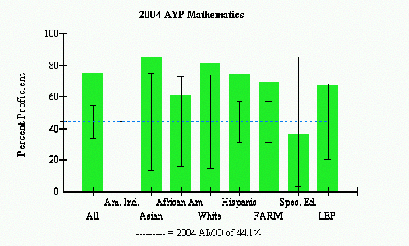
 |  | AYP Met |  |  | AYP Met with Safe Harbor |  |  | AYP Not Met
Source: 2004 Maryland Report Card

Areas of Needed Program Enhancement

The overall performance of Weller Road Elementary in 2004 against state and federal benchmarks are on target. Closer review indicates that yearly performance is generally showing improved performance in both Mathematics and Reading. The school should take careful consideration to augment programs in areas where scores are trending down or projected to miss next year’s state targets such as the African American and Special Education sub-groups.

References:

Maryland State Department of Education (2004), Maryland report card. Retrieved
December 11, 2004 from http://msp.msde.state.md.us/

2004 Maryland Report Card
(Online) at http://msp.msde.state.md.us/

Montgomery County Public Schools
(Online) at http://www.mcps.k12.md.us/

U.S. Census Bureau, American Factfinder
(Online) at http://factfinder.census.gov/servlet

