Data Analysis and Interpretation Paper
Data Analysis and Interpretation with Technology Module: EDHD 435
Part 1

Fall 2004
Megan Taylor
October 31, 2004

Background Information

Introduction

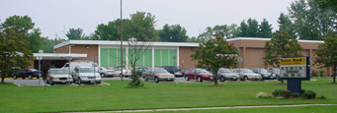
Source: Montgomery County Public Schools

Weller Road Elementary School is located in Silver Spring, Maryland. Its school id number is #1719 and it is located in Local Educational Agency (LEA) # 15. This school is located at 3301 Weller Road, Silver Spring, MD 20906, in Montgomery County. Weller Road was originally opened in 1953. There have been many additions done to the school since that date. A classroom addition was done in 1956 which included the whole kindergarten wing of the building. The Media Center was added in 1966 and the gym was added in 1974. Due to the school capacity many students have classes in trailers outside the school. The school is actually preparing for a much needed new addition in 2005. The current enrollment at Weller Road is 643 students ranging from Pre-K (Head Start) up to 5th grade. This school has a message that all students have heard repeated time and time again, which is “We are a family working hand-in-hand towards excellence.” This school has a strong emphasis on school unity and working towards success as a team.
The school has a strong PTA staff which has clear goals to lead the school towards greater parental involvement. The PTA has slowly increased every year and in continues to grow as more and more parents get involved with their children’s education.
Weller Road has a website that has information about the staff and the PTA staff and information about upcoming events. But, it says little about the school itself and the students that are enrolled. It has many links to help students, teachers, and parents but they are all sites associated with Montgomery County Public Schools (MCPS) and other organizations.
Weller Road Elementary is host to many after school activities and events. There is tutoring every Tuesday and Thursday. There are after school clubs including cheerleading. There have also been special events for parents including back to school night, reading night, and there is a math night that will be happening after the holidays.

Demographics

In the areas surrounding Weller Road Elementary School, which include Wheaton, Glenmont, and Silver Spring, 49.9% of the population is white. 25.9% of the population is Latino, 18.8% of the population is African American, followed by 12.2% being Asian. According to the 2000 U.S. Census, the majority of the population is in the labor force (67.3%). Only 6.4% of families located in this area are below poverty level. The average household size is 2.93. (2000 U.S. Census).
The demographics for the area surrounding Weller Road is very different from the demographics enrolled in the school. The majority of the students enrolled at Weller Road are Hispanic (58%), followed by White (16%), Asian (14%) and African American (12%). More than half the students at Weller Road are eligible for free or reduced meals (58%).
Table 1. Student Economic Level at Weller Road Elementary and Maryland by Ethnicity

 | This School | State Avg.  (grades K-5)

% of students receiving free or reduced-price lunch | 58% | 37%

Ethnicity | This School | State Avg.  (grades K-5)

African American | 12% | 38%
American Indian | 0% | <1%
Asian | 14% | 4%
Hispanic | 58% | 6%
White | 16% | 51%

Source: 2004 Great School, INC

Weller Road is a Title 1 school and the majority of the students come from low socio-economic status (SES) homes and the majority of students are minorities. In the neighborhoods surrounding Weller Road, 39.6% of the population is foreign born and 47.8% speak a language other than English at home. These numbers explain the high percentage of Limited English Proficiency (LEP) students at Weller Road Elementary which is about 17.3% of the population.

Staffing

In Montgomery County, in 2004, out of 754 teachers there were 458 new hires. At Weller Road Elementary in 2004, 30.6% of teachers hold advanced professional certificates. This number has jumped 5% from the previous years number (25.0%). According to the qualifications under the No Child Left Behind Act (NCLB) 11.3% of classes are taught by teachers who are not “highly qualified.”
In 2004, the staff at Weller Road were made up of 4 people in administration, 34 classroom teachers, 2 art specialists, 3 music specialists, 2 physical education specialists, 2 media specialists, 5 ESOL teachers, 8 para-educators, 4 maintenance people, 3 cafeteria workers, a health technician, and a school nurse. There is one thing that is really interesting about the staff at Weller Road, they have a support team. This team is composed of 12 people. These people are there to provide support for the staff and students. Some of these jobs include curriculum support, counselor, reading specialists, speech therapists and many more. The average ratio of student to child is 13.5 children to one teacher (Great School, Inc. and Montgomery County Public Schools, 2004).

Technology

The student to computer ratio for Weller Road Elementary School in 20004, was 3.8:1 which was lower than the Montgomery County Public Schools average of 4.2:1. So there are plenty of computers within the school, but that does not mean that they are necessarily used for educational gain. All computers have internet access and all students and teachers have access to at least one computer in their classroom. According to the Maryland Business Roundtable Report, OnTarget, teachers at Weller Road are slightly above (80%) the Montgomery County Public School average (77.29%) in their skills of technology. Their knowledge of internet use was shown as 75.00% which was slightly above the local school system average of 74.18%. Weller Road was however below the Montgomery County Public School average in Technology integration. Weller Road was listed at 65% compared to the local school system average of to 78.56%. The teachers at Weller Road understand technology, but may not be able to incorporate it into the classroom as the rest of Montgomery County Public Schools.

Table 2. Teacher Knowledge and Skills
Estimated Percentages of Teachers at Least at 'Intermediate' Technology Use

School | Computer Use | Internet Use | Technology Integration
Weller Road Elementary Totals | 80.00% | 75.00% | 65.00%
Montgomery County Totals | 77.29% | 74.18% | 78.56%
Maryland Totals | 72.84% | 67.12% | 68.65%
Maryland Target | 100% | 100% | 100%
Source: 2004 Maryland Report Card
Student Use of Technology for Achievement and Assessment

According to the 2004 Maryland Technology Inventory Report, Weller Road Elementary is doing very well with student use of technology. The students gather information and data from a variety of sources almost every day, they use information to form conclusions, ask questions, and discover relationships almost every day, they communicate/report information, conclusions, or results of investigations almost every day, they plan, draft, proofread, revise and publish written text almost every day, and much more. Some of the areas that they need to work on are: communicating/interacting with others in the classroom/school/outside of school (i.e. using e-mail, bulletin boards, discussion areas), performing calculations (i.e. graphing calculators or spreadsheets), developing a more complete understanding of complex material or abstract concepts (i.e. through visual models, animations, simulations), designing and produce a product (Computer-aided manufacturing), controlling other devices (robotics), supporting individualized learning or tutoring (i.e. using computer or Web-based modules or courses) and a few other things.

AYP Results and Other Assessments

Average Daily Attendance/Student Capacity

In 2004, the attendance rate at Weller Road was 96.1%. Itt has been above 95% since 1993. Out of the students who have been absent, 43.7% have been absent less than five days and only 2.6% have been absent more than 20. The school’s capacity for students is 630. But there were 643 students enrolled at Weller Road Elementary in 2004. The school is just slightly over crowded but trailers used for classrooms help eliminate overcrowding. Renovations are in progress to help fix this problem.

Reading and Mathematics

The Adequate Yearly Progress ( AYP) is a new addition to the public school assessments. It includes evidence of progress in attendance, reading and mathematics. The Maryland State Assessment or MSA includes testing on mathematics and reading which measures the student’s ability. Data is disaggregated by ethnic /race and special interest groups.
Weller Road Elementary School met AYP in 2994. As shown in Table 3, as a whole the student population met the annual Measurable Objective (AMO) set by the state by over 20%. The state set AMO in 2004 was 46.3%, next year it will be 57.8%. Even though the school passed at a 69.9% that is still not a very high passing percentage and it leaves a lot of improvement in this category. Even though our scores are still not that high there has been a lot of improvement in the past year. Last year, as a school, the percent proficient was 57.4% which is a huge improvement. This trend is seen throughout the different racial groups. The scores of the white students went up 6%. The Hispanic students went up an amazing 24% since last year. Free and reduced meals (FARM) students went up 13%. The limited English proficiency students went up 40%, this group was the only one that did not meet standards last year for the AYP. One concern is while the sub-groups met the AMO target, there was a drop in percentage proficiency across all groups. Asian/pacific students went down 4%, African American went down 5%, and special education went down 15%.

Table 3. 2004 Percent Proficiency and Number of Students proficient in reading at Weller Road Elementary by sub-groups

 |  |  | 2004 AYP Reading
 |  |  | Percent Proficient | Number Proficient | Total Students | Confidence Interval
 | All Students | 2004 | 69.9 | 121 | 173 | 35.9 - 56.7
 | All Students | 2003 | 57.4 | 105 | 183 | 33.6 - 53.9
 | Details Trends
 | Am. Indian/  AL Native | 2004 | -- | -- | -- | --
 | Am. Indian/  AL Native | 2003 | -- | -- | -- | --
 | Details Trends
 | Asian/Pacific Islander | 2004 | 75.0 | 15 | 20 | 15.6 - 77.0
 | Asian/Pacific Islander | 2003 | 79.2 | 19 | 24 | 15.9 - 71.6
 | Details Trends
 | African American | 2004 | 56.5 | 13 | 23 | 17.7 - 74.9
 | African American | 2003 | 61.5 | 16 | 26 | 17.0 - 70.5
 | Details Trends
 | White (not of Hispanic origin) | 2004 | 76.2 | 16 | 21 | 16.3 - 76.3
 | White (not of Hispanic origin) | 2003 | 70.6 | 24 | 34 | 20.3 - 67.2
 | Details Trends
 | Hispanic | 2004 | 70.6 | 77 | 109 | 33.2 - 59.5
 | Hispanic | 2003 | 46.5 | 46 | 99 | 30.0 - 57.5
 | Details Trends
 | Free/Reduced Meals | 2004 | 65.5 | 74 | 113 | 33.4 - 59.2
 | Free/Reduced Meals | 2003 | 52.7 | 58 | 110 | 30.7 - 56.8
 | Details Trends
 | Special Education | 2004 | 45.5 | 5 | 11 | 4.9 - 87.7
 | Special Education | 2003 | 60.0 | 6 | 10 | 0.5 - 87.0
 | Details Trends
 | Limited English Proficient | 2004 | 54.5 | 18 | 33 | 22.4 - 70.2
 | Limited English Proficient | 2003 | 14.3 | 4 | 28 | 17.9 - 69.6
 | Details Trends
Source: 2004 Maryland Report Card

The Weller Road students also met AMO in mathematics (see Table 4). As a whole the students met the target by over 30%. The students made a small improvement from last year’s scores by 4%. Their scores in math are much better than reading, but there is still room for improvement. There have already been some improvements since last year. The scores for the African American students have gone up by 7%. The scores for the Hispanic children went up 14%. The scores for the free/reduced lunch students went up 3%. Limited English proficiency children went up by 24%. All the scores for the other racial groups have dropped by as much as 6%.

Table 4. 2004 Percent Proficiency and Number of Students proficient in reading at Weller Road Elementary by sub-groups

 | View All Details  Hide All Trends |  | 2004 AYP Mathematics
 |  |  | Percent Proficient | Number Proficient | Total Students | Confidence Interval
 | All Students | 2004 | 74.6 | 129 | 173 | 33.7 - 54.5
 | All Students | 2003 | 70.5 | 129 | 183 | 31.4 - 51.4
 | Details Trends
 | Am. Indian/  AL Native | 2004 | -- | -- | -- | --
 | Am. Indian/  AL Native | 2003 | -- | -- | -- | --
 | Details Trends
 | Asian/Pacific Islander | 2004 | 85.0 | 17 | 20 | 13.5 - 74.6
 | Asian/Pacific Islander | 2003 | 91.7 | 22 | 24 | 13.7 - 69.1
 | Details Trends
 | African American | 2004 | 60.9 | 14 | 23 | 15.6 - 72.6
 | African American | 2003 | 53.8 | 14 | 26 | 14.8 - 68.0
 | Details Trends
 | White (not of Hispanic origin) | 2004 | 81.0 | 17 | 21 | 14.2 - 73.9
 | White (not of Hispanic origin) | 2003 | 82.4 | 28 | 34 | 18.1 - 64.7
 | Details Trends
 | Hispanic | 2004 | 74.3 | 81 | 109 | 31.0 - 57.2
 | Hispanic | 2003 | 65.7 | 65 | 99 | 27.8 - 55.0
 | Details Trends
 | Free/Reduced Meals | 2004 | 69.0 | 78 | 113 | 31.2 - 56.9
 | Free/Reduced Meals | 2003 | 66.4 | 73 | 110 | 28.5 - 54.3
 | Details Trends
 | Special Education | 2004 | 36.4 | 4 | 11 | 2.8 - 85.3
 | Special Education | 2003 | 40.0 | 4 | 10 | -1.4 - 84.3
 | Details Trends
 | Limited English Proficient | 2004 | 66.7 | 22 | 33 | 20.3 - 67.9
 | Limited English Proficient | 2003 | 42.9 | 12 | 28 | 15.8 - 67.0
 | Details Trends
Source: Maryland Report Card

Maryland State Assessment

3rd Grade Reading

The third grade students at Weller Road did well on their reading scores for the Maryland State Assessment (MSA). The school had 10.6% advanced, 67% proficient, and 22.4% basic. In comparison with the average of other Montgomery County Public Schools, Weller Road had 7% less advanced students, 7% more proficient students, and the same amount of basic. This shows that there should be more of a push from proficient level to the advanced level. In comparison with the state of Maryland (see Figure 1), Weller Road had 2 % less advanced students, about 9% more proficient students, and 7% less basic students. Weller Road is doing very well in comparison with the state of Maryland average.
Figure 1. 2004 3rd Grade Reading Proficiency Levels for Weller Road Elementary, MCPS and the State

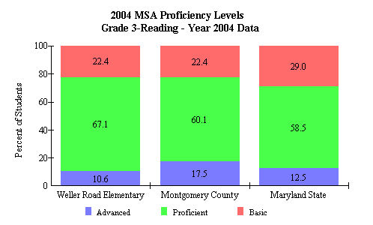
Source: 2004 Maryland Report Card

3rd Grade Mathematics

The third grade assessment data for Mathematics is shown in Figure 2. The school had 24.7% advanced, 55.3% proficient, and 20% basic level. They did much better in advanced compared to mathematics. When comparing to Montgomery County Public Schools, Weller Road had about 6% less advanced, 6% more proficient, and about the same amount of basic students. There is still a little room for improvement with the advanced students, but Weller Road was much closed to Montgomery County on mathematics. In comparison with the state of Maryland, Weller Road had about 5% more advanced, 3% more proficient, and almost 8% less students who were basic. Weller Road was definitely on the higher end of the state of Maryland.

Figure 2. 2004 3rd Grade Mathematics Proficiency Levels for Weller Road Elementary, MCPS and the State

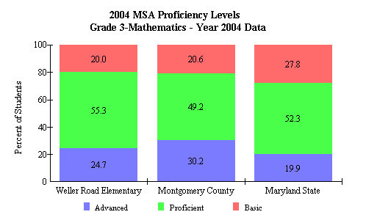
Source: 2004 Maryland Report Card

5th Grade Reading

As shown in Figure 3, the fifth grade shows a slight improvement in comparison with the third grade scores. There were 19.4% advanced, 44.1% proficient, and 36.6% basic. This shows that there were a few more advanced, a lot less proficient and a lot more basic students. In comparison with Montgomery County, Weller Road 20% less advanced, 4% more proficient, and about 11% more basic students. This is not a very good balance, there are far too many basic students, and far too few advanced students, there needs to be a better balance. In comparison with the state of Maryland, Weller Road had 9% less advanced, about 5% more proficient and about 5% more basic. In regards to the state of Maryland, Weller Road is not that far off, but there is a lot of room for improvement.

Figure 3. 2004 5th Grade Reading Proficiency Levels for Weller Road Elementary, MCPS and the State
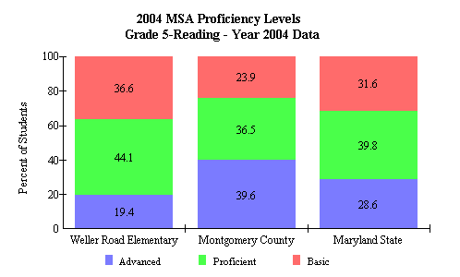
Source: 2004 Maryland Report Card

5th Grade Mathematics

The fifth grade students, as shown in Figure 4, are not as strong in mathematics as they are in reading. There were only 5.4% advanced students, 64.5% proficient, and 30.1% basic. In comparison with Montgomery County there is a lot of work that needs to be done. In comparison, Weller Road had 18% less advanced, 14% more proficient, and 4% more basic. The only area that really needs help is getting the children to move from proficient to advanced. When comparing scores to the state of Maryland, Weller Road had 7% less advanced, 14% more proficient, and 6% less basic. The scores compared to Maryland are not that bad but it looks like the whole state of Maryland has to make a lot of improvements.

Figure 4. 2004 5th Grade Mathematics Proficiency Levels for Weller Road Elementary, MCPS and the State
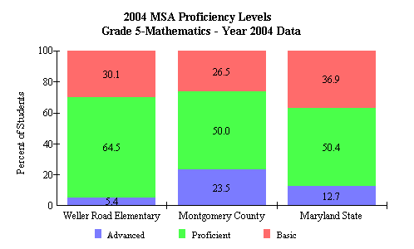

Source: 2004 Maryland Report Card

Areas of Needed Improvement

There are numerous things that need to be improved at Weller Road, one being assessment scores. All the teachers at Weller Road are working hard in Mathematics and Reading but they are teaching to the test. I feel like there is so much teaching to the test that it is causing the students to just spit out the information with out actually understanding what it is that they are learning. Something that I have learned from classes like our mathematics class is that you can teach math by route memorization, the students have to really understand the concepts to actually be able to explain their thinking. I think that more students would be able to make the jump from proficient to advanced if they learned more about the process of mathematics than the product. I think that the more the teachers move away from teaching to the test, the better the students will do on the exams.

Bibliography

The Maryland Business Roundtable (2004). Maryland technology inventory
report: OnTarget. Retrieved December 16, 2004 from http://reports0304.md.ontargetus.com/

The Census Bureau Fact Finder
http://factfinder.census.gov/home/saff/main.html?_lang=en

Maryland State Department of Education/School Improvement in Maryland
www.mdk12.org

The official site of Weller Road Elementary School
http://www.mcps.k12.md.us/schools/wellerroades/

Information taken from School Profiles at http://www.greatschools.net/modperl/browse_school/md/975/

