Data Analysis and Interpretation Paper
Data Analysis and Interpretation with Technology Module: EDHD 435
Part 1

Fall 2004
Jennifer Marousek
November 1, 2004

Woodlin Elementary School

Background Information

Woodlin Elementary School is located at 2101 Luzerne Avenue in Silver Spring Maryland. The surrounding community’s population has a very high percentage of Black/African Americans (28.1%) and Hispanic Latino Americans (22.2%) (2004, American FactFinder). Moreover, 35.1% of Silver Spring’s population is foreign born and 41.4% of the population (5 years and over) speaks a language other than English at home. From these statistics it is safe to conclude that Woodlin Elementary serves a very diverse population. In the 2003-2004 academic year, there were 481 students in the school: 47% were female and 53% were male. Approximately 30% (29.5%) were African American, 8.1% were Asian, 15.4% were Hispanic, and 47% were White. Also, Woodlin serves a very high population of FARMS students. During the same time, 26.8% of the total population was FARMS. Furthermore, 9.4% of the population was ESOL and 14.8% were classified as Special Education. (2004 Maryland Report Card) This diverse population of students can have positive and negative effects for the students in the school. Children are exposed to many different cultures and languages which enhances their cultural knowledge and acceptance. However, when there are a lot of students who speak languages other than English, teachers sometimes have difficulty communicating with the children and families.
In addition to diversity, the mobility rate, including entrants and withdrawals, for Woodlin also tends to be high. In the 2002-2003 academic year, the mobility rate was 19.3% (Woodlin Elementary School - #764: Schools at a Glance). In the 2003-04 school year, Woodlin had a total of 482 students, 40 teachers, and 40 classrooms (Maryland Technology Inventory Summary Report). The average class size for kindergarten was 14.5, for grades 1 to 2 it was 17.6, and for grades 3 to 5 it was 21.1 (Woodlin Elementary School - #764: Schools at a Glance).

Assessment Record

In 2004, Woodlin did not meet its Adequate Yearly Progress (AYP). AYP is a measure used to show whether students are making adequate yearly progress in reading, math, attendance and one other state determined measure. In order for a school to make AYP, all indicators must be met by all sub-groups. At Woodlin, indicators were not met by the special education sub-group. On the 2004 Maryland State Assessment (MSA) Reading test, only 12.5% of the special education students met the proficiency level. As indicated in Table 1, all other indicators were met. AYP in reading and mathematics was met by all racial groups and ethnic groups. Furthermore, the AYP participation and attendance rates in both areas were met. (2004 Maryland Report Card).
Table 1. 2004 AYP Disaggregated Proficiency Level in Reading for Woodlin Elementary School
Montgomery County (LEA:15) Woodlin Elementary (ID:0764)

 | 2004 AYP: |  | Not Met
 | Show Trends |  |  | All indicators must be "Met" to make AYP. For details, click on the links below.
 |  |  |  | Percent Proficient |  |  |  | Participation Rate
 |  |  |  | Reading | Mathematics |  |  | Reading |  | Mathematics |  |  | Attendance
 | All Students |  |  | Met |  | Met |  |  | Met |  | Met |  |  | Met
 | American Indian/ Alaskan Native |  |  | -- |  | -- |  |  | -- |  | --
 | Asian/Pacific Islander |  |  | Met |  | Met |  |  | na |  | na
 | African American |  |  | Met |  | Met |  |  | na |  | na
 | White (not of Hispanic origin) |  |  | Met |  | Met |  |  | Met |  | Met
 | Hispanic |  |  | Met |  | Met |  |  | na |  | na
 | Free/Reduced Meals |  |  | Met |  | Met |  |  | na |  | na
 | Special Education |  |  | Not Met |  | Met |  |  | na |  | na
 | Limited English Proficient |  |  | Met |  | Met |  |  | na |  | na

'--' indicates no students in the category. 'na' indicates too few students for AYP rules.
Source: 2004:Maryland Report Card
Data indicates that the majority of students, with the exception of those receiving special education, are showing progress in the areas of math and reading. This is a positive sign for general education reading and math instruction at Woodlin Elementary School. However, this is a negative sign for reading instruction for special education students.
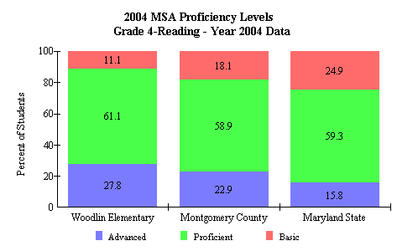
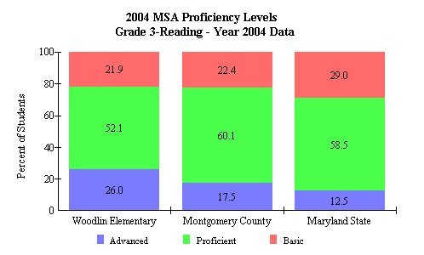
Interestingly, students at Woodlin Elementary did quite well on the 2004 MSA reading and mathematics assessments. As indicated by the table below, on the reading test, 26.0% of students in grade 3 scored in the advanced proficiency level, whereas in Montgomery County and Maryland State, only 17.5% and 12.5% of students respectively, scored in the advanced level. Similarly, in grades 4 and 5, a significantly higher percentage of students scored in the advanced levels compared to the overall results for Montgomery County and Maryland State. In addition, a smaller percentage of students in grades 3, 4, and 5 at Woodlin scored in the basic proficiency range compared to the total scores for Montgomery and Maryland. For example, in grade 4, only 11.1% of Woodlin students were at the basic level, whereas 18.1% of all Montgomery students and 24.9% of all Maryland students were at this level (see table above). This means that reading instruction at Woodlin is of high quality. In fact, compared to other schools in Montgomery County, Woodlin is doing much better. (2004 Maryland Report Card: Montgomery County-Woodlin Elementary)
Students at Woodlin Elementary not only did well on the MSA reading assessment, but they also scored well on the 2004 MSA mathematics test. In grade 3, 31.9% of Woodlin students scored within the advanced level (refer to table below). In Montgomery County, only 30.2% of students, and in Maryland only 19.9% of students, scored at this level.
Figure 3. 2004 MSA Proficiency level comparison between Woodlin Elementary, Montgomery County Public Schools and Maryland.
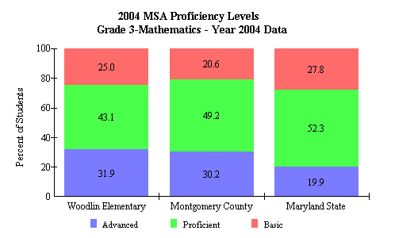
Moreover, in grades 4 and 5, more students at Woodlin were in the advanced range compared to the results for the
Source: 2004 Maryland Report Card
entire state. However, interestingly, in grades 4 and 5, less Woodlin students were in the advanced range compared to the overall scores for Montgomery County. Nonetheless, the majority of students at Woodlin Elementary received scores that categorized them as advanced or proficient at mathematics. Again, this is a positive sign for the mathematics instruction at Woodlin. However, a reasonable goal for Woodlin would be to bring their mathematics scores up to that of the scores of Montgomery County, or to have more students score in the advanced range, comparable to that of Montgomery County (2004, Maryland Report Card: Montgomery County-Woodlin Elementary).

Teacher and Staff Qualifications

Another important aspect of Woodlin Elementary is its attendance rate. In 2003-2004, Woodlin’s attendance rate was 95.2%, which met AYP (Woodlin Elementary School - #764: Schools at a Glance). Also, the majority of teachers at Woodlin Elementary have a professional teaching certificate, with 43.8% having an advanced professional certificate and 40.6% having a standard professional certificate (Woodlin Elementary School - #764: Schools at a Glance). Moreover, 9.4% of the teachers have a conditional certificate. Since most teachers hold a professional teaching certificate, the instruction at Woodlin is likely to be of higher quality than if the teachers did not hold professional certificates.

Technology Use

In addition to assessment results, teacher qualifications, and AYP, it is important to look at how technology is used in the school. At Woodlin, 100% of the classrooms have internet access, which meets Maryland’s target. Moreover, 100% of students have access to computers in the classroom (1+ computer), and 100% of teachers have access to computers (1+). Both of these statistics meets Maryland’s target, which is a great sign for Woodlin. In addition, 75% of teachers at Woodlin feel like they have at least an “intermediate” ability to use computers. This is higher than Maryland’s totals, but it does not meet Maryland’s target . As indicated in Table 2 below.

Table 2: Comparison of Woodlin Elementary, Montgomery County and Maryland Technology Use
School | Computer Use | Internet Use | Technology Integration
Woodlin Elementary Totals | 75.00% | 60.00% | 50.00%
Montgomery County Totals | 77.29% | 74.18% | 78.56%
Maryland Totals | 72.84% | 67.12% | 68.65%
Maryland Target | 100% | 100% | 100%
Source: 2004 Maryland State Technology Inventory
In addition, only 60% of teachers feel like they have at least an “intermediate” ability to use the internet. This is quite upsetting since 100% of the classrooms have internet access. If teachers do not know how to use the internet, they will not be able to help students use it. Even more disturbing, only 50% of teachers feel like they can integrate technology into the classroom activities. In addition, when asked how often students use technology to gather information from a variety of online/technology-based resources, Woodlin responded “a few times per month”. The same response was given for using technology to “display data/information” and “organize and store information.” Furthermore, when asked how often students use technology “to develop a more complete understanding of complex material or abstract concepts”, Woodlin responded “a few times per year.” Therefore, it is apparent that Woodlin teachers are not using technology as much as they should. The resources are there, they just need to integrate technology into the daily routine (Woodlin Elementary Technology Inventory Summary Report).

Future Directions
In summary, Woodlin Elementary School serves a very diverse population of students. They are showing annual yearly progress in mathematics and reading in all areas except special education. Woodlin needs to focus on improving reading instruction in special education so that it can meet its AYP. Only 9.1% of third grade special education students scored in the proficient/advanced range on the 2004 MSA Reading Assessment (MSA Proficiency Data for 2003 – 2004 Montgomery County Elementary Schools: Woodlin Elementary). In fact, the difference in scores from 2003 to 2004 for third grade special education students is devastating: the amount of students scoring in the proficient/advanced level went down 40.9% (MSA Proficiency Data for 2003 – 2004 Montgomery County Elementary Schools: Woodlin Elementary). Special education students in fifth grade did not do much better on the 2004 MSA Reading test. Only 16.7% of these students scored within the proficient/advanced range, which was a decrease of 14% from last year (MSA Proficiency Data for 2003 – 2004 Montgomery County Elementary Schools: Woodlin Elementary). Therefore, it is imperative that the staff at Woodlin, including the principle, special education teachers and helpers, and the reading specialist, work together to improve the reading instruction that the special education students are receiving. AYP should be met for this group of students by 2005. In addition to the problems regarding the quality of special education being received, technology is not being used enough in the classrooms. As stated above, only 50% of teachers feel like they can and do integrate technology into classroom activities. Moreover, students are not using computers on a daily, or even weekly, basis. All teachers, including special education teachers and specialists, need to develop ways to integrate technology use into the curriculum. By and large, Woodlin Elementary would be able to offer a higher quality of education if the staff improves the special education program (especially in regards to reading) and integrates technology into the curriculum.

