New Hampshire Estates Elementary School
Data Analysis and Interpretation Paper
Data Analysis and Interpretation with Technology Module: EDHD 435
Part 1

Fall 2004
Kathleen Nelson
November 31, 2004

Background Information

Introduction

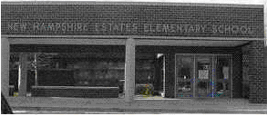
New Hampshire Estates Elementary School (NHE) is located at 8720 Carroll Avenue in Silver Spring, Maryland. New Hampshire Estates opened in 1954 and faculty recently conducted a celebration of the school’s fiftieth anniversary. This is a primary school for students from pre-K through second grade. When New Hampshire Estates students have completed second grade they are transferred to Oak View Elementary school in Silver Spring. The mission of NHE is “to
Figure 1. Image of NHEES
provide a language-rich learning environment for students, parents, and staff which promotes individual growth, creativity and independence through active participation, risk-taking opportunities, and real-life problem solving experiences.” NHE offers a variety of special services to students including an accelerated math program, a Head Start program for three and four year olds, sports and science after school clubs, and instructional assistants in every classroom. The average class size for grades 1 and 2 at NHE is 16.8 students. The average kindergarten class is 13.9 students. The student to instructional staff ratio is 5.2:1.
Demographics
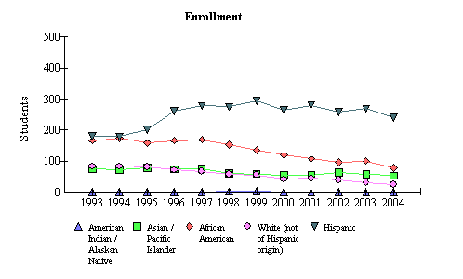
The official enrollment at NHE for the 2003-2004 school year was 394 students, which is well below the school capacity of 611 students. Of these students, 60.9 % were of Hispanic origin, 19.5% were of African American descent, 13. 5% were of Asian origin, and 6.1% were White. Figure 2 shows the enrollment of students by race at New Hampshire Estates from 1993 to 2004. This graph clearly shows that the student population is predominantly of Hispanic origin. The school has a large percentage (81.5%) of students receiving free and reduced meals (FARMS). The school is considered a Title 1 school, which means that the school receives targeted assistance programs, for example, translators for parents and students, teaching assistants, after school supplemental tutoring programs etc… Title I services are paid by federal funds through the Elementary and Secondary Education Act (ESEA) (the Hawkins-Stafford Amendments of 1988).
Figure 2: NHE Student Enrollment by Race from 1993 to 2004
Source: 2004 Maryland Report Card
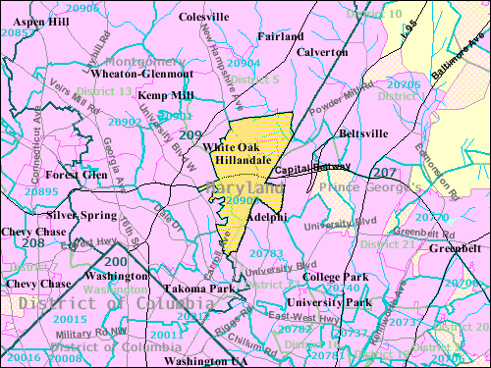
The demographics of the area surrounding NHE are quite different then that of the school. According to the 2000 US Census Bureau, the total population within the boundaries of the 20903 zip code, which is represented in Figure 3, is 22,679. From this population, 30.5% are White, 32.1% are Black or African American, 13.2% are Asian, and 17.9% are of another race. From all of these races, 34.2% of the population is Hispanic or Latino. The average family size of this area is 3.53 persons. One important characteristic to note about this population is that 49.5% of the people of this area are foreign born and 57.9% speak a language other than English at home. Also, 9.5% of families are below the poverty line. The school is taking appropriate steps toward including all families through the employment of a full time parent and community coordinator who is fluent in Spanish. Also, it is likely that the seven ESOL teachers at NHE are very beneficial in this unique situation. For more information about the population surrounding New Hampshire Estates Elementary School, visit http://factfinder.census.gov/home/saff/main.html?_lang=en and enter the city and state.
Figure 3: Reference Map of NHE Surrounding Areas
Source: 2000 US Census Bureau: Fact Finder
Staffing
Jane Litchko, the principal of NHE has been at this school for two years. Forty eight percent of teachers hold an advanced professional certificate which means at least 3 years of full-time professional school-related experience, 6 semester hours of acceptable credit; and a master’s degree, or a minimum of 36 semester hours of post baccalaureate course work which must include at least 21 hours of graduate credit. Fifty two percent of teachers hold a standard professional certificate, meaning a valid certificate to teach in Maryland to teach in the core academic subject areas (reading, mathematics, writing). None of New Hampshire Estates’ classroom teachers are provisionally or conditionally certified.
The teaching staff consists of seven kindergarten teachers, 24 classroom teachers, seven ESOL teachers, three Preschool teachers, and two special education professionals. There are specialists in the areas of reading, physical education, art, and music. Other positions include 11 para-educators, a counselor, a media specialist, two secretaries, and a parent/ community coordinator.
Technology
Specifics about technology equipment and use are collected each year by the Maryland Business Roundtable, through the Annual Maryland Technology Inventory Report. The data shows that in 2004, NHE was performing well in the areas of teacher knowledge and skills and student to computer ratio in comparison to state and county performances. Ninety percent of teachers are estimated to have intermediate knowledge of computer use as compared to seventy two percent of teachers at the state level. Eighty percent of teachers at NHE are estimated to have intermediate knowledge of technology integration, while only sixty eight percent of Maryland teachers are estimated to have this knowledge. The student to computer ratio at NHE was 3.9 students for every 1 computer. This is well below the state target of 5 students for every 1 computer. Figure 4 displays the student to computer ratios from NHE, Montgomery County, and the state in comparison to the state target. One hundred percent of classrooms have computers, all of which have internet access.
Figure 4: Student to Computer Ratios of NHE Compared to County, and State Ratios

Student to Computer Ratio
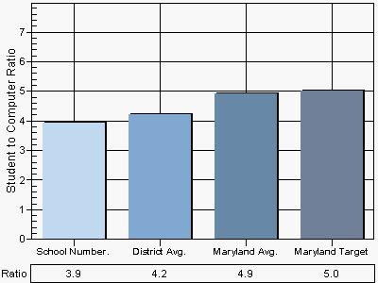
Source: 2004 Annual Maryland Technology Inventory Report

AYP Results and Other Assessments
Average Daily Attendance
The state standard for satisfactory attendance is 94%. The elementary attendance rate is defined as "the percent average daily attendance of elementary students (grades 1 through 5), including un-graded special education students under age 11” (Maryland Report Card, 2004). NHE has shown to have satisfactory attendance for the past 2 years. In 2004, the total school attendance rate was 95.2%. In 2004, the total school attendance rate was almost the same at 95.1%.
Reading
In order to meet the federal requirement contained in No Child Left Behind, Maryland must assess student achievement. The Maryland School Assessment (MSA) measures student achievement in K-8 reading and math and grade 10 reading. The MSA information is reported for grades 3 through 8 and for grade 10 in reading (Maryland Report Card, 2004).
The Maryland School Assessment is reported with three statewide performance standards. These standards are divided into three levels of achievement. These levels are Basic, Proficient, and Advanced. The Maryland Report Card explains the differences between the levels as:
- Advanced is a highly challenging and exemplary level of achievement indicating outstanding accomplishment in meeting the needs of students.

- Proficient is a realistic and rigorous level of achievement indicating proficiency in meeting the needs of students.

- Basic is a level of achievement indicating that more work is needed to attain proficiency in meeting the needs of students.

Before understanding the data presented in Figure 5, it is important to know that because there is no grade 3 at NHE, their students are tested at Oak View Elementary School in the middle of their third grade year. Thus, the time spent at Oak View could impact the scores of NHE students.
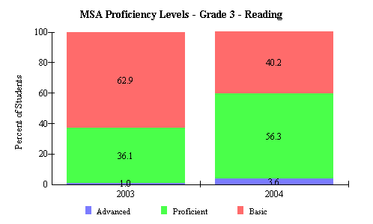
The percentage of students reading at an advanced level rose from 1.0 to 3.6 percent from 2003 to 2004. The percentage of students
Figure 5: NHE Reading Assessment Scores
reading at a proficient level rose from 36.1 percent to 56.3 percent. The percentage of students reading at a basic level dropped from 62.9% to 40.2%. According to these statistics, NHE students are in general progressing well in their reading level. The largest ethnic
populations at NHE are African American
and Hispanic. The percentage of Hispanic students reading at a basic level was 39.1, while the percentage of African American students reading at a basic level was 48.0%. There are no Hispanic students reading at an advanced level, but 8.0% of African American students are advanced readers. The majority of students from both groups are reading at a proficient level, with 60.9% of Hispanic students and 44.0% of African American students. Slightly over half of the students at NHE who are receiving free and reduced meals are reading at least at a proficient level, while 92% of students who are not receiving free and reduced meals are reading at least at a proficient level. Likewise, only about forty percent of students receiving special education services are reading at least at a proficient level, compared to more than sixty percent of students who are not receiving special education services.
Source: 2004 Maryland Report Card
Mathematics
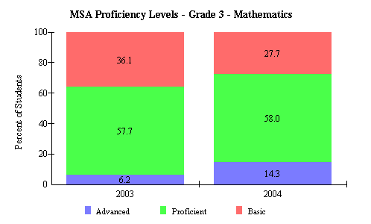
The mathematics proficiency levels for students at NHE, shown in Figure 6, are similar to the reading proficiency levels. The percentage of students performing at an advanced level rose from 6.2% in 2003 to 14.3% in 2004. From 2003 to 2004 there was a slight rise in the percentage of students performing at a proficient level, form 57.7% to 58.0%. There was a substantial drop in students reading at a basic level, from 36.1% down to 27.7%. This evidence shows that the largest growth occurred in the area of advanced mathematics students. This could possibly be in part due to the advanced mathematics program available to students.
Figure 6: NHE Mathematics Assessment Scores
Source: 2004 Maryland Report Card
Adequate Yearly Progress
Table 1 is evidence that New Hampshire Estates has met every indicator in order to achieve adequate yearly progress (AYP). Although these indicators have been met, two groups were only satisfied due to the confidence intervals or state formula adjustments used when small numbers of students make up a sub-group. Reading performance of students receiving special education services and Asian students was below that required for adequate yearly progress. Also, mathematics performance of students receiving special education services was below the AYP requirement, but was satisfied through the confidence interval.
Table 1: New Hampshire Estates AYP Performance in 2003 and 2004
Montgomery County (LEA:15) New Hampshire Estates Elem (ID:0791)
 | 2004 AYP: |  | Met
 | Hide Trends |  |  | All indicators must be "Met" to make AYP. For details, click on the links below.
 |  |  |  | Percent Proficient |  |  |  |  |  | Participation Rate
 |  |  |  | Reading |  | Mathematics |  |  |  | Reading |  | Mathematics |  |  |  | Attendance
 | All Students |  |  | 03 | 04 |  | 03 | 04 |  | 03 | 04 |  | 03 | 04 |  | 03 | 04
 | American Indian/ Alaskan Native |  |  | 03 | 04 |  | 03 | 04 |  | 03 | 04 |  | 03 | 04
 | Asian/Pacific Islander |  |  | 03 | 04 |  | 03 | 04 |  | 03 | 04 |  | 03 | 04
 | African American |  |  | 03 | 04 |  | 03 | 04 |  | 03 | 04 |  | 03 | 04
 | White (not of Hispanic origin) |  |  | 03 | 04 |  | 03 | 04 |  | 03 | 04 |  | 03 | 04
 | Hispanic |  |  | 03 | 04 |  | 03 | 04 |  | 03 | 04 |  | 03 | 04
 | Free/Reduced Meals |  |  | 03 | 04 |  | 03 | 04 |  | 03 | 04 |  | 03 | 04
 | Special Education |  |  | 03 | 04 |  | 03 | 04 |  | 03 | 04 |  | 03 | 04
 | Limited English Proficient |  |  | 03 | 04 |  | 03 | 04 |  | 03 | 04 |  | 03 | 04
Source: Maryland Report Card

Although Table 1 clearly shows that in 2003 and 2004 NHE has satisfied all components of AYP, a more precise examination of data will show that without the use of confidence intervals, AYP would not have been met for Asian/ Pacific Islander populations and special education populations.
Areas of Needed Program Enhancement
Based on all the information that has been provided here, New Hampshire Estates is progressing. All AYP indicators were satisfied in 2004, although not all groups met AYP proficiency level benchmarks set by the state. A comparison of data from 2003 to 2004, in Figures 5 and 6, has shown that students are progressing in both reading and math. , Attendance levels at NHE are satisfactory. Technology levels are above the state and county average performance scores, although these scores are still below the state goal of 100% competency in teacher knowledge and skills. As with all schools there are areas of improvement at NHE. While progress has been made in reading and mathematics, based on the data, reading is still an area of need at NHE. Forty percent of students continue to read at a basic level. Furthermore, students who are receiving special education services and students who are receiving free and reduced meals are an area of concern. Although there is a very small Asian population at this school, if AYP is to be met without the confidence interval, teachers must work with this population to raise MSA reading proficiency levels.

Bibliography
Maryland Business Roundtable (2004). Maryland Technology Inventory: OnTarget. Retrieved
December 12, 2004 from the World Wide Web: http://reports0304.md.ontargetus.com/
Maryland State Department of Education (2004). Maryland report card. Retrieved December 12,
2004 from the World Wide Web: http://www.mdk12.org/
Montgomery County Public Schools. (2004, December 10). New Hampshire Estates ES.
Retrieved December 12, 2004 from the World Wide Web: http://www.mcps.k12.md.us/schoolodex/schooloverview.cfm
U.S. Census Bureau (2000). Factfinder: Community profile for the 20903 zip code area. Retrieved December 12, 2004 from the World Wide Web: http://factfinder.census.gov/servlet/SAFFFacts?_event=Search&geo_id=010 00US&_geoContext=&_street=&_county=&_cityTown=&_state=&_zip=20 903&_lang=en&_sse=on

