Data Analysis and Interpretation Paper
Data Analysis and Interpretation with Technology Module: EDHD 435
Part 1

Fall 2004
Kafi Lewis
November 1, 2004

Background Information

Introduction

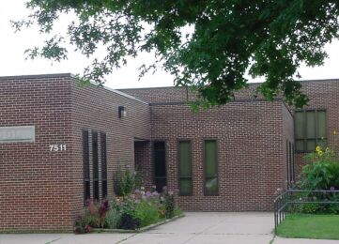
Figure 1. Takoma Park Elementary imageTakoma Park Elementary
Takoma Park Elementary School (school ID #0754), located at 7511 Holly Avenue, Takoma Park, Maryland, is found within Local Education Agency #15, in Montgomery County(Maryland State Department of Education, 2004).

The school is also a part of the Montgomery Blair Cluster which has recently been renamed as the Downcounty Consortium. When the school was constructed in 1979 it was created to serve students in grades K-6. Years later, when Piney Branch Elementary School opened its doors, Takoma Park Elementary began to house students up to third grade. Currently, the school provides services to students from kindergarten to second grade. The school also houses a school community based program for special needs students in first and second grade. In the past, Takoma Park Elementary has also been a Head Start location, but the 2004-2005 school year will be the first year that the school will go without the preschool program. The school currently has the only Gifted and Talented magnet program in Montgomery County Schools which follows the school wide motto of “Jump into learning!” (Montgomery County Public Schools, 2004).
The school has not been renovated since opening in 1979, and has surpassed its expected enrollment capacity. Currently, all eight of the second grade classes are located outside in portables.
The majority of the staff at Takoma Park Elementary are returning teachers. There have been some new hires, with four of the nine kindergarten teachers beginning their first year teaching in Montgomery County this school year. The other new hire is a first grade classroom teacher.

Although the school is the site of nonstop activity during the day, the excitement does not stop after school hours. On Sundays the facility is used by a church group. The PTA chapter is also very active at the school, holding events such as the Fall Festival, and also spearheading school fundraisers.
Figure 2: The Takoma Park Elementary service area is pictured in yellow.

Figure 1: The Takoma Park Elementary service area is pictured in yellow.

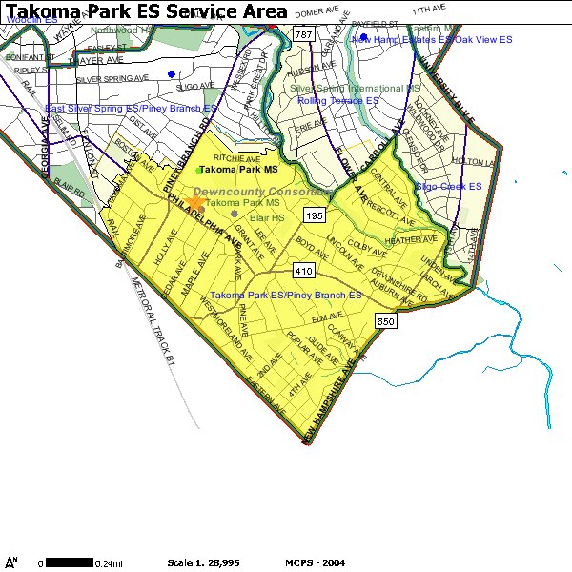
Demographics of the school and surrounding community
The Takoma Park Elementary service area is pictured in yellow.Source: where did the picture come from it is listed hereSource: Montgomery County Public Schools
The Takoma Park Elementary service area is pictured in yellow.Source: where did the picture come from it is listed hereSource: Montgomery County Public Schools
Takoma Park, Maryland was reported as being approximately 2.1 square miles in the 2000 U.S. Census. The area has a diverse population of White, African American, and Hispanic people among its approximate 24,498 inhabitants. The median age of the community is 34, with 7.4% of the population below the age of 5. Approximately 75% of the residents are 18 years or older, and 7.5%, of Takoma Park residents are above the age of 65. Of the population, 43% of Takoma Park residents are White, 35.5% are African American, and 4.5% are Asian. Eleven percent reported being some other race, and 20.5% of the reported population in the 2000 Census was Hispanic. The Hispanic population rose from 1,437 in the 1990 census to 5,020 in the 2000 census. This represents a rise of almost 350%. In 1990, Hispanics or Latinos consisted of 8.6% of the people who lived in Takoma Park, and they currently are 20.5% of Takoma Park’s population (United States Census Bureau, 2000).
Within the Hispanic population there are many other racial groups. Of the reported 5,020 Hispanic residents in Takoma Park in the most recent census, 1.5% hailed from Mexico, .7% were Puerto Rican, and .5% were Cuban. The remaining 17.7% reported that they were of some other Hispanic or Latino heritage (United States Census Bureau, 2000).

The households in Takoma Park have a mean income of $57,757, and a median income of $44,572. 25.1% of the population has an annual income of less than $25,000. On the extremes, 8.3% earn less than $10,000 in annual income, and 2.6% earn $200,000 or more.
For more detailed information of the demographics of Takoma Park, please visit the United States Census Bureau (Fact Finder) at http://factfinder.census.gov/home/saff/main.html?_lang=en, and enter the school’s city and state, or the zip code.
Figure 3: Enrollment trends at Takoma Park Elementary

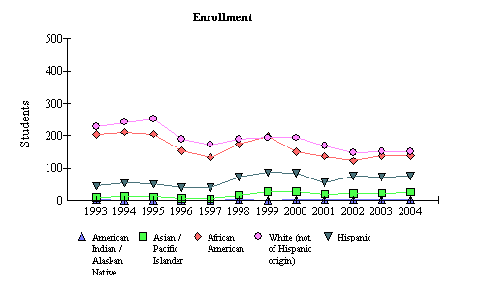
In the fall of 2003, there were 390 students enrolled at Takoma Park Elementary. Data concerning enrollments for the fall

Source: 2004 Maryland Report Card
of 2004 has not yet been released. In the 2003-2004 school year, when the school still had a Head Start program, there were 21 children receiving those services. In kindergarten and first grade there were a total of 243 students, and second grade had 126 students. The majority of the students that year, 38.5%, were White (not of Hispanic origin) (Maryland State Department of Education, 2004). African American children were 35.4% of the school’s population, and Hispanic students represented 19.2%. Finally, Asian/Pacific Islander and American Indian/Alaskan native represented 6.4% and .5% of the school body respectively. Since 1993, the enrollment of White, African American, and Hispanic students has dipped, but has stabilized within the last two years. Since 2001, there has been a rise in the number of Hispanic students attending the school, from 54 students, to 75. Since that time, those numbers have also stabilized, leaving Hispanics as the third most populated ethnic group in the school (Maryland State Department of Education, 2004).
Of the students enrolled at the school that year, 19.7% were Limited English Proficient students. Many of these children live in homes where their parents are also lacking in English-language skills, so these students receive all of their English language instruction at school. The school has programs to reach out to these non-English speaking homes. Much of the information that is sent home is in both English and Spanish. Other information has been translated into Vietnamese, Amharic, French, and Chinese for the benefit of these students and their parents (Maryland State Department of Education, 2004).
More than a third of the students, 37.1%, qualified for and received free or reduced lunch in this Title I school. Title I schools have assistance programs that provide federal money for extra educational services such as instructional assistants, inservice training for teachers, translators, and supplemental programs. These funds come from the Elementary and Secondary Education Act (ESEA). The students who receive free/reduced meals met requirements of family size and income requirements set by the U.S. Department of Agriculture. Other students were approved through direct certification (Maryland State Department of Education, 2004).

Staffing

There were 28 teachers employed at Takoma Park Elementary in the 2003-04 school year. Of these 28 teachers, 15 of them (53.5%) had standard professional certification. All teachers who teach a core academic subject must have a valid certificate to practice in the state of Maryland. Advanced Professional Certificates, meaning at least 3 full years of professional school related experience, 6 semester hours of acceptable credit, and a master’s degree; or a minimum of 36 hours of post-baccalaureate work which includes 21 graduate school credits, were held by 39.3% of the 28 teachers. There were 2 teachers that held conditional teaching certificates, signifying that these teachers did not meet all certification requirements, but were issued certification at the request of the local school system superintendent (Maryland State Department of Education, 2004).
That year the staff consisted of 41.2 professional positions, and 16.378 supporting services. There were 27.5 classroom teachers, 1 staff development teacher, and 1.5 ESOL teachers, since one teacher is only present at the school three days a week. The specialists at the school included a reading teacher, a physical education teacher, an art teacher, a music teacher, a Head Start teacher who was present only half-day, two special education teachers, and one resource teacher. The remaining professional positions were filled by counselors, media specialists, and other Special Education related staff. The staff development teacher works to create workshops and find information to address the concerns and issues of the other teachers in the school (Montgomery County Public Schools School, 2004).

Technology

At Takoma Park Elementary, there is a 3.1:1 ratio of students to computers. This is higher than the average for Montgomery County which is 5.2:1. This is also higher than both the state targets and state estimates of 5.3:1 and 5:1 respectively. At the school 16% of classrooms have 5 computers dedicated to student use. Furthermore, 100% of the school’s computers are connected to the internet, meeting Maryland’s target of percentage of classrooms with internet access.
The teacher knowledge and skills, although higher than the state totals, is still below the Maryland target of 100%. Eighty percent of the teachers are competent at using computers and can backup their files, 70% of the teachers can design classroom or homework activities for students that require that they use the internet as a reference (intermediate internet use), and 80% of teachers use technology for intermediate technology integration, meaning that they can use the computer for word processing, to develop lesson plans, to help the students use instructional software, and to access web sites. This information can be seen in the 2004 Maryland Technology Inventory Report. (Maryland Technology Report, 2004.)

AYP Results and Other Assessments

Average Daily Attendance
The attendance rate is calculated by data that reflects how many students were at school for at least half the average school day during the school year. In the elementary grades, this includes special education students under the age of 11, but excludes summer school attendance. At Takoma Park Elementary, this data consists only of students in first or second grade. In the 2004 school year, the attendance rate for those two grades was 95.3%. Although that represents a decrease of .3% from the year before, over the last five years Takoma Park Elementary has remained consistent at an average of 95% attendance for these grades. Of the students who were absent, 32.7% missed fewer than 5 days, and 5.4% were absent from school for more than 20 days of the school year. Attendance was also similar across race. White, African American, and Asian/Pacific Islander students had an attendance rate of more than 95%. Hispanic students had a lower rate of 93.7%. There was only a .1% difference by gender with the female attendance rate at 94.4% and the male attendance rate at 95.3% (Maryland State Department of Education, 2004).

Reading
Since its inception in the year 2000, No Child Left Behind (NCLB) brought many changes to the face of American education. One of the federal regulations that has affected Maryland is the requirement that the state must assess student achievement annually. As a result the Maryland School Assessment (MSA) was created to assess student achievement in the content areas of reading and math. The MSA replaced what used to be the Maryland School Performance Assessment Program (MSPAP). It assesses student achievement in math and reading starting in kindergarten and continuing on through eighth grade. The test reappears in 10th grade to assess the reading skills of high school students.
The scores from the MSA are reported on the basis of statewide performance standards that reflect three levels of achievement. These levels are Basic, Proficient, and Advanced.
The Maryland Report Card reports the levels as the following:
- Advanced is a highly challenging and exemplary level of achievement indicating outstanding accomplishment in meeting the needs of students.
- Proficient is a realistic and rigorous level of achievement indicating proficiency in meeting the needs of students.
- Basic is a level of achievement indicating that more work is needed to attain proficiency in meeting the needs of students.
Student performance is reported in terms of these achievement levels for reading. A basic performance signifies that the students at this level are unable to read and comprehend grade level literature and informational passages. Proficient students can read appropriate text, and are able to understand literature and informational passages. Finally, advanced students are capable of reading above grade level, while also demonstrating the ability to comprehend complex literature and informational passages (Maryland State Department of Education, 2004).

Student performance is also reported in terms of these achievement levels for math. Students at the basic level show only a partial mastery of the skills and concepts defined in the Maryland Mathematics Content Standards. Proficient students demonstrate an understanding of the fundamental skills and concepts for their grade level. These students are able to solve entry-level math problems. Finally, Advanced students can solve regularly complex math problems, and demonstrate a superior ability to reason mathematically.

Figure 4. 2004 Takoma Park Elementary School AYP Reading Percent Proficiency by Ethnic/Race and Special Interest Groups
Montgomery County (LEA:15) Takoma Park Elementary (ID:0754)
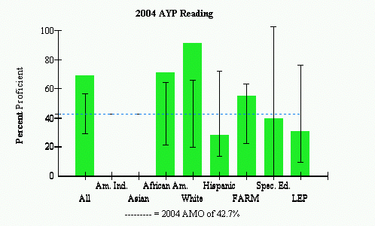
 |  | AYP Met |  |  | AYP Met with Safe Harbor |  |  | AYP Not Met

NOTE: 2005 AMO will be 50.9%
Source: 2004 Maryland Report Card
Figure 5. 2004 Takoma Park Elementary School AYP Mathematics Percent Proficiency by Ethnic/Race and Special Interest Groups
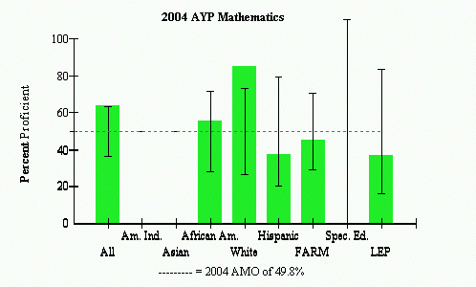
 |  | AYP Met |  |  | AYP Met with Safe Harbor |  |  | AYP Not Met

NOTE: 2005 AMO will be 57.0%
Source: 2004 Maryland Report Card

As indicated in Figure 4, Takoma Park Elementary School met AYP in reading although several sub-groups did not meet the state Annual Measurable Objective (AMO) target set at 42.7% in 2004. Specifically, the Hispanic, Limited English Proficiency and Special Education sub-groups did not meet the targeted benchmark. Since there were fewer number of these students in these subgroups, the confidence interval (a formula) depicted by the black “I” allows these groups to still met AYP. However, these will be areas for the school to work on and may be harder to reach AYP when the targeted state set AMO benchmark is raised to 50.9% in 2005.
Figure 5 shows similar results for the Hispanic, LEP and FARM sub-groups not reaching the targeted AMO proficiency benchmark. The AMO in mathematics will be raised to 57.0% in 2005. As a result, the school must begin to work with these students so that they can begin to reach these higher targets.

FEEDER SCHOOL

Takoma Park Elementary is a primary school for students in grades K-2,which feeds into Piney Branch Elementary for grades 3-5. This section will focus on the assessment data for Piney Branch Elementary. Piney Branch Elementary School showed improvement in MSA data between 2003 and 2004. The 3rd grade reading proficiency scores at the basic level decreased from 40.5% to 36%. There was in increase of 9.8% in the rate of students who were reading on the proficient level from 39.7% to 49.55. Nevertheless, there was a decrease of 5.4% in the amount of students who were reading at the advanced level (Maryland State Department of Education, 2004).

Figure 6: Percent Students 3rd Grade Maryland State Assessment Reading
Figure 6: Percent Students 3rd Grade Maryland State Assessment Reading Trends

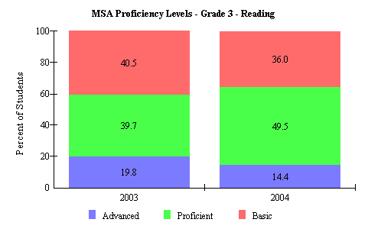 Source: 2004 Maryland Report Card
Source: Maryland Report Card

Figure 7: Percent Students 3rd Grade Maryland State Assessment Reading by
Race/Ethnicity and Gender

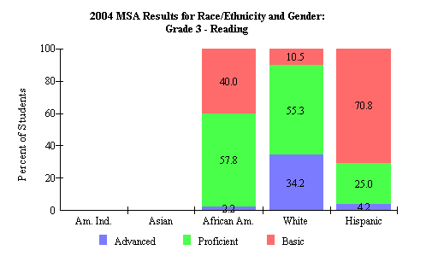
Source: Maryland Report Card
Source: 2004 Maryland Report Card

As shown in Figure 7, there were major differences in the scores of the different racial groups at Piney Branch Elementary. The White sub-group had the best scores when compared to their other 3rd grade peers. Approximately thirty-four percent of White students scored on the advanced proficiency level in reading, higher than African American and Hispanic students who had percentages of only 2.2% and 4.2% respectively. Nearly fifty-eight percent of African American students scored on a proficient level, compared to 55.3% of White students and 25.0% of Hispanic students. Hispanic students had the most children reading on a basic level, with 70.8%. This score can be compared to 40% of African American students who read at a basic level and 10.5% of White students (Maryland State Department of Education, 2004).

The MSA results for mathematics show small changes between the 2003 and 2004 assessments. As indicated in Figure 8, there was an increase of .3% in the number of students who scored on the advanced level for mathematics. There was a large decrease in the percentage of students who were scored at the proficient level in mathematics, which could be an area of concern in the coming years. This decrease was seen as an increase (7.4%) in the amount of students rated as having a basic level of math ability.

Figure 8: Percent Students 3rd Grade Maryland State Assessment Mathematics

Proficiency Levels Trends
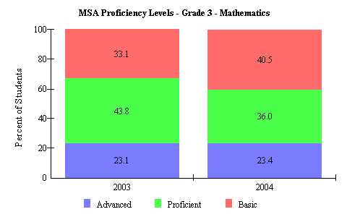
Figure 6: 3rd grade Maryland State Assessment scores for Mathematics

Surce: Maryland Report Card

Source: 2004 Maryland Report Card

As indicated in Figure 9 5th grade students also showed some differences between the 2003 and 2004 math scores. The group of students who were categorized as being on the basic level decreased by 10.2%, from 51.7% in 2003 to 41.5% in 2004. The group of proficient students increased from 33% to 45.9% (a 12.5% increase). There was also a decrease in the amount of students on the advanced level of 2.6%, which may suggest that more students are either becoming proficient, or that students are losing their skills and are reverting back to the basic level (Maryland State Department of Education, 2004).

Figure 9: Percent Students 5th Grade Maryland State Assessment Mathematics

Proficiency Levels Trends

Figure 8: 5th grade Maryland State Assessment scores for Mathematics

Source: Maryland Report Card

Figure 9: 5th grade Maryland State Assessment scores for Reading

Source: 2004 Maryland Report Card
Source: Maryland Report Card

Figure10: Percent Students 5th Grade Maryland State Assessment Reading

Proficiency Levels Trends

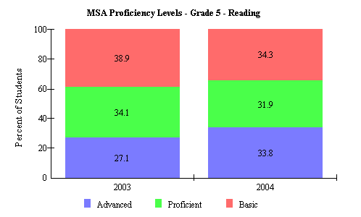

Source: 2004 Maryland Report Card

On the 5th Grade MSA Reading Assessment, there were also some significant changes in the 2003 and 2004 scores. As shown in Figure 10, the percent of students showing only a basic reading proficiency decreased 4.6%. Furthermore, the percentage of student demonstrating a proficient reading performance decreased 2.2%. Nevertheless, there were gains of 6.7% in the number of students who demonstrated advanced reading skills (Maryland State Department of Education, 2004).

Figure 10: Adequate Yearly Progress Scores for Takoma Park Elementary

Source: Maryland Report Card

Areas of Needed Program Enhancement

Takoma Park Elementary has shown that it is working towards achieving goals set by the state and federal mandates in meeting Adequate Yearly Progress. Nevertheless, there are areas that the school
should focus on, specifically they should concentrate on the Hispanic, special education, FARM and LEP students who did not meet the AMO. Each year the AMO rises, in the hopes that in the 2013-2014 school year, 100% of the students will have reached proficiency in the areas of reading and mathematics (Maryland State Department of Education, 2004). Perhaps to address this problem the school can give more assistance to the teachers that instruct these groups so that in the coming years their scores will rise in correspondence to the rising AMO.

Figure 11: Maryland State Assessment by Race/Ethnicity

Source: Maryland Report Card

Although Takoma Park met AYP in 2004, there is a gap between ethnic/race sub-groups and their White peers on the MSA, and more attention may help to close the divide. If the school were able to have a translator available at all times the non-English speaking parents would feel more comfortable coming to the school with their concerns. Perhaps the school could also have a meeting to address the needs and concerns of the families of these students.
igure 12: 2004 Adequate Yearly Progress in Mathematics

Source: Maryland Report Card

Figure 13: 2004 Adequate Yearly Progress in Reading

Source: Maryland Report Card

Furthermore, Piney Branch Elementary, the feeder school from Takoma Park, also shows data that indicates special education students did not met the AMO goals (Maryland State Department of Education, 2004). This school may need to provide additional attention and resources to the special education program to assist them in preparing their students for the assessment.
Outside of the needs of these English-language students, there are other students who could benefit from extra attention. These include some of the African American students whose scores are behind those of their White peers. To address the needs of these forgotten children, the school could begin after school homework programs to supplement the instruction that these students receive during school hours. There used to be such a program at the school, but it ceased to exist because of a lack of funds. A committee could be created to look for tutors who were willing to work with students as volunteers.

Bibliography

Maryland Technology Report. (2004). Retrieved October 30, 2004 from http://reports0304.md.ontargetus.com/SchoolSum.asp?otid=15x0754&accDesc=Takoma+Park+Elementary
Montgomery County Public Schools School-odex Results, (2004). Retrieved October 30, 2004, from http://www.mcps.k12.md.us/schoolodex/schooloverview.cfm
Maryland State Department of Education, (2004). Maryland State Report Card. Retrieved October 30, 2004 from http://msp.msde.state.md.us/school.aspx?WDATA=School&K=150754
United States Census Bureau, (2000). United States 2000 Census. Retrieved October 30, 2004 from http://factfinder.census.gov/servlet/SAFFFacts?_event=Search&geo_id=01000US&_geoContext=&_street=&_county=&_cityTown=takoma+park&_state=&_zip=&_lang=en&_sse=on

