Data Analysis and Interpretation Paper
Data Analysis and Interpretation with Technology Module: EDHD 435

Part 1

Fall 2004

Kathleen Sayers

November 1, 2004

Background Information

Introduction

Bel Pre Elementary School, school ID# 780, is located in Montgomery County, at 13801 Rippling Brook Drive, Silver Spring, MD 20906. It serves a diverse population and was Title 1 School several years ago. The mission of Bel Pre is in partnership with family and community is to enable each child to develop the knowledge and competencies necessary for success.
The school offers a morning and afternoon pre-K program, as well as a Head Start program, nine Kindergarten classes, nine first grade classes, and eight second grade classes. Following second grade, students at Bel Pre attend Strathmore Elementary School. The mascot at Bel Pre is a panda bear named Happy, who all of the children love and see when they enter the building each morning.
Staff
Bel Pre offers a low teacher to student ratio. The average Kindergarten class has 15.3 students and the average first or second grade classroom has 16.7 students. In addition to the teachers staffed in each room, the pre-K program has two classroom teachers, and there is a large support staff. The support staff consists of two art and two music teachers, a physical education instructor, a staff developer, an academic support person, an ESOL transition staff person, a math and a reading specialist, literacy support staff, speech, a special education instructor, a counselor, a media specialist, two nurses, and an ESOL specialist. There are also thirteen paraeducators that rotate through out the classrooms based on the class’ needs. More information can be found on Bel Pre Elementary School’s website at http://www.mcps.k12.md.us/schools/belprees/.
Demographics
The majority of people residing in the 20906 zip code region of Silver Spring in Montgomery County, Maryland, the community that Bel Pre Elementary School serves, vary from the racial/ethnic makeup of student enrollment at Bel Pre Elementary School. Figure 1 compares racial makeup of the neighborhood vs. the current student enrollment of Bel Pre Elementary School. In addition, Census data shows that this same neighborhood has a 34.1% immigration rate. This means, that 20,909 of the 61, 284 residents are not naturally born citizens. Of the 20,909, 55% were not citizens as of 2000. Approximately 40% of those over the age of five speak a language other than English in their home, and about half of these people speak Spanish as their primary language.

Figure 1: Racial Makeup Comparison of Bel Pre Elementary School Student Enrollment and Neighborhood

Source: 2000 U.S. Census Report and 2004 Maryland Report Card
As shown in Figure 1, in 2004, the 462 students at Bel Pre Elementary School represented a diverse community. Of those students, 48.5 percent are female and 51.5 percent are male, meaning there is hardly any gender gap. Approximately seven percent (7.4%) percent of the students are in special education programs, the majority of these being African American males. Eight percent (8.2%) of the students are in the ESOL program, the majority being Hispanic, and split rather evenly between males and females. However, these statistics are constantly changing as Bel Pre Elementary School has a profound mobility rate of 21.4 percent. The high mobility rate makes it more difficult to teach as children are coming and going during the year and do not have the same experience as the other children who have been there.
Socio-economic Status
In 2004, almost half (47.5%) of the students received FARMS (Free and reduced meal plans). Figure 2 shows the racial make-up of those receiving FARMS.
Figure 2: Racial/Ethnic Makeup of FARMS at Bel Pre Elementary School in 2004.
Source: 2004 Maryland Report Card
As the graph shows, over half of the students on FARMS are African American, and over a third are Hispanic, consistent with the enrollment at Bel Pre Elementary School.

Annual Yearly Progress
In 2004, Bel Pre Elementary School met Adequate Yearly Progress (AYP). Additionally, in 2004, the attendance rate reached 95 percent. Currently (2004-05), the school announces each day classes who had perfect attendance the previous day. All of the children listen to hear their class announced. This helps encourage them to want to be in school everyday.
Figure 3: Bel Pre Elementary School 2004 AYP Reading by Race/Ethnic and Special Interest Groups

Montgomery County (LEA:15) Bel Pre Elementary (ID:0780)
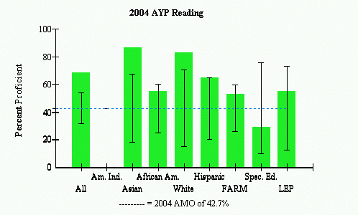
Source: 2004 Maryland Report Card
Figure 3 indicates that in 2004 AYP was met, as all sub-groups, except Special Education, met the states Annual Measurable Objective (AMO), represented by the blue dotted line, which was set at 42.7%. The Special Education sub-group is an area of concern, as they did meet the AMO, but due to the small number of special education students, the confidence interval or formula, allowed them to meet AYP. Two other areas that the school will need to concentrate on are the African American sub-group and the FARM special interest group. These two sub-groups actually overlap, as many African Americans enrolled at Bel Pre Elementary School are also FARM students. Figure 3 shows that while there are many of these students (the confidence interval represented by the black “I” bar is fairly short) the group is only moderately passing the states AMO. As the state’s AMO is increased each year, in 2005, this group may find it harder to meet the AMO unless the school has targeted this group improvement.

Figure 4: Bel Pre Elementary School 2004 AYP Mathematics by Race/Ethnic and Special Interest Groups

Montgomery County (LEA:15) Bel Pre Elementary (ID:0780)
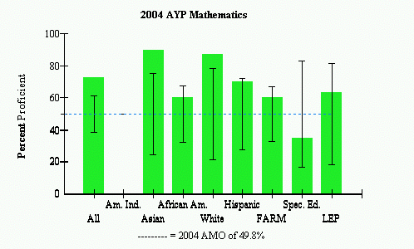
 |  | AYP Met |  |  | AYP Met with Safe Harbor |  |  | AYP Not Met

Source: 2004 Maryland Report Card
Figure 4 shows the AYP in Mathematics was met in all areas except for Special Education. As explained above, Bel Pre Elementary School has a small population of special education students, so the confidence interval allows them to met AYP. Similar to the AYP in Reading, the results for Mathematics show areas of concern for African American and FARMS students. Both groups, which overlap, barely passed the AYP in both areas. These need to be a strong area of focus in the future for this school.

Technology
Each classroom in the school has two computers for student and teacher use, all of which have Internet access. Each class also goes to a computer lab once a week to play games, read books on the computer, or for other instructional purposes. Bel Pre has a student to computer ratio of 3.3:1, better than the Montgomery County average of 4.2:1, and well below the Maryland target of 5:1. Bel Pre Elementary School obviously has a lot of computers and uses them often so that children are aware of technology and know how to use it. This is extremely important as this school since only 45 percent of the students have Internet access at home. Technology is also implemented by use of overhead projectors. Many classrooms have learning games children can use with overheads, and at times simply allow the younger children to draw on transparencies using the overhead. Further information can be found at the Maryland Technology Inventory Report. Bel Pre Elementary School also has TV’s for the classrooms to share, so that power point presentations or videos can be shown to the class or parents. An area of concern, however, is what the computers are used for. So far I have only seen them used as supplementary reading and mathematics resources.

Areas for Improvement
Bel Pre Elementary School is an advanced school that offers many programs and advantages to a diverse population. One area for improvement, however, is increased home school communication. While there are some parents that are involved with the school, the majority have never been to the school or even met their child’s teacher. The open house had a rather low attendance and it might be a good idea to implement home visits before the start of each school year.

Bibliography
Maryland Business Roundtable (2004). Where do we stand in 2004?: OnTarget
Technology Inventory Report. Retrieved November 1, 2004, from
http://reports0304.md.ontargetus.com/
Maryland State Department of Education (2004). 2004 Maryland report card. Retrieved
November 1, 2004 from http://msp.msde.state.md.us/
Everitt,C.F., Klavans,P.A., Schnabel,D., & Uruburo,G. (2004). Bel Pre Elementary
Website. Retrieved November 1, 2004 from
http://www.mcps.k12.md.us/schools/belprees/

