Data Analysis and Interpretation Paper
Data Analysis and Interpretation with Technology Module: EDHD 435
Part 1

Fall 2004
Amanda Turner
November 31, 2004

Background Information

Introduction

Bel Pre Elementary School, school ID # 0780, is located in Local Educational Agency #15, in Montgomery County Maryland, at 13801 Rippling Brook Drive, Silver Spring, Maryland. Bel Pre currently has one Head Start program for four year old students, two sections of Extended Elementary Education Program (Pre-K) for four year old students, nine sections of full-day Kindergarten, nine sections of First Grade, and eight sections of Second Grade. This school is a primary school, housing Pre-K to Second Grade, and feeds into Strathmore Elementary School which houses third through fifth grade. The mission of Bel Pre Elementary School in partnership with family and community is to enable each child to develop the knowledge and competencies necessary for success. One-seventh of the faculty members are new to the building, meaning that most of the faculty members are returning from last year. The school represents a multicultural neighborhood, and consists of mainly African American students (38%), Hispanic students (24%), White students (10%), Asian students (8%), and American Indian students (.05%). Total, Bel Pre has 560 students.
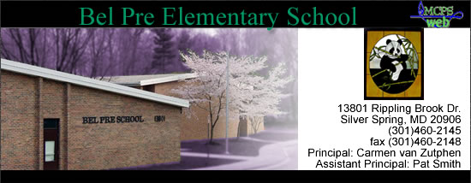Source: Bel Pre Website
Figure 1: Bel Pre Elementary School Student Enrollment by Race/Ethnicity from 1993-2004.
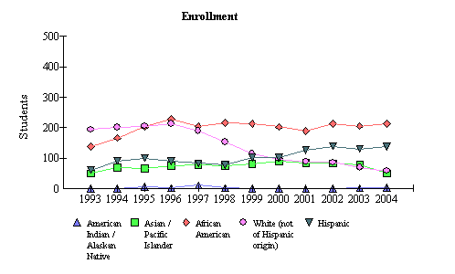

Source: 2004 Maryland report Card

Bel Pre is a Title 1 State Compensatory Education program school. The Title 1 instructional assistants, under the direction of teachers, work with students to improve the students’ reading/language arts and mathematics skills using such programs as MARS (Moving Ahead in Reading with Students) and MARS STARS (a modified Reading Recovery Program).
Character Education is very important at Bel Pre, and the school emphasizes four bi-monthly themes: responsibility, caring and sharing, honesty, and courtesy. Each year, “Panda Pennies” are collected to help sick children who stay at the inn at N.I.H.
Parent Volunteers are also vital to Bel Pre, and the school has received Outstanding Volunteer Awards from the state for many years. A previous Bel Pre PTA president, John Hallen, was also awarded recognition at the county and state level for his work on the Nature Trail—a marvelous, mile-long outdoor classroom for environmental study that was completed by parents, community members, and staff.
Bel Pre has an active mentoring program, including staff mentors and also students from Kennedy High School who come to Bel Pre once a week to meet with one of their fifteen mentees. Additionally, members of the Battle Cry of Innocence (BCOI) have mentored ten children in grades one and two. They will continue working with these students throughout the year. More information about the school can be accessed from the school’s website: http://www.mcps.k12.md.us/schools/belprees/index.shtm.
Demographics
Detailed demographic information for the Bel Pre Elementary School community neighborhood can be found through the U.S. Census Bureau. The last Census indicates 36.5% (or 17, 105) of individuals age five and older speak a language other than English at home (compared to the average of 17.9% in the United States).

Figure 2: Map of Bel Pre Elementary and Silver Spring, Maryland in relation to the individuals who speak a language other than English at home
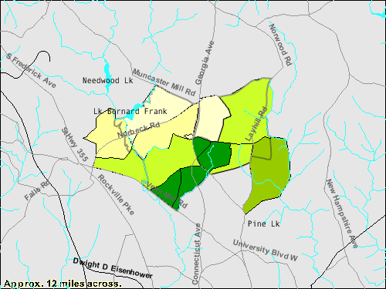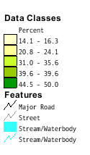
Source: 2000 U.S. Census Bureau
Figure 2 exhibits information on the percentage of individuals over the age of five who speak a language other than English at home. The dark green areas of the map indicate an area where many people speak other languages at home other than English, and the yellow areas represents an area less populated by those over age five that speak a language other than English at home. By examining the neighborhood surrounding Bel Pre Elementary, one can infer that the school needs to encourage an English Language Learners (ELL) Program, due to the diverse population and needs of incorporating teaching the English language in the school environment. 30.5% of the surrounding Bel Pre Elementary population is foreign born (compared to 11.1% of the average U.S. population), further supporting the need for an ELL program.

Staffing
Currently, Bel Pre has 71 Staff Members total. They consist of 32 classroom teachers, 1 ESOL teacher, 1 Focus ESOL Transition teacher, 1 Math Specialist, 2 art teachers, 1 media specialist, 2 music teachers, 1 Academic Support, 1 Reading Specialist, 1 Literacy Support, 1 Resource teacher, 1 Speech teacher, 1 Staff Development, and 13 paraeducators. Supporting students’ learning via special service providers, EMT specialists, and academic supporters are a priority at Bel Pre in order to meet all the individual, diverse needs of the school population.
At this time, 12.6% of the classes are not taught by highly qualified teachers. According to the 2004 Maryland Report Card, "Highly qualified" is a specific term defined by No Child Left Behind (NCLB). The law outlines a list of minimum requirements both in content knowledge and teaching skills to meet the "highly qualified" status. The law requires teachers to have a bachelor's degree and full state certification and to demonstrate content knowledge in the subjects they teach. Under NCLB, states decide what is necessary for certification and for determining subject-matter competency. Rules surrounding the requirements for highly qualified teachers continue to be developed and refined. More information about the definition of “Highly Qualified” can be obtained from this website: www.marylandpublicschools.org/MSDE/divisions/certification.
About 59.4% (19 out of 32) of the staff hold Advanced Professional Certificates, meaning at least 3 years of full-time professional school-related experience, 6 semester hours of acceptable credit, and a master’s degree, or a minimum of 36 semester hours of post baccalaureate course work which must include at least 21 hours of graduate credit. This percentage is up 3.4% from last year’s 55.9% (19 staff members out of 34), but the staff also lost two members this year from last, allowing for a higher percentage.

Technology
According to the information obtained from the Maryland On-Target website about Bel Pre’s individual technology report, it is obvious that the student to computer ratio is excellent at 3.3 students to 1
Source: http://reports.md.ontargetus.com
Figure 3: Bel Pre Student to Computer Ratio
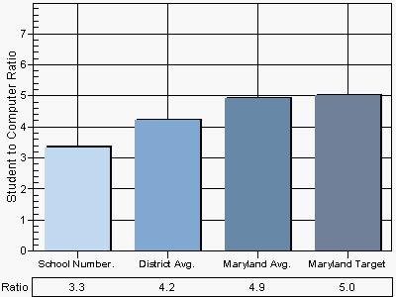
computer. Figure 3 demonstrates the outstanding ratio above, showing that the Maryland average ratio is 4.9 children to 1 computer, and the Maryland target (the goal ratio) is 5.0 children to 1 computer. Bel Pre is 1.7 students below the goal, demonstrating a first-rate ratio.
In 1997 the Maryland State Board of Education approved Bel Pre as a school for inclusion in the Technology in Maryland Schools Program. Funds for this program were allocated for installation of a building-wide network and additional computer hardward and software. The Research/Learning Hub is locating in the Media Center where five computer work stations are available to students for research or other academic purposes. There are four computers in each classroom, and it is apparent that every opportunity is utilized to infuse technology into all instruction settings. For example, Bel Pre’s Computer Use, according to the On-Target website, is 91.00%. This is an excellent percentage compared to the Maryland average total computer use of 72.84%. Maryland Target is obviously 100%, but Bel Pre is not far behind from the Target. Bel Pre’s Internet Use is also at a high percentage (80%) compared to the Maryland Totals (67.12%). Most importantly, Bel Pre’s Technology Integration is the most exceeding at 99.00%, extremely high compared to the Maryland Totals of only a mere 68.65%.
It is obvious that Bel Pre is exceeding in its Technology integration, and the school makes the use of technology a top-notch priority. One can also infer that the teachers and media specialists are very educated in this technology and do not lack training, being that they incorporate it into their teaching and are able to put their computers to use during the school day.

AYP Results and Other Assessments
Average Daily Attendance
Bel Pre’s attendance rate for 2004 is 95.0%, a pretty consistent average since 1993. The average daily attendance for a given year is based on the aggregate number of enrolled students who are present in school each day of the September to June school year. The percent average daily attendance is calculated by dividing the aggregate number of students in attendance by the aggregate number of students in membership for the September to June school year. This year, 38.8% of the children absent missed fewer than 5 days, while 8.2% have missed more than 20 days.
Attendance rate across Race/Ethnicity and Gender was very similar: African American 95.5%, Hispanics 94.7%, Asian 95.4%, and White 94.1%.
Reading
Figure 4: Bel Pre’s 2004 AYP Percent Proficiency for Reading by Ethnic/Race and Special Interest Groups
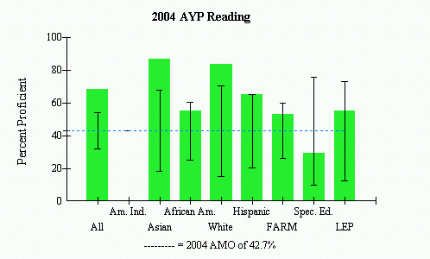
Source: 2004 Maryland Report Card
As figure 4 shows, 68.2% of all Bel Pre students were proficient in Reading in 2004. This chart also demonstrates that 86.7% of all Asians were proficient, 83.3% of all White students were proficient, 64.9% of Hispanics were proficient, while only 55% of all African Americans were proficient. Although the school as a whole met AYP requirements for reading, it appears that the Hispanic students, and even more, the African American students are struggling. Out of 37 Hispanic students, only 24 were proficient. Worse, only 33 of African American students out of 60 were proficient.
The Special Education students did not meet the Annual Measurable Objective (AMO) proficiency level benchmark set by the state. However, because there only a few of these students, the confidence interval allows this sub-group to meet AYP.
MSA Third Grade Reading at Strathmore Elementary
Figure 5: Strathmore Elementary MSA Proficiency Levels for grade 3 Reading
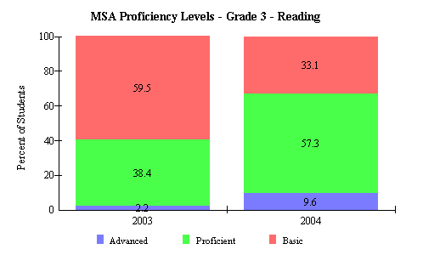
Source: 2004 Maryland Report Card
Strathmore Elementary School is Bel Pre’s feeder school into third grade (third through fifth). Therefore, it is imperative one study the MSA Reading scores for third graders to see improvement or decent once Bel Pre students graduate to Strathmore. It is apparent by Figure 5 that all areas (Basic, Proficient, and Advanced) have improved from 2003 to 2004. The Advanced percentage has increased by 7.4%, the Proficient level percentage has increased by 18.9%, and the Basic level has improved by 26.4%--incredible increases. However, it is still a major goal to have all students in either the Advanced or Proficient levels by third grade, and this is needed to be achieved at Bel Pre in order for them to be Proficient or Advanced at Strathmore.

Math
Figure 6:Bel Pre’s AYP Percent Proficiency Report 2004 for Math by sub-groups
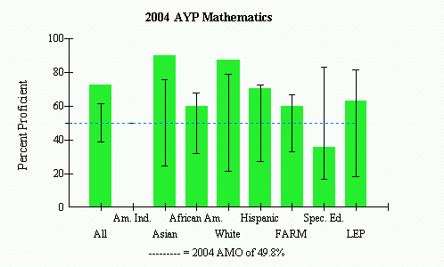
Source: 2004 Maryland Report Card

As seen in Figure 6 72.5% of all students at Bel Pre Elementary School were proficient in Math. One can also see that 89.7% Asian students were proficient, 87% of White students were proficient, while only 70% of Hispanics and 60% of African Americans were proficient. Once again, although the school as a whole met AYP, these two sub-groups (Hispanic and African Americans) seem to be struggling. Only 26 out of 37 Hispanic students were proficient, and only 36 out of 60 African American students were proficient. Special Education is once again did not meet the Annual Measurable Objective (AMO) proficiency level benchmark set by the state. However, once again since there are so few of them, the confidence interval allows them to meet AYP.

MSA Third Grade Math at Strathmore Elementary
As stated above, Strathmore Elementary School is the feeder school from Bel Pre. Therefore, Strathmore’s third grade math MSA scores reflect the jobs the teachers at Bel Pre are doing, and it important to analyze this data.
Figure 7: Third Grade Math MSA Data from Strathmore Elementary School
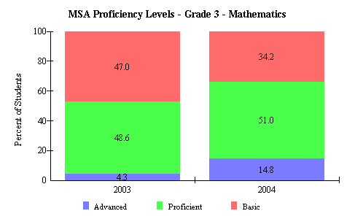
Source: 2004 Maryland Report Card
As in Reading, the percentages have increased positively from 2003 to 2004. The Advanced level percentage has risen from 4.3% in 2003 to 14.8%--a dramatic increase of 10.5% in one year. The Proficient level has only risen from 48.6% in 2003 to 51.0% in 2004—only an increase of 2.4%. The Basic level has decreased from 47% in 2003 to 34.2% in 2004—a positive decrease of 12.8%.
Areas of Needed Improvement
It is apparent through Strathmore’s third grade MSA scores in Reading and Math that Bel Pre is working towards dramatic improvements every year. The fact that they met AYP is excellent, although they need to concentrate on their Hispanic and African American students’ Reading and Math abilities. Classroom activities and procedures should allow for more teaching assistants, parents, community volunteers, or Bel Pre’s mentoring program to help with supplemental activities that are usually done at home. Directions that go home for homework should also be offered in Spanish for those Hispanic families that speak a language other than English at home. Since technology is so big at Bel Pre, and the children use it regularly, perhaps some sort of online communication could be used a resource for those families who have computers at home. Overall, Bel Pre needs to continue the hard work and improvement—but they need to focus on these sub-groups of students who need to catch up.

References

Maryland State Department of Education. “Maryland Teacher Staffing Report 2004-2006”.
http://www.marylandpublicschools.org/NR/rdonlyres/B552E542-F940-4BD2- 88C0-532BA4EEF4BB/3168/TEACHERSTAFFING.pdf (29 Oct. 2004)

Montgomery County Schools. “Bel Pre Elementary School”.
http://www.mcps.k12.md.us/schools/belprees/index.shtm (29 Oct. 2004)

School Improvement in Maryland. “Analyzing your MSA data Galway Elementary”.
http://www.mdk12.org/data/msa_data/index.asp?K=150313 (29 Oct. 2004)

U.S. Census Bureau. “American Fact Finder”.
http://factfinder.census.gov/home/saff/main.html?_lang=en (29 Oct. 2004)

