Data Analysis / Interpretation
Weller Road Elementary

Alexandra Rattner
EDHD435
Final Prjoect
December 12, 2004

Background Information

Introduction

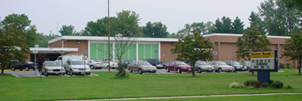
Weller Road Elementary School is located in Montgomery County Maryland, at 3301 Weller Road in Silver Spring. It is school ID # 777 and is part of the Downcounty Consortium. The mission of Weller Road Elementary is we are a family working hand in hand towards excellence. The school first opened in 1953 and we renovated the first time in 1975. The school has just been approved for school renovation and student regrouping plans to start effective September 2007. Weller Road Elementary has 566 students ranging in ages and grade levels from Pre – K through fifth grade. The community of the school is very multicultural with many different language learning students in the school. The school offers three different buses to three different parts of the town that are too far for children to walk. However, most of the students are either picked up by their parents or walk home.
Source: Montgomery County Public Schools, 2004
Weller Road is open on the weekends for teachers to use the facilities to do work; the computer lab, copy room, and library are also open for their convenience. Over the past few years the enrollment at Weller Road has been on a steady increase, and continues to do so. However, the number of students will change when the new renovation project of the consortium begins.

Demographics
The total population for the town of Wheaton, where Weller Road Elementary is located
has a total population of 57,694. Weller Road Elementary, and just like many of the neighborhoods in which children attend Title 1 schools, many of the families there are immigrants from other countries. Although from the school environment the demographics of the families that live there would seem quite diverse 75.1% of the population is White, while only 12.3% are African American and 12.5% are Hispanic or Latino. The total number of households in the city of Wheaton was 19,608 as recorded in the 2000 Census. The mean income for these households $69,368, while the medium income was $59,211. Of the total number of households only 15.4% of the households had an income less than $25,000 a year. The educational attainment is quite interesting to look at. For the year 2000 there was a total of 4,716 people in some sort of educational institute. Of those 4,716 1,485 attained an education of less than high school, 1,009 had a high school degree, 1,615 had a some college or associate degree and 607 had a bachelor’s degree or higher.
Figure 1 shows the trends in student enrollment at Weller Road Elementary School by Race.

Figure 1. Student Numbers enrolled at Weller Road Elementary School from 1993-2004
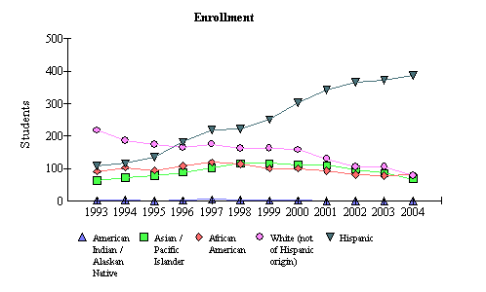

Source: 2004 Maryland report Card
In the beginning of 2004 there were 614 students enrolled at Weller Road. Of those, 387 were Hispanic, 79 were White, 80 were African American, and 68 were Asian / Pacific Islander. Figure 1 indicates that in 1999 there began a huge increase in the number of Hispanic students enrolled in the school, while there was a steady drop in the number of White, African American and Asian / Pacific Islander students. These increases and drops in certain races of students continues to be the trend to the present day. By looking at the numbers one might infer that many of the students probably speak English as a second language. The language barrier at Weller Road, as well as among other Title 1 schools in Montgomery County Public Schools makes parent involvement difficult not only in the home but in the school as well. There is a barrier between the teachers, the specialists and the administrators that make it very difficult to communicate issues and concerns of children.
In Weller Road there were 62 students in Pre – K, 88 students in Full Day Kindergarten, 94 students in first grade, 97 students in second grade, 84 students in third grade, 95 students in fourth grade and 94 students in fifth grade in 2004. Of those 614 students 61.6% are receiving free and reduced meals. The mobility rate at Weller Road (entrants and withdrawals) was only 21.4%. Most of the students in the Weller Road Community come from low social economic status (SES) families and therefore show the high percentage of students who receive free or reduced meals (FARM). Title 1 services like Free and Reduced Meals are provided to schools like Weller Road who are in need of support. Title 1 is the largest program of federal funding in education, signed into law in 1965 by President Lyndon Johnson. President Johnson recognized the extremely difficult problem that children throughout the country were having with their reading and mathematics. In an effort to help them catch up, extra attention, materials, and teachers were provided by the Elementary Secondary Education Act, Title 1 (ESEA).

Staffing
The school staff at Weller Road is quite a young staff. 25 % of the teachers have Advanced Professional Certificates, 63.9% have Standard Professional Certificates, and 8.3% have Conditional Certificates. The percent of teachers is based on the number of teachers assigned in the school building to each core academic subjects.

The school has 28 classrooms, 14 portables, a gym, and an All Purpose Room which doubles as the cafeteria, and auditorium. The school also has a media center, two art rooms, two music rooms, one for instrument use and one for music education, and a computer lab which every class has full access to. There are 5.6 paraeducators in the school, 3 math curriculum specialists (one for Kindergarten – 2nd and one from 3rd – 5th) 5 ESOL teachers, 1 staff development supervisor, and 4 building service workers. The average class size in Kindergarten is 14.2 students, 1st and 2nd grade has roughly 16 students in a class and 3rd – 5th grade has around 22.5 students in each class. As a result of the small class size and the abundance of teachers working in the school the Student / Instructional Staff Ration is 10:1.

Technology
As we move into the 21st century, technology has become an important part of the education of young children. Weller Road Elementary School offers technological resources for all of the students and the teachers in the school. In the classroom the ratio is about 5: 1 for student to computer use (Maryland Technology Inventory, 2004).
Every classroom and portable has access to the internet and computer use. Every classroom has at least two computers besides the teachers’ computer. The library also has eight extra computers for use, as well as a computer lab of about 25 computers. Since most of the teachers at Weller Road Elementary School are young, most of them have experience with computers and internet use. The school just started using Palm Pilots for Running Records and every teacher must go through two sessions of training so they can appropriately be able to use them in the classroom. This year the Math Curriculum Specialists starting making data charts of each class after each Unit Test. Using these spreadsheets they use conditional formatting to red flag the questions that the students had the most trouble with so they can go over it and know which questions they need to retest the students on.

AYP Results and Other Assessments
Maryland State Assessment (MSA) measures the progress of schools on yearly basis. Student achievement must be assessed in accordance with federal requirements since the passing of No Child Left Behind. Schools must report achievement in reading, mathematics and attendance for five race/ethnic groups, as well as, special education, FARM, and Limited English Proficiency (LEP) students. These assessments are broken into three performance proficiency standards: Advanced, Proficient and Basic.
The Maryland Report Card explains these levels as:
- Advanced is a highly challenging and exemplary level of achievement indicating outstanding accomplishment in meeting the needs of students.
- Proficient is a realistic and rigorous level of achievement indicating proficiency in meeting the needs of students.
- Basic is a level of achievement indicating that more work is needed to attain proficiency in meeting the needs of students.
All categories must be met for by all sub-groups for schools to met the state’s Adequate Yearly Progress (ATP) measure.

Average Daily Attendance
The attendance rate reflects the percentage of students present in the school for least half the average school day during the school year. Weller Road Elementary School in 2004 had an attendance rate of 96.2% and met the annual AYP. Over the last two years their attendance has remained at the same level, if not improved.

Reading & Mathematics
Figure 2 shows the changes of assessment from 2003 to 2004. The figures show that between 2003 and 2004 the number of students assessed at a basic reading level dropped by more than half (49.5% to 22.4%) The students at the proficient level went from 44.3% to 67.1% an increase of 22.8%. There was also an increase in the advanced level; a 4.4% increase, which is great. Overall the proficiency levels of grade 3 improved.

Figure 3 indicates that the mathematics assessments were of similar nature. The level of students on a basic level decreased 8.9% between 2003 and 2004. The level of students on the proficient level in increased slightly by .7%, while the number of students on the advanced level increased by 8.2%

Figure 2. 2004 Percent Reading Proficiency Levels for grade 3 Reading at Weller Road Elementary School between 2003 and 2004
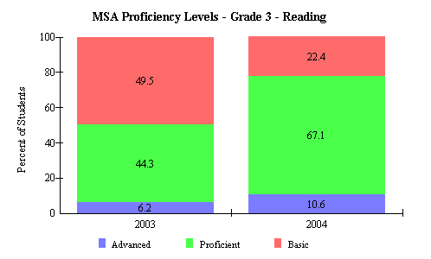

Source: 2004 Maryland Report Card
Figure3. 2004 Percent Mathematics Proficiency Levels for grade 3 Reading at Weller Road Elementary School between 2003 and 2004
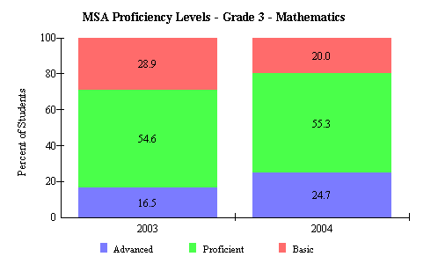

Source: 2004 Maryland Report Card
Source: 2004 Maryland Report Card

Although Weller Road Elementary School met AYP in 2004, there are still areas for the school to work on. Figure 4 shows Weller Road Elementary Schools’ percent proficiency for reading in 2004 by sub-groups. While all sub-groups meet the Annual Measure Objective (AMO) set by the state at 46.3% in 2004, Special Education just reached the target and the LEP and African American groups only just surpassed this target. All these groups could show increased performance.
Figure 4. Weller Road Elementary School percent proficiency for reading in 2004 by sub-groups
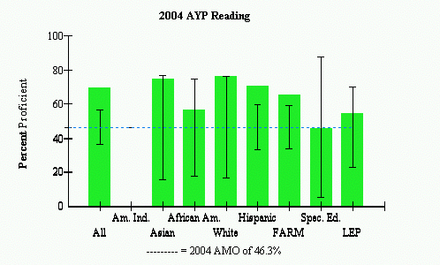
 |  | AYP Met |  |  | AYP Met with Safe Harbor |  |  | AYP Not Met
Source: 2004 Maryland Report Card

Additionally, as shown in Figure 5, the Special Education sub-group did not meet the state set AMO in 2004. The formula adjustment for number of students allows the group to still fall within the confidence interval, indicated by the black “I”, and therefore still able to meet AYP. However, this should be an area of concern for the school.

Figure 5. Weller Road Elementary School percent proficiency for math in 2004 by sub-groups

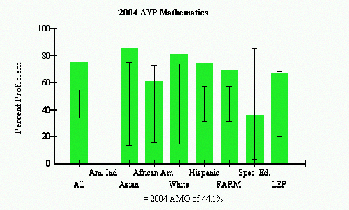
 |  | AYP Met |  |  | AYP Met with Safe Harbor |  |  | AYP Not Met
Source: 2004 Maryland Report Card

Areas of Needed Improvement
Although Weller Road Elementary has meet all of their objectives for AYP there is always room for improvement. The school can and should work to continue the increased reading improvement and try to move as many students out of the basic level as possible. They should also try and figure out ways to increase the communication between the parents and the school. Looking at the diversity of the community language and culture will be a barrier and continue to be in the future, so necessary steps are going to be needed to create less of a barrier and more a bridge between the two. Don’t forget parents and teachers working together is the best way to make sure that the students in the school have a successful education.

