Data Analysis and Interpretation Paper
Data Analysis and Interpretation with Technology Module: EDHD 435
Part 1

Fall 2004
April Lachica
November 1, 2004

Background Information

Introduction

New Hampshire Estates Elementary School (NHE), school ID # 0791, is located in Local Educational Agency # 15, in Montgomery County, Maryland, at 8729 Carroll Avenue, Silver Spring, Maryland. NHE just celebrated its 50th birthday this past October 2, 2004. The school holds only primary grades, from pre-kindergarten, including a Head Start program to second grade. NHE is part of the Montgomery Blair High School Cluster. It feeds into Oakview Elementary School, with grades three through five. Previously, the school traditionally had grades pre-K to fifth grade until they split the grades between NHE Elementary and Oakview Elementary School. There are four different buses that take children to and from school, while the majority of the students are dropped off and picked up by parents or guardians. The mission of New Hampshire Estates is here, taken from the school’s website:
What makes NHE so special?
We are a primary school with a special school focus on Reading and Language Arts. Our mission is to provide a language-rich learning environment for students, parents, and staff, which promote individual growth, creativity and independence through active participation, risk-taking opportunities, and real-life problem solving experiences. To insure (sic) success for every student, instruction takes place at developmentally appropriate levels in a variety of group sizes from individualized to whole class.

NHE offers several programs, including, Academic Support-Federal Title I Funds, Head Start, Full Day Kindergarten, Reading/Language Arts Magnet, Linkages to Learning, Language Disabilities for kindergarten. There is also a teacher resource center, computer lab, instructional assistants (IA) in every class, Internet and soccer after school clubs, and a Pathways Accelerated Math Program.
As far as involving families in school life, each month there is a parent coffee meeting where parents can meet with the Parent Involvement Coordinator. There is also a Family Learning Night, which many of the students and families attend. The music teacher and students also put on seasonal music concerts.
Demographics:
School Demographics
In 2004, the official enrollment was 394 students. This number can move up or down during the course of the year due to a high mobility rate of 36.1 percent. Roughly 49.5 percent of the 2004 enrollment is female, with 50.5 percent male. Nineteen percent is African American, 13.5 percent Asian, 60.9 percent Hispanic, and 6.1 percent White. About 74 percent of the students are on Free and Reduced Meals (FARMS), which qualifies the school for its Title I funds. About 37 percent are in the ESOL program. The percentage of students in Special Education is about six percent of the school population (Maryland report Card, 2004).
Community Demographics
In Silver Spring, MD, 46.6 percent of people are White, 28,1 percent are Black or African American, 0.4 percent is American Indian or Alaskan, 22.2 percent are Latino and 8.2 percent are Asian (American Fact Finder, 2004). Silver Spring has multiple zip codes, much like Washington DC. Therefore, because Silver Spring is a large city, the racial makeup of an area can vary from zip code to zip code. The NHE community has more Latino people, which is evident from the official school enrollment data. Approximately 60 percent of the students are Latino.
According to the American Fact Finder, there are 1,127 families in the NHE community that are below the poverty level, which are 6.4 of the overall population in the area. Of those 1,127 families below the poverty level, 843 families have children under the age of 15, which is roughly 8 percent of the overall population. About 22 percent of the population in the NHE area is Latino, with eight percent being Mexican, about 3 percent Puerto Rican, and about two percent Cuban. The remainders of the Latino group are from Central America, South America, or Spain (American Fact Finder, 2004). NHE serves a diverse group of students according to these percentages in Silver Spring, MD.
Staffing
The student/Instructional Staff Ratio in 2004 was 5.2. The average Kindergarten class size was 13.9 students. Grades 1-2 had 16.8 students on average. There are 24 classroom teachers, one staff development professional, 7 ESOL teachers, one reading teacher, one P.E, Music and art teacher, one Special Education teacher, one teacher for the Resource Program, and three preschool (Head Start) teachers. There are a total of 46.9 teachers for the 2002-2003 school year. There are also various support staff. There are about 15 Instructional Assistants, one interpreter, and one regular media assistant. In total, there are about 54 professional staff positions and about 24 supporting staff positions (Montgomery County Public Schools, 2004).
Of all teachers at NHE in 2003, 41.9 percent of teachers were state certified, with Advanced Professional Certificates. In 2004, the percentage went up to 48 percent of teachers with an Advanced Professional Certificate (Maryland Report Card, 2004). To obtain an Advanced Professional Certificate, a teacher must have, “verification of 3 years of full-time professional school-related experience, 6 semester hours of acceptable credit; and a master’s degree, or a minimum of 36 semester hours of post baccalaureate course work which must include at least 21 hours of graduate credit,” (Maryland State Department of Education, 2004) In 2003, 54.8 percent of teachers had a Standard Professional Certificate. To obtain a Standard Professional Certificate, teachers must have, “3 years of satisfactory, professional school-related experience plus 6 hours of acceptable credit and a professional development plan for the Advanced Professional Certificate,” (Teacher Qualifications in Maryland: Definitions: 2004 Maryland Report Card). In 2004, the percentage went down to 52 percent of teachers that held a Standard Professional Certificate. There are currently no teachers who hold a Resident Teacher Certificate, which is a teacher who specializes in a program and is chosen by MCPS. Also, in 2004, there are no teachers with conditional certificates, which the superintendent specially requests for a person who does not meet all the criteria for a certificate.

Technology

According to Table 1, New Hampshire Estates has an excellent ratio of students to computers. Students at NHE have great availability of computer use to them because the Maryland Target is five students to one computer, which NHE has surpassed with 3.8 students to one computer. NHE has also passed Montgomery County Public Schools average of 4.2 students to one computer.

Table 1: New Hampshire Estates Elementary Student to Computer Ratio

School | Ratio
New Hampshire Estates Elementary | 3.8 :1
Montgomery County Average | 4.2 :1
Maryland Average | 4.9 :1
Maryland Target | 5 : 1
Source: 2004 OnTarget New Hampshire Estates Elementary Report

Teachers also are quite skilled in technology use. As shown in Table 2, 75 percent of teachers at NHE are skilled at understanding file organization, utilizing the computer to browse the structure of files, and backing up files. The Maryland total for teachers who have knowledge of Computer Use was 72.84 percent. For Internet use, 60 percent of NHE teachers know how to use the Internet. This means that they know how to design assignments which would have students make use of the Internet as a resource. Finally, just 50 percent of NHE teachers know how to integrate this technology into their classroom. This means that they know how to use Word and Excel to plan for their lessons. They can also help students use computer games for instruction and access Internet sites.

Table 2: New Hampshire Estates Elementary Teacher Knowledge and Skills
School | Computer Use¹ | Internet Use² | Technology Integration³
NewHampshireEstates Elementary | 75.00% | 60.00% | 50.00%
Montgomery County Totals | 77.29% | 74.18% | 78.56%
Maryland Totals | 72.84% | 67.12% | 68.65%
Maryland Target | 100% | 100% | 100%

1. Intermediate Computer Use: Understands file organization. Uses computer utilities to browse file structure. Knows how to backup files.
2. Intermediate Internet Use: Able to design classroom or homework activities for students, which require the students to use the Internet as a reference resource.
3. Intermediate Technology Integration: Uses productivity tools, such as word processing and spreadsheets, to develop lesson plans. Able to help students use Instructional software and access Web sites.
Source: 2004 OnTarget New Hampshire Estates Elementary School

Adequate Yearly Progress and Other Assessments
According to Table 3, Adequate Yearly Progress (AYP) was met at NHE Elementary School in 2004. In order for a school to meet AYP, all the indicators must be met by all of the subgroups.
Table 3: 2004 New Hampshire Estates Elementary School Percent Proficiency by Race/Ethnicity and LEP, FARMS and Special Education
 | 2004 AYP: |  | Met
 | Show Trends |  |  | All indicators must be "Met" to make AYP. For details, click on the links below.
 |  |  |  | Percent Proficient |  |  |  | Participation Rate
 |  |  |  | Reading | Mathematics |  |  | Reading | Mathematics |  |  | Attendance
 | All Students |  |  | Met |  | Met |  | Met |  | Met |  | Met
 | American Indian/ Alaskan Native |  |  | -- |  | -- |  | -- |  | --
 | Asian/Pacific Islander |  |  | Met |  | Met |  | Na |  | na
 | African American |  |  | Met |  | Met |  | Na |  | na
 | White (not of Hispanic origin) |  |  | Met |  | Met |  | Na |  | na
 | Hispanic |  |  | Met |  | Met |  | Met |  | Met
 | Free/Reduced Meals |  |  | Met |  | Met |  | Met |  | Met
 | Special Education |  |  | Met |  | Met |  | Na |  | na
 | Limited English Proficient |  |  | Met |  | Met |  | Met |  | Met

'--' indicates no students in the category. 'na' indicates too few students for AYP rules.
Source: 2004 Maryland Report Card

Because NHE is a primary school, none of its students take the Maryland School Assessment. However, there are data available that reflect the Math, Reading and Attendance trends.
Figure 1. 2004 New Hampshire Estates Elementary School AYP Results in Reading

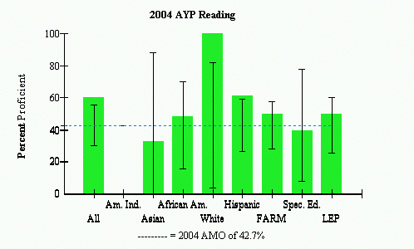
 |  | AYP Met |  |  | AYP Met with Safe Harbor |  |  | AYP Not Met
Source: 2004 Maryland Report Card
For the AYP Reading scores at NHE (see Figure 1), all of the groups met the AYP. However, the Asian and Special Education groups did not meet the Adequate Measurable Objective (AMO), of 42.7 percent set by the state in 2004. White students had the highest percent Proficiency, with nearly 100 percent, and Hispanic students came in second, with roughly 60 percent. African-American, FARMS, and LEP students came in around the same percentage, slightly above the AMO.
As shown in Figure 2, the 2004 mathematics AYP was met by NHE. The AMO were met by all sub-groups except for the special education students. They did not meet the 2004 AMO of 49.8 percent. The three highest student groups that scored well on the mathematics proficiency assessment were the White, Hispanic and LEP students.

Figure 2. 2004 New Hampshire Estates Elementary School AYP Results in Mathematics

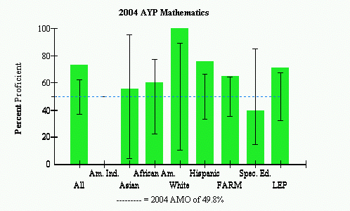
 |  | AYP Met |  |  | AYP Met with Safe Harbor |  |  | AYP Not Met

Source: 2004 Maryland Report Card

AYP also includes the attendance results for each school. As shown in Figure 3, NHE was above the 2004 AMO set by the state at 94 percent. Students have to be present in school to be able to learn. Next years attendance AMO is also set at 94%.
Figure 3: 2004 New Hampshire Estates Elementary School AYP Results: Attendance
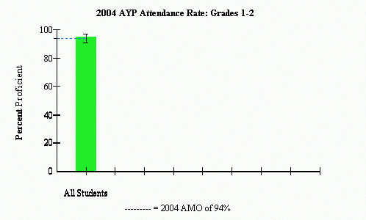
 |  | AYP Met |  |  | AYP Met with Safe Harbor |  |  | AYP Not Met

Source: 2004 Maryland Report Card

Areas of Needed Program Enhancement
After reading the School Improvement Plan for NHE, I learned that the main objective for their plan was to “improve student achievement in reading and writing as measured by state and county assessments through the implementation of a comprehensive literacy plan” (School Improvement Plan September 2004). They want to meet the Maryland 2005 annual measurable objective of 50.9 percent.
Their second objective was “to improve student achievement in math as measured by state and county assessments through the development and implementation of a comprehensive math delivery program” (School Improvement Plan September 2004). They want to meet the Maryland 2005 annual measurable objective of 57 percent.
The plan went through various aspects of how to improve student achievement in the school. One of the ways teachers would improve achievement would be to give students a variety of opportunities to respond in writing to texts read during read aloud. Another was to develop math workshops for parents to increase/develop skills in order to better support their children in math. They had two programs available for parents, which are the Family Learning Night for both Math and Reading and also Parent Workshops. NHE should also work with their Special Education students to bring them up to the AMO in mathematics and reading. With high goals set for itself, NHE will be on its way to increasing their student achievement.

Works Cited

American FactFinder—Fact Sheet: Silver Spring, Maryland. (n.d). Retrieved December 2, 2004, from http://factfinder.census.gov/

2004 Maryland Report Card: Montgomery County-New Hampshire Estates Elementary. (n.d.). Retrieved December 2, 2004, from http://mdreportcard.org/aypintro.asp?K=150791

New Hampshire Estates Elementary School - #791: Schools at a Glance. (n.d.). Retrieved November 25, 2004, from http://www.mcps.k12.md.us/departments/regulatoryaccountability/glance/fy2004/schools/02791.pdf

New Hampshire Estates Elementary Technology Inventory Summary Report. (n.d.). Retrieved December 13, 2004, from http://reports0304.md.ontargetus.com/SchoolSum.asp?otid=15x0764&accDesc=NewHampshireEstates+Elementary

School Improvement Plan: New Hampshire Estates, Downcounty Consortium: Montgomery County Public Schools, September 2004.

