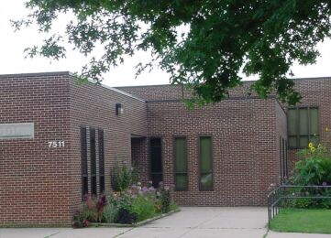

Takoma Park Elementary

Data Analysis and Interpretation Paper
Data Analysis and Interpretation with Technology Module: EDHD 435
Part 1

Fall 2004
Amy Estes

December 13, 2004

Background Information

Introduction

Takoma Park Elementary School, school # 754, is located in Montgomery County at 7511 Holly Avenue, Takoma Park Maryland. The school began as a K-6 school in 1979 and currently is a K-2 school, which also offers a school community based program and it is the only primary gifted and talented program in Montgomery County. The motto of Takoma Park Elementary School is “Jump into Learning” and the school mascot is the dolphin. Children at Takoma Park Elementary receive instruction from 9:15-3:30 and there is full day kindergarten. The school is in the Blair Cluster. All of the elementary and middle schools in the Blair Cluster feed into Montgomery Blair High School. The cluster is as follows:

- Montgomery Blair HS (9-12)
  - Eastern MS (6-8)
    - Montgomery Knolls ES (PreK-2)
    - New Hampshire Estates ES (PreK-2)
    - Oak View ES (3-5)
    - Pine Crest ES (HS, 3-5)
  - Silver Spring International MS (6-8)
    - Forest Knolls ES (K-5)
    - Highland View ES (PreK-5)
    - Sligo Creek ES (K-5)
    - Rolling Terrace ES (PreK-5)
  - Takoma Park MS (6-8)
    - East Silver Spring ES (PreK-3)
    - Piney Branch ES (3-5)
    - Takoma Park ES (PreK-2)



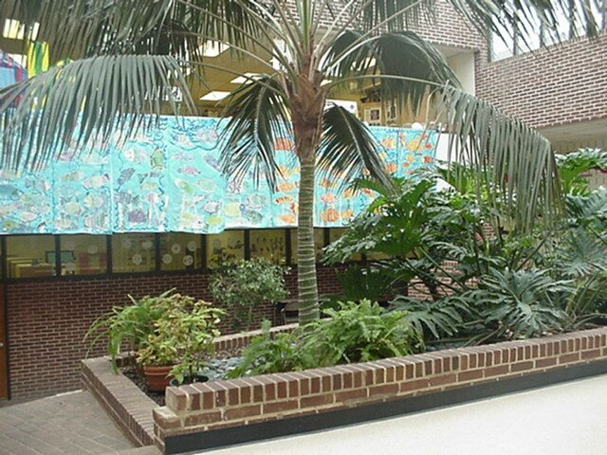
Takoma Park Elementary school is located in a very diverse neighborhood along side Takoma Park Public Library, Takoma Park Middle School and Piney Branch Elementary. Similarly, the school is located on a 4.7acre site that houses the main building and 8 portable classrooms, which are referred to as “learning cottages.” The school offers a playground, gymnasium, art studio, media center, and atrium as well as stairwells and ramps to access all parts of the school.
Figure 1: The Atrium at Takoma Park Elementary
Source: Montgomery County Public Schools

The principal of the school is Ms. Zadia Broadus and the contact number for the school is (301) 650-6414. The fax number is (301) 650-6526. More information about the school can be found at the schools website: http://www.mcps.k12.md.us/schools/takomaparkes/.

Figure 2. Outside Takoma Park Elementary School

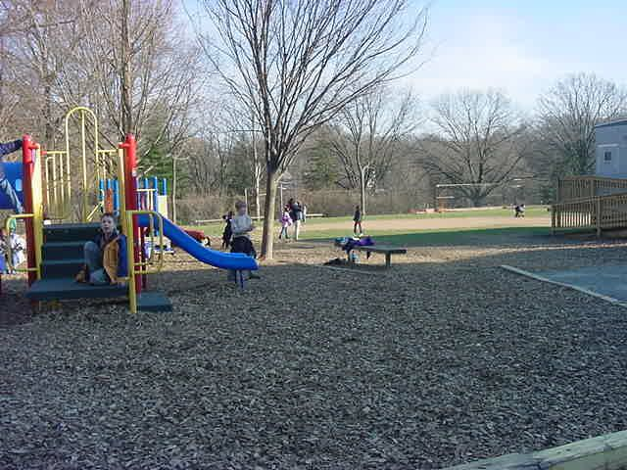

Source: Montgomery County Public Schools

Community Demographics

Information regarding the neighborhood of Takoma Park, Maryland can be found through the 2000 U.S. Census Report. The city of Takoma Park is approximately 4 miles across and has a total population of 17, 299 people. Approximately 29 percent of the population are immigrants and the total population remains diverse with 48.8% White, 34% black or African American, 4.4% Asian, and 14.4 % Hispanic. The residents of Takoma Park have a median household salary of 48, 490 dollars per year and 10.3% of the population is below the poverty level. A map of the city of Takoma Park is shown in Figure 3.
Figure 3: A map of Takoma Park
Figure 3. Map Image of Takoma Park, Maryland
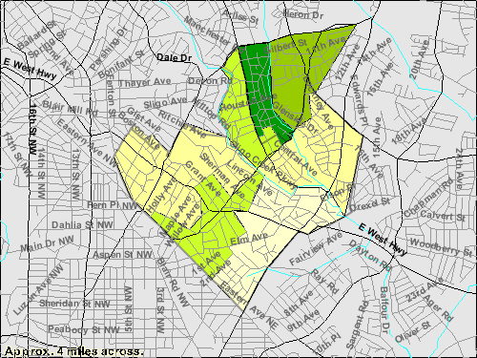
Source: U.S. Census Bureau, Census 2000 Summary File 1, Matrix P1

Demographics Takoma Park Elementary School
For the fall of 2004, Takoma Park Elementary had 390 students. Of those students 106 were in Kindergarten, 137 were in first grade, and 126 were in second grade. 7.9% of the total student population received special education and 10.5% of the students were students with Limited English Proficiency (LEP). 35.5% of the students in the school were African American, 0.5% were American Indian, 6.4% were Asian, 19.2% were Hispanic, and lastly 38.5% were White. The school is a Title I school, 35.6% of it student population is eligible for free and reduced meals (FARM), and it has a mobility rate of 19.6%. Since the mobility rate and FARM percentage are both high the school need to continue striving to reach out to parents. Strong communication between home and school is essential for the students at Takoma Park Elementary School as is continuing to offer a wide variety of services for parents and different types of communication to keep them informed about their children’s education.
Figure 4: Pumpkin Day at TPES
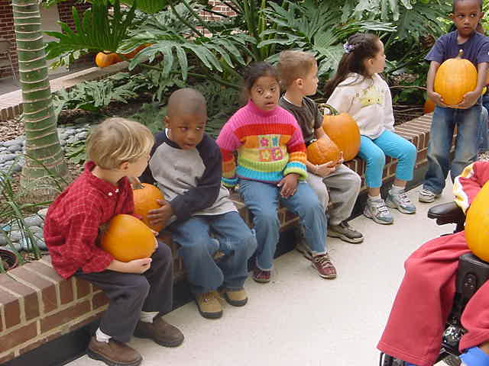
Source: Montgomery County Public Schools

Staffing

The 2004 staff at Takoma Park Elementary School consists of 9 kindergarten teachers, 8 first grade teachers, 7 second grade teachers, 5 instructional assistants, 2 ESOL teachers, 1 reading specialist, 1 reading recovery teacher, 1 art teacher, 1 music teacher, 1 P.E. teacher, 1 media specialist, 1 media assistant, 1 magnet coordinator, 1 resource teacher, 1 speech/language pathologist, 3 academic intervention/support personnel, 1 staff development teacher, and 1 guidance counselor. Of the staff, a majority of teachers have been teaching for five years or less. Moreover, Takoma Park Elementary School has an average class size of 14.4 for kindergarten and 15.9 for first and second grades. Since many of the teachers have not been teaching long, the school needs to focus on its staff development, providing its teachers with information regarding continuing education and also they need to continue to host staff needs workshops. The school is beginning to have their staff conduct peer visit with other staff members at their school as well as at other local elementary schools, which will help the teachers at Takoma Park Elementary School gain more ideas and information that will help them in their own classrooms.

Technology

As shown in Figure 5, in 2004 Takoma Park Elementary had a student to computer ratio of 3.1:1, which fares better than the local school system average of 4.2:1 (Maryland Technology Inventory Report, 2004). Also, Takoma Park Elementary computer ratio exceeds that of the State average of 4.9:1 and the Maryland target of 5:1.
Figure 5: A Graph Comparing TPES Computer Ratio with the District and State Averages

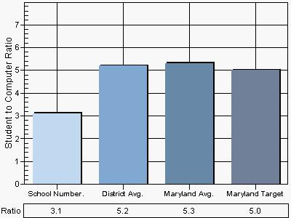
Source: 2004 Maryland Technology Inventory Report

All classrooms at Takoma Park Elementary have Internet connections and teachers utilize computers on a regular basis. The children engage in computer use during their media time, during literacy and math centers, when they research a subject as for a class book, and during their free choice time. While the school uses its technology resources on a daily basis only 50% of the students at Takoma Park have Internet access at home. Considering this statistics, teachers need to continue focusing heavily on technology in the classroom so all students will be exposed to technology. Providing teachers with staff development concerning technology use will ensure that they are able to incorporate technology in the classroom.

AYP Results and Other Assessments

Average Daily Attendance
The attendance rate for Takoma Park Elementary is satisfactory at 95.3% meeting the state Annual Measurable Objective (AMO) for 2004. Takoma Park Elementary School places great importance on attendance and strives for all of its students to come to school everyday.

Reading

Takoma Park Elementary met AYP for reading in 2004. Figure 7 displays results, indicating that though all groups have met the AYP for reading in 2004, several groups such as, the Hispanic, special education, and the LEP population have not met the targeted AMO percent proficiency level. Teachers must focus on helping these students to reach proficiency in their reading abilities as assessed by the state to meet adequate yearly progress.
Figure 7: 2004 AYP Percent Proficiency by Race/Ethnicity and Special Interest Groups Reading

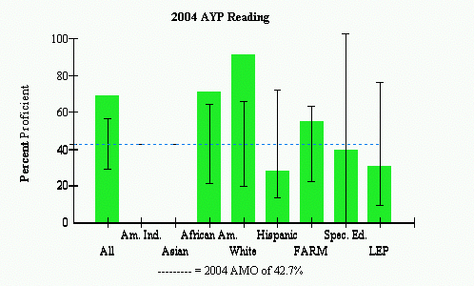
Source: 2004 Maryland Report Card

Mathematics

As shown in Figure 8, Takoma Park Elementary met AYP for mathematics in 2004, although several sub-groups did not meet the state set AMO. These were the Hispanic population, the FARM population, and the LEP population.

Figure 8: 2004 AYP Mathematics Percent proficiency by Sub-Groups

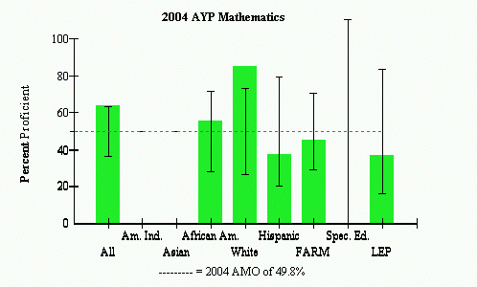

Source: 2004 Maryland Report Card

Again along with the reading scores, though the students have met their AYP requirements, the teachers need to focus on helping more of the student population reach the state target AMO percent proficient level so that they can met or exceed their AYP in the coming years. Moreover, focusing on narrowing the achievement gap will also be beneficial to the students at Takoma Park Elementary.

Areas of Needed Program Enhancement

Takoma Park Elementary School needs to focus on staff development so that more teachers can integrate technology into the classroom, which will help the children have a strong foundation in technology even if it is not available to them at home. Moreover, the school needs to focus on the achievement gap between races and help more children reach the proficient level in reading and in mathematics as Figures 7 and 8 show that only some of the students at Takoma Park Elementary School are meeting the proficiency levels as measured by the state assessment for AYP. Focusing on the connection between school and home and offering support services for parents, especially for parents who do not speak English will help increase the social climate of the school and the attendance rate. Lastly, helping teachers reach the diverse needs of their students by continuing to offer them many support services and a diverse staff will help them to continue striving for the best education for the children of Takoma Park.

Bibliography
Maryland State department of Education (2004). Maryland report card. Retrieved
November 11, 2004 from http://www.mdreportcard.org

Takoma Park Elementary Website: http://www.mcps.k12.md.us/schools/takomaparkes. Accessed November 10, 2004.

U.S Census Bureau Fact Finder Website: http://factfinder.census.gov/home/saff/main.html?_lang=en. Accessed November 6, 2004.

2004 Maryland Technology Inventory Report: http://reports0304.md.ontargetus.com/
Accessed November 8, 2004.

Maryland Report Care: http://www.mdreportcard.org Accessed November 11, 2004.

