Data Analysis and Interpretation Paper
Data Analysis and Interpretation with Technology Module: EDHD 435
Part 1

Fall 2004
Sharon H. Grotsky
December 16, 2004

Background Information

Introduction

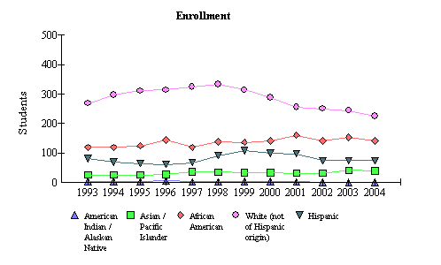
Woodlin Elementary School, school ID# 0764, is located at 2101 Luzerne Avenue, Silver Spring, MD 20910, just outside of downtown Silver Spring. It is part of the Albert Einstein cluster. The school got its start in 1945 when it opened its doors to 95 students, servicing kindergarten through third grade. Now, the school services full-day kindergarten through fifth grade. The school is currently under enrolled, as its maximum capacity is 583 students, and current enrollment is 481. As Figure 1 shows, there has been a slight decline in enrollment since 2001. The school’s mission is to maintain an environment of safety and mutual respect in which students can work and learn. Furthermore, everyone in the Woodlin community is responsible for promoting this kind of environment. The school is home to a diverse population of students.
Figure 1: Enrollment by Racial makeup from 1993 to 2004 at Woodlin Elementary School
http://msp.msde.state.md.us/

Demographics
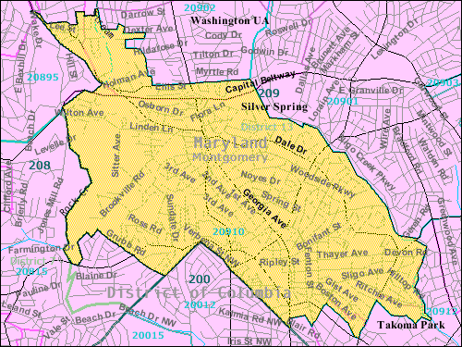
An exploration of census data, available at www.census.gov, tells the following information of the demographics of the population that Woodlin Elementary serves. Woodlin Elementary School is located in Silver Spring, Maryland (zip 20910), see figure 2. The city is home to over 35,000 people, with just over 50 percent of the population being female. Renters occupy about two-thirds of the 16,781 housing units in the area. The remaining portion of Silver Spring-20910 residents (Silver Spring has many different zip codes) own their home, which averages at about 208,000 dollars. The mean annual family income is just over 65,000 US dollars. Upwards of 10,000 of its residents are foreign-born and 11,118 people over the age of 5 speak a language other than English at home. About 66% of the population, over the age of 16, is currently in the labor force, and the mean travel time to places of employment is upwards of 30 minutes.
Figure 2: Map of Silver Spring, MD 20910
http://www.census.gov/
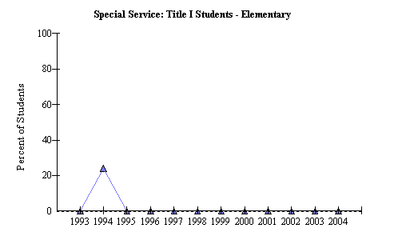
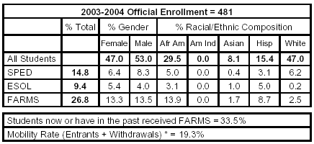
Woodlin Elementary School serves children in Kindergarten (full day) through Grade 5. As figure 3 indicates, after 1995, Woodlin Elementary School was no longer considered Title 1. Enrollment at Woodlin Elementary School for the 2004 fiscal year was 481 students, with the average class size ranging from 14.5 students, in Kindergarten, and 17.6 students in Grades 1-2, to 21.1 students in Grades 3-5. 14.8 percent of the total student population is considered a part of the Special Education program, 9.4 percent are ESOL, and 26.8 percent receive Free and Reduced Meals. 47 percent of the student population is female, and 53 percent are males. While the percentage of White students is larger than any other race/ethnicity represented in our student population, it accounts for less than half of all racial/ethnic groups reflected in our diverse student population. African Americans represent 29.5 percent of the student population, Asian students represent 8.1 percent, and Hispanic students represent 15.4 percent of the student body. Table 1 summarizes these findings. The preceding information came from the MCPS Schools at a Glance data collected from the 2004 fiscal year for Woodlin Elementary School and from the Maryland State Report Card (http://www.msp.msde.state.md.us).
Figure 3: Percentage of Title 1 Students at Woodlin Elementary School
http://msp.msde.state.md.us/

Table 1: 2003-2004 Percent Demographics of Woodlin Elementary School Students
http://www.mcps.k12.md.us/
Figure 4 shows the trends in enrollment for the past 11 years (http://msp.msde.state.md.us). Since the last fiscal year, Woodlin Elementary School has experienced a decline in enrollment. The Hispanic population is the only racial/ethnic group whose enrollment numbers did not reflect change over the course of the last fiscal year.
Figure 4: Enrollment by Racial Makeup from 1993 to 2004 at Woodlin Elementary School

Staffing

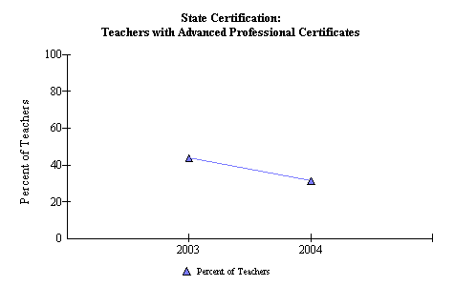
The percentage of teachers holding Advanced Professional Certificates has decreased since the last fiscal year by about ten percent. This accounts for 32 classroom teachers. However, the percentage of teachers with Standard Professional Certificates has increased. This might suggest that a large percentage of teachers are relatively new to the field since Montgomery County Public Schools requires that teachers obtain a Master’s Degree within 10 years of completing their Bachelor’s Degree.
Figure 5: Teachers at Woodlin Elementary School with Advanced Certificates
http://msp.msde.state.md.us/
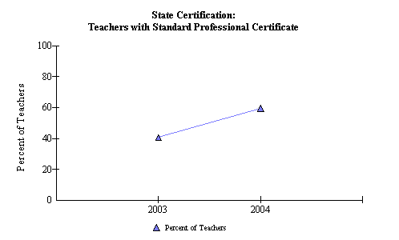
The staff consists of 6 kindergarten teachers, 19.5 classroom teachers, 4 special education teachers, 1.2 ESOL teachers, 1 reading specialist, 1 staff development specialist, 3.9 specials teachers (art, music, physical education), 7.375 paraeducators, 1 media assistant, .625 instructional data assistant, 1 media specialist, 1 counselor, 4 building service workers, .625 food service worker, 2 administrative assistants, 1.125 lunch hour aides and 1 principal.
Figure 6: Teachers at Woodlin Elementary School with a Standard Professional Teaching Certificate
http://msp.msde.state.md.us/
Technology
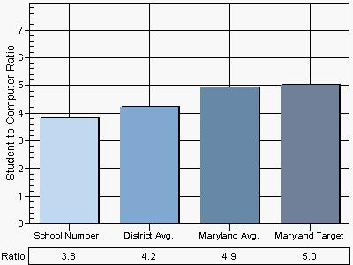
Information about the state technology inventory can be retrieved from http://reports0304.md.ontargetus.com/ via the Maryland Business Roundtable for Education (http://mbrt.org/). On last year’s state technology inventory, Woodlin had a lower computer to student ratio than county and state. However, 66 percent of the school’s PCs are located in the classrooms. On that note, Woodlin’s percentage of classrooms with PCs is equal to that of Montgomery County’s percentages, at 100%. This figure is higher than the state of Maryland’s average, at 93%, but level with the state’s target. 100% of the classrooms at Woodlin have at least one computer dedicated to student usage, which is higher than MCPS’s 89% and Maryland’s 76.96%. Woodlin is right at the state’s target of 100%. Woodlin utilizes a school website and email as one form of communication with families.
Figure 7: Comparison of Student to Computer Ratio
http://reports0304.md.ontargetus.com/
The school takes advantage of assistive technologies for use primarily with students with either an IEP or a 504 plan. Table 2 shows that 75% of teachers at Woodlin have at least an intermediate working knowledge of technology use. The percentage of teachers who have at least this intermediate working knowledge (75%) falls short of the county projection (77.29%), but is a few percentage points above the state’s totals (72.84%). However, the percentages of teachers at Woodlin who have an intermediate working knowledge of internet use and technology (60% and 50% respectively) fall below the MCPS and state totals (MCPS: 74.18% and 78.56% respectively; MD: 67.12% and 68.65% respectively). As a goal, the school should work to increase school totals for computer use to reach the state target of 100%. Furthermore, they should set a goal to increase school totals for internet use and technology integration to be at least where the state of Maryland is at, but strive to catch up to county totals. A long-term projection goal would be to achieve the Maryland target of 100% in all areas.
School | Computer Use | Internet Use | Technology Integration
Woodlin Elementary Totals | 75.00% | 60.00% | 50.00%
Montgomery County Totals | 77.29% | 74.18% | 78.56%
Maryland Totals | 72.84% | 67.12% | 68.65%
Maryland Target | 100% | 100% | 100%
Table 2: Comparison of Use for Woodlin, County and State
http://reports0304.md.ontargetus.com/

Based on information gathered about student use of technology in the classroom, the school should work to integrate technology every day, or almost every day.
Currently, the 2004 Maryland Technology Inventory Report indicates that technology is used a few times per month, and 83% of Woodlin Elementary School families have access to the internet. As table 3 shows, this falls just below the county average, by 1 percent, but is higher than the state average by about 15%.
Table 3: Home Internet Access Comparison Between School, County & State
http://reports0304.md.ontargetus.com/

School | % of Students with Home Access to the Internet
Woodlin Elementary Totals | 83%
Montgomery County Totals | 84%
Maryland Totals | 68.03%
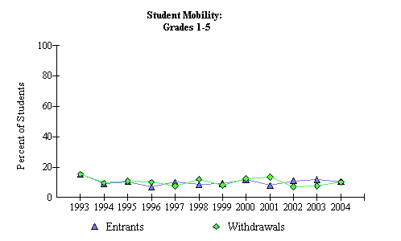
Woodlin Elementary School: Student Population
Mobility Rate
The mobility rate at Woodlin Elementary School for the 2004 fiscal year was 19.3 percent (see figure 8). Mobility includes both entrants into and withdrawals from the school. The number of entrants has decreased since the previous fiscal year, while the number of withdrawals increased. The graph below shows trends in student mobility for grades 1 through 5 from the 2004 fiscal year at Woodlin Elementary School.
Figure 8: Student Mobility Rate at Woodling Elementary School
http://msp.msde.state.md.us/
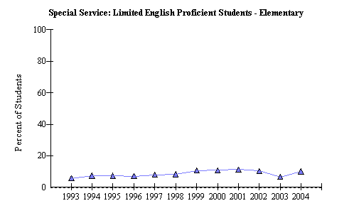
Since the last fiscal year, the number of students with limited English proficiency has increased, and numbers look to be comparable to the 2002 fiscal year, at about 10 percent.
Figure 9: Enrollement of LEP Students at Woodlin Elementary School
http://msp.msde.state.md.us/

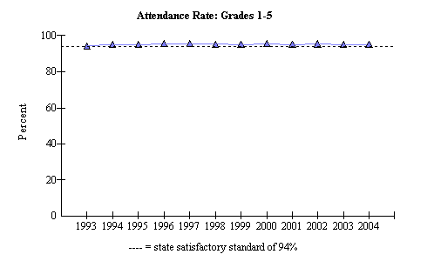
The attendance rate at Woodlin Elementary School has remained constant at just over 90 percent, since 1993 (see figure 10) over the years. This trend has continued, with little fluctuation, over the past 11 years. Figure 10 shows the attendance rate from 1993 to 2004, for grades 1 through 5.
Figure 10: Attendance Rate at Woodlin Elementary School
http://msp.msde.state.md.us/

AYP: Adequate Yearly Progress
Adequate yearly progress is the gain that schools, school systems, and states must make each year in the proportion of students achieving proficiency in reading and math. AYP replaces the School Performance Index as the method by which Maryland tracks academic progress and makes accountability decisions.
http://www.msp.msde.state.md.us
Average Daily Attendance
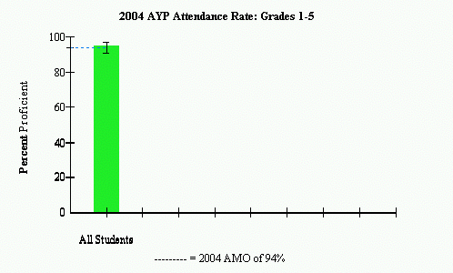
As mentioned earlier, Woodlin’s attendance rate has been consistent over the past 11 years. Figure 11 shows that the attendance rate at Woodlin Elementary School, for the 2004 fiscal year, was 95.2 percent. The AMO, or annual measurable objective for the 2004 fiscal year was 94 percent. While the school surpassed the AMO, it was not higher than the confidence interval, which was 91 to 97 percent. One goal that Woodlin could set for improvement could be to surpass the current confidence interval for the next year.
MSA: Maryland School Assessment
Figure 11: Average Daily Attendance at Woodlin Elementary School for Grades 1-5 during the 2004 fiscal year
http://www.mdk12.org/
*the following background information is taken directly from the template, for part 1 of the final project, and it should noted that I do not take credit as the author of this portion*

In order to meet the federal requirement contained in No Child Left Behind, Maryland must assess student achievement. The Maryland School Assessment (MSA) measures student achievement in K-8 reading and math and grade 10 reading. The MSA information is reported for grades 3 through 8 and for grade 10 in reading (Maryland Report Card, 2004).
The Maryland School Assessment is reported with three statewide performance standards. These standards are divided into three levels of achievement. These levels are Basic, Proficient, and Advanced. The Maryland Report Card explains the differences between the levels as:
- Advanced is a highly challenging and exemplary level of achievement indicating outstanding accomplishment in meeting the needs of students.
- Proficient is a realistic and rigorous level of achievement indicating proficiency in meeting the needs of students.
- Basic is a level of achievement indicating that more work is needed to attain proficiency in meeting the needs of students.
MSA Grade Three: Reading
Student performance is reported in terms of the following achievement levels:
Reading:
Basic: Students at this level are unable to adequately read and comprehend grade appropriate literature and informational passages.
Proficient: Students at this level can read grade appropriate text and demonstrate the ability to comprehend literature and informational passages.
Advanced: Students at this level can regularly read above-grade level text and demonstrate the ability to comprehend complex literature and informational passages.

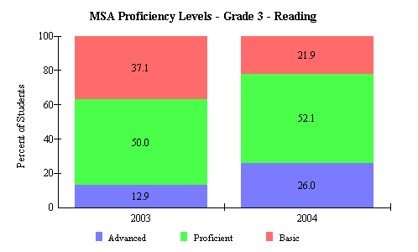
From 2003 to 2004, the percentage of Woodlin Elementary School students performing at a basic level decreased from 37.1 to 21.9 percent (-15.2%). The percentage of students performing at a proficient level increased from 50 to 52.1 percent (+2.1%). The percentage of students performing at an advanced level increased from 12.9 to 26 percent (+13.1). Figure 12 shows the yearly change for MSA proficiency in third grade reading, found at the School Improvement in Maryland website, http://www.mdk12.org/.
Figure 12: Maryland School Assessment Proficiency Levels for Third Grade Students at Woodlin Elementary School from 2003 to 2004
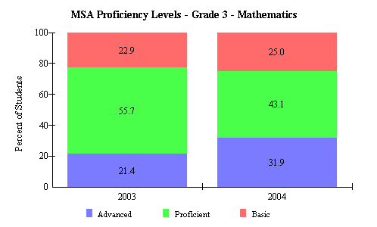
MSA Grade Three: Mathematics
The results from the third grade MSA for mathematics is different from reading. From 2003 to 2004, the percentage of students performing at a basic level increased from 22.9 to 25 percent (+2.1%), the percentage of students performing at a proficient level decreased from 55.7 to 43.1 percent (-12.6%), and the percentage of students performing at an advanced level increased from 21.4 to 31.9 percent (+10.5). While we would not necessarily want the percentage of students performing at a basic level to increase, it is promising that the percentage of students performing at an advanced level has increased by 10.5 percent since the last year, despite the decrease in the percentage of students performing at a proficient level.
Figure 13: Maryland School Assessment Proficiency Levels for Third Grade Students at Woodlin Elementary School from 2003 to 2004
http://www.mdk12.org/
MSA Grade Five: Reading
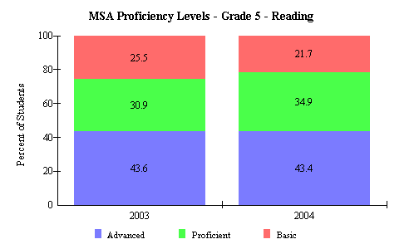
In the fifth grade at Woodlin Elementary School, the percentage of students performing at an advanced level in reading stayed just about the same from 2003 to 2004. Figure 14 also shows that while the percentage of students performing at basic decreased by 3.8 percent from 25.5 percent (2003), the percentage of students performing at a proficient level increased by 4 percent from 30.9 percent (2003). This change shows positive progress, and reflects a decreasing number of students testing at a basic level and moving towards proficiency and advanced levels (http://www.mdk12.org).
Figure 14: Maryland School Assessment Proficiency Levels for Fifth Grade Students at Woodlin Elementary School from 2003 to 2004
MSA Grade Five: Mathematics
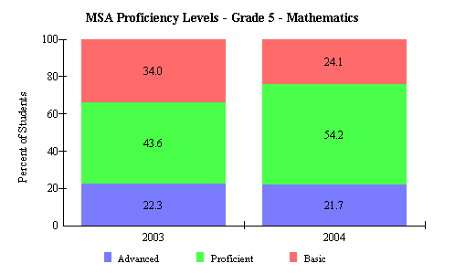
For fifth grade MSA in mathematics, the percentage performing at a basic level decreased by 9.9 percent from 34 percent (2003), the percentage performing at a proficient level increased by 10.6 percent from 43.6 percent (2003), and the percentage of students performing at an advanced level decreased by 0.6 percent from 22.3 percent (2003). This information suggests that while the percentage of students who tested at a basic level decreased from one fiscal year to the next (a good thing), the percentage of students who tested at an advanced level also decreased, though not substantially. One goal for Woodlin could be to take measures to avoid percentages of students testing at an advanced level to decrease, but continue to work towards decreasing the percentages of students who test at a basic level.
Figure 15: Maryland School Assessment Proficiency Levels for Fifth Grade Students at Woodlin Elementary School from 2003 to 2004
Woodlin did not meet AYP (adequate yearly progress) for special education reading proficiency. They did however, make AYP for all other indicators. This is a change from 2003, when the school did meet AYP for all indicators.
Areas of Needed Program Enhancement
If Woodlin fails to meet AYP for a second year it must, in accordance with the state of Maryland, create a school improvement plan. This plan is a 2-year plan for improvement in each subgroup’s achievement. Overall, Woodlin is making good progress in improving student achievement. However, they need to focus attention on students in the special education program to improve proficiency in reading. It would also be helpful for the school to work to promote shifts in MSA reading and math scores to continue to shift away from basic levels of proficiency towards advanced levels of proficiency. One benchmark in an effort to promote this shift would be to look for a shift away from the basic level of proficiency, toward the proficient level of proficiency, before reaching advanced levels of proficiency, without seeing the advanced levels of proficiency go down. Woodlin also needs to work on improving the role of technology in the school community. One goal would be to increase the student to computer ratio. However, it is promising that 100 percent of the classrooms are equipped with at least one computer designated for student usage. A goal that should definitely be considered is to increase the number of Woodlin staff who have an intermediate working knowledge of technology use and integration, and further the proficiency of those staff that already have an intermediate working knowledge of these skills. Over time, the goal should be for 100 percent of the staff to have an intermediate, if not higher, working knowledge of technology use and integration. Furthermore, it would wonderful if Woodlin strived to incorporate technology into the classroom experience on a daily, or almost daily, basis.

