Data Analysis and Interpretation Paper
Data Analysis and Interpretation with Technology Module: EDHD 435
Part 1

Fall 2004
Megan Lucks
December 13, 2004

Background Information

Introduction

Galway Elementary School (School ID #0313) opened in 1967, and is located on the Prince George’s and Montgomery County line. When the school first opened, most of the students were walkers. As the district grew to include Paint Branch Creek and Briggs Chaney Road, enrollment grew and more students began arriving through the bus system. Currently there are 710 students in grades K-5. In 1993, an addition was opened which holds a media center, art room, computer lab, four classrooms and student bathrooms. In 1997 a gym was added.

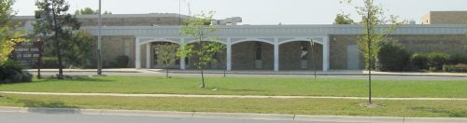
Galway Elementary School
Since the school has opened, it has under gone many expansions. At one point the student population enrollment was only 185, but it has been as high as 785. Today, there are 710 students in grades K-5. Some additions since its opening have been: a media center, an art room, a computer lab, four classrooms, student bathrooms, and a gym. The mission of Galway this year is the “Three R’s”: Rights, Respect and Responsibility. Their goal is to “develop a learning environment where everyone is valuable, able and responsible.” Everyday after the Pledge, students recite a school song called the Galway pledge.

PTA membership has gone up 20% since 2003, although PTA membership is still low, and so is parental involvement. The PTA tries to increase volunteerism through their school newsletters.

The school does have a website (http://www.mcps.k12.md.us/schools/galwayes/) but it is not very up to date. Galway Elementary School has hosted many events and holds a variety of extracurricular activities after school for students. The PTA has hosted many cultural and heritage events and has brought in speakers to discuss bilingualism. Currently there are basketball leagues for boys and girls in the gym after school.

Demographics

The majority of the population in Silver Spring, Maryland is White, 46.6%. The next largest racial group is Black (28.1%). The 2000 census indicates that 70.9% of the population are in the work force, with a medium family income of $60,631 (the average for the U.S. is $50,046) and the average family size of 3.21 (average for U.S. is 3.14).

Figure 1: 2000 U.S. Census Percent Population of Silver Spring, Maryland by Race
Race | % of population in Silver Spring, MD
White | 46.6%
Black | 28.1%
Hispanic | 22.2%
Asian | 8.2%
Other | 12.1%
Source: 2000 Census Bureau (Fact Finder)

While the majority of the population of Silver Spring is White, the make-up of Galway Elementary is very different. In Galway more than half of the students are African American, and 46.5% of the students are receiving or have received Free and Reduced Meals (FARMS). The next largest race in the schools population is Asian, followed by White. The school’s demographics are very different compared to the Silver Spring neighborhood. Based on 2002-2003 school data, the gender percentages were 53.1% male and 46.9% female. Almost 10% of the school’s population needs special education.
Figure 2: Table of Galway Student Population
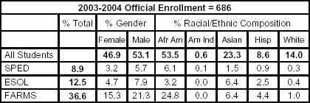
Source: 2002-2003 Montgomery County Public School Year Data

Galway Elementary School is a Title I school. The majority of the students are minorities and come from low-income families. In the area surrounding the school, 2.5% of the families are below the poverty line. About one-quarter of the people in the school’s area code are foreign born (the average for the U.S. is 11.1%). The percentage of people who speak a language other than English at home is 28.1% (the average for the U.S. is 17.9%). This helps explain the high percentage of ESOL students at Galway, which is 12.5%.

Staffing

In Montgomery County, 458 out of 754 teachers were new hires in 2004. Nearly two-thirds of teachers that were hired were new teachers. Also, out of 296 experienced teachers that were hired, 166 were from out of the state of Maryland.
Teachers at Galway with Advanced Professional Degrees have grown from 45.2% in 2003, to 51.2% in 2004. The percentage of teachers with Standard Professional Certificates has not really grown in the past year, and is currently 48.8%.
The staff at Galway consists of 35 classroom teachers and 19 specialists: 2 art specialist, 1 counselor, 2 ESOL teachers, 1 instrumental musical specialist, 1 media specialist, 2 music specialists, 2 P.E. teachers, 1 reading recovery specialist, 1 reading specialist, 3 resource teachers, 1 special education teacher, 1 speech specialist, and 1 staff development teacher. Galway also has one Head Start program inside the school. There are still positions that need to be filled, including chairpersons for “race to read” and “special needs”. The average student to teacher ratio in a Kindergarten class is 14:1, in grades 1 and 2 the ratio is 17:3, and in grades 3 to 5 the ratio is 25:1.

Technology

Galway Elementary School’s Student to Computer Ratio is 4.0:1. The average for Montgomery County is 4.2:1. Teachers’ knowledge in Galway is almost 20% lower in computer use, 12% lower in Internet use, and 11% lower in technology integration compared to Montgomery County totals.

Figure 3: Teacher Knowledge and Skills of Technology at Galway Elementary School
Teacher Knowledge and Skills
Estimated Percentages of Teachers at Least at 'Intermediate' Technology Use

School | Computer Use | Internet Use | Technology Integration
Galway Elementary Totals | 57.00% | 62.00% | 67.00%
Montgomery County Totals | 77.29% | 74.18% | 78.56%
Maryland Totals | 72.84% | 67.12% | 68.65%
Maryland Target | 100% | 100% | 100%
Source: 2004 Maryland State Department of Education

This school does have adequate computer resources showing a higher computer to student ratio than the average in the county, but teacher technology training is really needed to improve teacher knowledge and skills.

Student Use of Technology for Achievement and Assessment

As indicated in the 2004 Maryland Technology Inventory Report, most schools in Montgomery County did use technology in some way everyday or a few times a month. Although at Galway, the children hardly ever worked with technology. This school needs to improve gathering information/data from a variety of sources (e.g. via Internet, World Wide Web, Online services, CD-ROM-based reference software) since Montgomery County’s average was 73% for “uses everyday”, and Galway only did this “every few months”. They also should improve manipulate/analyze/interpret information or data to discover relationships, generate questions, and/or reach conclusions. Ninety-percent of schools in Montgomery County do this more than Galway. The school must also work on accommodating for a disability/limitation (Montgomery County: 66% everyday, Galway: few times a month). This data shows that Galway is really lacking in computer and technology knowledge and use. In today’s society technology is very important, and Galway needs to improve their technology use for its students.

AYP Results and Other Assessments

Average Daily Attendance/Student Capacity

The attendance rate at Galway is 96.2%, and has been rated “excellent” according to state standards for the past five years. The current capacity of the school is 629 students, but current enrollment is 676 students. The school is over its enrollment capacity, so some classrooms are overcrowded. Over the next three years, enrollment capacity is expected to decrease slightly.

Reading and Mathematics

Due to No Child Left Behind, Maryland must assess student achievement and other measurement indicators, like attendance to show Annual Yearly Progress (AYP). The Maryland State Assessments (MSA), in reading and mathematics are used to measure student proficiency level for five racial groups, as well as special education, Limited English Proficiency, and Free and Reduced Meal sub-groups.

Galway did meet its AYP for reading. The only race that was counted as “N/A” for AYP was American Indians. Each racial/ability group of children made great improvements in proficient reading, except for Asian/Pacific Islanders. African students improved 5% in reading proficiency, White students improved 12%, Hispanic students improved 15%, Free/Reduced Meals (FARMS) students have improved 21%, special education student have improved 11% and Limited English Proficient (LEP) students improved 50%. Asian/Pacific Islanders dropped 0.5% in proficient reading.

Figure 4: Galway Elementary School 2004 AYP State Reading Proficiency for Third and Fifth Grade students by Race/Ethnicity and Special Education, FARM and LEP
Source: 2004 Maryland State Department of Education
2004 AYP Reading
 |  |  | Percent Proficient | Number Proficient | Total Students | Confidence Interval
 | All Students | 2004 | 72.3 | 175 | 242 | 37.5 - 55.1
 | All Students | 2003 | 67.6 | 152 | 225 | 34.6 - 52.9
 | Am. Indian/  AL Native | 2004 | na | na | na | na
 | Am. Indian/  AL Native | 2003 | na | na | na | na
 | Asian/Pacific Islander | 2004 | 72.3 | 34 | 47 | 26.3 - 66.3
 | Asian/Pacific Islander | 2003 | 72.7 | 40 | 55 | 25.3 - 62.2
 | African American | 2004 | 65.0 | 89 | 137 | 34.6 - 58.0
 | African American | 2003 | 60.7 | 68 | 112 | 30.8 - 56.7
 | White (not of Hispanic origin) | 2004 | 97.4 | 37 | 38 | 24.0 - 68.6
 | White (not of Hispanic origin) | 2003 | 85.0 | 34 | 40 | 22.1 - 65.4
 | Hispanic | 2004 | 73.7 | 14 | 19 | 14.8 - 77.8
 | Hispanic | 2003 | 58.8 | 10 | 17 | 10.6 - 76.9
 | Free/Reduced Meals | 2004 | 61.4 | 54 | 88 | 31.7 - 60.9
 | Free/Reduced Meals | 2003 | 39.2 | 29 | 74 | 27.9 - 59.6
 | Special Education | 2004 | 32.0 | 8 | 25 | 18.8 - 73.8
 | Special Education | 2003 | 21.4 | 6 | 28 | 17.9 - 69.6
 | Limited English Proficient | 2004 | 72.2 | 13 | 18 | 13.9 - 78.7
 | Limited English Proficient | 2003 | 22.2 | 2 | 9 | -1.7 - 89.3

Galway met its AYP requirements in mathematics proficiency in 2004. Asian/Pacific Islander students and White students sub-groups decreased in math proficiency compared to a year ago. African American students improved 7%, Hispanic students improved 3%, Free/Reduced Meals students increased 10%, special education student improved 7%, and Limited English Proficient students improved 17%. White students decreased 0.3% and Asian/Pacific Islander students decreased 2%.

Figure 5: Galway Elementary School 2004 AYP State Mathematics Proficiency for Third and Fifth Grade students by Race/Ethnicity and Special Education, FARM and LEP
2004 AYP Mathematics
 |  |  |  | Percent Proficient |  | Number Proficient | Total Students | Confidence Interval
 | All Students | 2004 |  | 73.3 |  | 176 | 240 | 35.2 - 52.9
 | All Students | 2003 |  | 70.7 |  | 159 | 225 | 32.4 - 50.4
 | Am. Indian/  AL Native | 2004 |  | na |  | na | na | na
 | Am. Indian/  AL Native | 2003 |  | na |  | na | na | na
 | Asian/Pacific Islander | 2004 |  | 74.5 |  | 35 | 47 | 24.1 - 64.0
 | Asian/Pacific Islander | 2003 |  | 76.4 |  | 42 | 55 | 23.1 - 59.7
 | African American | 2004 |  | 66.7 |  | 90 | 135 | 32.3 - 55.8
 | African American | 2003 |  | 59.8 |  | 67 | 112 | 28.6 - 54.2
 | White (not of Hispanic origin) | 2004 |  | 94.7 |  | 36 | 38 | 21.9 - 66.2
 | White (not of Hispanic origin) | 2003 |  | 95.0 |  | 38 | 40 | 20.0 - 62.8
 | Hispanic | 2004 |  | 73.7 |  | 14 | 19 | 12.7 - 75.4
 | Hispanic | 2003 |  | 70.6 |  | 12 | 17 | 8.5 - 74.3
 | Free/Reduced Meals | 2004 |  | 58.1 |  | 50 | 86 | 29.3 - 58.8
 | Free/Reduced Meals | 2003 |  | 48.6 |  | 36 | 74 | 25.6 - 57.2
 | Special Education | 2004 |  | 32.0 |  | 8 | 25 | 16.7 - 71.4
 | Special Education | 2003 |  | 25.0 |  | 7 | 28 | 15.8 - 67.0
 | Limited English Proficient |  | 2004 | 72.2 |  | 13 | 18 | 11.8 - 76.3
 |  |  | 2003 | 55.6 |  | 5 | 9 | -3.7 - 86.6
Source: 2004 Maryland State Department of Education

Maryland School Assessment (MSA)

Third grade Galway students’ level of proficient readers is slightly lower than compared to the rest of Montgomery County. The percent of proficient readers in Galway is 59.5%, the level of advanced readers is only 6.1% and the level of basic readers is 34.4%. Compared to the rest of the state, Galway had much more basic readers, and half as many advanced readers.

Figure 6: 2004 MSA Reading Proficiency Levels for Third Graders at Galway Elementary
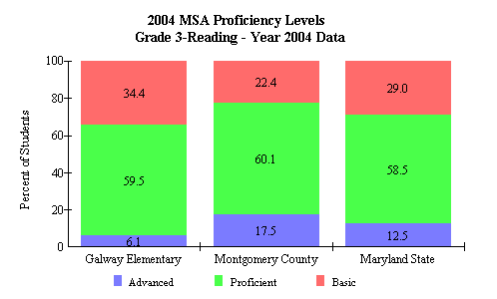
Source: 2004 Maryland Report Card

Third grade Galway students are performing almost the same as the rest of the state in all levels of math. These break down of these students are 53.5% proficient, 27.1% basic, and 19.4% advanced readers. There are many more advanced readers in the county, the percent of advanced readers is 30.2%.

Figure 7: 2004 MSA Math Proficiency Levels for Third Graders at Galway Elementary
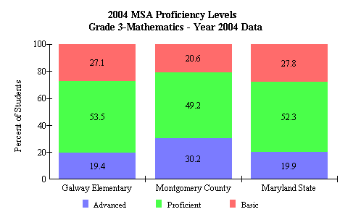
Source: 2004 Maryland Report Card

By fifth grade, Galway students have made improvements in reading compared to the county and the state. Galway is performing almost as well as Montgomery County students by the fifth grade. It is performing better than compared to the state of Maryland by fifth grade as well in all areas.

Figure 7: 2004 MSA Reading Proficiency Levels for Fifth Graders at Galway Elementary
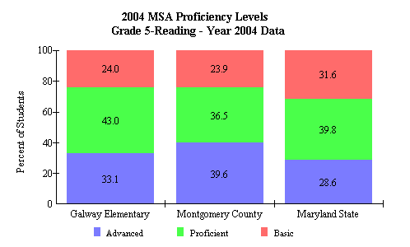
Source: 2004 Maryland Report Card

By fifth grade, Galway students have increased in proficiency. They are still behind Montgomery County in advanced and basic level math. Although, by fifth grade, students are performing better than Maryland state students on all levels. The percentage of students who have basic proficiency in math is 30.6%, 52.1% are proficient, and 17.4% are advanced. By fifth grade, students have improved in math and reading compared to their proficiency levels in third grade.

Figure 8: 2004 MSA Math Proficiency Levels for Fifth Graders at Galway Elementary
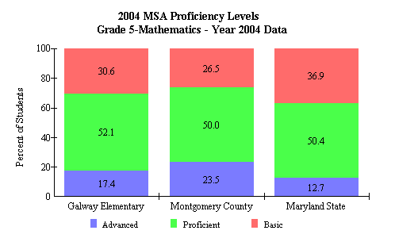
Source: 2004 Maryland Report Card

Areas of Needed Program Enhancement

Galway needs more parent involvement. The involvement of parents is lacking, and the PTA and teachers need to find ways to reach out to more parents. This school also needs to improve teacher knowledge and skills of technology since it is very poor compared to the rest of the county. Galway should also focus on helping Asian/Pacific Islanders more in math and reading, since they are the only group of students who have dropped in AYP proficiency levels. Galway teachers also need to help White students with mathematics, since their proficiency has been decreasing. Galway also needs to improve the level of third graders proficiency in math and reading since they are so behind the County at that grade level. They may need more instruction on these subjects in first and second grade.

Resources

Maryland State Department of Education. “Maryland Teacher Staffing Report 2004-2006”.
http://www.marylandpublicschools.org/NR/rdonlyres/B552E542-F940-4BD2- 88C0-532BA4EEF4BB/3168/TEACHERSTAFFING.pdf (29 Oct. 2004)

Montgomery County Schools. “Galway Elementary School”.
http://www.mcps.k12.md.us/departments/regulatoryaccountability/glance/fy2004/ schools/02313.pdf. (29 Oct. 2004)

School Improvement in Maryland. “Analyzing your MSA data Galway Elementary”.
http://www.mdk12.org/data/msa_data/index.asp?K=150313 (29 Oct. 2004)

U.S. Census Bureau. “American Fact Finder”.
http://factfinder.census.gov/home/saff/main.html?_lang=en (29 Oct. 2004)

