Sunday | Monday | Tuesday | Wednesday | Thursday | Friday | Saturday
April is Cyber-Awareness Month!
Click on a Day for Activity Detail
Completion Certificate for your Students [PDF... Black & White PDF]
1. Try some fun stuff with McGruff | 2. Take a quiz from San Mateo CTL to learn if your research ethics are on par. | 3. Translate internet slang and take a quiz to see how well you can decipher text messages using noslang.coms slang translator | 4. Read about plagiarism | 5. View a clip from i-SAFE's webcast: "Cyber Harrassment" | 6. Sign a family internet safety contract. From ProtectKids.com | 7. Are you a good cybercitizen? Check out the USDOJ site specifically designed for kids to learn more about cyberethics.
8. Learn how to tell a good website from a bad one: Media Awareness Network | 9. What do you really know about copyright?  - Kids, check out: Copyright Society  - Teens, check out: University of St. Francis | 10. What in the world is an AUP? An excellent explanation from PCS. Can you find your schools AUP? | 11. How much info is too much?  - Kids, check out Childnet International  - Teens, check out: StaySafe.org | 12. Learn how to pass on cybersafety rules to peers: TeenAngels a Division of WiredSafety | 13. Learn how to create secure passwords: PasswordExperts  or Watch this excellent humorous GMU video clip | 14. Be aware of cyberbullying:  - Kids, check out: WiredKids  - Teens, check out: StaySafe.org
15. How many of these letters have you received? SOPHOS | 16. Learn what you do if you get a hoax from Hoaxbusters | 17. What can you do to defeat Spam? AC3 | 18. Why do you need a strong password? | 19. About to download something? Stop! Stopbadware | 20. Got a virus? Learn ways to rid viruses eHow, Inc. | 21. Learn how words steal credit card BBC News
22. Learn the Eight Cyber Security Practices to Stay Safe Online | 23. Do you know how to safely surf? Of course we don’t mean in the ocean but on the net! Take the online SafeKids quiz and see if you know the cyber sharks out to get you! | 24. Do you know your ABC’s? How about the ABC’s of the Internet? Discover the important terms that you need to know about cyberspace from Kaboose Inc. | 25. If you love Walt Disney, then you’ll love Surf Swell Island, the adventurous site all about playing it safe on the Internet. | 26. How Safe are you? Take the NCSA quiz | 27. Where do you fall in the digital divide? Take the eDivide, Inc. “eTape” quiz at the following site to find out! | 28. There are many predators lurking online trying to exploit your children. Discover tips and learn the dangers by visiting the NCMEC website.
29. Help the “Netsmartz Agents” find where Derek went to go meet his new online friend. He is in serious danger and can use the help of a teenager. Click the following link and find the Netsmartz Agents game. | 30. View the interactive FTC activities that provide practical tips to help you be on guard against Internet fraud, secure your computer, and protecting your personal information. | Additional resources can be found at: ETO's C3 Cybersecurity Portal  April 2007 Calendar created by Winter 2006 EDUC 698T course (Cyberethics, Cybersafety and Cybersecurity in the Classroom Setting) members Shona Holmes, Tracy Masterson, Pamela Shurkin & Brian White |  |  |  | 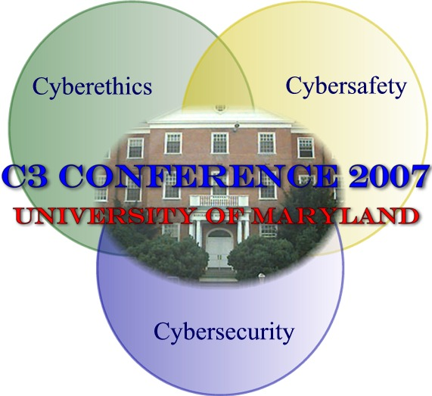

Links
April
- Try some fun stuff with McGruff - http://www.mcgruff.com/games/
- Take a quiz from San Mateo CTL to learn if your research ethics are on par. http://www.smccd.net/accounts/webready/lesson9_fairuse-check.asp
- Translate internet slang and take a quiz to see how well you can decipher text messages using noslang.coms slang translator. http://www.noslang.com/
- Read about plagiarism. http://turnitin.com/research_site/e_what_is_plagiarism.html
- View a clip from i-SAFE's webcast: "Cyber Harrassment" - http://www.isafe.org/
- Sign a family internet safety contract. From ProtectKids.com http://www.protectkids.com/parentsafety/pledge.htm
- Are you a good cybercitizen? Check out the USDOJ site specifically designed for kids to learn more about cyberethics. http://www.cybercrime.gov/rules/kidinternet.htm
- Learn how to tell a good website from a bad one: Media Awareness Network http://www.media-awareness.ca/english/games/jocool_jofool/kids.cfm
- What do you really know about copyright? Kids, check out: Copyright Society http://www.copyrightkids.org Teens, check out: University of St. Francis http://www.stfrancis.edu/cid/copyrightbay/
- What in the world is an AUP? An excellent explanation from PCS http://www.pcs.k12.va.us/public/AUP-kids.html Can you find your schools AUP?
- How much info is too much? Kids, check out Childnet International: http://www.chatdanger.com Teens, check out :StaySafe.org http://www.msn.staysafeonline.com/teens/whats_hot/blogging.html
- Learn how to pass on cybersafety rules to peers: TeenAngels a Division of WiredSafety http://teenangels.org
- Learn how to create secure passwords: PasswordExperts http://www.passwordexperts.com/article01.shtml or Watch this excellent humorous GMU video clip : http://media.mesa.gmu.edu/laird/securepswd.wmv
- Be aware of cyberbullying: Kids, check out: WiredKids http://www.wiredkids.org/ktt_universal/games/javascript/cyberbullying_quiz_1/index.html Teens, check out: StaySafe.org http://www.msn.staysafeonline.com/teens/whats_hot/no_grief.html
- How many of these letters have you received? SOPHOS http://www.sophos.com/security/hoaxes/index_scam.html
- Learn what you do if you get a hoax from Hoaxbusters http://hoaxbusters.ciac.org/HBHoaxInfo.html#whattodo
- What can you do to defeat Spam? AC3 http://www.uic.edu/depts/accc/newsletter/adn29/spam.html
- Why do you need a strong password? http://www1.umn.edu/oit/security/passwordattackdiscussion.html
- About to download something? Stop! Stopbadware http://stopbadware.org/
- Got a virus? Learn ways to rid viruses eHow, Inc. http://www.ehow.com/how_11818_rid-computer-virus.html
- Learn how words steal credit card BBC News http://news.bbc.co.uk/2/hi/technology/3776247.stm
- Learn the Eight Cyber Security Practices to Stay Safe Online http://staysafeonline.org/practices/index.html
- Do you know how to safely surf? Of course we don’t mean in the ocean but on the net! Take the online SafeKids quiz and see if you know the cyber sharks out to get you! http://www.safekids.com/quiz/index.html
- Do you know your ABC’s? How about the ABC’s of the Internet? Discover the important terms that you need to know about cyberspace from Kaboose Inc.. http://www.kidsdomain.com/features/safesurf/gloss.html
- If you love Walt Disney, then you’ll love Surf Swell Island, the adventurous site all about playing it safe on the Internet. http://disney.go.com/surfswell/index.html
- How Safe are you? Take the NCSA quiz http://staysafeonline.org/basics/quiz.html
- Where do you fall in the digital divide? Take the eDivide, Inc. “eTape” quiz at the following site to find out! http://library.thinkquest.org/05aug/00036/en/Fun/index.html
- There are many predators lurking online trying to exploit your children. Discover tips and learn the dangers by visiting the NCMEC website. http://tcs.cybertipline.com/
- Help the “Netsmartz Agents” find where Derek went to go meet his new online friend. He is in serious danger and can use the help of a teenager. Click the following link and find the Netsmartz Agents game. http://www.netsmartzkids.org/games/index.htm
- View the interactive FTC activities that provide practical tips to help you be on guard against Internet fraud, secure your computer, and protecting your personal information. http://onguardonline.gov/quiz/index.html

Additional resources can be found at: ETO's C3 Cybersecurity Portal - http://www.edtechoutreach.umd.edu/civics.html#Cybersecurity

