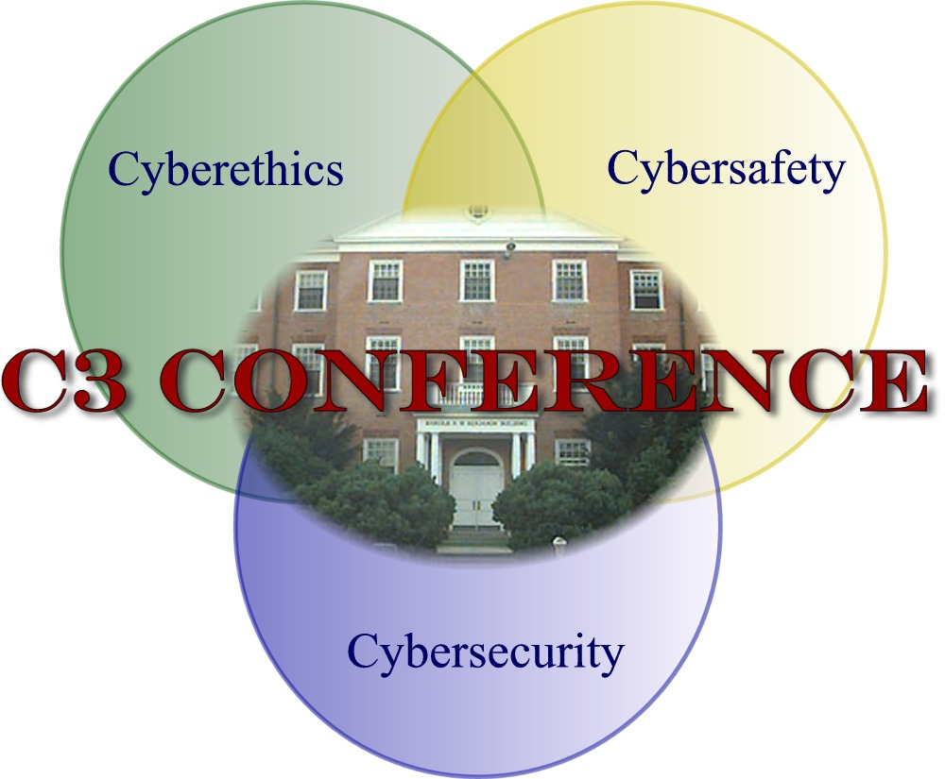

Grant Application for 2011-2012

ETPRO and the C3 Conference offers educators an opportunity to apply for grants to encourage the effective dissemination of Cyberawareness content that supports the use of technology in teaching and learning. Grants not to exceed $750 will be awarded through a competitive grant process. Grant funding must be used to promote empowering students to become ethical, responsible, and resilient cybercitizens who are comfortable navigating the digital world. Grants may include “stand alone” activities (i.e., PTA or faculty presentations) but must include the integration of C3 content into existing curriculum. Emphasis should be added to integrate all three Cyberethics-safety and security (C3) topics.

Who is eligible to participate in the C3 grant award program?
- All 2011 C3 conference attendees are eligible to apply for a grant

What are the criteria for the grant application?
- States the title of the proposal.
- Includes a brief description of the grant. (Maximum of 75 words. This description will be published if the grant proposal is selected for an award.)
- Lists the item(s) being requested, the planned use/purpose, and the cost of the item(s)-estimated. If the total cost exceeds the amount requested, indicates how additional funding will be obtained.
- States the purpose and objectives of the proposed program.
- Describes how the program will be assessed.
- Lists specific State Content Standard/s, which is/are being addressed by this grant application.
- Lists specific State Technology Standards for Students which will be addressed.
- Lists specific C3 Matrix Proficiency Areas which will be addressed.
- Includes a timeline or chart that outlines the implementation plan of the proposal and includes the following: Activity, Person Responsible, Start Date, Completion Date, and Evidence of Successful Completion.
J. Includes a brief statement of the qualifications of the applicant(s) administering the program.
- Grant recipients must present a summary of the grant implementation at the 2012 C3 Conference at UMD on October 4 or 5th, 2012.
- Grant recipients must submit a summary of their grant implementation to the C3 Conference webmaster for publication on the 2011 C3 Conference website and, also, submit verification of expenses to the C3 Grant Chair by June 4, 2012.
- Grant recipients will be invited to share a summary of their grant implementation at the 2013 MSET (formally MICCA) Conference, at the Baltimore Convention Center.

How may grant funds by used?
- Grant funds may be used for software, hardware or peripherals, curriculum development and/or lesson plans needed to complete the program.
- Grant funds may be used for student prizes and consumables if supporting a larger implementation effort.

How will grants be awarded?
- Members of the C3 Grant Committee will evaluate all grant proposals. Selections will be final.
The scoring rubric for the grants program will be available at the C3 Conference website

Timeline: June 4, 2012 Grant applications are due
End of June Applicants notified of status of grant application
2012 MSET DATE Invite to present at MSET Conference 2013 at a Poster
Session or be accepted to present a concurrent session.
June 4, 2012 Submit a summary article to C3 Conference webmaster for publication on the 2012 C3 Conference website.
Oct , 2012 Submit verification of expenses to C3 Grant Chair.
October 4 or 5, 2012 Present at 2012 C3 Conference.

C3 GRANT APPLICATION
Applicant Information: No more than two persons may be named as applicants. All persons listed as applicants must have attended the 2011 C3 Conference. Use the information below to prepare your application.

- Name of Primary Applicant:
- Name of Secondary Applicant:
- School Name:
- School Address including street address, city, state, zip code.
- School Phone Number:
- Local School System or if Independent School:
- Email Address of Primary Applicant:
- Email Address of Secondary Applicant:
- Please check: ______Primary Applicant attended the 2011 C3 Conference
- Please check: ______Secondary Applicant attended the 2011 C3 Conference

Grant Application Information:
  - States the title of the proposal.
  - Includes a brief description of the grant. (Maximum of 75 words. This description will be published if the grant proposal is selected for an award.)
  - Lists the item(s) being requested, the planned use/purpose, and the cost of the item(s)-estimated. If the total cost exceeds the amount requested, indicates how additional funding will be obtained.
  - States the purpose and objectives of the proposed program.
  - Describes how the program will be assessed.
  - Lists specific State Content Standard/s, which is/are being addressed by this grant application.
  - Lists specific State Technology Standards for Students which will be addressed.
  - Lists specific C3 Matrix Proficiency Areas
  - Includes a timeline or chart that outlines the implementation plan of the proposal and includes the following: Activity, Person Responsible, Start Date, Completion Date, and Evidence of Successful Completion.
  - Includes a brief statement of the qualifications of the applicant(s) administering the program.

I understand that the awarding of all grants, and the amount of any grant, shall be at the sole discretion of the C3 Grant Committee and, in the event that I am awarded a grant for the project described herein, the C3 Grant Committee shall have the right to publish a description of the program. I will be available to make a presentation at the 2011C3 Conference on October 4-5, 2012. .I I will also prepare a summary for the 2012 C3 conference website, and will submit verification of expenses by October 2012. I will verify that any software or resource to be purchased has been approved by my school/school district.
Please initial: ______ I agree to the above statement.
My principal/supervisor is aware of this grant application and, if awarded a grant, I will need to be available to make a presentation at the 2012 C3 Conference on October 4-5, 2012.
Please initial: ______ My principal/supervisor has read and agrees with the above statement.

Signature of Primary Applicant: ________________________________________________ Date ________________

Grant application and the scoring rubric available on the 2012 C3 website website: http://www.edtechpolicy.org/C32012/
Email questions to Davina Pruitt-Mentle: dpruitt@umd.edu
Submit grant applications to: ETPRO, c/o C3 Grant Committee, 5333 Broadwater, Clarksville, MD 21029
If you have an electronic signature, grants may be emailed to dpruitt@umd.edu

Refer to the C3 framework document and C3 Matrix document.
To comply with copyright law, software purchases for a computer lab must reflect a site license or the number of copies equal to the number of computers available and the software must be approved for use.

