

CyberEthics, CyberSafety & CyberSecurity (C3) Conference
Sessions at a Glance
“I have come away with a new strong resolve to make this an important on-going topic in my school, with administration, faculty and students. Definitely, the whole community needs to be informed of these issues and more aware of how technology is really changing our ways and responsibilities.”

“Wonderful experience – worth the time. Thank you for sharing.”

“Great speakers, Great forum for sharing with others. Concrete examples, great resources!”
Past Conference Participants
Presented by:
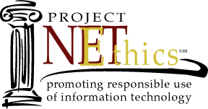


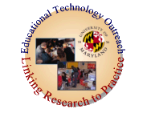
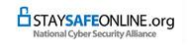

Register Today Online!
(301) 405-8202
For more information see:
www.edtechoutreach.umd.edu/C32006/
Implications for the Educational Community
Part of the National Cyber Security Awareness Month Initiative
October 5- Pre-conference Workshops
October 6-7, 2006 - Conference Sessions
University of Maryland, College Park, MD
University of Maryland

Walk away with CDROMs and at least Ten Strategies to implement in your instruction as soon as you return to your classroom!
- Property Rights and Copyright issues
- Plagiarism, Electronic Cheating and Ethical Development, Decision Making and Character Education
- Safety and Security: Internet Citizenship,Rights and Responsibilities
- Effective Security Practices
- iSAFE, NetSmatz, iKeepSafe & other Curriculum Resources
- Viruses, Hoaxes, Trojan Horses: Backing Up, Anti-virus protection, and Firewalls
- Mail, Messaging, Spam Control
- Privacy and Identity Protection

The digital age has created new concerns regarding the use of non-traditional electronic and Internet resources in the classroom setting. Unfortunately, while the teaching of technology processes and skills has been handed to the classroom teacher, most educators lack the knowledge and up-to date information related to Cyberawareness issues. Teacher technology training has been geared towards skills development and integration techniques. Teachers, in many instances, model incorrect protocol and behavior to their students. Not only does this increase the chance of improper use it, also increases the risks to the security of the teacher’s classroom and local school system’s information systems.
and the University of Maryland Libraries

Sponsored by:

