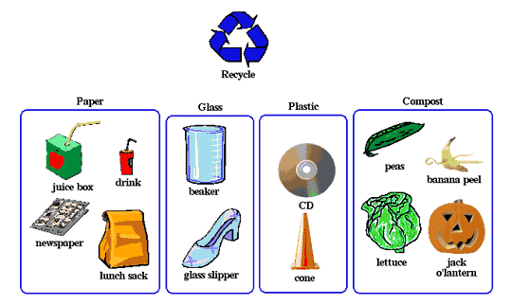
The organizer would enable students to understand similarities and differences.

