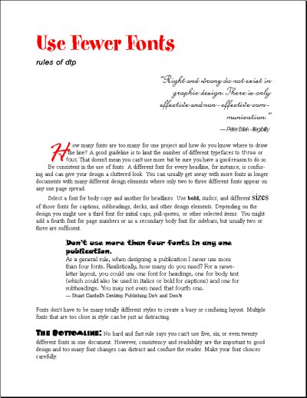

There are ten different typefaces competing for attention in this example. Can you see the two script fonts, three decorative fonts, two sans serifs, and three serifs? Mixing two script typefaces is rarely a good idea.
Varying the size of just two or three typefaces would have been more effective with, perhaps, a single script typeface for the pull-quote and initial cap.
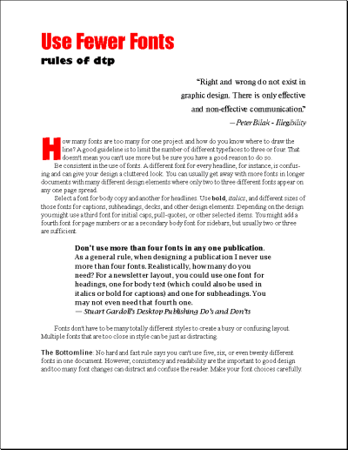
The eight typefaces in this example break two different rules — too many fonts and using fonts that are too similar in style. There are four different sans serif typefaces and four sans serif.
The lack of contrast, along with lack of consistency, throws off the design (more obvious when seen full size). There's little reason to use multiple typefaces if they are so similar in style. It would probably be better to use that 'tried-and-true formula' of pairing one serif and one sans serif.

